Final Project Proposal on

**Urban Sprawl Prediction**



Submitted to

**Department of Computer Science and Engineering**

**Nepal Engineering College**

in Partial Fulfillment of the

Requirements for the Degree of B.E. in Computer

Submitted By

Pawan Shrestha (021-353)

Prashows Amatya (021-359)

Sananda Satyal (021-376)

Date: 02/09/2082

# Abstract

The "Urban sprawl Prediction" is an innovative model designed to for sustainable urban planning, particularly in areas like Nepal's Kathmandu Valley that are expanding quickly. We create an end-to-end, beginner-friendly deep learning pipeline in this study that uses open-source, multi-year satellite imagery (Sentinel 2 and Landsat 8) and land-cover labels (ESA WorldCover and OpenStreetMap) to map the past extent of urban areas and predict their future growth. Once the images have been preprocessed using Google Earth Engine (cloud masking, NDVI and NDBI index computation), we train a U-Net model for pixel-level urban classification and add a ConvLSTM layer to capture temporal dynamics. Accuracy, F1-score, and IoU are used to assess performance, and the results show strong segmentation and accurate predictions. The resulting interactive visualizations, time-series graphs, and GeoTIFF maps give environmental researchers, resource managers, and city planners useful information. All code, scripts, and documentation are openly shared to enable reproducibility and adaptation to other urban areas. Our model is sure to give planners useful information by generating prediction maps showing future urban expansion and gives city planners proper information about how the land is going to change.

#### [Keywords: Deep learning (U-Net, ConvLSTM), Satellite imagery, Google Earth Engine, NDVI/NDBI analysis, Sustainable urban planning]

**TABLE OF CONTENTS**

Abstract i

List of figures iii

Chapter 1: Introduction 1

1.1 Background 1

1.2 Problem Statement 1

1.3 Objectives 2

1.4 Aim 3

1.5 Motivation 3

1.6 Scope and Applications 3

1.7 Feasibility Study 4

1.7.1 Technical Feasibility 4

1.7.2 Economic Feasibility 4

1.7.3 Operational Feasibility 5

1.7.4 Schedule Feasibility 5

Chapter 2: Literature Review 6

Chapter 3: System Design 8

3.1 Flowchart of the Urban Sprawl Prediction 8

3.2 System Requirements 10

Chapter 4: Expected Output 11

Chapter 5: Conclusion 12

References 13

# List of figures

Figure 1 Flowchart of Urban Sprawl Prediction 8

# Chapter 1: Introduction

## Background

The term "urban sprawl" describes the quick and frequently unplanned growth of cities into nearby rural or natural areas. Globally, cities are growing quickly and frequently expanding into neighboring rural or green spaces. While, urban development is essential, but if it proceeds too quickly or without adequate planning, it can lead to major issues like pollution, traffic jams, farmland loss, and strain on public utilities like electricity and water. The Kathmandu Valley in Nepal is one region that is seeing a rapid increase in urbanization. It has undergone substantial change in recent decades as a result of development, migration, and population growth. Satellite photos, which show how land is used and changes over time, provide a clear view of these changes from space. Ground surveys have historically been necessary for researching urban growth, but they are costly and time-consuming. However, we can now use computer models to analyze city expansion because of publicly available satellite data (such as Sentinel-2 and Landsat-8). Policymakers, environmental researchers, and city planners can all benefit from our ability to forecast future urban growth thanks to these models.

In this project, we employ machine learning models and satellite image time series (images from various years) to forecast the likely growth of urban areas in the Kathmandu Valley. Even lone researchers or novices with some coding knowledge can use the project's tools, which include Google Earth Engine, Python, and deep learning models like U-Net and ConvLSTM.

## Problem Statement

Urban areas are growing quickly, frequently without adequate control or planning. Urban sprawl, a term used to describe this type of unplanned growth, presents numerous difficulties. Road congestion, the loss of green areas, pollution, and excessive use of public resources like electricity and water can all result from it. These problems are getting worse in areas like Nepal's Kathmandu Valley as the city keeps expanding rapidly.

One of the primary issues is that decision-makers and city planners frequently lack current knowledge about how the land is changing or where future development is most likely to occur. Without this information, it is difficult to make informed choices about the locations of sustainable housing, schools, and roads. Field surveys and manual mapping are two examples of traditional urban sprawl research methods that are costly, time-consuming, and difficult to replicate frequently. However, a reliable substitute is provided by satellite imagery. They offer a consistent, comprehensive perspective of land use changes over time. These photos, when paired with machine learning methods, can assist in forecasting future urban growth areas.

In order to address the challenge of forecasting urban sprawl, this project will develop a deep learning-based system that can learn from historical satellite imagery and produce forecasts of future urban growth. Through this approach, we can offer practical resources for environmental preservation and urban planning, despite our limited technical expertise and resources.

## Objectives

* To Collect satellite images (Sentinel-2, Landsat-8) for Kathmandu Valley covering multiple years (2000–2024).
* To Preprocess the satellite data using cloud masking and feature extraction (e.g., NDVI, NDBI) to prepare it for analysis.
* To label urban and non-urban areas using land cover maps and OpenStreetMap data.
* Build a spatial classification model (U-Net) to detect urban areas in satellite images.
* Develop a spatio-temporal prediction model (ConvLSTM) to learn how urban areas change over time and forecast future growth.
* Evaluate the performance of the models using accuracy, F1-score, and other metrics.
* Generate prediction maps showing future urban expansion in the Kathmandu region.
* Visualize results with maps and graphs for easier understanding and presentation.

## 1.4 Aim

The main aim is to build a beginner‑friendly deep learning pipeline that uses multi‑year satellite imagery to map and predict urban sprawl.

## 1.5 Motivation

In the past few decades, the Kathmandu Valley has seen fast, unplanned urban growth that has stretched infrastructure, caused traffic jams, reduced green space, and degraded the environment. Planners and policymakers find it challenging to predict where the city will grow next because traditional surveys can't keep up with these changes. Using publicly available satellite imagery (Sentinel-2, Landsat-8) and basic deep learning models, we can automatically track previous development and predict future sprawl, giving local authorities timely and affordable insights for more sustainable, intelligent urban planning.

## 1.6 Scope and Applications

It can be applied to other areas due to its use of open-source tools and public datasets. The projected maps of urban sprawl generated by this pipeline can help city planners prioritize investments in public services, utilities, and roadways as well as identify new expansion fronts. The projections can be used by resource managers to predict future demands on waste, energy, and water systems, and by environmental organizations to identify conservation initiatives and identify places at risk of losing green space. Authorities in charge of transportation can match transit routes with probable development corridors, and disaster management teams can gain a better understanding of how expansion affects areas at danger for earthquakes or flooding. Finally, this open-source, user-friendly approach is a useful model for scholars and students who want to investigate urban dynamics and land-cover change in various cities across the world.

## 1.7 Feasibility Study

The feasibility study shows that the project is viable and has the potential to succeed. Here are the key factors:

### 1.7.1 Technical Feasibility

The system can be developed using existing technologies and resources. Developing the Urban sprawl prediction doesn't require inventing anything new, we can use tools and programming languages that people already know how to use. All required satellite collections (Sentinel‑2, Landsat‑8) and land‑cover products (ESA WorldCover, OpenStreetMap) are readily available via Earth Engine’s APIs. Prebuilt deep‑learning architectures (U‑Net, ConvLSTM2D) and utilities for cloud masking and index calculation simplify implementation. In simple terms, we have everything we need to make this project work from a technical perspective.

### Economic Feasibility

The system is going to be developed as part of the project so there is no cost to spend for the proposed system. Since all software tools and data sources are open-source and free. Larger runs can make use of Google Colab's free GPU tier, while small to medium-sized data preparation and model training can be handled by a consumer-grade laptop or desktop with modest GPU capabilities. This project is very cost-effective because all the resources are already available which gives the indication of the system to be economically possible for development.

### Operational Feasibility

The proposed system is designed to be user-friendly and the workflow is made to be simple to use and repeat. There is no need for local data storage because preprocessing and preliminary analyses take place in Google Earth Engine's web environment. In Jupyter notebooks, model development and evaluation are carried out using well-defined, documented procedures and sample scripts. Plotting in Python or directly loading visual outputs allows for simple interpretation and sharing. Future users can maintain, expand, or modify the system without the need for specialized IT.

### Schedule Feasibility

The project is estimated to take 5 month from initial planning to final development. This includes time for GEE setup and data acquisition. The project team members are allocated different tasks such as handling GEE setup and data acquisition, cloud masking, index computation, and label creation. We are also confident that make sure that the spatial U-Net model is trained and validated. The use of high‑level APIs help ensure the project stays on track and delivers meaningful predictions within this schedule.

# 

# Chapter 2: Literature Review

The quick, frequently unplanned growth of urban regions into nearby rural areas, has an effect on the environment, infrastructure, and society. Over the past few decades, the Kathmandu Valley in Nepal has experienced rapid urbanization, leading to issues like traffic jams, environmental damage, and stress on resources. Urban sprawl prediction sits at the intersection of remote‐sensing land‐cover mapping and spatio‐temporal modeling. Early work in semantic segmentation of high‐resolution imagery demonstrated the power of encoder–decoder CNNs for urban land‐cover classification. For instance, a recent study applied a U Net modelwith a ResNeXt based encoder to very‐high‐resolution (VHR) satellite images, achieving superior F1‐scores compared to traditional maximum‐likelihood classifiers across five urban classes (water, vegetation, bare soil, road, building) [1].

Likewise, MDPI’s Land Use–Land Cover Classification work demonstrated that combining SAR and multispectral inputs in a U Net architecture outperforms random‐forest baselines, underlining the value of multi‐source data fusion for detailed urban mapping [2]. Building on pure spatial segmentation, spatio‐temporal deep models such as ConvLSTM have been introduced to capture both spatial patterns and their evolution over time. In the Seoul metropolitan area, a ConvLSTM trained on land‐cover maps from 1980, 1990, and 2000 successfully predicted urban expansion up to 2030, providing actionable insights for regional planning [3]. Urban sprawl has been related to numerous negative environmental and socioeconomic impacts. Meanwhile, urban areas have been growing at alarming rates, urging for assessing sprawl towards sustainable development. However, sprawl is an elusive term and different approaches to measure it have lead to heterogeneous results. Moreover, most studies rely on pri-vate/commercial data-sets and their software is rarely made public, impeding research reproducibility and comparability. Furthermore, many works give as result a unique value for a region of analysis, dismissing local spatial diversity that is vital for urban planners and policy makers [4].

Comparative analyses have further refined these approaches. A ScienceDirect study benchmarking ConvLSTM against Pix2Pix and Dual‐GAN networks found that ConvLSTM delivers better temporal consistency and sharper boundary delineation for urban growth tasks [5]. Another work contrasted cellular automata–Markov forecasting with deep recurrent models on Sentinel 2 sequences, finding that deep architectures better capture non‐linear expansion trends, though CA–Markov remains competitive in low‐data regimes [6]. This study examines urban growth to support sustainability by investigating urban sprawl in the Vila Velha Urban Agglomeration (UA). If the spatial area of Vila Velha UA increases by 24.36%, from 22.98 km2 in 1994 to 51.64 km2 in 2024, urban sprawl may affect surrounding areas. Landsat satellite images from 1994, 2004, 2014, and 2024 were analyzed to study the spatiotemporal pattern of urban growth. Shannon's entropy index identified urban sprawl in Vila Velha UA. The QGIS software's MOLUSCE (Modules for Land Use Change Simulations) plug-in, utilizing Cellular Automata (CA) and Artificial Neural Network-Multi Layer Perceptron (ANN-MLP) models, forecasted urban expansion for 2034. The built-up area is projected to increase from 51.64 km2 in 2024 to 62.31 km2 in 2034. Shannon's entropy index indicated a high rate of urban sprawl. Remote sensing and machine learning techniques are crucial for understanding spatial trends, forecasting future expansion, and informing sustainable urban planning [7].

Despite these advances, most implementations remain region‐specific (e.g., Seoul, Shenzhen, Saudi cities) and often require substantial computational resources. Moreover, cloud‐processing platforms like Google Earth Engine (GEE) are under‐utilized in published pipelines, even though GEE can automate cloud‐masking, composite creation, and index calculation at scale. Integrating transfer learning from pretrained encoders (e.g., SK ResNeXt) within a U Net/ConvLSTM hybrid could both accelerate training and improve generalizability to diverse geographies such as Kathmandu Valley. This gap motivates our proposed scalable, GEE driven workflow for urban sprawl prediction in Nepal’s rapidly evolving urban landscape

# Chapter 3: System Design

## Flowchart of the Urban Sprawl Prediction

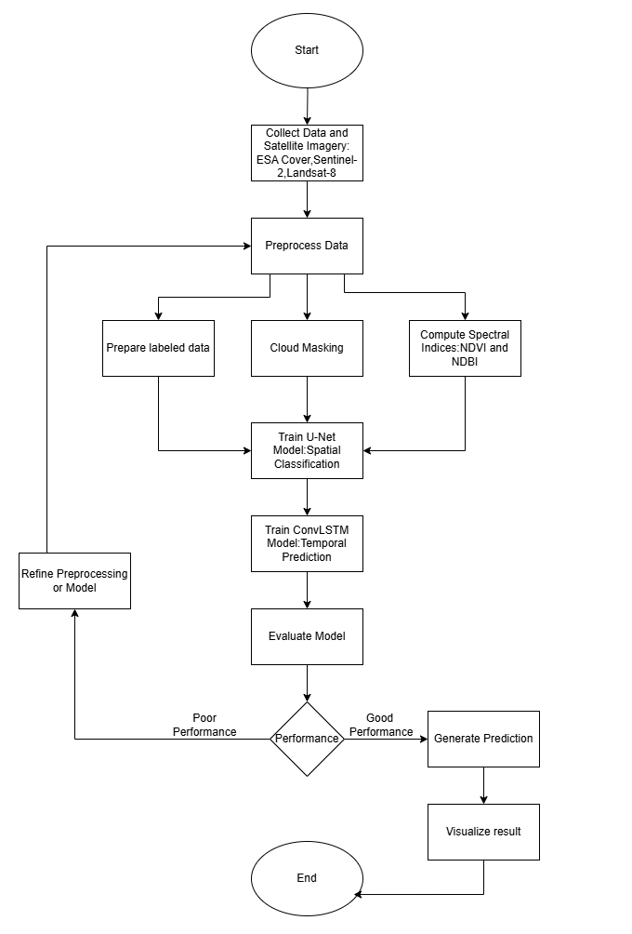

Figure 1 Flowchart of Urban Sprawl Prediction

This flowchart outlines the workflow of our urban sprawl prediction system, guiding users through its data-driven process from start to finish. The journey begins with data collection, where satellite imagery from sources like Sentinel-2 and Landsat-8 is gathered to capture the study area’s landscape over time. These raw images are then cleaned and refined during preprocessing—clouds and distortions are removed, and key spectral indices like NDVI (to measure vegetation) and NDBI (to detect urban areas) are calculated. Next, the system prepares labeled datasets by distinguishing urban and non-urban regions using ESA WorldCover maps and OpenStreetMap data.

With the data ready, the workflow shifts to model training. First, a U-Net model is trained to classify urban areas spatially, acting like a digital cartographer that maps city boundaries pixel by pixel. If the model’s accuracy falls short, the process loops back to refine preprocessing steps or adjust the model architecture. Once validated, a ConvLSTM model is trained to predict *how* these urban areas will expand over time, learning patterns from historical growth trends.

The system then evaluates performance using metrics like accuracy, F1-score, and Intersection over Union (IoU) to ensure reliable predictions. Successful validation leads to generating forecasts, which produce maps highlighting future urban expansion zones. Finally, these predictions are translated into visualizations—interactive maps, time-lapse animations, and graphs—to help planners and policymakers grasp complex trends at a glance. The workflow concludes by delivering actionable insights, empowering stakeholders to design sustainable cities while balancing growth and conservation.

## System Requirements

1.Geospatial Tools:

* Google Earth Engine (GEE): For cloud-based preprocessing (cloud masking, NDVI/NDBI computation).
* QGIS/ArcGIS: For manual labeling, visualization, and GIS analysis.

2.Programming Languages & Libraries:

* Python 3.8+: Core language for scripting.
* TensorFlow/PyTorch: Deep learning frameworks for U-Net and ConvLSTM.
* Scikit-learn: For performance metrics (accuracy, IoU, F1-score).
* Geopandas/Matplotlib: For spatial data handling and plotting.

3.Data Management:

* Jupyter Notebook/Lab: For interactive code development and documentation.

4. Data Requirements

* Satellite Imagery:
* Sources: Sentinel-2 ,Landsat-8 (30m resolution).

# Chapter 4: Expected Output

The expected output of the “Urban Sprawl Prediction” project includes following points:

* To Collect satellite images (Sentinel-2, Landsat-8) for Kathmandu Valley covering multiple years (2000–2024).
* Preprocessed and cloud-masked satellite imagery of Kathmandu Valley (2000–2024).
* NDVI and NDBI index maps indicating vegetation and built-up areas.
* A labeled dataset for training urban vs. non-urban classification models.
* A trained U-Net model capable of detecting urban areas in satellite images.
* A trained ConvLSTM model for predicting future urban sprawl over time.
* Accuracy, F1-score, and IoU metrics for model performance evaluation.
* Urban classification maps for each year in the time series.
* Predicted urban expansion maps for future years based on historical patterns.
* Visual graphs and charts showing the extent and rate of urban growth.

.

# Chapter 5: Conclusion

Our proposed urban sprawl prediction system offers a valuable tool for monitoring and forecasting urban growth in rapidly expanding cities like Kathmandu. By leveraging multi-year satellite imagery and deep learning models, the system provides accurate insights into how urban areas evolve over time. In regions where unplanned development poses serious environmental and infrastructural challenges, this system serves as a crucial decision-support aid.

By combining spatial classification (U-Net) and temporal prediction (ConvLSTM), the model not only maps current urban areas but also forecasts future expansion. This empowers urban planners, policymakers, and researchers to make proactive, data-driven decisions. The use of free, open-source data and tools makes the system accessible and scalable for individual researchers and government institutions alike.

In growing urban environments, understanding where and how sprawl is happening helps optimize infrastructure development, reduce environmental impact, and support sustainable planning. This system transforms raw satellite data into actionable insights—delivering not just predictions but a deeper understanding of urban dynamics.

.

# References

|  |  |
| --- | --- |
| [1] | M. F. a. A. Barsi, "A U-Net Model for Urban Land Cover Classification Using VHR Satellite Images," *Period. Polytech. Civil Eng,* vol. 69, no. 1, pp. 98-108, 2025. |
| [2] | J. V. a. M. J. F. a. G. Y. a. G.-C. J. A. Solórzano, "Land Use Land Cover Classification with U-Net: Advantages of Combining Sentinel-1 and Sentinel-2 Imagery," *Remote Sensing,* vol. 13, no. 18, 2021. |
| [3] | J. P. J.M. Kim, "PREDICTING OF URBAN EXPANSION USING CONVOLUTIONAL LSTM," *Remote Sensing and Spatial Information Sciences,* vol. 10, pp. 19-21, 2022. |
| [4] | M. B. S. F. P. S. Luciano Gervasoni, "Calculating spatial urban sprawl indices using open data," in *15th International Conference on Computers in Urban Planning and Urban Management*, Adelaide, Australia, 2017. |
| [5] | W. G. H. K. M. A. Boulila, "A novel CNN-LSTM-based approach to predict urban expansion," *Ecological Informatics,* vol. 64, 2021. |
| [6] | C.-E. L. a. Y. M. Reda Yaagoubia, "A comparative analysis on the use of a cellular automata Markovchain versus a convolutional LSTM model in forecasting urbangrowth using sentinel 2A images," *JOURNAL OF LAND USE SCIENCE,* vol. 19, no. 1, pp. 258-277, 2024. |
| [7] | A. M. e. al, "An analysis of urban sprawl growth and prediction using remote sensing and machine learning techniques," *Journal of South American Earth Sciences,* vol. 142, no. 1, p. 104988, 2024. |