Case Study

# **Abstract**

Considering todays need in the field of Education System and other learning system, we the student of BEIT VI ‘M’ have planned to develop the website named “Online Learning System” which meets almost all the demands required in the field of online Learning System. An online learning system is a web-based platform that provides a virtual environment for students and teachers to engage in learning and teaching activities. The system offers a range of courses and educational programs that can be accessed anytime, anywhere, and at the learner's own pace.To achieve the goal of preparation of website it is very necessary to choose appropriate programming language which can meet the goal in given time and budget. Taking all this in mind we have to choose IDE (Integrated Development Environment) of Visual Studio 2017 with Language HTML, CSS, Bootstrap, PostgreSQL, JS, Django for develop our website. It provides features such as course creation and management, student enrollment and management, download course material and interact with lectures online, learning analytics and security and privacy. Instructors can create, edit, and manage courses, while students can browse and enroll in courses and track their progress. The platform supports a variety of multimedia resources and tools, such as videos, interactive simulations to enhance the learning experience.

**Keywords:** *Online Learning System, web-based platform, PostgreSQL, Django.*

# **Use case Diagram**

Here, three actors are shown in the use case diagram below. A student can login, access courses and enroll into courses .Teachers can login, create courses and manage courses. Admin also login, create courses and manage courses.

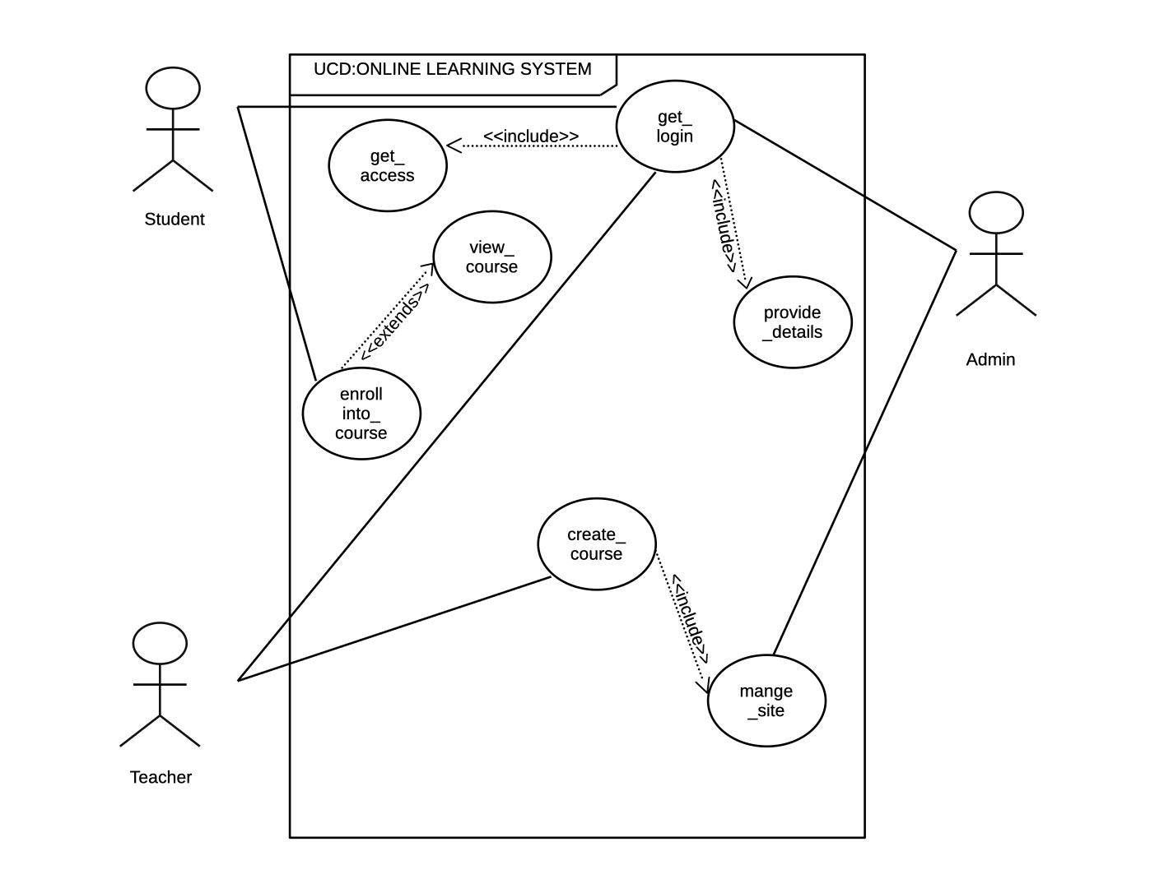

## **Brief**

**Usecase name:** Login (UC#1)

A user opens the online learning system’s website. They try to login into the website. If they haven’t registered their account then first they have to register their account and login into their account . After that, they enter the dashboard.

**Usecase name:** Create Course (UC#2)

Admin and teacher open the online learning system’s website. They login into the website and create a course.Then they can post the material in this section.

**Usecase name:** Manage Courses(UC#3)

Admin can create courses by uploading the files or video into the website through the admin's dashboard. Also admin has the privilege to edit , delete or update the course too.

**Usecase name:** Access Courses (UC#4)

Students open the online learning web application. System displays the user-dashboard. Then the student provides details to get logged in .Once logged in he/she chooses a course and gets enrolled.

**Usecase name:** Enroll courses (UC#5)

Students first visit the online learning web application. System displays the user-dashboard. Then the student provides details to get logged in . Once logged in he/she chooses a course and gets enrolled and the enrolled course is available to the student’s dashboard.

## **Casual**

**Usecase name:** Login (UC#1)

**Main Success Scenario:**

A user opens the system’s tab and login into the webpage. The system checks the validation. Now, the system is logged in and the user enters the dashboard.

**Alternate Scenarios:**

* If the account is not registered
* If email is not valid
* If password is not matched
* If password is forgotten
* If system failure occurs

**Usecase name:** Create Course (UC#2)

**Main Success Scenario:**

Admin and Teacher open the system’s tab and login into the webpage. The system checks the validation. Now, the system is logged in and the user enters the dashboard then they can create a course.

**Usecase name:** Manage Courses(UC#3)

**Usecase name:** Access Courses (UC#4)

**Main Success Scenario:**

Students enroll into the course and can access the contents.If the credentials during login are correct,he/she can process further and if incorrect they need to login with proper credentials as if the credentials are incorrect, the login is not granted.

**Usecase name:** Enroll courses (UC#5)

## **Fully dressed**

**Usecase name:** Login (UC#1)

**Scope:** Web Application

**Level:** User goal

**Primary actor:** Student, Teacher and Admin

**Stakeholders and Interests:**Student, Teacher and Admin

**User:** Student,Teacher/Admin.

**Preconditions:** Student, Teacher and Admin identified and authenticated

**Success Guarantee/Post conditions:**Create Course,View and update courses

**Main success scenario/Basic Flow:**Student can View course, Teacher Provide content and Admin manage the courses.

**Extensions/Alternate Scenario:**At any time system fails,

**Special Requirements:**

**Technology and data variation list:**

**Frequency of Occurrence:**

**Miscellaneous:**

**Usecase name:** Create Course (UC#2)

**Scope:**

**Level:**

**Primary actor:**Admin/Teacher

**Stakeholders and Interests:**Teacher/Instructor: Responsible for creating and delivering the course content.

**User:**Student/Teacher/Admin

**Preconditions:**The user/student has a registered account in the online learning system.

**Success Guarantee/Post conditions:**

**Main success scenario/Basic Flow:**

**Extensions/Alternate Scenario:**

**Special Requirements:**

**Technology and data variation list:**

**Frequency of Occurrence:**

**Miscellaneous:**

**Usecase name:** Manage Courses(UC#3)

**Scope:** Online learning System

**Level:** AdminGoal

**Primary actor:** Admin

**Stakeholders and Interests:** Admin has to manage the site.

**User:** Admin

**Machine learning system:**

**Preconditions:** The courses need to be created first.

**Success Guarantee/Post conditions:**

* After successful creation of courses, they can be managed properly.

**Main success scenario/Basic Flow:**

1. After successful creation of course ,admin then manages all the functionalities related to the available courses.

**Extensions/Alternate Scenario:** If the courses are not created beforehand,there remains nothing to be managed .

**Special Requirements:** The courses must be properly created.

**Technology and data variation list:**

**Frequency of Occurrence:**

**Miscellaneous:**

**Usecase name:** Access Courses (UC#4)

**Scope:** Online Learning System

**Level:**User Goal

**Primary actor:**Student

**Stakeholders and Interests:**

→ Student: Want to access the course content.

→ Admin: Wants to make sure that the student can easily access the course materials.

**User:** Student

**Machine learning system:**

**Preconditions:** The user/student has a registered account in the online learning system.

**Success Guarantee/Post conditions:**

* If the access of course is successful, the student can then view the contents and even download them for future reference.
* If the enrollment of course is not successful, the student then can’t perform further activities.

**Main success scenario/Basic Flow:**

1. Students launch the application.
2. Students then provide credentials for login into the application.
3. Students then choose the desired course and provide access requests.
4. If the access to the site was successful, he/she can enroll into the course .
5. If the access to the site was denied,he/ she needs to try again with proper credentials in order for the course to be accessed.

**Extensions/Alternate Scenario:**

* If the student enters incorrect information during login, he/she needs to try again with the correct credentials.

**Special Requirements:** The courses available should be propely created/managed and the one accessing them must be with proper crendentials.

**Technology and data variation list:**

**Frequency of Occurrence:**

**Miscellaneous:**

**Usecase name:** Enroll courses (UC#5)

**Scope:**

**Level:**

**Primary actor:**

**Stakeholders and Interests:**

**User:**

**Machine learning system:**

**Preconditions:**

**Success Guarantee/Post conditions:**

**Main success scenario/Basic Flow:**

**Extensions/Alternate Scenario:**

**Special Requirements:**

**Technology and data variation list:**

**Frequency of Occurrence:**

**Miscellaneous:**

## **Two column variation**

**Usecase name:** Login (UC#1)

| Actor Action | System Response |
| --- | --- |
| 1. Users lodge the application. |  |
|  | 1. System displays the user dashboard. |
| 1. Users provide credentials. |  |
|  | 1. System validates and then provides access. |

**Usecase name:** Create Course (UC#2)

**Usecase name:** Manage Courses(UC#3)

**Usecase name:** Access Courses (UC#4)

| Actor Action | System Response |
| --- | --- |
| 1. Students open the applications. |  |
|  | 1. System displays a user dashboard. |
| 1. Students login the applications. |  |
|  | 1. Teachers create course contents. |
| 1. Students choose a course and enroll into it. |  |
|  | 1. System provides access to the course. |
| 1. Students download the course contents. |  |
| 1. Students provide their feedback. |  |

**Usecase name:** Enroll courses (UC#5)

# SSD

A System Sequence Diagram (SSD) illustrates the interactions between an external actor i.e., student and the system to accomplish a specific use case which is Online Learning System. Here's an example of a System Sequence Diagram.

**Usecase name:** Login (UC#1)

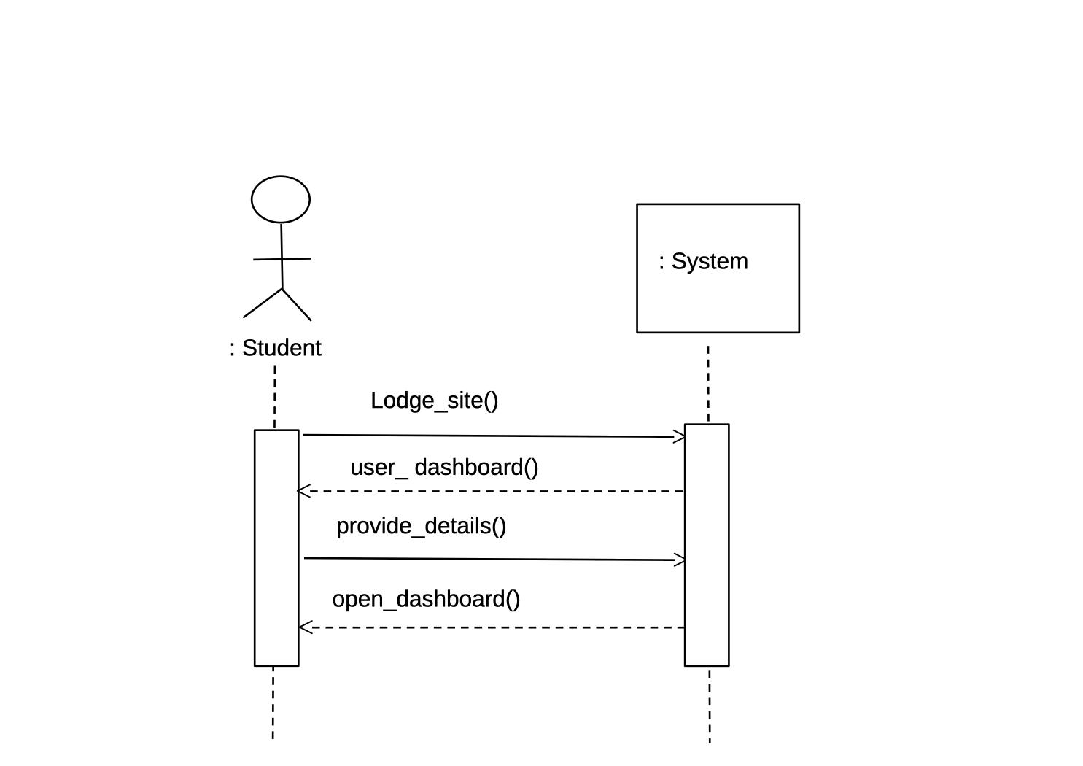

**Usecase name:** Create Course (UC#2)

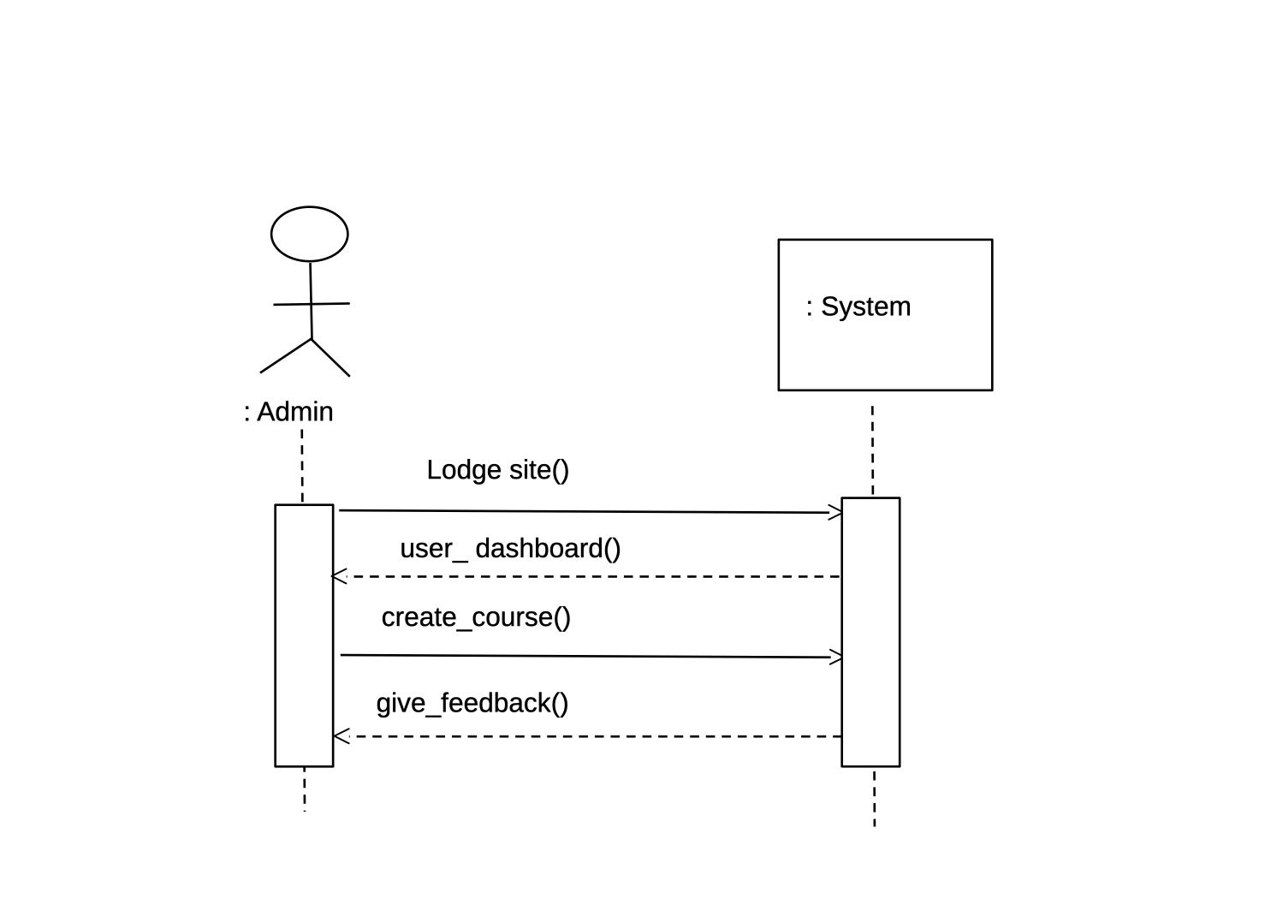

**Usecase name:** Manage Courses(UC#3)

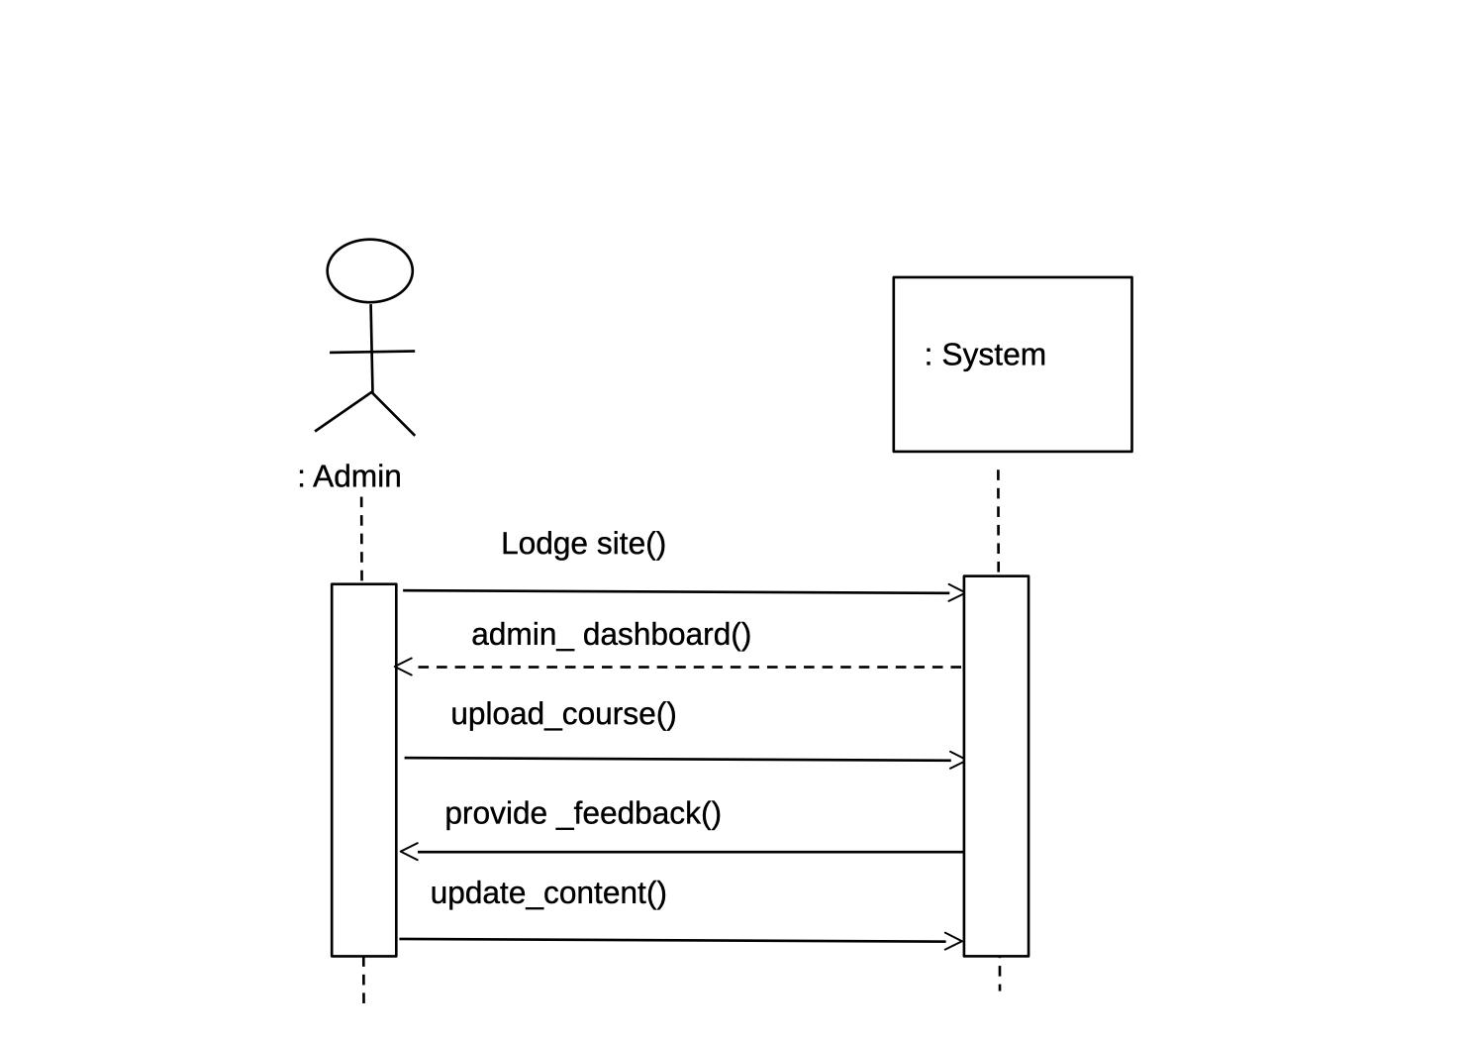

**Usecase name:** Access Courses (UC#4)

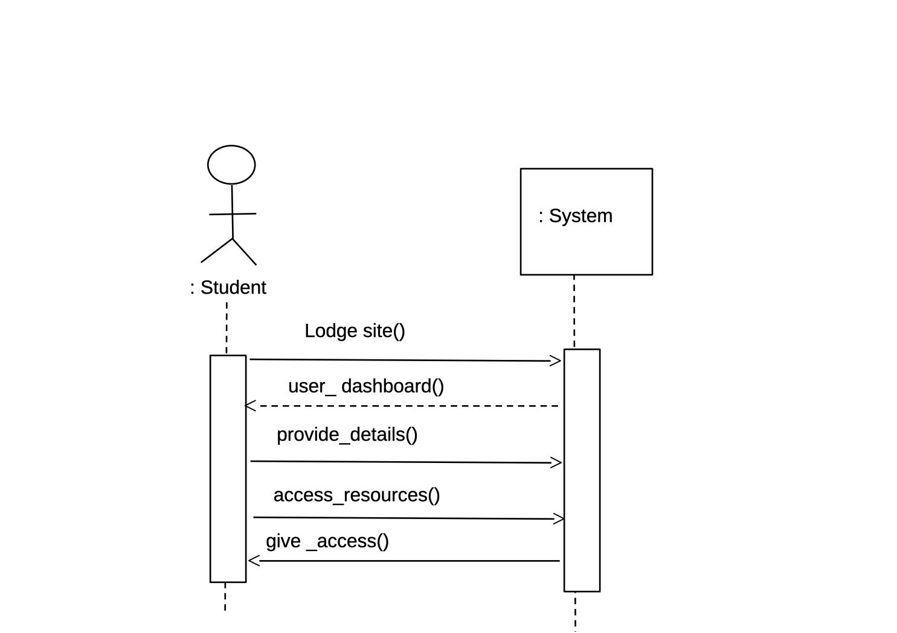

**Usecase name:** Enroll courses (UC#5)

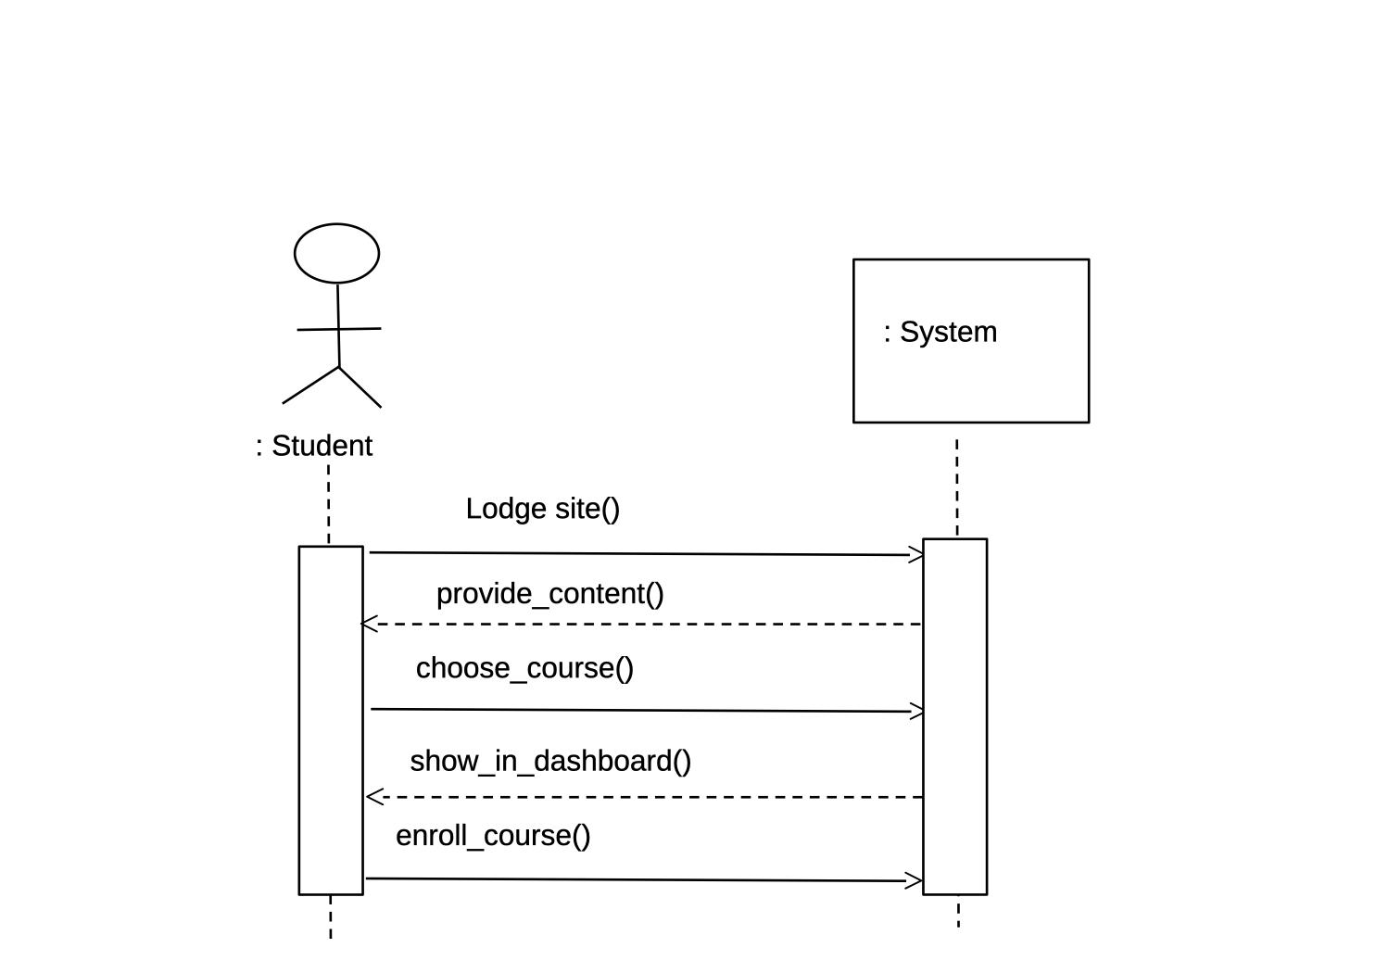

Domain Model:

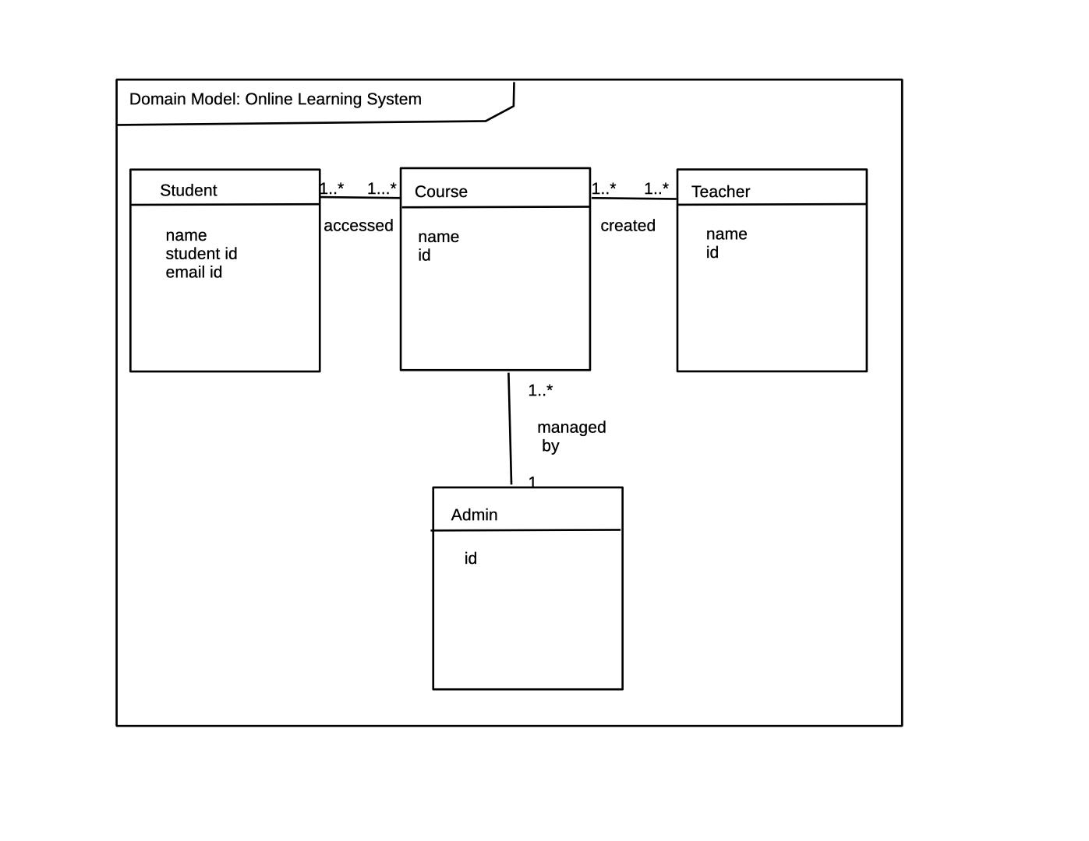

Operational Contract:

**Operation:**Make login.

**Cross References:** Use Case:Login

**Precondition:**

* Login should be done with proper crenditials.

**Postcondition:**

* After getting logged in one can access the site properly.

**Operation:**Make access into course

**Cross References:** Use Case: enroll into course

**Preconditions:**

* The student has a registered account in the system.

**Postconditions:**

* If the enrollment is successful, he/she can then access the course contents.