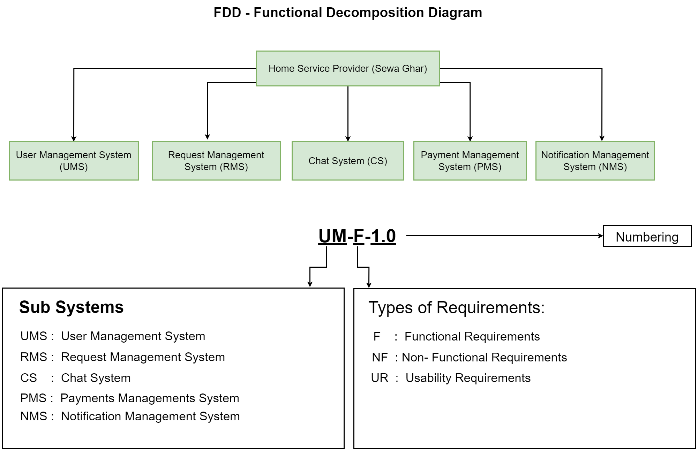

User Management System (UMS)
Req. Code | Req. Desc
UM-F-1.0
UM-F-2.0
UM-F-3.0
UM-F-4.0

Request Management System (RMS)
Req. Code | Req. Desc | Use Case
RMS-F-1.0
RMS-F-2.0
RMS-F-3.0
RMS-F-4.0

