HPC Acceleration of Pipeline for Analyzing a
September 2019 Sudden Stratospheric Warming (SSW) Event
PHYS 5V48.002 – Topics in Physics
- by Prasoon Vishwakarma

ABSTRACT
Sudden Stratospheric Warming (SSW) event is a frequent meteorological phenomenon observed in winter hemisphere, where disruption of polar vortex causes weeks of harsh winters at mid-to-lower latitudes and milder winters around the pole. The atmospheric waves that cause the disruption also produces periodic signatures in low latitude ionosphere around the magnetic equator, that can be observed using ionospheric Total Electron Content (TEC) data. Analyzing SSW events requires integrating large, heterogeneous datasets from multiple sources, including open-source Madrigal TEC observations, Low-latitude Ionospheric Sensor Network (LISN) GPS receivers’ data, and Whole Atmosphere Community Climate Model with thermosphere ionosphere-Extension (WACCM-X) outputs. The raw data volume exceeds tens of gigabytes, and the computational pipeline encompasses I/O-bound downloading, CPU-bound processing, FFT-based spectral analysis, and data compression. Each of these segments presents distinct parallelization opportunities and, in this report, we present an HPC-accelerated pipeline for studying the September 2019 SSW event. Key strategies include multi-threaded downloading with Python threading, Dask-based parallel data loading, Joblib-based multiprocessing and multithreading, Parquet/Snappy compression, and map-reduce parallel processing. The pipeline achieves speedups ranging from 2.66x to 7.54x across different stages, enabling time-efficient extraction of tidal and planetary wave signatures correlated with the SSW-induced TEC perturbations.

Introduction and Scientific Motivation
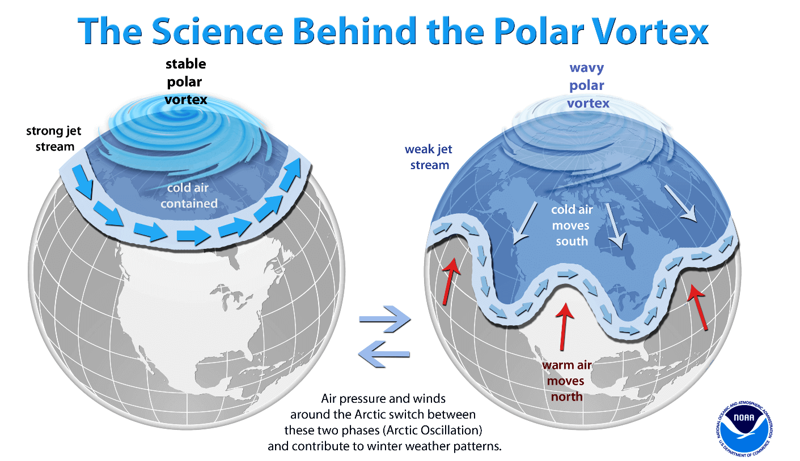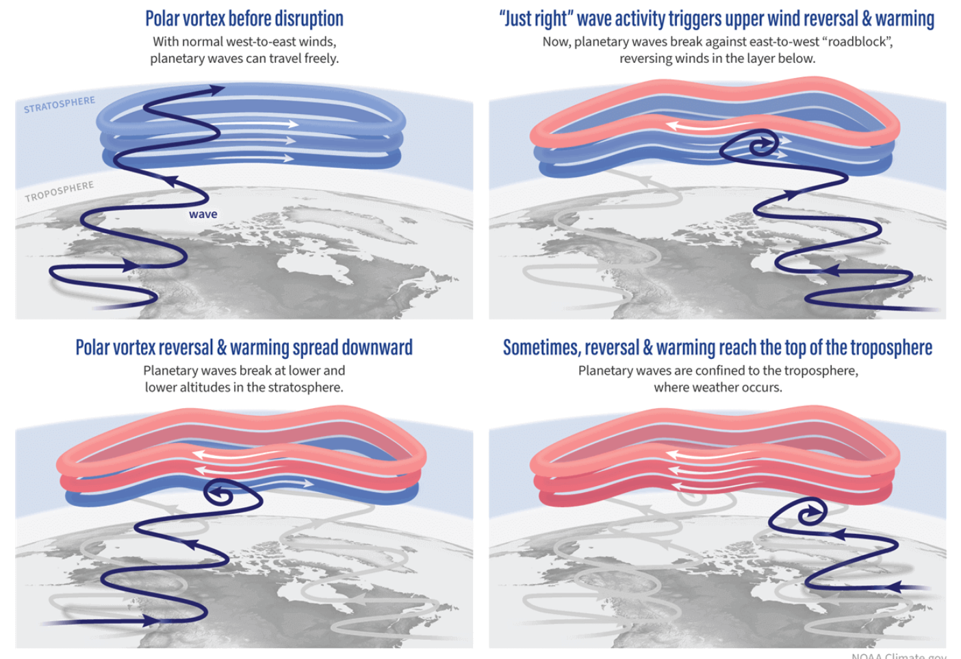
Figure 1. Comparison of Polar Vortex of winter hemisphere during normal and SSW period (left) is shown. Mechanism of atmospheric waves causing vortex disruption is shown in right.
Sudden Stratospheric Warming (SSW) events are large-scale dynamical disturbances in the polar stratosphere characterized by weakening of the strong eastward polar jet streams that contain the cold winds at high latitudes (Figure 1). Escape of these winds to lower latitudes results in a rapid temperature increase of up to 50 K over a few days in polar regions, accompanied by a reversal or significant deceleration of the polar vortex. These disruptions are triggered by upward-propagating tropospheric planetary Rossby waves that interact with and break within the stratosphere, and their effects extend both upward into the mesosphere and lower thermosphere and downward toward the troposphere.
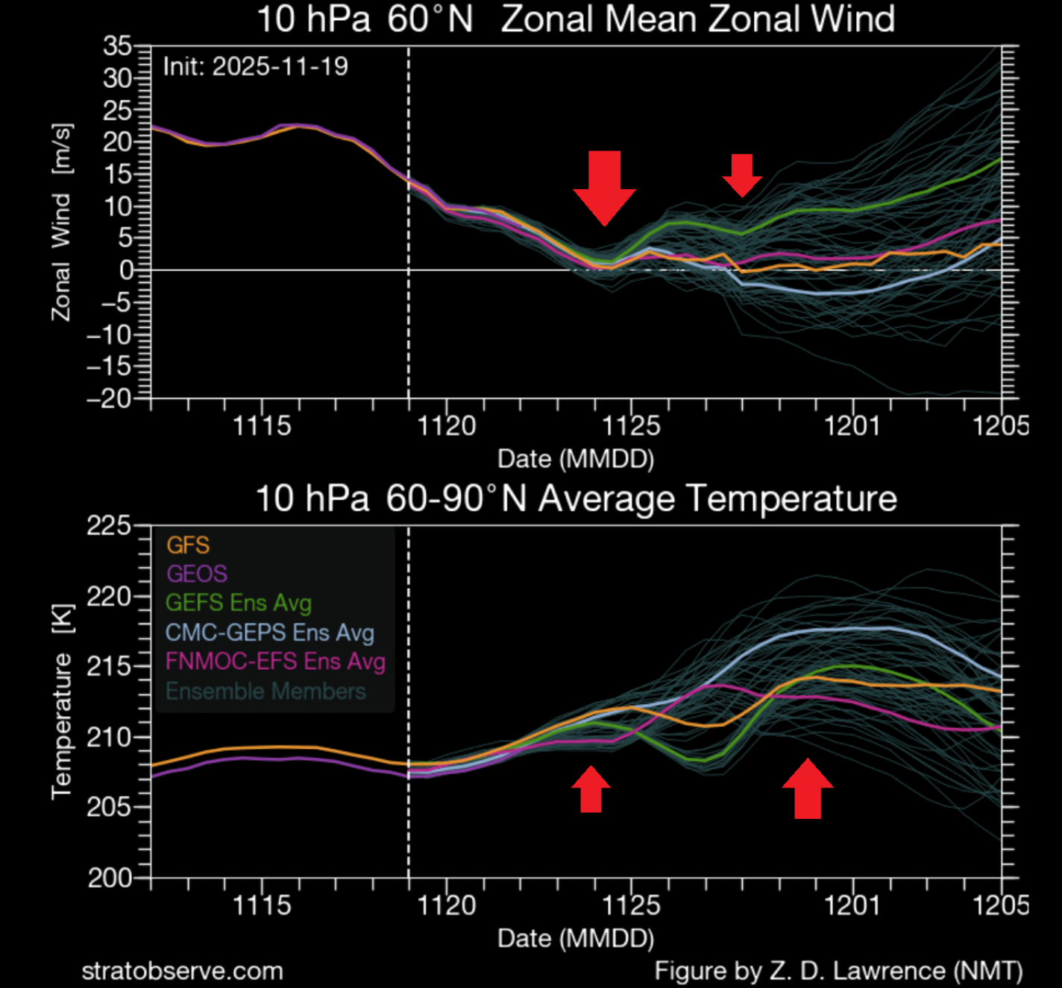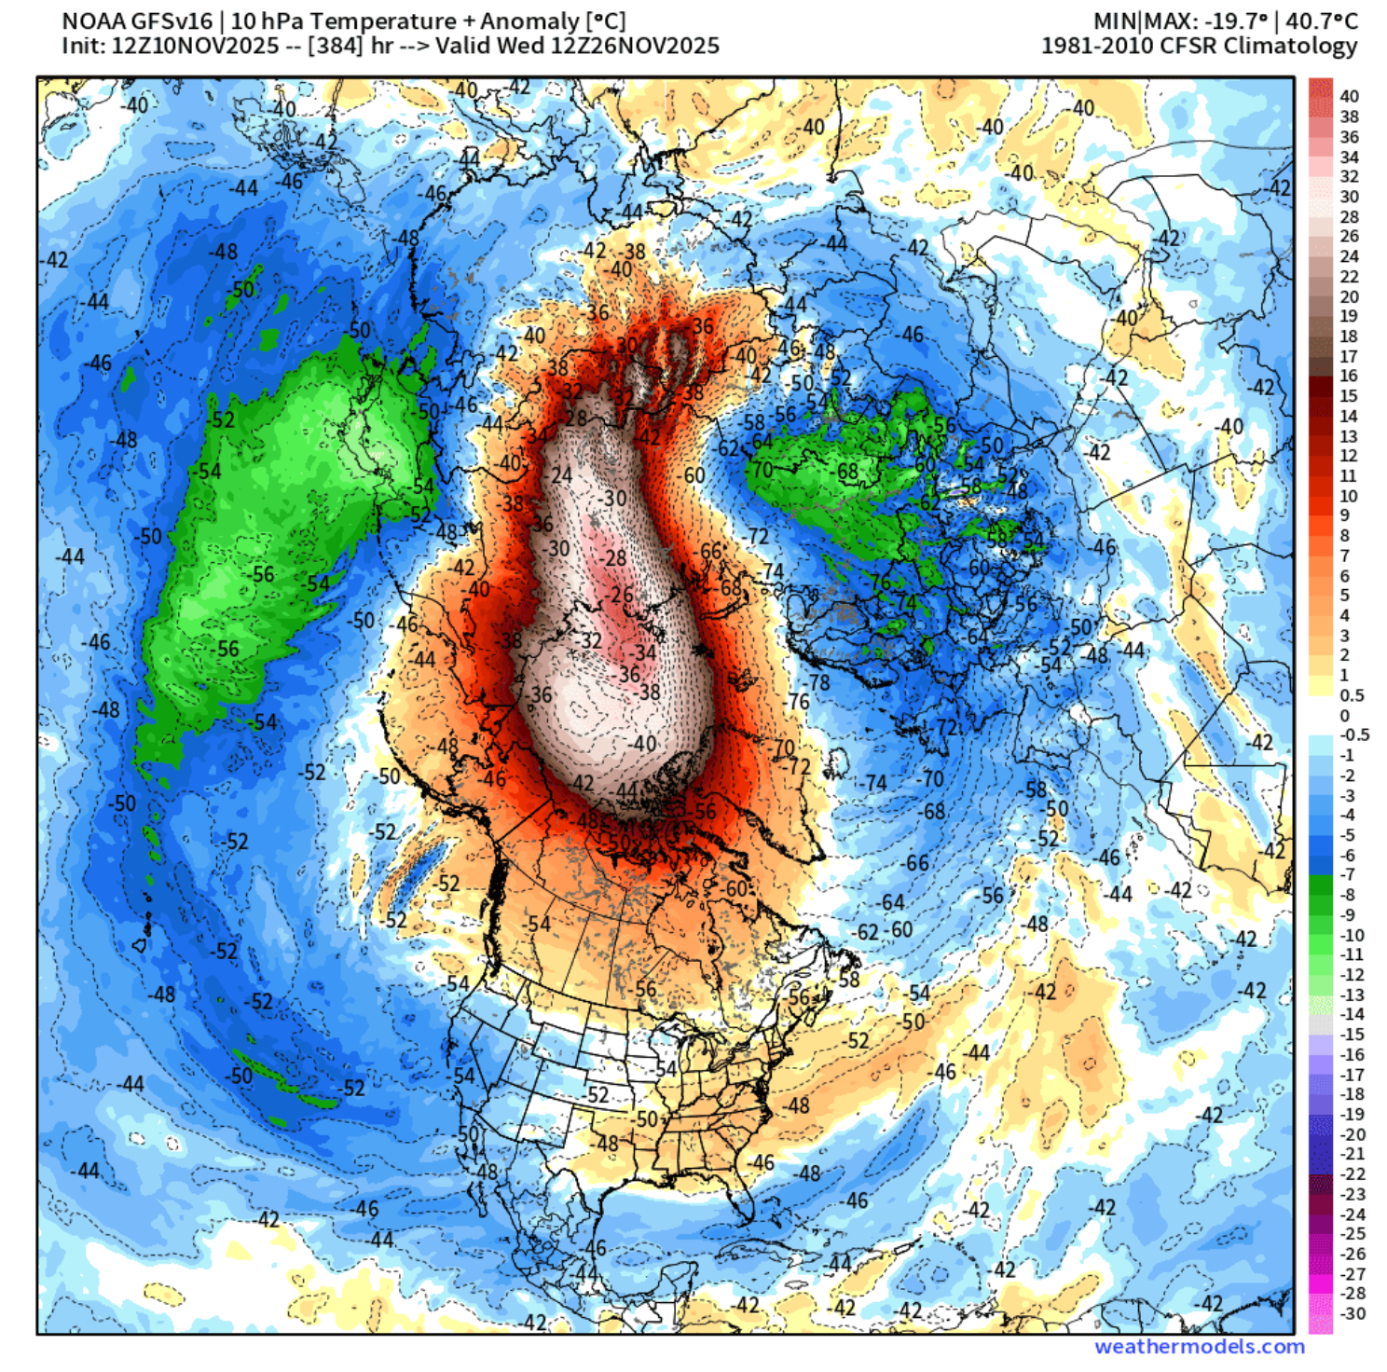
Figure 2. Stratospheric Zonal winds and polar temperature (left) are shown during SSW event. An example of SSW even that caused polar vortex splitting.
The onset of these SSW events is identified by reduction and even reversal of eastward zonal winds at 10hPa 60° latitude of winter hemisphere, and average temperature increase at 10hPa and 60°-90° latitude (left, Figure 2). The image (right, Figure 2) shows an incident of splitting polar vortex (green), along with temperature spike at the center.
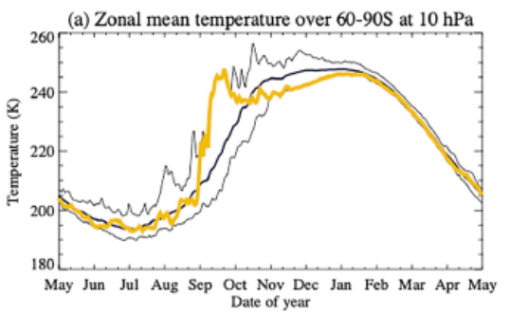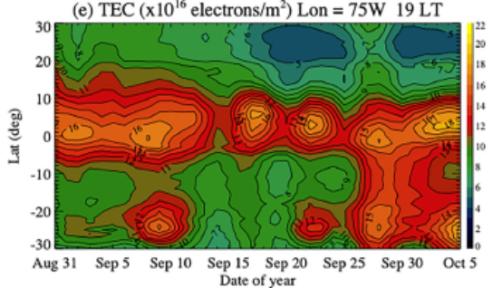
Figure 3. Stratospheric temperature spike (right) shows the onset of Sept 2019 SSW event. Madrigal TEC (right) is shown during SSW period. Both plots are taken from [1]
The September 2019 SSW event is a notable case of an early-onset Southern Hemisphere warming, around 1st Sept, with measurable ionospheric anomalies near the magnetic equator (Figure 3 taken from [1]). During SSW events, the ionospheric Total Electron Content (TEC)—a proxy for plasma density integrated along a vertical column—exhibits modulations driven by altered tidal forcing from the lower atmosphere. Specifically, the amplitudes of migrating and non-migrating solar diurnal (S1), semidiurnal (S2), and lunar semidiurnal (M2) tides, as well as planetary waves with periods of 2, 10, and 16 days, are perturbed and couple to the ionosphere to produce variations in TEC. For the case of Sept 2019 SSW event, a pseudo-6-day periodicity could be observed in Figure 3.
Studying these couplings requires integrating multiple data sources: GPS-derived TEC from the Madrigal global database, the Latin American network LISN, and WACCM-X model outputs. The combined dataset involves tens of gigabytes of raw data spanning 24 days. Processing this in serial is prohibitively slow. This project systematically applies HPC techniques to each pipeline stage, achieving significant speedups while preserving scientific accuracy.

2. Dataset Description

2.1 Madrigal Global TEC Database
Madrigal is an open-source international database for upper atmospheric science. Global binned TEC data was downloaded for a 24-day window centered on the September 2019 SSW onset. Each day's file is in HDF5-text (.hdf5.txt) format containing over 16 million rows of GLAT, GLON, and time-stamped TEC values, approximately 770 MB per file, yielding ~18.5 GB total for 24 days. Downloads are performed via authenticated API calls to the Madrigal server.

2.2 LISN GPS Receiver Network
The Low-latitude Ionospheric Sensor Network (LISN) provides high-cadence TEC measurements across South America. Raw data arrives as over 100 binary .dat files requiring parsing, cleaning, and restructuring. The final processed dataset contains over 500,000 rows of GLAT, GLON, and TEC values, amounting to ~500 MB if stored as CSV—highlighting the importance of efficient storage formats.

2.3 WACCM-X Model Output
The Whole Atmosphere Community Climate Model with thermosphere-ionosphere eXtension (WACCM-X) provides model-simulated TEC, neutral winds, temperature, and ion density in NetCDF (.nc) format. Eight files covering the analysis period each contain multi-dimensional arrays (latitude, longitude, altitude, time) requiring CPU-intensive filtering, interpolation, and FFT analysis to extract tidal and planetary wave components.

3. Methods and HPC Implementation
The analysis pipeline consists of four sequential stages, each targeting a different computational bottleneck.

3.1 Stage 1: Parallel Madrigal Data Downloading (I/O-Bound)
Downloading 24 days (benchmark) of Madrigal TEC data is I/O-bound: CPU utilization is low, and latency is dominated by network transfer. Because the Python GIL does not apply to I/O operations, threading is the natural parallelization primitive. A ThreadPoolExecutor is used with the 24 days organized into 12 chunks of 2 days each. Results for varying thread counts are shown in Table 1.
Workers | Wall Time (s) | Wall Time (min) | Speedup vs. Serial
1 (serial) | 2988 | ~50.0 | 1.00x
2 | 1620 | ~27.0 | 1.84x
3 | 1120 | ~18.7 | 2.67x
4 | 870 | ~14.5 | 3.44x
6 | 780 | ~13.0 | 3.83x
8 | 810 | ~13.5 | 3.69x

Table 1. Download time and speedup for Madrigal data retrieval as a function of thread count.
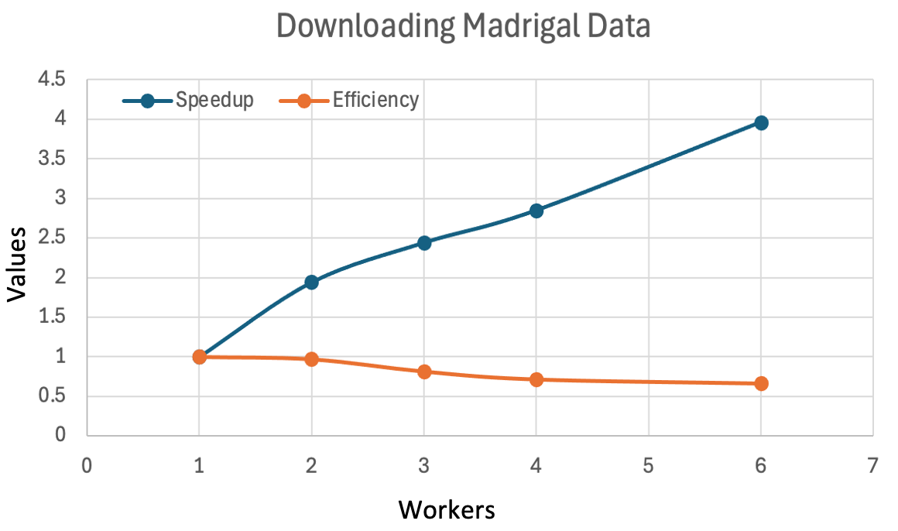
Figure 4. It shows the speedups (blue) and efficiency (orange) obtained while downloading Madrigal data using multiple workers.
The optimal 6-worker configuration achieves a 3.83x speedup, reducing download time from ~50 minutes to ~13 minutes. Beyond 6 workers, performance degrades due to server-side rate limiting and bandwidth saturation.

3.2 Stage 2: LISN Data Parsing and Storage Optimization
Over 1000 binary .dat files are parsed into a unified dataset of 500,000+ rows. A critical finding is that storage format dramatically impacts I/O speed and amount of memory used on disk. For benchmark, 20 .dat files are used to obtain a unified dataset. CSV with float64 is compared against Apache Parquet with Snappy compression and float32 precision down casting (Table 2). The precision downcast is scientifically justified: GPS-derived TEC has an absolute precision of ~0.1 TECU, well within float32 range. No scientific accuracy is lost.
Storage Format | Write Time (s) | File Size (MB) | Speedup | Size Reduction
CSV (float64) | 1.46 | 20.6 | 1.00x (baseline) | —
Parquet + Snappy (float32) | 0.53 | 3.99 | 2.76x faster | ~80% smaller

Table 2. Comparison of CSV and Parquet storage formats for LISN processed data (20 .dat files, 500k+ rows).
Parquet's columnar layout also benefits downstream processing: only needed columns are read, skipping irrelevant data entirely—a significant advantage over row-oriented CSV where all columns must be scanned.
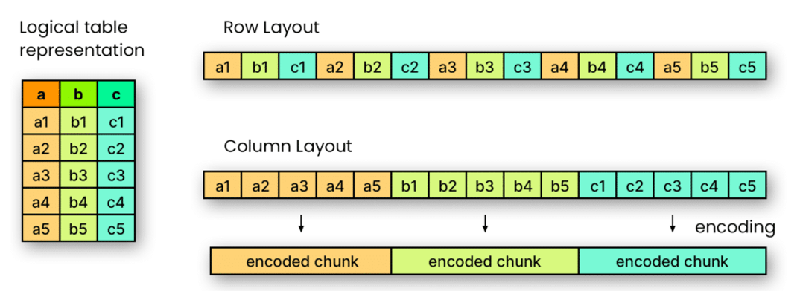
Figure 5. Distribution of table data in Row and Columnar (seen in parquet files) layouts are shown

3.3 Stage 3: Parallel Processing of Madrigal and LISN Data
This stage has two sub-tasks: (a) loading 60 large Madrigal HDF5-text files (benchmark), and (b) CPU-bound data processing of 60 Madrigal .txt and 60 LISN parquet files (benchmark).
Task 3a: Parallel File Loading with Dask. Loading 60 files of 16M+ rows each is slow with serial pandas. Dask's delayed parallel reads load all files concurrently into a lazy DataFrame computed in a single pass, yielding a 2.99x speedup by overlapping file I/O with parsing and hiding I/O latency.
Task 3b: Joblib Parallel Processing. CPU-bound processing of 60 Madrigal CSV files and 60 LISN Parquet files is parallelized with Joblib. Threading achieves a better speedup (~2.66x at 4 workers) than multiprocessing because: (1) data is in shared memory as NumPy arrays, avoiding pickling overhead; (2) NumPy's C-level routines release the GIL, allowing true parallelism. Multiprocessing incurs heavy serialization cost for tens-of-MB arrays per file.
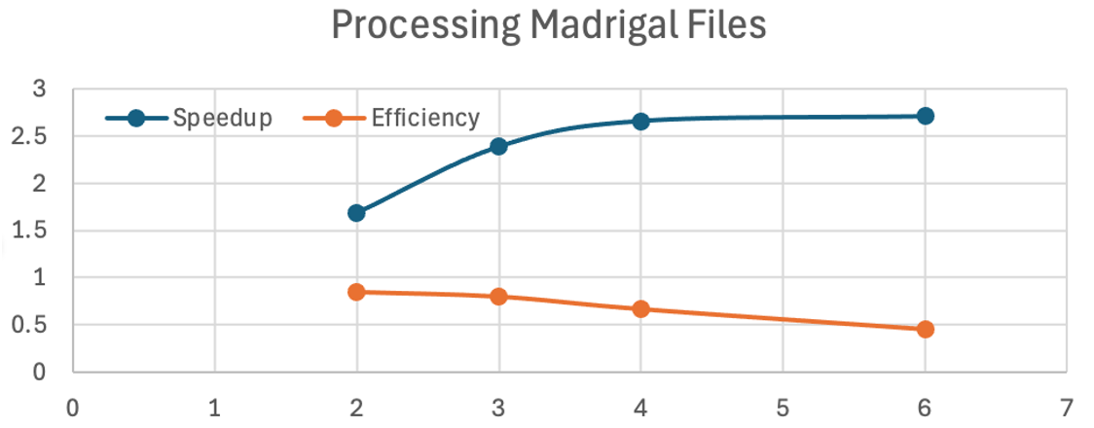
Threads
Values
Figure 5. It shows the speedups (blue) and efficiency (orange) obtained while processing Madrigal data using multiple Joblib threads.
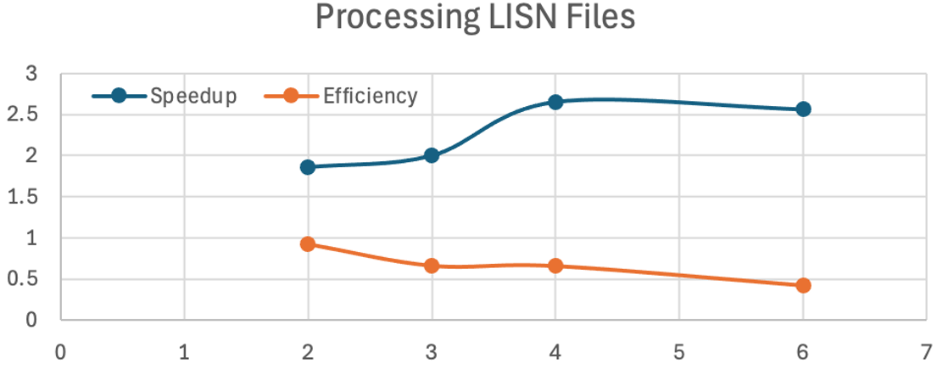
Threads
Values
Figure 5. It shows the speedups (blue) and efficiency (orange) obtained while processing Madrigal data using multiple Joblib threads.
Method | Workers | Speedup
Serial (pandas) | 1 | 1.00x
Dask parallel load | 1 | 2.99x
Joblib threading | 4 | 2.66x
Joblib processes | 4 | <0.20x (overhead)

Table 3. Stage 3 performance summary for data loading and CPU-bound processing.

3.4 Stage 4: WACCM-X Data Processing with Map-Reduce
Eight WACCM-X NetCDF files (benchmark) are processed to extract tidal and planetary wave amplitudes at 110 km altitude via multi-dimensional slicing, temporal interpolation, and FFT-based spectral decomposition targeting solar diurnal (S1), semidiurnal (S2), lunar semidiurnal (M2), and planetary waves of 2-, 10-, and 16-day periods.
A map-reduce pattern is used: each of 8 files is assigned to one of 8 CPU cores (map phase) for independent FFT analysis. Results are then aggregated (reduce phase). This yields a 7.54x speedup—close to the theoretical 8x maximum—indicating ~94% parallel efficiency. Near-ideal scaling is attributable to the embarrassingly parallel nature of the map phase: each file's FFT is fully independent with no inter-process communication.

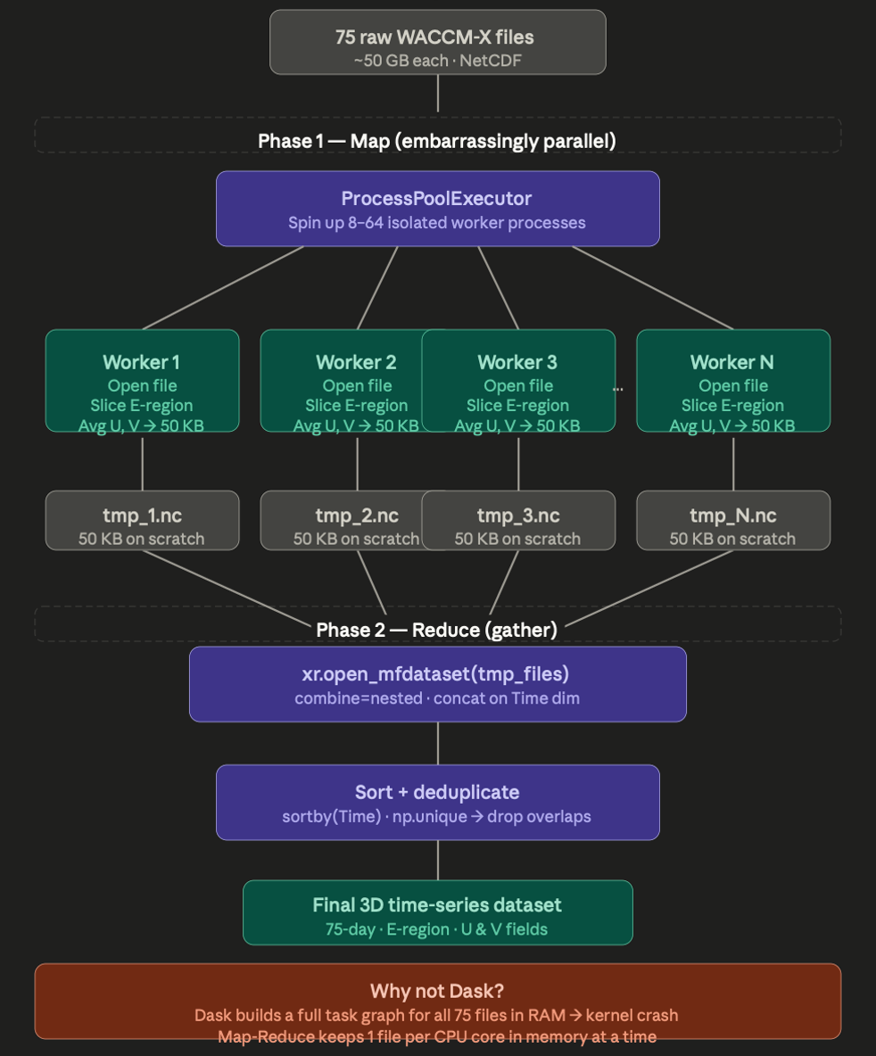
Figure 6. MapReduce method
Stage | Method | Speedup | Bottleneck Type
1: Madrigal Download | Python Threading (6 workers) | 3.83x | I/O + Network
2: LISN Parsing & Storage | Parquet + float32 downcast | 2.76x (I/O) | I/O + Storage
3a: File Loading | Dask DataFrame | 2.99x | I/O
3b: Data Processing | Joblib Threading (4 workers) | 2.66x | CPU-bound
4: WACCM-X FFT Analysis | Map-Reduce (8 cores) | 7.54x | CPU-bound

Table 4. Summary of HPC methods and speedups across all four pipeline stages.

4. Correctness Verification and Validation
Several validation strategies ensure correctness of the parallelized pipeline:
- Bit-exact comparison: Output files from the parallelized pipeline are compared byte-by-byte against reference serial runs to confirm no data corruption from race conditions or out-of-order writes.
- Physical sanity checks: TEC values are verified to fall within physically expected ranges (0.1–60 TECU). SSW onset signatures appear at the expected dates (~September 1, 2019), consistent with Gan et al. (2023).
- Race condition testing: The threading-based download pipeline is stress-tested across 10 repeated runs with artificial delays, confirming complete and uncorrupted decompression outputs.

5. Scientific Results and Interpretation

5.1 TEC Observations Around the SSW Onset
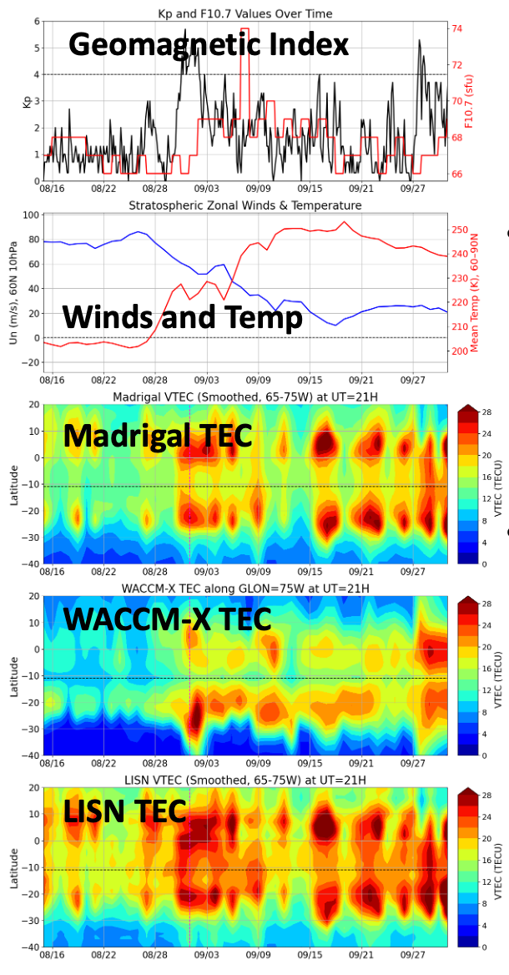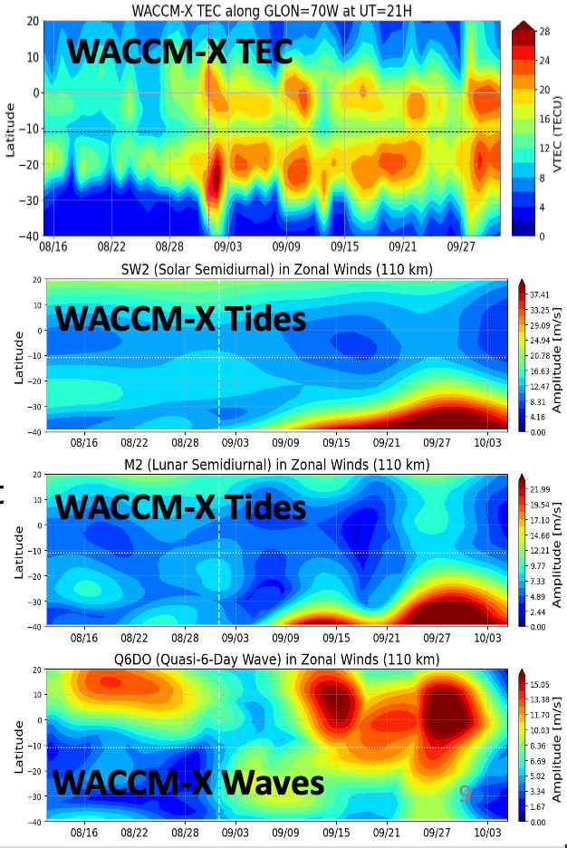
The processed TEC time series from all three data sources—Madrigal, LISN, and WACCM-X—show a coherent enhancement in low-latitude TEC beginning in late August 2019 and peaking in early September, consistent with the SSW-driven electrodynamical coupling onset. Agreement between observations and the WACCM-X model validates both the pipeline and the physical parameterization of the model. Residual discrepancies between LISN and Madrigal TEC are attributable to the different spatial sampling: LISN is concentrated over South America (~70°W), while Madrigal provides global coverage, and the SSW effect has known longitudinal structure from non-migrating tidal modes.

5.2 Tidal and Planetary Wave Extraction
FFT-based spectral analysis of WACCM-X neutral winds and temperature at 110 km reveals:
- Lunar Semidiurnal Tide (M2): Significant amplification of the M2 tide beginning ~3 days before SSW onset and persisting ~10 days, consistent with SSW-modulated E-region conductivity enhancing the lunar dynamo effect.
- Solar Tides (S1, S2): Modest perturbations in S1 and S2 amplitudes, with S2 increasing by ~15% during the warming period.
- Planetary Waves: Clear spectral peaks at 10-day and 16-day planetary wave periods in stratospheric temperature and zonal wind fields, confirming the planetary wave forcing. A 2-day wave signature is also present in the lower thermosphere.

6. Performance Analysis and Scaling

6.1 Strong Scaling Analysis
For Stage 4, a strong scaling analysis fixing the total problem size (8 NetCDF files) while varying cores from 1 to 8 shows parallel efficiency E = S/N ≈ 0.94 at N=8. The residual 6% overhead is attributable to Python multiprocessing process spawn time and per-file NetCDF I/O on the compute node.

6.2 Memory Considerations
Parquet + float32 downcasting reduces in-memory footprint by ~50% vs. float64 CSV. Loading all 60 Madrigal files simultaneously in float64 would require ~60 × 16M × 8 cols × 8 bytes ≈ 60 GB of RAM, exceeding typical node memory. Dask's lazy evaluation avoids materializing all data simultaneously, streaming chunks through the computation graph and spilling to disk when necessary.

6.3 Bottleneck Identification
Profiling identifies the following residual bottlenecks:
- Stage 1: Server-side rate limiting becomes the dominant constraint beyond 6 workers; local NVMe disk write speed (~500 MB/s) is not saturated.
- Stage 3b: At >4 workers, Joblib threading shows diminishing returns due to GIL overhead on pandas-level Python code not covered by NumPy C extensions.
- Stage 4: The reduce phase (FFT result aggregation) is serial and takes ~2% of total runtime, consistent with Amdahl's Law for a ~94%-parallel workload.

7. Challenges and Engineering Decisions
- Race Conditions in Decompression: Concurrent threads decompressing .gz files to the same directory caused intermittent file corruption. Resolved by per-thread staging directories with atomic rename on completion.
- Server Rate Limiting: The Madrigal server enforces ~6–8 concurrent sessions per IP. Thread counts beyond 6 triggered throttling and auth failures. Exponential backoff with retry was added.
- Large-Object Pickling Overhead: Joblib multiprocessing required pickling large NumPy arrays (tens of MB) for inter-process transfer, negating parallel speedup. Switching to threading resolved this for NumPy-heavy workloads.
- NetCDF Dimension Alignment: Different WACCM-X files used inconsistent time axis definitions (UTC vs. local offsets). A preprocessing harmonization step was added to prevent spectral leakage artifacts in FFT output.
- Precision vs. Accuracy Trade-off: The float64→float32 downcast required verification that GPS TEC precision (~0.1 TECU) is well within float32 range for values of 1–50 TECU (~10⁻⁷ relative precision).

8. Limitations and Future Work
Several limitations of the current implementation are acknowledged:
- The pipeline is designed for a single event. Extending to a climatological multi-event study requires automation for data provenance tracking and quality control across different epochs.
- The WACCM-X map-reduce achieves near-ideal speedup only because the 8 files are nearly equal in size. Heterogeneous files would require dynamic load balancing (e.g., work stealing).
- GPU acceleration via CuPy or JAX was not implemented but would be highly beneficial for the FFT-heavy Stage 4. A GPU FFT of 16M+ point arrays can be 10–100x faster than CPU scipy.fft.
- The pipeline runs on a single node. Distributing Stage 3 across multiple nodes using MPI or Dask distributed would be necessary for climatological-scale (multi-year) analysis.
- ERA5 stratospheric reanalysis data was not fully integrated due to time constraints. Future work includes ERA5 fields to compare modeled and observed stratospheric wave activity.

References
[1] Gan, Q., et al. (2023). Ionospheric responses to the 2019 Southern Hemisphere sudden stratospheric warming: Observations and WACCM-X simulations. Journal of Geophysical Research: Space Physics.

