GAS LEAKAGE DETECTION USING ARDUINO AND MQ SENSORS WITH A GSM

MODULE ATTACHED

BY

19BEC1327 – PRASSANTH.A

19BEC1330 – VENKATSUNDHAR.SP

# A project report submitted to

# DR.V. R. BALAJI

SCHOOL OF ELECTRONICS ENGINEERING

in partial fulfillment of the requirements for the course of

**ECE2002 – ANALOG ELECTRONIC CIRCUITS**

**I****N**

**B.Tech ELECTRONICS AND COMMUNICATION ENGINEERING**



**Vandalur – Kelambakkam Road**

**Chennai – 600127**

**NOVEMBER 2020**

# 

# BONAFIDE CERTIFICATE

Certified that this project report entitled **“GAS LEAKAGE DETECTION USING ARDUINO AND MQ SENSORS WITH A GSM MODULE ATTACHED”** is a bonafide work of 19BEC1327 – Prassanth.A and 19BEC1330 – VenkatSundhar.SP who carried out the Project work under my supervision and guidance for ECE2002 – ANALOG ELECTRONIC CIRCUITS.

# DR.V. R. BALAJI

# Assistant Professor

SCHOOL OF ELECTRONICS ENGINEERING

VIT University, Chennai – 600 127

# ABSTRACT

A gas detector is a device that detects the presence of gases in an area, often as part of a safety system. This type of equipment is used to detect a gas leak or other emissions and can interface with a control system so a process can be automatically shut down. A gas detector can sound an alarm to operators in the area where the leak is occurring, giving them the opportunity to leave. This type of device is important because there are many gases that can be harmful to organic life, such as humans or animals. Gas detectors can be used to detect combustible, flammable and toxic gases, and oxygen depletion. This type of device is used widely in industry and can be found in locations, such as on oil rigs, to monitor manufacture processes and emerging technologies such as photovoltaic. They may be used in firefighting.

# ACKNOWLEDGEMENT

We wish to express our sincere thanks and deep sense of gratitude to our project guide, **DR.V. R. BALAJI**, Assistant professor in School of electronics engineering, for his consistent encouragement and valuable guidance offered to us in a pleasant manner throughout the course of the project work. We are extremely grateful to **DR. SIVA SUBRAMANIAN. A**, Dean of School of Electronics Engineering, VIT Chennai, for extending the facilities of the School towards our project and for his unstinting support.

We also take this opportunity to thank all the faculty of the School for their support and their wisdom imparted to us throughout the course.

We thank our parents, family and friends for bearing with us throughout the course of our project and for the opportunity they provided us in undergoing this course in such a prestigious institution.

 

# TABLE OF CONTENTS

|  |  |  |  |
| --- | --- | --- | --- |
| **CHAPTER** | SUB | **TITLE** | PG NO. |
|  |  | **ABSTRACT** | 3 |
|  |  | **ACKNOWLEDGEMENT** | 4 |
| **1** |  | **INTRODUCTION** | 6 |
|  | 1.1 | OBJECTIVES |  |
|  | 1.2 | APPLICATIONS |  |
|  | 1.3 | FEATURES |  |
| **2** |  | **DESIGN AND SPECIFICATIONS** | 7 |
|  | 2.1 | BLOCK DIAGRAM |  |
|  | 2.2 | HARDWARE SPECIFICATIONS |  |
|  | 2.3 | HARDWARE DESIGN |  |
| **3** |  | **IMPLEMETATION AND ANALYSIS** | 11 |
|  | 3.1 | EXSITING AND PROPOSED SYSTEMS |  |
|  | 3.2 | IMPLEMENTATIONAL PROCESS |  |
|  | 3.3 | CODE ANALYSIS |  |
| **4** |  | **RESULTS AND DISCUSSION** | 15 |
|  | 4.1 | RESULTS AND INFERENCE |  |
|  | 4.2 | DISCUSSION |  |
| **5** |  | **CONCLUSIONS AND FUTURE WORK** | 17 |
|  | 5.1 | CONCLUSIONS |  |
|  | 5.2 | FUTURE WORK AND COST |  |
| **6** |  | **REFERENCES** | 18 |

# CHAPTER 1

# INTRODUCTION

* 1. **OBJECTIVES**
* To detect gas leakage using MQ2 sensor which detects the presence of methane, butane LPG and smoke.
* To Setup a call based alert mechanism through GSM Module.
* Produce alarm sound upon gas leakages.
* To use LCD screen to display the status.

# APPLICATIONS

The application of this project is to detect gas leakages to avoid disastrous situations by notifying them and alerting them at required and correct time so that the user could take the next step of actions to avoid miss happenings.

* 1. **FEATURES**
* This is basically a 3-stage alert protection system which would never fail at any cost.
* Each and every system has different requirements.
* If any one of the alerting systems faces issues, the 2 others can easily do it’s job which is an added advantage.

**CHAPTER** 2

# DESIGN AND SPECIFICATIONS

* 1. **BLOCK DIAGRAM**

INFORMATION

TRANSMITTED

BUZZER

LCD

DISPLAY

GAS SENSOR

LPG

GSM

ARDUINO

R3

*Figure1: Information bring collected and transmitted by the system*

CALL

ACTIVATION

INFORMATION

RECIVED

MOBILE

*Figure2: Information being received and activating the call system*

* 1. **HARDWARE SPECIFICATIONS**

>>MQ2-Detects Methane, Butane, LPG gases and Smoke.

>>Arduino Uno Microcontroller to Carry Out all the Operations.

>>GSM-Global System for Mobile (Sim900a) for making the call.

>>I2C chip for working integrated with LCD screen which shows the user about the amount of gas present.

>>Buzzer which beeps when the gas exceeds its limit.

**ARDUINO UNO**

The Arduino Uno is an [open-source](https://en.wikipedia.org/wiki/Open-source) [microcontroller board](https://en.wikipedia.org/wiki/Microcontroller_board) based on the [Microchip](https://en.wikipedia.org/wiki/Microchip_Technology) [ATmega328P](https://en.wikipedia.org/wiki/ATmega328P) microcontroller and developed by [Arduino.cc](https://en.wikipedia.org/wiki/Arduino). The board is equipped with sets of digital and analog [input/output](https://en.wikipedia.org/wiki/Input/output) (I/O) pins that may be interfaced to various [expansion boards](https://en.wikipedia.org/wiki/Expansion_board) (shields) and other circuits.

The board has 14 digital I/O pins (six capable of [PWM](https://en.wikipedia.org/wiki/Pulse-width_modulation) output), 6 analog I/O pins, and is programmable with the [Arduino IDE](https://en.wikipedia.org/wiki/Arduino#Software) (Integrated Development Environment), via a type B [USB cable](https://en.wikipedia.org/wiki/USB_cable). It can be powered by the USB cable or by an external [9-volt battery](https://en.wikipedia.org/wiki/9-volt_battery), though it accepts voltages between 7 and 20 volts. It is similar to the [Arduino Nano](https://en.wikipedia.org/wiki/Arduino_Nano) and Leonardo.

The Arduino/Genuino Uno has a number of facilities for communicating with a computer, another Arduino/Genuino board, or other microcontrollers. The ATmega328 provides UART TTL (5V) serial communication, which is available on digital pins 0 (RX) and 1 (TX). An ATmega16U2 on the board channels this serial communication over USB and appears as a virtual com port to software on the computer. The 16U2 firmware uses the standard USB COM drivers, and no external driver is needed. However, on Windows, a .inf file is required.

Arduino Software (IDE) includes a serial monitor which allows simple textual data to be sent to and from the board. The RX and TX LEDs on the board will flash when data is being transmitted via the USB-to-serial chip and USB connection to the computer (but not for serial communication on pins 0 and 1). A SoftwareSerial library allows serial communication on any of the Uno's digital pins.

**GSM**

A GSM modem is a device which can be either a mobile phone or a modem device which can be used to make an Arduino microcontroller or any other processor communicate over a network. A GSM modem requires a SIM card to be operated and operates over a network range subscribed by the network operator. It can be connected to an Arduino through serial, USB or Bluetooth connection

A GSM modem can also be a standard GSM mobile phone with the appropriate cable and software driver to connect to a serial port or USB port on your Arduino. GSM modem is usually preferable to a GSM mobile phone. The GSM modem has wide range of applications in transaction terminals, supply chain management, security applications, weather stations and GPRS mode remote data logging.

# MECHANISM OF THE MQ SENSORS

The sensor is actually enclosed in two layers of fine stainless-steel mesh called Anti-explosion network**.** It ensures that heater element inside the sensor will not cause an explosion, as we are sensing flammable gases. It also provides protection for the sensor and filters out suspended particles so that only gaseous elements are able to pass inside the chamber. The mesh is bound to rest of the body via a copper plated clamping ring.

The tubular sensing element is made up of Aluminum Oxide (AL2O3) based ceramic and has a coating of Tin Dioxide (SnO2). The Tin Dioxide is the most important material being sensitive towards combustible gases. However, the ceramic substrate merely increases heating efficiency and ensures the sensor area is heated to a working temperature constantly.

When tin dioxide (semiconductor particles) is heated in air at high temperature, oxygen is adsorbed on the surface. In clean air, donor electrons in tin dioxide are attracted toward oxygen which is adsorbed on the surface of the sensing material. This prevents electric current flow

In the presence of reducing gases, the surface density of adsorbed oxygen decreases as it reacts with the reducing gases. Electrons are then released into the tin dioxide, allowing current to flow freely through the sensor.

The analog output voltage provided by the sensor changes in proportional to the concentration of smoke/gas. The greater the gas concentration, the higher is the output voltage; while lesser gas concentration results in low output voltage. Likewise, the change in voltage is converted into ppm.

**PEIZO BUZZER**

A "piezo buzzer" is basically a tiny speaker that you can connect directly to an Arduino. "Piezoelectricity" is an effect where certain crystals will change shape when you apply electricity to them. By applying an electric signal at the right frequency, the crystal can make sound.

From the Arduino, we can make sounds with a buzzer by using tone. We have to tell it which pin the buzzer is on, what frequency (in Hertz, Hz) we want, and how long (in milliseconds) the buzzer should keep making the tone.

**I2C WITH LCD**

I2C is short for Inter-IC. And it is a type of BUS. This is designed by Philips semiconductors. I2C is a synchronous, multi slave, multi master packet switched, single-ended serial bus. i.e. multiple chips can be connected to the same bus.I2C uses only two bidirectional open collector or open drain lines, Serial Data Line (SDA) and Serial Clock Line (SCL), pulled up with resistors. Typical voltages used are +5 V or +3.3 V, although systems with other voltages are permitted.

It has total of 20 male pins. 16 pins are faced to rear side and 4 pins faced towards front side. The 16 pins for connect to 16x2 LCD and the 2 pins out of 4 pins are SDA and SCL. SDA is the serial data pin and SCL is the clock pin. The rest 2 pins for power supply (Vcc and ground). There is a POT on the I2C Module. We can control the contrast of the LCD display by rotating this POT. And there is a jumber fixed on the module. When we remove the jumber, the backlight of the LCD display will go OFF.

* 1. **HARDWARE DESIGN**

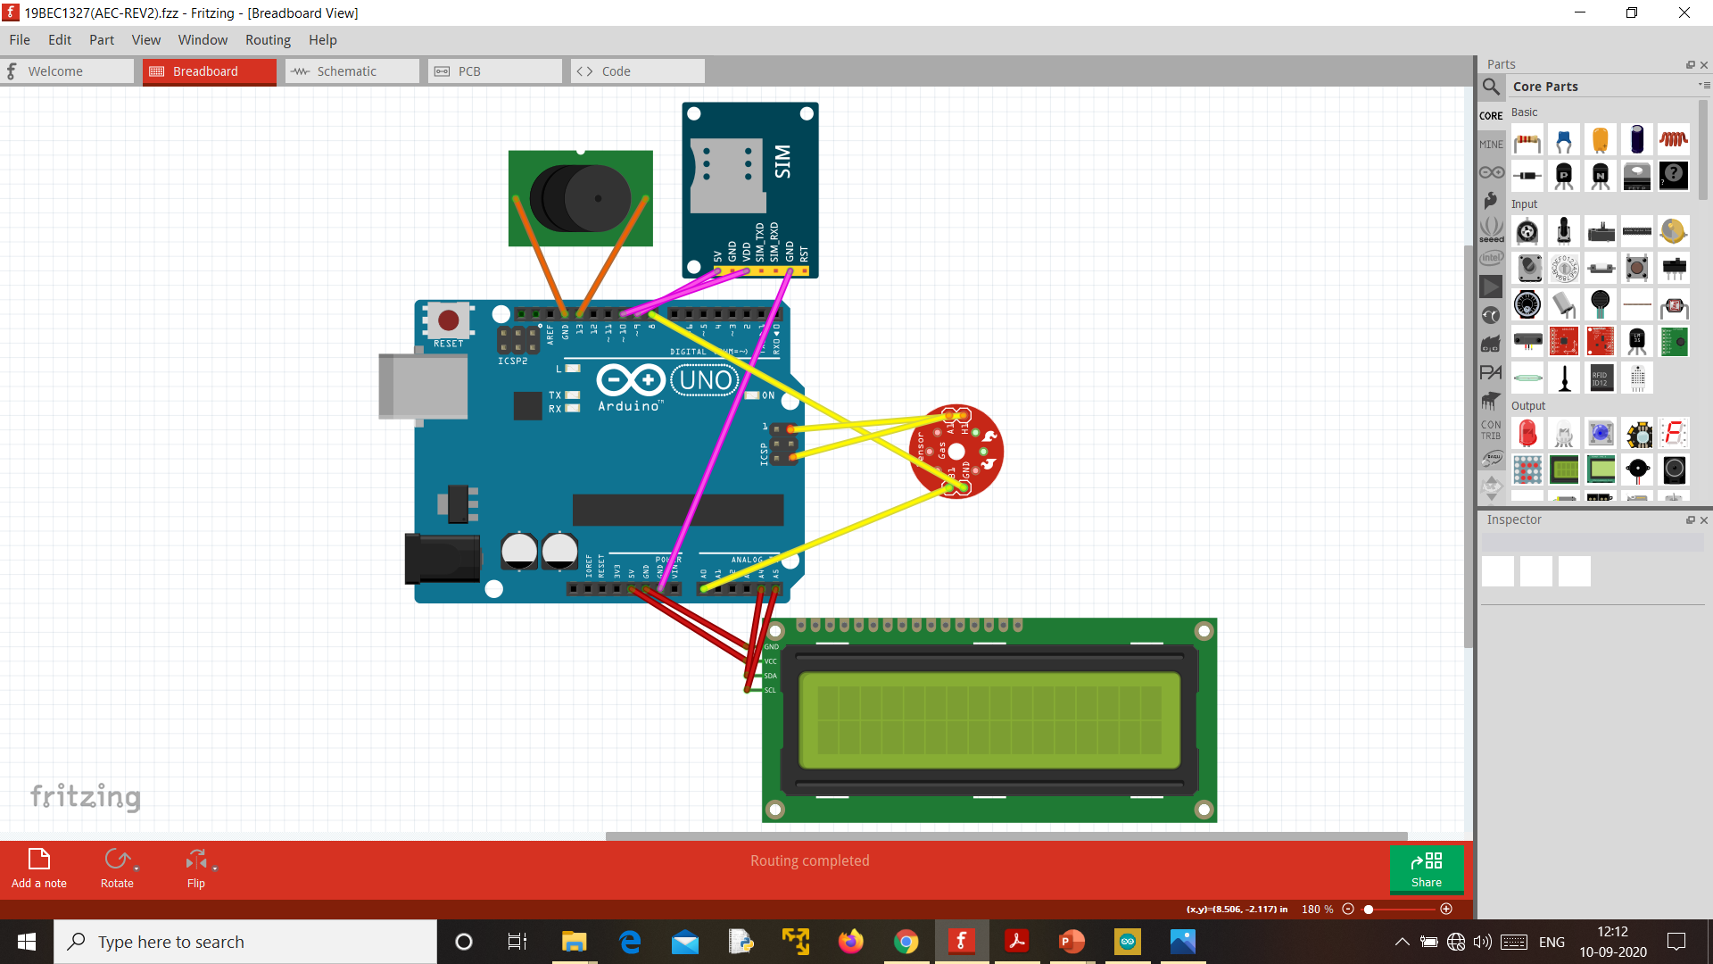

*Figure3: Created using fritzing in order to get more clear view on how to proceed*

**CHAPTER 3**

**IMPLEMENTATION AND ANALYSIS**

**3.1) EXISTING AND PROPOSED SYSTEMS**

EXISTING SYSTEM:

* Most of the existing system which we referred or took inspiration from, didn't have these many levels of alert system.
* They mostly had only one type of alert system and which was commonly through Wi-Fi communication.
* Also, most of those projects involved heavy costs due to the costlier and more sophisticated components like esp32 microcontroller and raspberry pi which is not actually required for these types of projects.
* Another main disadvantage of bringing in Wi-Fi system is that, you should have always been connected to the internet which is quite difficult when the user is not at home or he may have switched of the Wi-Fi by mistake.
* Anyhow in this project all of those issues are cleared as the user only needs a decent signal in order to receive a call which is more efficient.

PROPOSED SYSTEM:

* We proposed an innovative, modern and cost-effective device for gas leakage detection.
* Whenever there is a gas leak, it gives 3 outputs which are complimented by 3 components namely LCD screen, Buzzer, GSM module.

Their functionalities in the project:

1. LCD Screen: Displays the amount of gas present and displays whether it is normal or danger.
2. Buzzer: Alarms the user with a loud buzz so that the user can solve the problem when inside a home.
3. GSM Module: When there is a gas leak in the house where no one is at home, it makes a call to the mobile phone that his/her registered the sim with the module.

**3.2) IMPLEMENTATIONAL PROCESS**

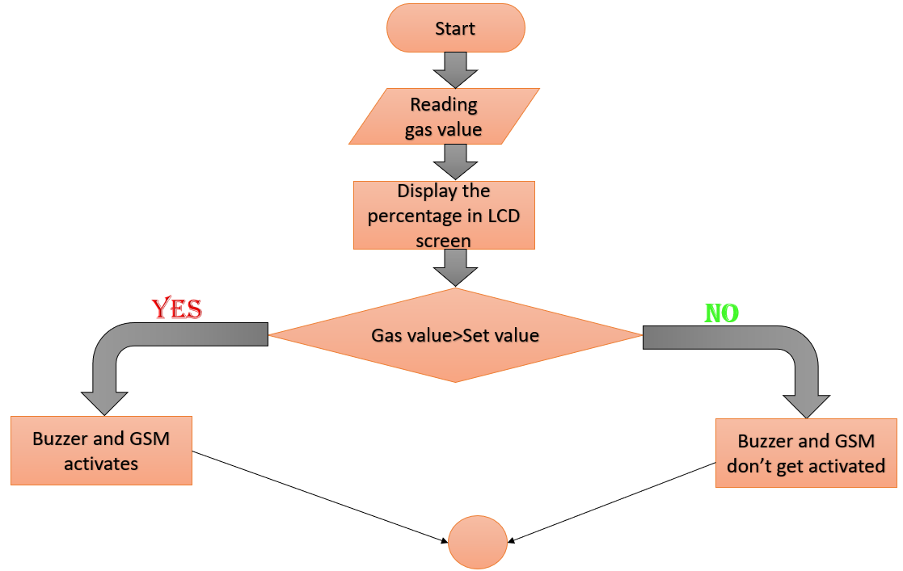

# *Figure4: The flowchart methodology of sequential steps involved in making this project*

# DETECTION SCOPE OF OUR USED MQ’s MQ2

>>200ppm-5000ppm LPG and propane

>>300ppm-5000ppm butane.

>>5000ppm-20000ppm methane.

# 

# 3.3) CODE ANALYSIS:

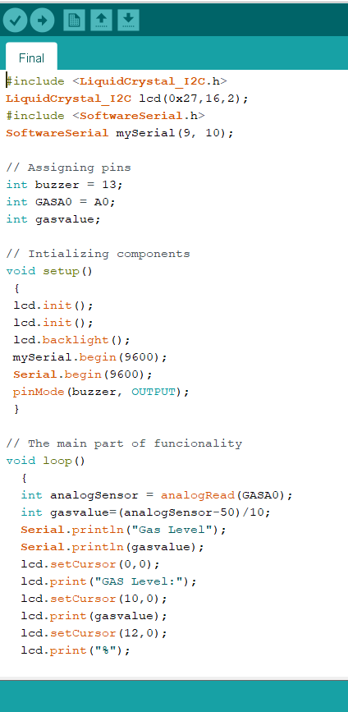

*Figure 5: Used here is Arduino code, which helps us to identify the required gases through the sensor and activate the alert systems.*

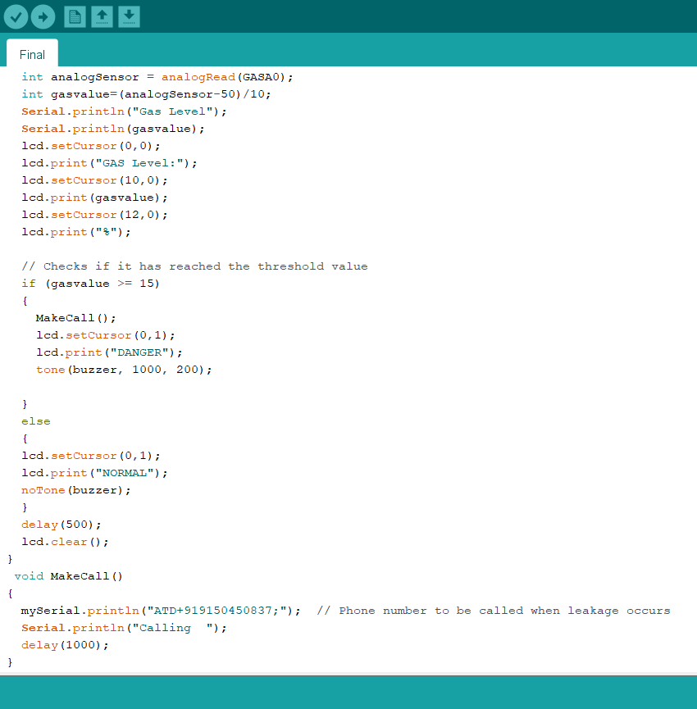

*Figure 6: Used here is Arduino code, which helps us to identify the required gases through the sensor and activate the alert systems.*

**CHAPTER 4**

# RESULTS AND DISCUSSION

* 1. **RESULTS AND INFERENCE**

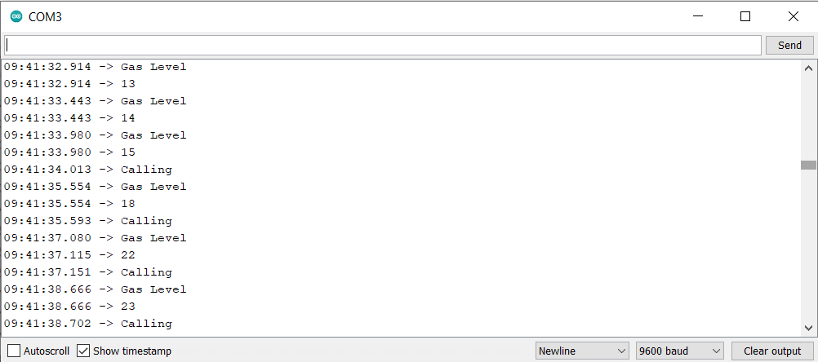

*Figure 7: Sensor reading the values from the surrounding and displaying it on com monitor.*

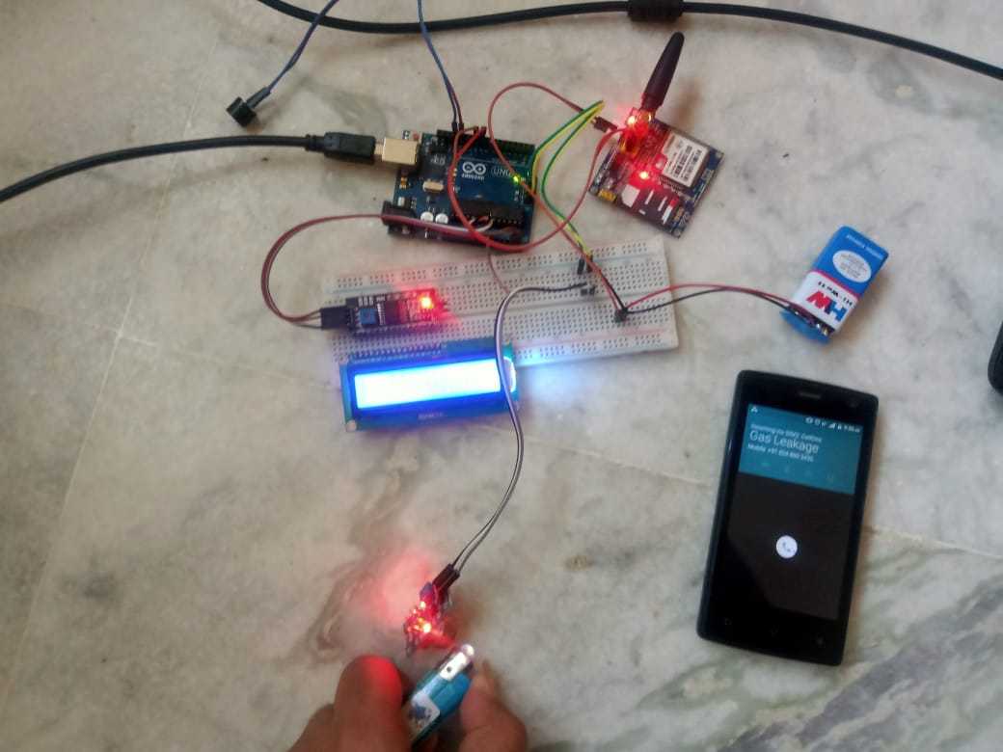

*Figure 8: The final hardware setup displaying the result of whole project*

* 1. **DISCUSSIONS**

**MAXIMUM PERMISSIBLE LEVEL FOR ALL GASES**

* Maximum level LPG- 2100 ppm (15 percent in air as per regular standards which is used as the concept of the project).
* Maximum level Benzene is 50 ppm for 15 minutes.
* The permissible exposure limit of ammonia is 25 ppm, and lethal above 500 ppm. Low level: 50 PPM and less. Mid-level: Between 51 PPM and 100 PPM. High level: Greater than 101 PPM if no one is experiencing symptoms. Dangerous level: Greater than 101 PPM if someone is experiencing symptoms.
* Exposure to butane at 270,000 ppm for 2 h was lethal to 4 of 10 mice. Isopropyl alcohol should not exceed an 8-h TWA of 400 ppm in the working atmosphere.
* Safe methane concentration during an 8-hour period is 1,000 ppm

**CHAPTER 5**

# CONCLUSION AND FUTURE WORK

**5.1) CONCLUSIONS**

Our project shows that:

* Detection of toxic and inflammable gas, smoke and leakages using Arduino uno is built and implemented successfully which achieves preliminary requirements.
* Precaution is better than cure, so it is better to implement a system which would detect the leakage at the earliest and intimate the user around it. This intimation is in form like buzzer, SMS or even through android app (GSM and buzzer are yet to be connected).
* Thus, our team effort has been very instrumental in completing this project.

# 5.2) FUTURE WORKS AND COST

* Voice guidance system can be enabled so as to make it user friendly and comfortable
* These can also made as a theft alert when user is not available at home using GSM communication would be easy
* Customization can be made according to the user’s location (normal gases threshold values). By doing this, we can prevent false alarm
* Smoke sensor can also be made to detect even a small amount of smoke.
* Could be installed in bigger industries when integrated on a large scale.
* The components of this project can be purchased for around 2k. The cost is affordable and cheap.

**CHAPTER 6**

**REFERENCES**

[1] Banik, A., Aich, B., & Ghosh, S. (2018, March). Microcontroller based low cost gas leakage detector with SMS alert. In *2018 Emerging Trends in Electronic Devices and Computational Techniques (EDCT)* (pp. 1-3). IEEE.

[2] Mujawar, T. H., Bachuwar, V. D., Kasbe, M. S., Shaligram, A. D., & Deshmukh, L. P. (2015). Development of wireless sensor network system for LPG gas leakage detection system. *International Journal of Scientific & Engineering Research*, *6*(4), 558-563.

[3] Varma, A., Prabhakar, S., & Jayavel, K. (2017, February). Gas leakage detection and smart alerting and prediction using IoT. In *2017 2nd International Conference on Computing and Communications Technologies (ICCCT)* (pp. 327-333). IEEE.

[4] Macker, A., Shukla, A. K., Dey, S., & Agarwal, J. (2018, May). ARDUINO Based LPG Gas Monitoring… Automatic Cylinder Booking with Alert System. In *2018 2nd International Conference on Trends in Electronics and Informatics (ICOEI)* (pp. 1209-1212). IEEE.

[5] Faisal, M. M. A., & Rahman, S. M. (2017). Arduino based gas leakage detector with short message service and sound alarm. *Journal of Emerging Trends in Engineering and Applied Sciences*, *8*(3), 113-116.

[6] Hasan, R., Khan, M. M., Ashek, A., & Rumpa, I. J. (2015). Microcontroller Based Home Security System with GSM Technology. *Open Journal of Safety Science and Technology*, *5*(02), 55.

[7] Nasution, T. H., Muchtar, M. A., Siregar, I., Andayani, U., Christian, E., & Sinulingga, E. P. (2017, April). Electrical appliances control prototype by using GSM module and Arduino. In *2017 4th International Conference on Industrial Engineering and Applications (ICIEA)* (pp. 355-358). IEEE.

**BIODATA**

Name: Prassanth.A

Mobile: 9150450837

Email: [prassanth.a2019@vitstudent.ac.in](mailto:prassanth.a2019@vitstudent.ac.in)

Address:No6/9,KKnagar,1stStreet,Kolathur,Chennai-99

Name: VenkatSundhar.S.P.

Mobile: 6383058044

Email: venkatsundhar.sp2019@vitstudent.ac.in

Address:D031,Sbioa-unity-enclave,Mambakkam,Chennai-27