**Spis treści**

***Introduction 2***

***Options Designer 2***

***SaveLoad Creator .3***

# **Introduction**

***using TP.Achievement; // If you want to use achievement system you need to add it.***

***Achievement Creator is manager for whole functionality, you want only single instance of it.***

# **Options Designer**

***Refresh and update – it refreshes references if you’ve made some changes and they haven’t updated.***

***Toggle Debug Mode – Toggles Debug Mode, you can’t make any changes, but you can see everything serialized in inspector***

***Achievements – it opens new editor window to manage Achievements.***

***Notification – it opens new editor window to manage Notification layout.***

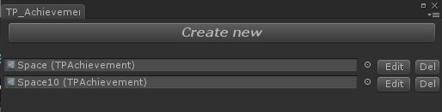

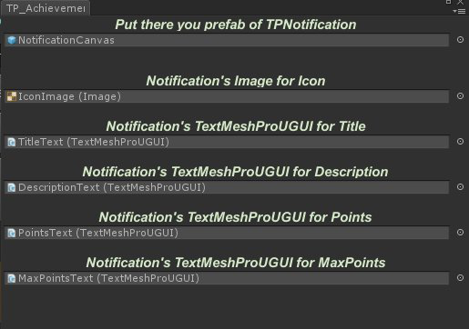

# **Achievement Creator**

## ***TPAchievementCreator creator;***

***creator.Achievements; // List of all exists TPAchievement’s.***

***creator.GetAchievement(string name); // Get TPAchievement by its name.***

***creator.AddPointTo(TPAchievement achievement, float value, bool showProgressNotify, bool showNotifyAfterCompleted); // Adds points to achievement, shows or not notification if it’s not completed, shows or not notification if its completed.***

***creator.CompleteAchievement(TPAchievement achievement, bool showNotification); // Instant completes achievement and shows or not notification.***

***creator.SetOnNotifySet(NotifySettingEventHandler _NotifySetting); // Sets delegate void which is called before notifications is showed.***

***creator.SetOnNotifyActive(NotifyActivationEventHandler _NotifyActivation); // Sets delegate void which is called when notification should be active and deactivated.***

# **Notification**

## ***TPNotification notify;***

## ***Notify.iconImage; // Get/Set Image UI of notification.***

## ***notify.pointsText; // Get/Set TextMeshProUGUI of notification for points.***

## ***notify.maxPointsText; // Get/Set TextMeshProUGUI of notification for max points.***

## ***notify.titleText; // Get/Set TextMeshProUGUI of notification for title.***

## ***notify.descriptionText; // Get/Set TextMeshProUGUI of notification for description.***

## ***notify.OnAchievement; // Get TPAchievement which is actually set on this notification.***

## ***notify.SetNotification(TPAchievement achievement); // Set information from achievement to notification layout.***

# **Achievement**

## ***TPAchievement achievement;***

## ***achievement.Title; // Get/Set title of notification.***

## ***achievement.Description; // Get/Set description of notification.***

## ***achievement.IsCompleted; // Returns true if achievement is completed.***

## ***achievement.Icon; // Get/Set icon sprite of notification.***

## ***achievement.Points; // Get/Set points of notification.***

## ***achievement.MaxPoints; // Get/Set Max points of notification.***

## ***achievement.Notification; // Get/Set notification layout.***

## ***achievement.NotifyLong; // Get/Set time of showing notification.***