**Spis treści**

***Introduction 2***

***Fader Designer 2***

***Fader Creator 3***

***Fader 3***

# **Introduction**

***Every Reference Must be Prefab!***

***using TP.Fader; // If you want to use some references to Fader you need to add it.***

***Fader Creator is manager for whole functionality, you want only single instance of it.***

***Alpha Fade is a type which’ll fade by texture to next scene.***

***Progress Fade is a type which’ll fade to progress layout, load by image or slider bar or percentage text and then instant load next scene or wait for key to load scene.***

***Fader – GameObject with this script will execute Fade on OnClick.***

***FaderEditorGUIData is located in “Assets/TP_Creator/TP_FaderCreator/EditorResources/FaderEditorGUIData.asset”***

***You can change:***

***Empty Fader Prefab – prefab of example of Progress Fade.***

# **Fader Designer**

***Spawn Empty Progress Fade – it spawns empty example of Progress Fader.***

***Refresh and update – it refreshes references if you’ve made some changes and they haven’t updated.***

***Reset Manager – Resets reference to Fader Creator.***

***Toggle Debug Mode – Toggles Debug Mode, you can’t make any changes, but you can see everything serialized in inspector***

***Alpha Fade – it opens new editor window to manage Alpha type Fade.***

***Progress Fade – it opens new editor window to manage Progress type Fade.***

***Faders – it opens new editor window to manage your Faders.***

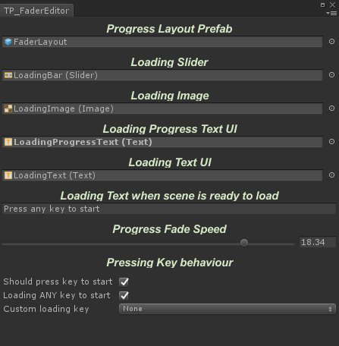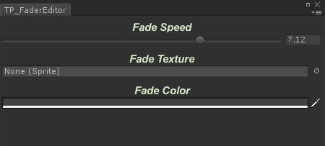

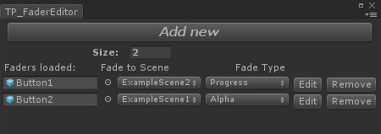

# **Fader Creator**

## ***TPFaderCreator creator;***

## ***creator.Faders; // Gets List of Faders;***

***creator.Refresh; // Refreshes list and references on Creator***

***creator.IsFading;*** ***// Returns true if fading has started***

***creator.SetBeforeSceneLoaded(..); // delegate executes just before scene is loaded***

***creator.SetOnFaderStarted(..); // delegate executes just before fading has started***

***creator.AlphaFader.FadeSpeed; // Alpha Fade - speed***

***creator.AlphaFader.FadeTexture; // Alpha Fade - texture***

***creator.AlphaFader.FadeColor; // Alpha Fade – color***

***creator.ProgressFader.LoadingAnyKeyToStart***; ***// Progress Fade – if true and MustKeyToStart is true, script will check for any key***

***creator.ProgressFader.LoadingBar; // Progress Fade - Slider***

***creator.ProgressFader.LoadingImage; // Progress Fade - Image***

***creator.ProgressFader.LoadingKeyToStart; // KeyCode to check before scene is loaded if MustKeyToStart is true***

***creator.ProgressFader.LoadingProgressText; // Progress Fade – Progress Percentage Text UI***

***creator.ProgressFader.LoadingText; // Progress Fade – Text UI***

***creator.ProgressFader.LoadingTextString; // Progress Fade – string text***

***creator.ProgressFader.MustKeyToStart; // Progress Fade - If true, script will check for key before load next scene***

***creator.ProgressFader.ProgressFadeSpeed; // Progress Fade – speed of fading to progress layout***

## ***creator.ProgressFader.ProgressPrefab; // Progress Fade – prefab of layout***

# **Fader**

***TPFader fader;***

***fader.FadeToScene; // String of scene to fade***

***fader.FadeType; // Fade type (enum);***

## ***fader.SetOnFade(..);*** ***// delegate, executes before fade is starting***

***fader.OnPointerClick(..);*** ***// Unity Event, you can override it***