**Spis treści**

***Introduction 2***

***Options Designer 2***

***Options Creator 3***

***Options Layout 3***

# **Introduction**

***Every Reference Must be Prefab!***

***using TP.Options; // If you want to use some references to Options you need to add it.***

***Options Creator is manager for whole functionality, you want only single instance of it.***

***Options Layout is a script managing functionality of options layout.***

***OptionsEditorGUIData is located in “Assets/TP_Creator/TP_OptionsCreator/EditorResources/OptionsEditorGUIData.asset”***

***You can change:***

***Empty Options Prefab – prefab of example of Options Menu.***

# **Options Designer**

***Spawn Empty Options Menu – it spawns empty example of Options Menu.***

***Refresh and update – it refreshes references if you’ve made some changes and they haven’t updated.***

***Reset Manager – Resets reference to Options Creator.***

***Toggle Debug Mode – Toggles Debug Mode, you can’t make any changes, but you can see everything serialized in inspector***

***Options Menu Layout – it opens new editor window to manage Options Layout.***

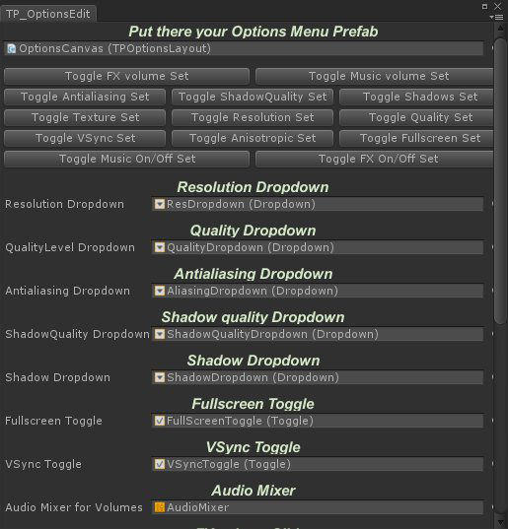

# **Options Creator**

## ***TPOptionsCreator creator;***

## ***creator.OptionsLayout; // Gets actual OptionsLayout;***

# **Options Layout**

***TPOptionsLayout layout;***

***layout.resDropdown; // Get/Set Dropdown of Screen Resolution***

***layout.qualityDropdown; // Get/Set Dropdown of Quality Level***

## ***layout.aliasingDropdown;*** ***// Get/Set Dropdown of antialiasing***

***layout.shadowQualDropdown; // Get/Set Dropdown of shadow quality***

***layout.shadowDropdown; // Get/Set Dropdown of shadow settings***

***layout.textureDropdown; // Get/Set Dropdown of texture quality***

## ***layout.fullscreenToggle;*** ***// Get/Set Toggle of fullscreen***

***layout.vSyncToggle; // Get/Set Toggle of vSync***

***layout.anisotropicToggle; // Get/Set Toggle of anisotropic***

## ***layout.fxButton;*** ***// Get/Set Button of FX***

***layout.fxImageOn; // Get/Set sprite of FX ON***

***layout.fxImageOff; // Get/Set sprite of FX OFF***

***layout.fxSlider;*** ***// Get/Set Slider of FX volume***

***layout.mixerFXText; //***

***layout.musicButton; // Get/Set Button of music***

## ***layout.musicImageOn;*** ***// Get/Set sprite of music ON***

***layout.musicImageOff; // Get/Set sprite of music OFF***

***layout.musicSlider; // Get/Set Slider of music volume***

## ***layout.mixerMusicText;*** ***//***

***layout.AudioMixer; // Get/Set AudioMixer***

***layout.Initialize(); // Initializes functionality to existing options***