**Spis treści**

***Introduction 2***

***SaveLoad Designer 2***

***SaveLoad Creator .3***

# **Introduction**

***using TP.SaveLoad; // If you want to use persistence system you need to add it.***

***SaveLoad Creator is manager for whole functionality, you want only single instance of it.***

***Attributes:***

***PersistantBinary – allows to save and load field via Binary Method***

***PersistantJSON(“Name of element”) – allows to save and load field via JSON Method***

***PersistantXML(“Name of element”) – allows to save and load field via XML Method***

***PersistantID – allows to save and load field via ID Method(TP Method that can’t be change)***

# **SaveLoad Designer**

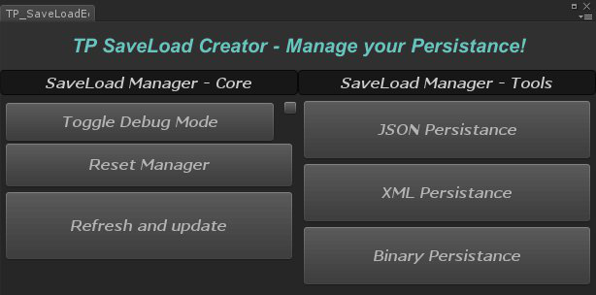***Refresh and update – it refreshes references if you’ve made some changes and they haven’t updated.***

***Reset Manager – Resets reference to SaveLoad Creator.***

***Toggle Debug Mode – Toggles Debug Mode, you can’t make any changes, but you can see everything serialized in inspector***

***JSON Persistance – it opens new editor window to manage JSON Persistance.***

***XML Persistance – it opens new editor window to manage XML Persistance.***

***Binary Persistance – it opens new editor window to manage Binary Persistance.***

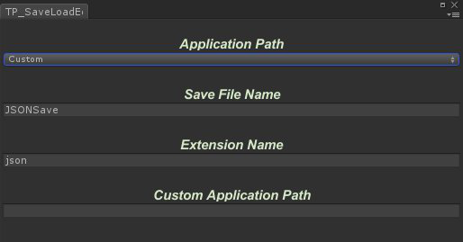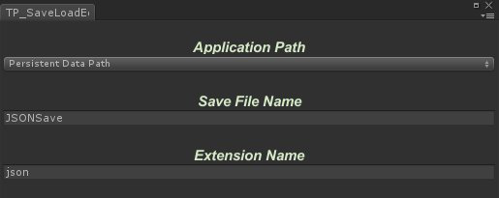

# **SaveLoad Creator**

## ***TPSaveLoadCreator creator;***

## ***creator.BinaryMethod; // Get/Set method struct for Binary Persistance.***

## ***BinaryMethod.UseApplicationPath; // enumeration for using Application Path***

## ***BinaryMethod.SaveName; // Name of save file***

## ***BinaryMethod.ExtensionName; // Name of extension of save file***

## ***BinaryMethod.CustomPath; // Full path for save file if UseApplicationPath is Custom***

## ***creator.JSONMethod; // Get/Set method struct for JSON Persistance.***

## ***JSONMethod.UseApplicationPath; // enumeration for using Application Path***

## ***JSONMethod.SaveName; // Name of save file***

## ***JSONMethod.ExtensionName; // Name of extension of save file – recommend “json” if you would like to read it***

## ***JSONMethod.CustomPath; // Full path for save file if UseApplicationPath is Custom***

## ***creator.XMLMethod; // Get/Set method struct for XML Persistance.***

## ***XMLMethod.UseApplicationPath; // enumeration for using Application Path***

## ***XMLMethod.SaveName; // Name of save file***

## ***XMLMethod.ExtensionName; // Name of extension of save file – recommend “xml” if you would like to read it***

## ***XMLMethod.CustomPath; // Full path for save file if UseApplicationPath is Custom***

***creator.GetSaveLoadPath(MethodEnum enum);*** ***// Gets string of persistence path for specific method***

***creator.XMLContainsKey(string Key); // Returns true if key exist in xml file***

***creator.JSONContainsKey(string Key); // Returns true if key exist in json file***

***creator.LoadObject(MonoBehaviour mono, string ID); // Loads all persistence fields from file to mono by ID***

***creator.SaveObject(MonoBehaviour mono, string ID); // Saves all persistence fields from mono to file by ID***

***creator.GetObjectID(MonoBehaviour mono); // Returns Unique ID of mono***