**Spis treści**

***Introduction 2***

***SoundManager Designer 2***

***Sound Manager Creator 3***

***Sound Bundle 3***

# **Introduction**

***using TP.SoundManager; // If you want to use some references to SoundManager you need to add it.***

***SoundManager Creator is manager for whole functionality, you want only single instance of it.***

***Sound Bundle is a ScriptableObject which contains AudioClips.***

# **SoundManager Designer**

***Refresh and update – it refreshes references if you’ve made some changes and they haven’t updated.***

***Reset Manager – Resets reference to Sound Creator.***

***Sound Bundles – it opens new editor window to manage Audio Bundles.***

***Toggle Debug Mode – Toggles Debug Mode, you can’t make any changes, but you can see everything serialized in inspector***

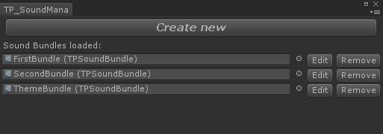

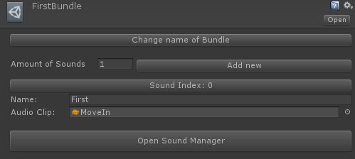

# **Sound Manager Creator**

## ***TPSoundManagerCreator creator;***

## ***creator.ActualSoundBundleFX; // Get/Set actual sound bundle loaded for Source***

## ***creator.ActualSoundBundleTheme; // Get/Set actual sound bundle loaded for ThemeSource***

## ***creator.SoundBundles; // List of TPSoundBundle***

## ***creator.Source; // Get AudioSource***

## ***creator.ThemeSource; // Get Theme AudioSource***

## ***creator.Refresh(); // Refreshes references***

## ***creator.GetSoundBundleByName(string name); // Returns TPSoundBundle by its name***

## ***creator.PlayOneShot(…); // PlayOneShot Source***

***PlayOneShot(int index);***

***PlayOneShot(string nameOfClip);***

***PlayOneShot(string nameOfBundle, int index);***

***PlayOneShot(string nameOfBundle, string nameOfClip);***

## ***creator.Play(); // Play Source;***

***Play(ulong delay);***

## ***creator.Stop(); // Stop Source;***

## ***creator.Pause; // Pause Source;***

## ***creator.UnPause(); // UnPause Source;***

## ***creator.PlayTheme(); // Play Theme Source;***

***PlayTheme(int index);***

***PlayTheme(string nameOfClip);***

***PlayTheme(ulong delay);***

***PlayTheme(string nameOfBundle, string nameOfClip);***

***PlayTheme(string nameOfBundle, int index);***

***creator.PauseTheme; // Pause Theme Source;***

## ***creator.UnPauseTheme(); // UnPause Theme Source;***

## ***creator.Stop(); // Stop Theme Source;***

***creator.FindAudioClip(…); // Returns Audio clip***

***FindAudioClip(TPSoundBundle soundBundle, string nameOfClip);***

***FindAudioClip(bool fromActualFX, string nameOfClip); // If fromActualFX is false, find from ActualTheme***

***FindAudioClip(bool fromActualFX, int index); // If fromActualFX is false, find from ActualTheme***

***FindAudioClip(string nameOfBundle, string nameOfClip);***

***creator.GetSoundBundleByName(string name); // Returns TPSoundBundle by name***

# **Sound Bundle**

***TPSoundBundle bundle;***

***bundle.Sounds; // Array of TPSound struct (AudioName + AudioClip)***