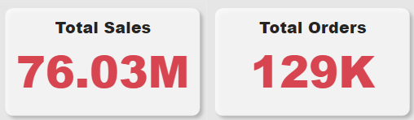

Currently, total sales have reached an impressive 76.0 million, with a total of 129,000 orders received.

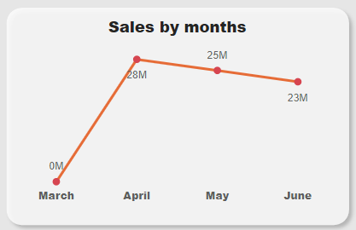

• There appears to be a seasonal trend, with sales increasing in the spring and summer months (March to June)

• Sales rise from March to May, then level off in June

• The highest sales month appears to be May

Overall, the graph suggests that the business does well during the spring and summer months. This could be because the products they sell are in higher demand during this time, or it could be because people are more likely to go shopping when the weather is nice.

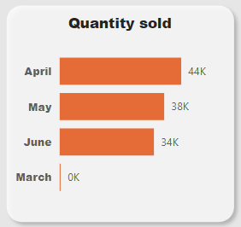

Month April has the highest quantity sales.

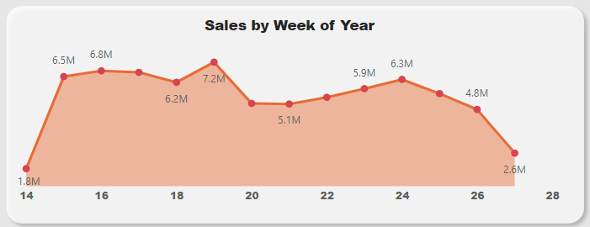

From above graph we can say that the week 19 has the highest sales.

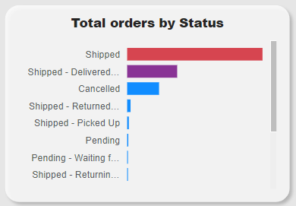

There are more orders shipped than any other status. This could mean that the business is efficient at shipping orders out. There are more orders delivered than there are cancelled orders. This suggests that most customers are receiving their orders.

Overall, the graph suggests that the business is shipping out a high volume of orders.

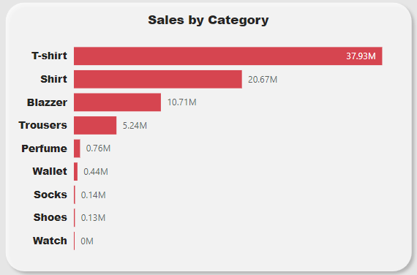

• T-shirts are the most popular category, with sales of 37.93 million. This is more than double the sales of the next highest category, shirts.

• Shirts are the second most popular category, with sales of 20.67 million.

• Blazers, trousers, perfume, wallets, socks, and watches are all significantly less popular than t-shirts and shirts. Their sales figures range from 0.13 million for watches to 10.71 million for blazers.

Overall, the chart suggests that t-shirts and shirts are the most popular items sold by this clothing store.

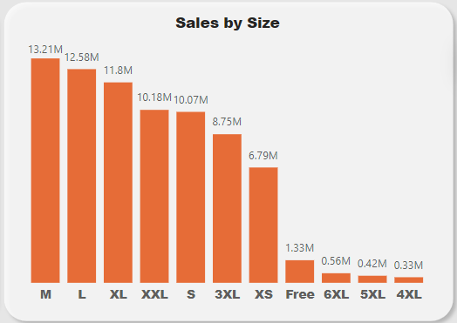

• **Small and medium sizes are the most popular.** Sales are highest for sizes S, M, L, and XL, with sales dropping significantly for sizes outside this range.

• There **is a wider range of sales for smaller sizes than for larger sizes.** While there are sales for sizes XS through 3XL, the sales figures for XS and XXS are much lower than for S and M. There is a similar drop-off in sales for sizes above XL.

Additionally, this data indicates that customers are purchasing products in a wide range of sizes, including M, L, XL, XXL, S, 3XL, and XS. Therefore, it is essential for Amazon to ensure that these sizes are consistently well-stocked to meet customer demand.

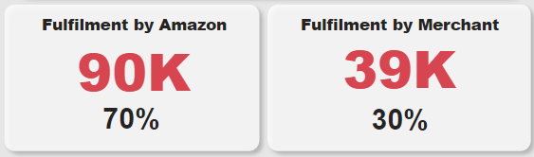

The above Figure shows that the most of the Fulfilment is Fulfilled by Amazon. which shows the Amazon delivery ability and good facility. Though Amazon can also approach this merchant and can provide the service to them also by giving some offers.

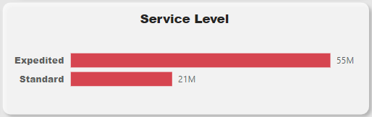

• Expedited delivery is the most popular choice. There are significantly more orders placed for Expedited service than for Standard service (21 million vs. 55 million).

• The difference in the number of orders between the two service levels is quite large. This suggests that the cost of expedited shipping may be a relevantly low.

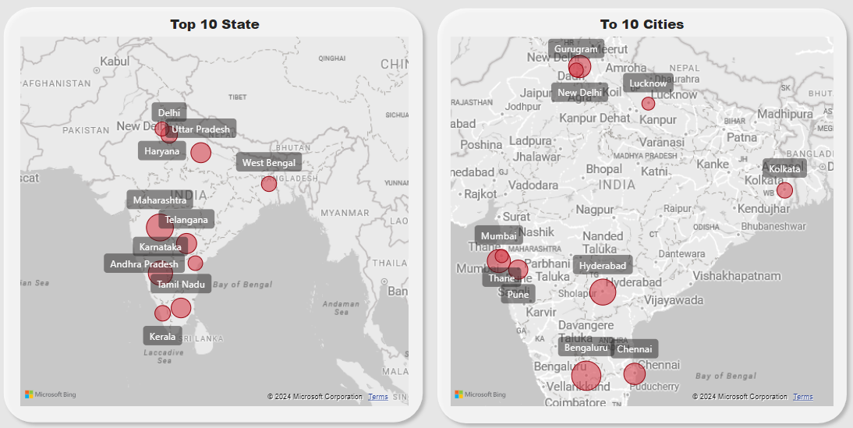

Above graph shows top 10 States and cities Sales.

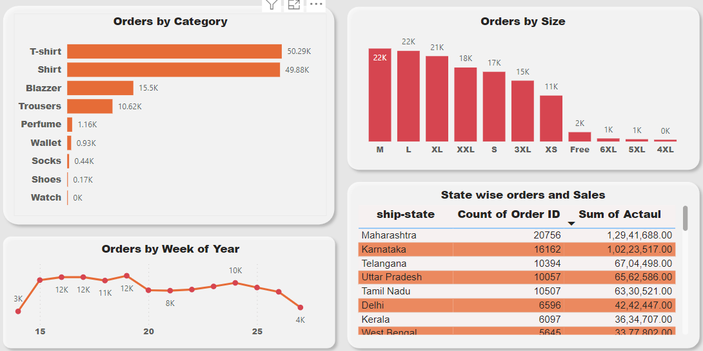

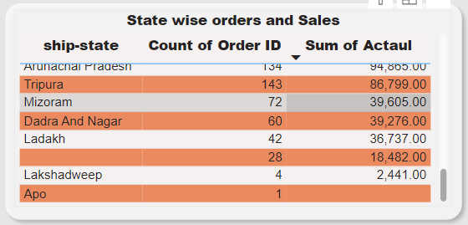

The above screenshot represents the customer behaviour, where customers are buying T-shirt, Shirt in large quantities. Also, we have week wise representation of orders where all weeks performs well .and State wise representation of Orders and Sales where we have Top in Maharashtra, Karnataka, Telangana followed by UP. So, Amazon can focus on this city and generate more revenues.

Amazon should also consider the states where Orders and Sales are very low .we can facilities this Sates by providing good offers .

To increase profits, Amazon should prioritize focusing on sales in the top cities. It appears that people in these locations are purchasing items like T-shirts and shirts more frequently, possibly due to their affordability. By honing in on these high-demand products in key urban areas, Amazon can capitalize on the market trends and boost revenue.