Machine Learning Based Design Patterns Prediction

Successful software development fully dependent on Design Patterns as this reduce development work by reusing already developed software’s functions. Incorrect design patterns often leads to failure and inexperience often fall prey for incorrect design pattern selection.

To overcome from this issues we are employing Machine Learning and WEB modules functions which will read source code as input from the user through web interface and then ML algorithms will rank source code to find suitable design pattern and then display predicted design pattern as output.

This ML models can be applied on UI/NON-UI based design patterns selection and for accurate selection we have evaluated performance of multiple ML algorithms like SVM, Random Forest and Decision Tree and each algorithm performance is evaluated in terms of accuracy, precision, recall and FCSORE.

To train above algorithms we have utilized Design Patterns prediction dataset downloaded from GITHUB URL and in below screen showing dataset details

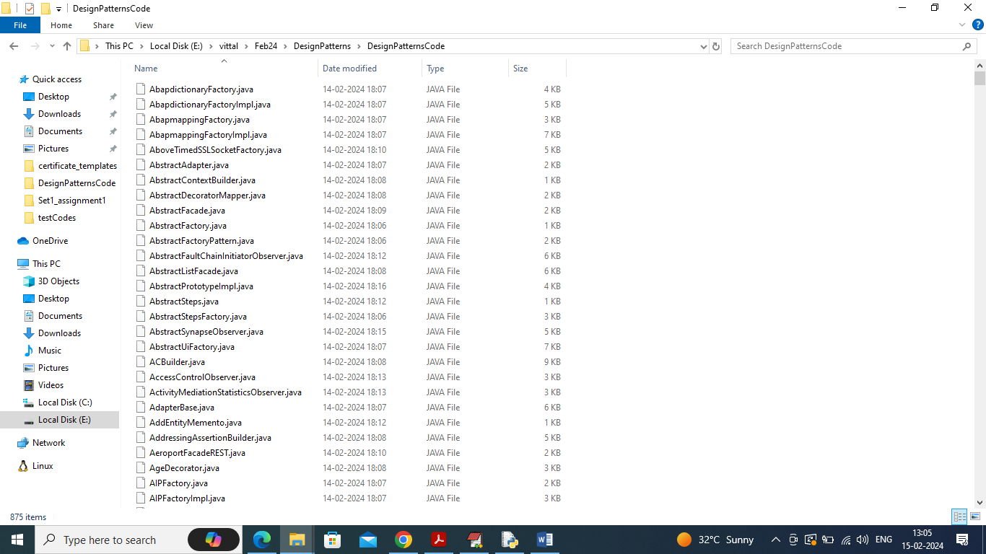

In above screen we have java code from 13 different designs patterns and all those patterns names we can see in below file

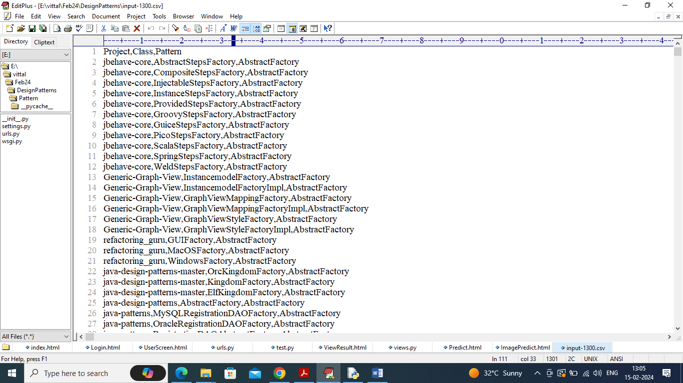

In above file first row represents column names like Project Name, source code class name and the pattern that class is following and remaining rows contains dataset values.

So by using above java source code we will train algorithms to predict design patterns. Each pattern will be selected by employing ontology based ranking calculations which will calculate rank between dataset source code and user uploaded source code and based in highest ranking Design Pattern will be selected.

By using this project developers can upload existing or current source code files and then application will predict Design Patterns and by using this prediction Developer can what type of code follow what patterns so for his next project he will choose correct patterns.

We have implemented this project as REST based web services which consists of following modules

1. User Login: user can login to system using username and password as ‘admin and admin’.
2. Load Design Patterns Code: after login user will run this module to upload dataset to application
3. Code to Numeric Vector: all codes will be converted to numeric vector which will replace each word occurrence with its average frequency.
4. Train ML Algorithms: processed numeric vector will be split into train and test with a ratio of 80:20. 80% dataset will be input to training algorithms to train a model and this model will be applied on 20% test data to calculate accuracy
5. Predict Design Patterns: user will upload test source code files and then ML algorithms will rank test file to predict accurate design patterns.

SCREEN SHOTS

To run code install python 3.7 and then install all packages given in requirements.txt file. Now double click on ‘run.bat’ file to start WEB REST server and get below output

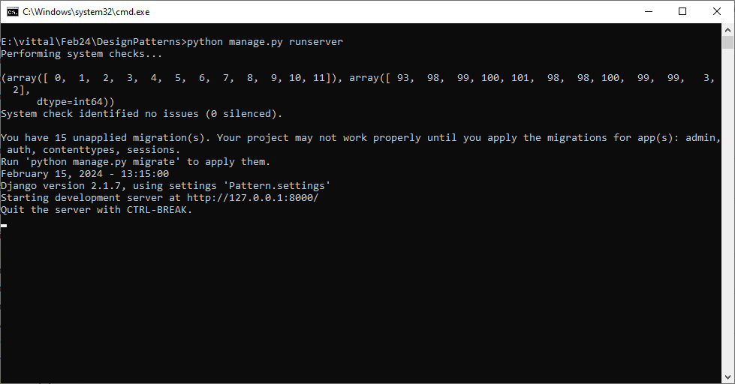

In above screen python server started and now open browser and enter URL as <http://127.0.0.1:8000/index.html> and press enter key to get below page

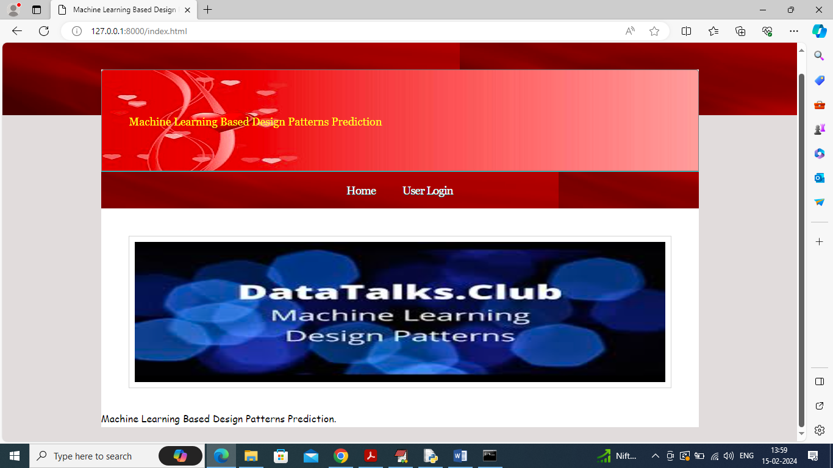

In above screen click on ‘User Login’ link to get below login page

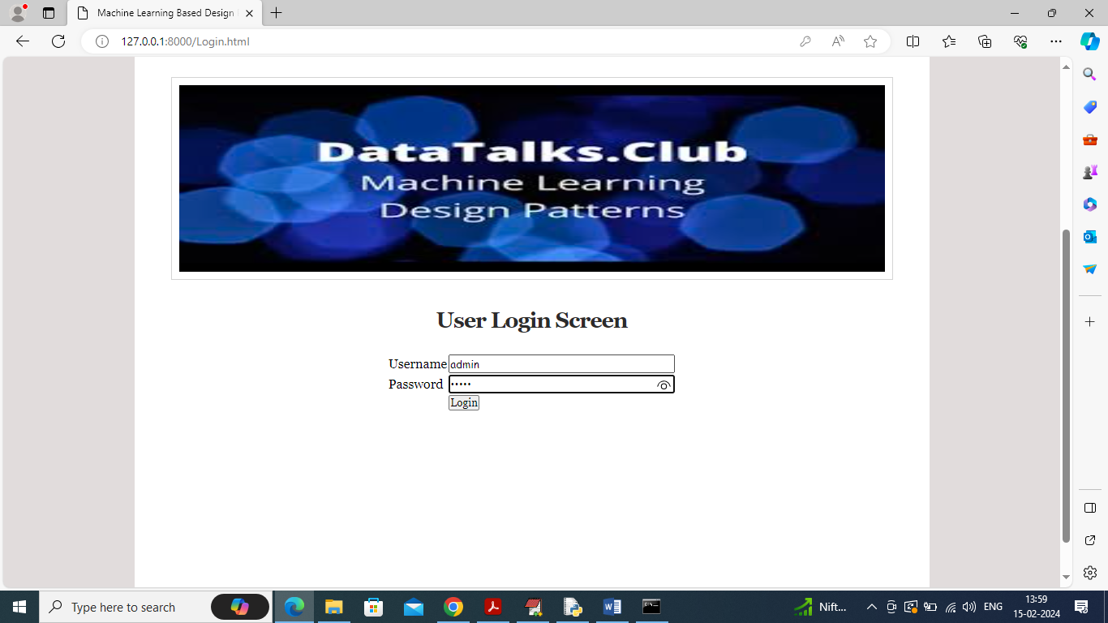

In above screen user is login by using username and password as ‘admin and admin’ and then click on ‘Login’ button to get below page

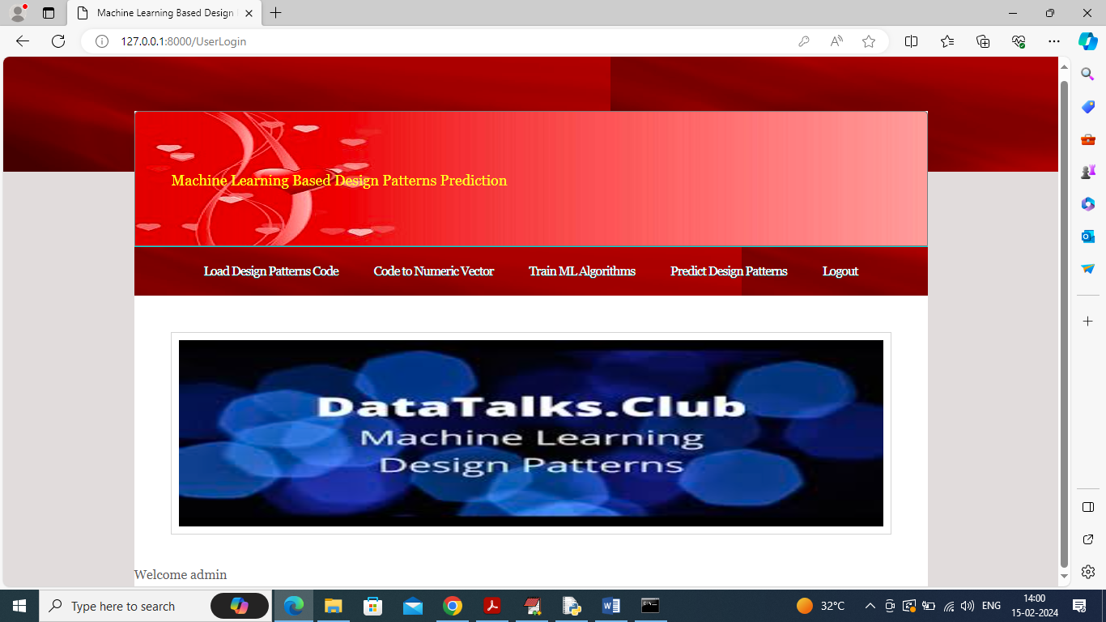

In above screen click on ‘Load Design Pattern Code’ link to load dataset and get below output

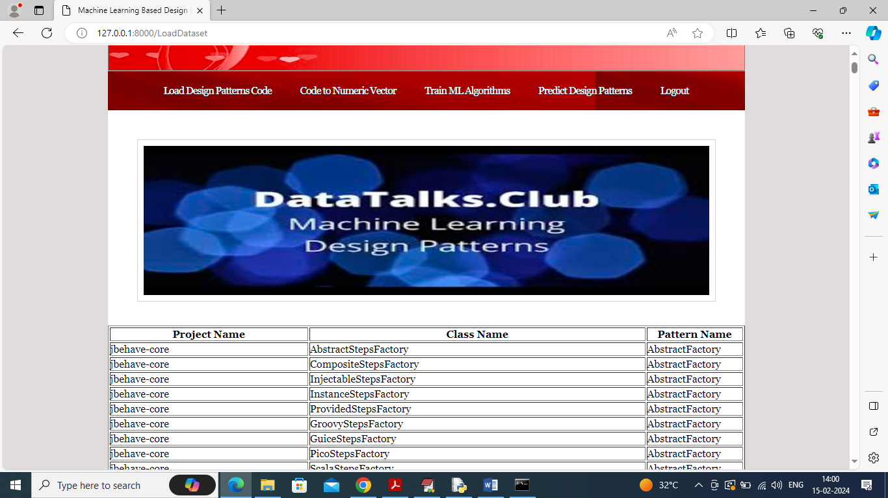

In above screen dataset loaded and now click on ‘Code to Numeric Vector’ link to convert dataset into numeric vector and get below output

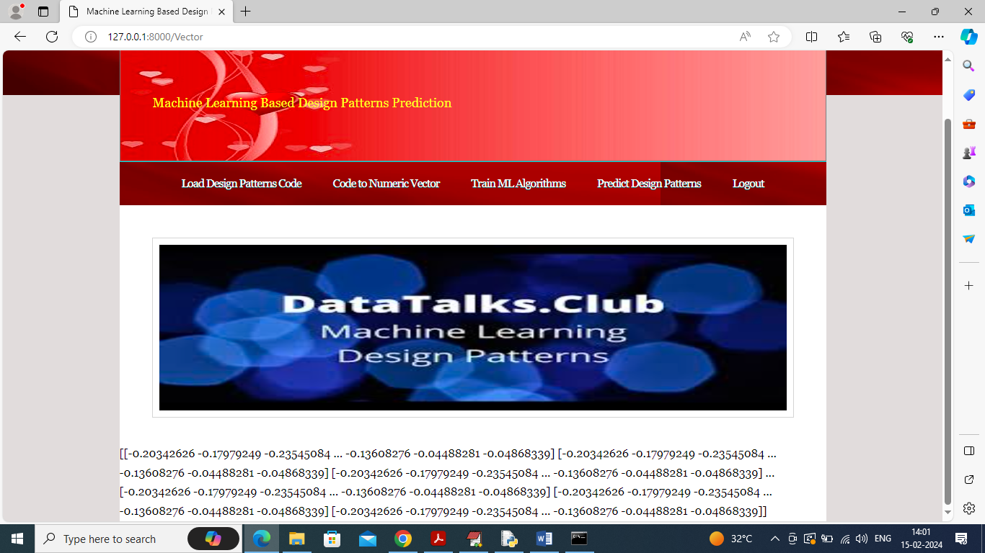

In above screen entire dataset converted to numeric vector and then click on ‘Train ML Algorithms’ link to train ML and get below output

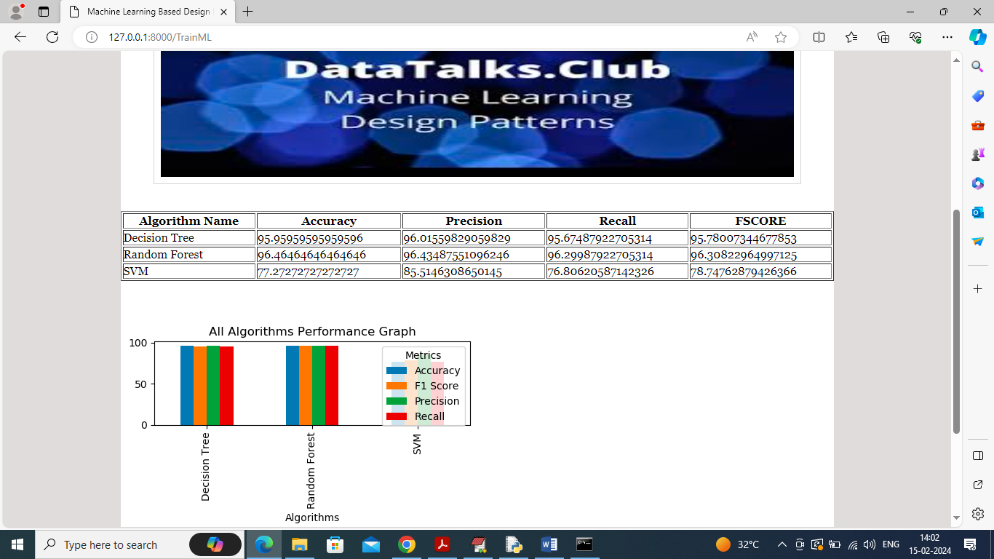

In above screen can see each algorithm performance in tabular and graph format and in all algorithms Random Forest got high accuracy and in graph x-axis represents algorithm names and y-axis represents accuracy and other metrics in different colour bars and now click on ‘Predict Design Patterns’ link to get below page

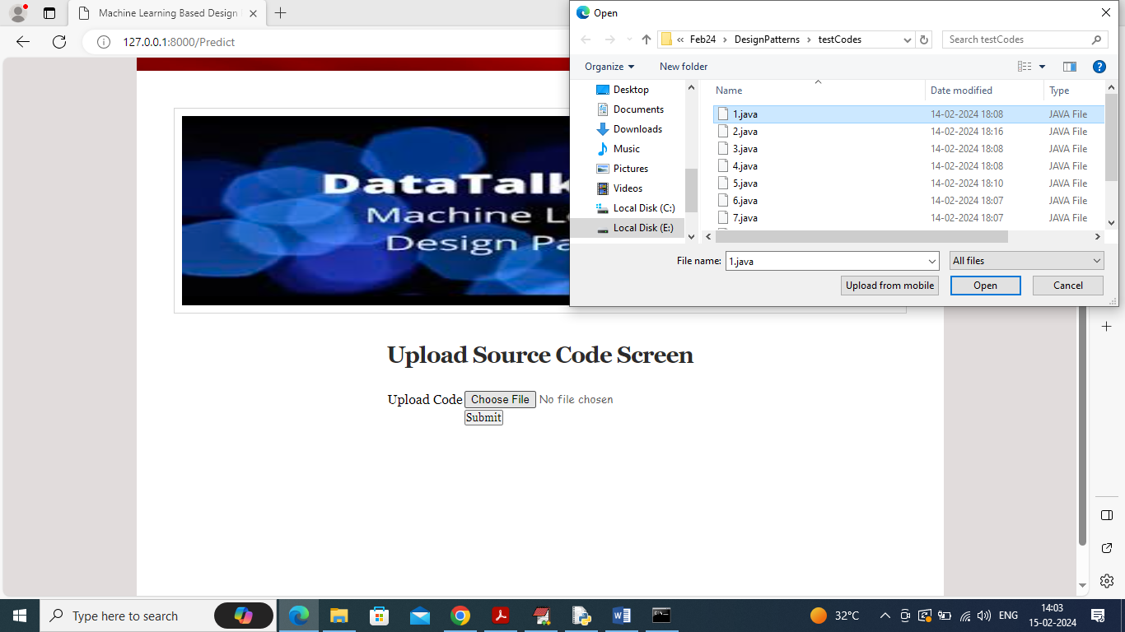

In above screen select and uploading any java source code in UI/non-UI format and then click on ‘Submit’ button to predict names of design pattern

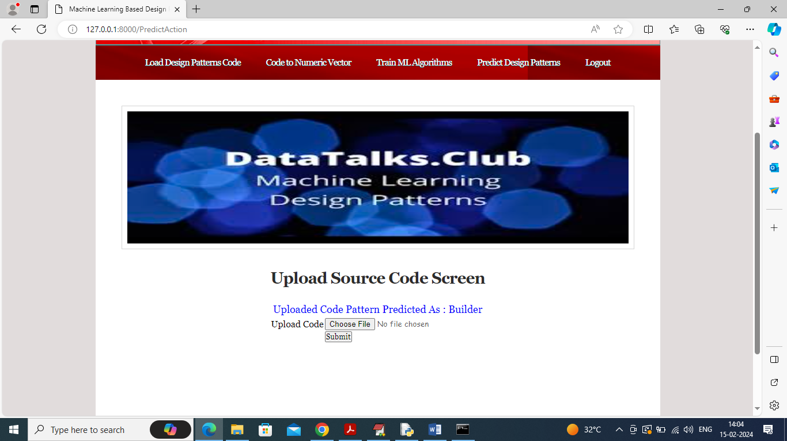

In above screen in blue colour text can see Design pattern predicted from uploaded source code as ‘Builder’ and similarly you can upload and test any other source code. Below is another example

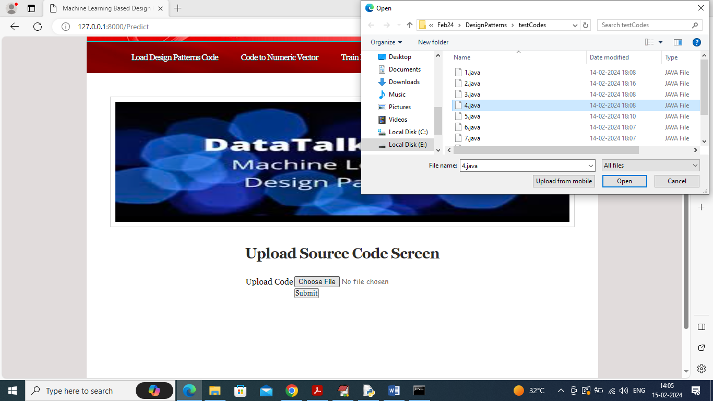

Uploading another code and below is the output

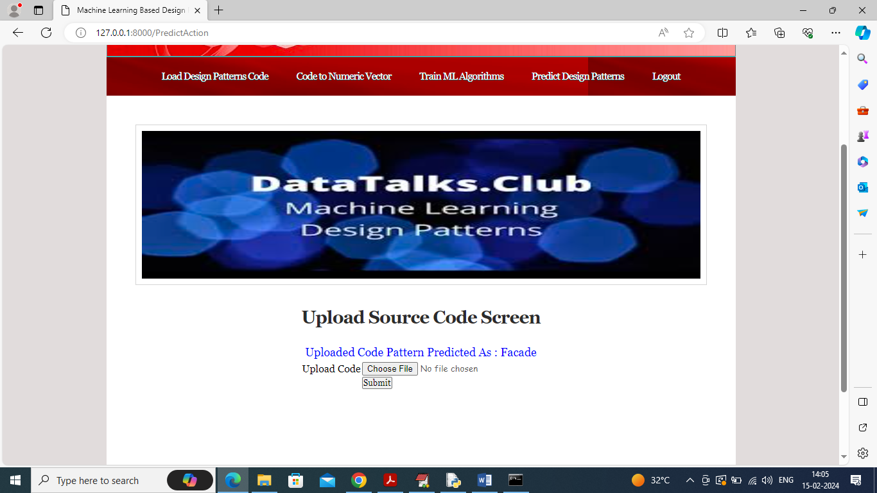

In above screen pattern detected as “Façade”

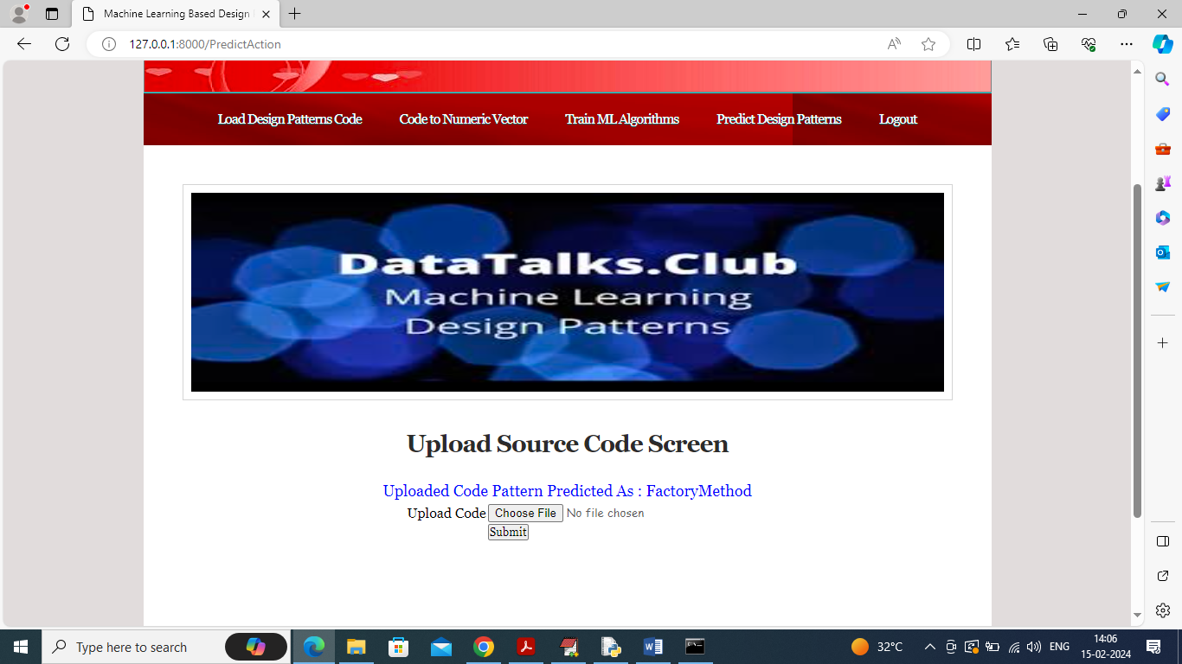

In above screen another code patterns predicted as ‘Factory Method’.