**Employee Emotion Detecttion**

**Problem Staement:** In Current Senario due to remote alignment of the team Organizaton is unable to judge the mental health of employee.

Accroding to W..H.O “Workplaces that promote mental health and support people with mental disorders are more likely to reduce absenteeism, increase productivity and benefit from associated economic gains”.

To Utlize the resource skills and human hours efficently it is necessary to take care of physical as well as mental health.

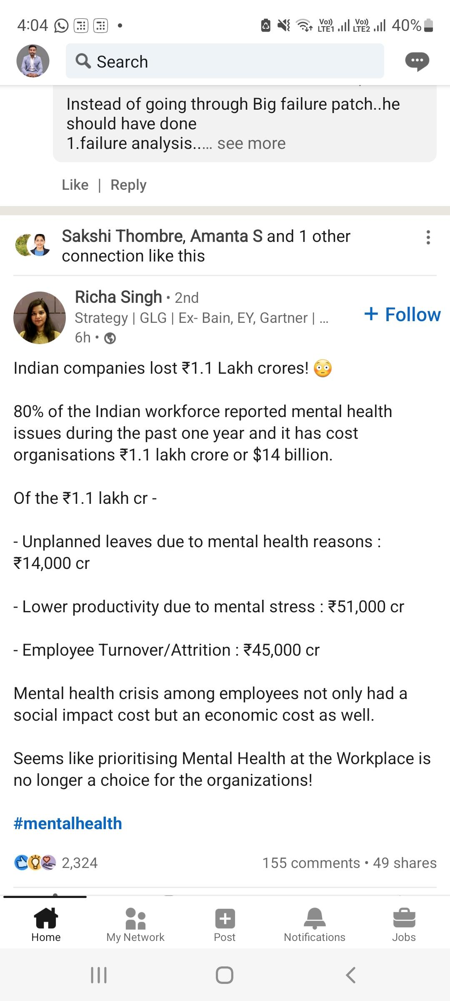

**Purposed Solution:** In this project we are going to make use of Artificial Inteligence to capture employee emotion detection (by face reading) and send him/her pesonalized email accordingly. That will help to connect them with oragnaiztion more personally.

Employee can Opt in/out (as there privacy concern) from this feature.

**Diagram**

