nii.gz format
nii is NIfTI (neuroimagining Informatics Technology Informatics)
gz (this is for zipping the file)
nii.gz combines depth wise also

download the dataset from here
http://medicaldecathlon.com/dataaws/

downloaded the Heart dataset

here teh affine matrix is this one
array([[1.25, 0. , 0. , 0. ],
[0. , 1.25, 0. , 0. ],
[0. , 0. , 1.37, 0. ],
[0. , 0. , 0. , 1. ]])

means (0,0,0,1) last column so no shift is there, no shift

x,y,z = 1.25, 1.25, 1.37 (means image scaling in x,y and z directions)

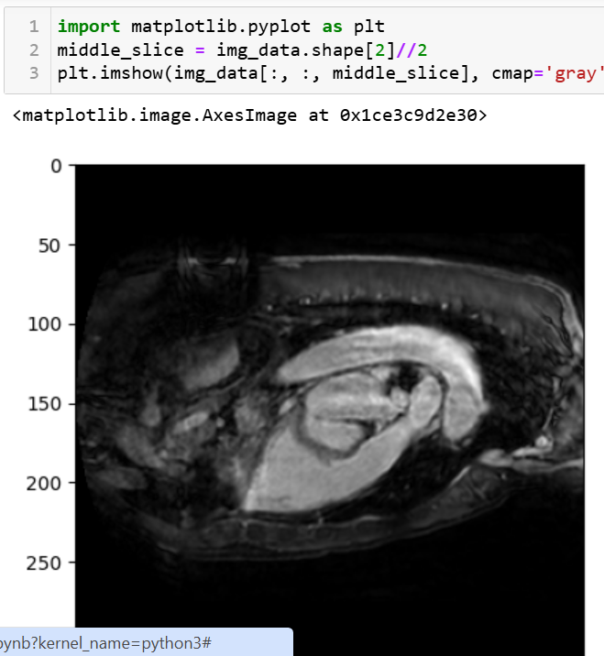

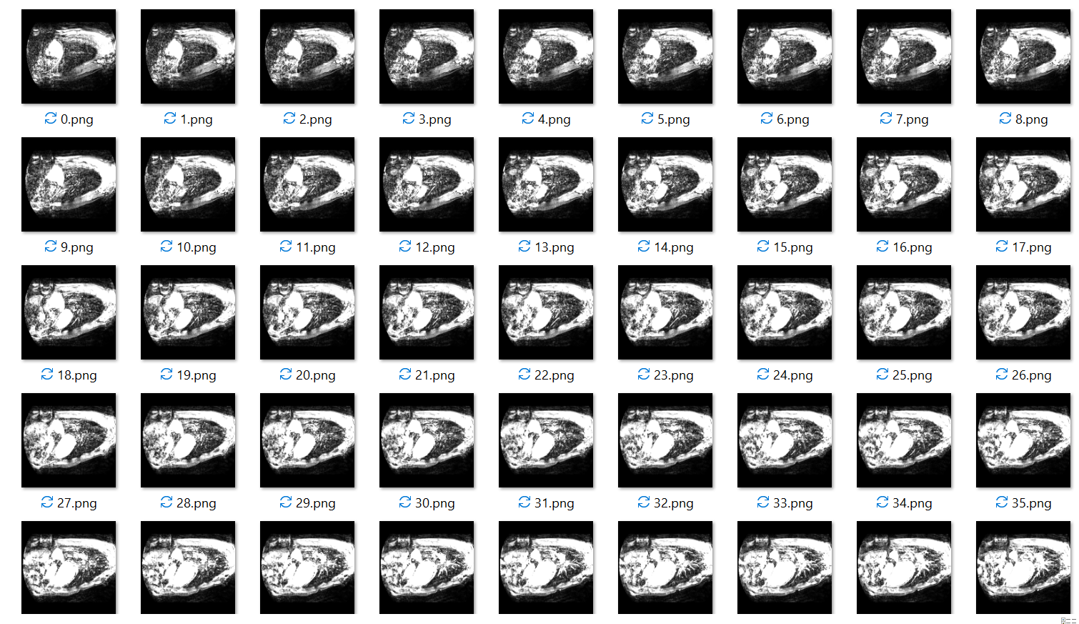

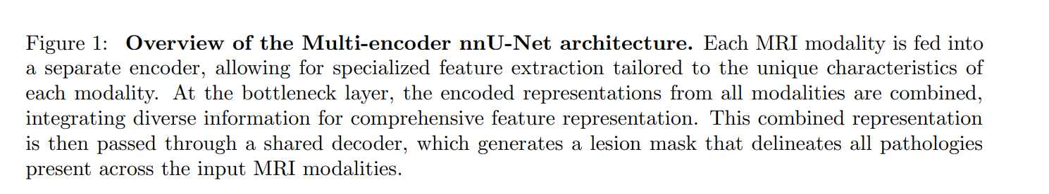

What is modality here?

configuration = '2d' # or '3d_fullres', '3d_lowres', etc.
what is the difference between all this?

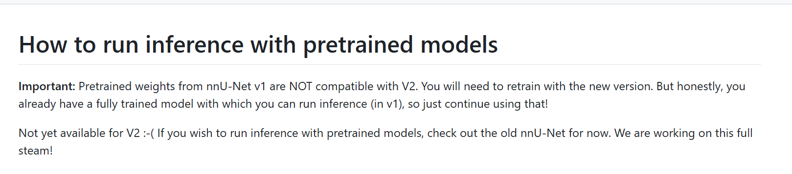
How should I run the inference for this file now?

"C:\Users\prasuna\OneDrive - Micron Technology, Inc\Desktop\BRATS\nnUNet\nnUNet_preprocessed\Dataset002_Heart\nnUNetPlans.json"
// earlier bath size was 2
"patch_size": [
48,
96,
96
],
Earlier patch size //80, 192, 160
Cerebral Aneurysms Jonathan L. Brisman, M.D., Joon K. Song, M.D., and David W. Newell, M.D.
In this paper, when they say colining how is coliling done?

