1) ggplot(ign, aes(x = factor(genre), y = editors_choice, col = factor(platform))) + geom_point()

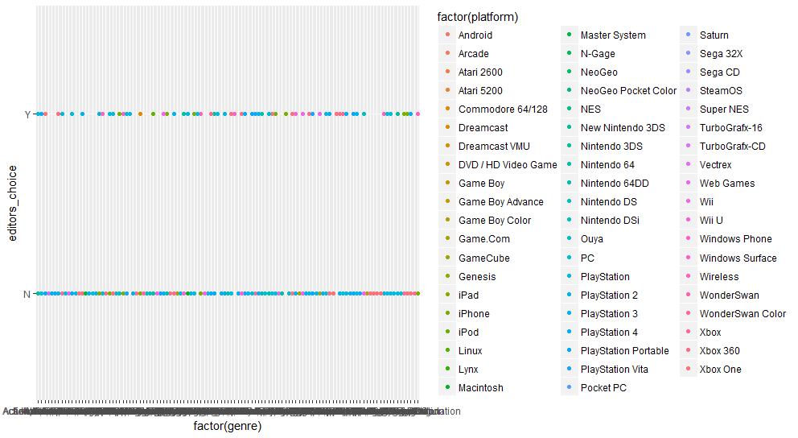

2) ggplot(ign, aes(x = factor(genre), y = editors_choice, col = factor(platform))) + geom_point() + geom_jitter()

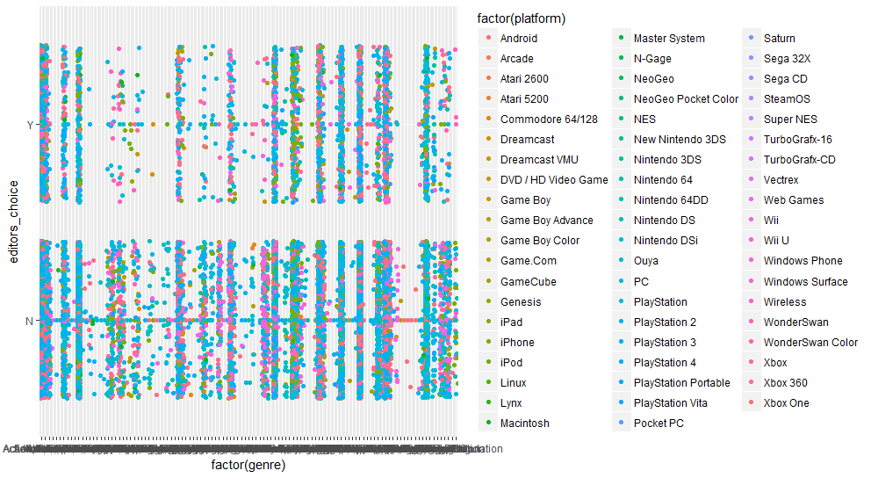

3) ggplot(ign, aes(x = factor(platform), y = editors_choice, col = factor(genre))) + geom_point()

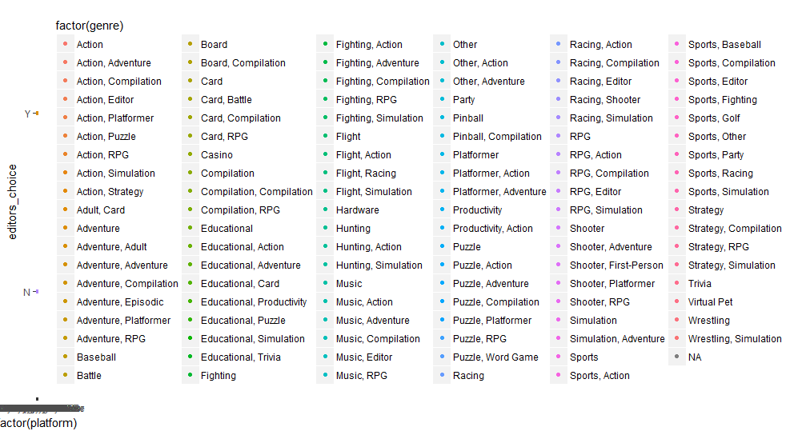

4) ggplot(ign, aes(x = factor(platform), y = editors_choice, col = factor(genre))) + geom_point() + geom_jitter()

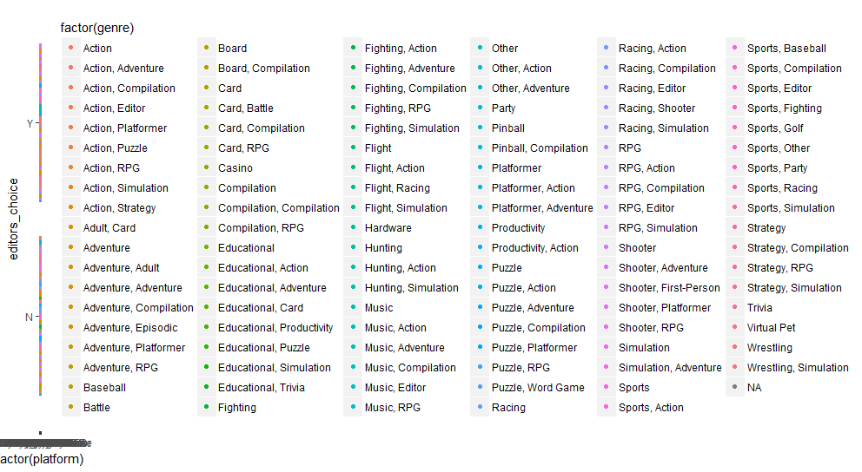

5) ggplot(ign, aes(x = factor(genre), y = score, col = factor(platform))) + geom_point()

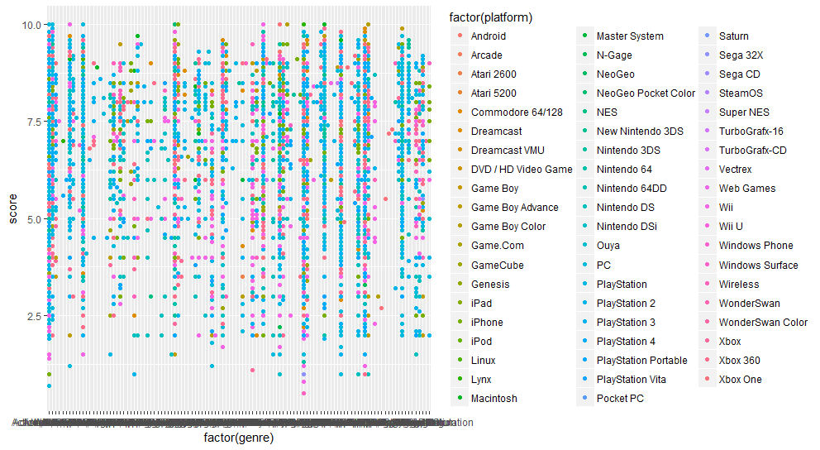

5) ggplot(ign, aes(x = factor(genre), y = score, col = factor(platform))) + geom_point() + geom_jitter()

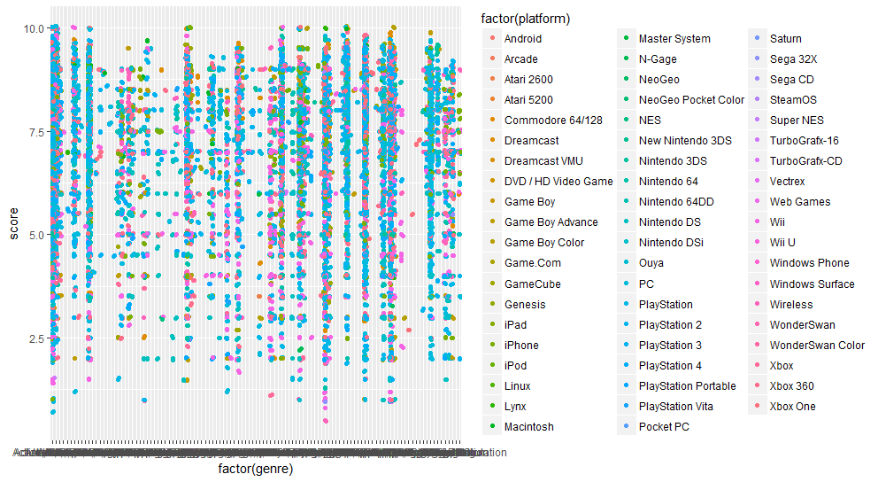

6) ggplot(ign, aes(x=score)) + geom_histogram()

