**Online Voting System**

### A PROJECT REPORT

#### Submitted by

**PRATYUSH KUMAR (21BCS3228)**

**PALAK PARMAR (21BCS3278)**

**SAKSHAM SADOTRA (21BCS3282)**

#### in partial fulfillment for the award of the degree of

**BACHLOR’S OF ENGINEERING**

###### IN

##### COMPUTER SCIENCE AND ENGINEERING



###### Chandigarh University

April 2024



**BONAFIDE CERTIFICATE**

Certified that this project report **“ONLINE VOTING SYSTEM”** is the bonafide work of “**PRATYUSH KUMAR, PALAK PARMAR and SAKSHAM SADOTRA”** who carried out the project work under my/our supervision.

###### SIGNATURE

Dr. Sandeep Singh Kang

###### HEAD OF THE DEPARTMENT

Department of Computer Science and Engineering

###### SIGNATURE

Er. Neha Rajput

**Assistant Professor**

Department of Computer Science and Engineering

Submitted for the project viva-voce examination held on

INTERNAL EXAMINER EXTERNAL EXAMINER

# TABLE OF CONTENTS

# List of Figures …………………………………………………...4

# Abstract ……………………………………………………….. 5

# Chapter 1 INTRODUCTION ………..…………………………6

1.1. Client Identification/Need Identification/Identification of relevant Contemporary issue...............................................…..6

1.2. Identification of Problem…………………………….…...7

1.3. Identification of Tasks……………………………….……7

1.4. Timeline…………………………………………………...8

1.5. Organization of the Report………………………………...9

**Chapter 2 DESIGN FLOW/PROCESS……………………………10**

2.1. Evaluation & Selection of Specifications/Features………10

2.2. Design Constraints ………………………………….…...10

2.3. Analysis and Feature finalization subject to constraints…11

2.4. Design Flow ..……………………………………………12

2.5. Design selection……………………………………….13

2.6. Implementation plan/methodology…………………..14

**Chapter 3 RESULTS ANALYSIS AND VALIDATION……..16**

3.1. Implementation of solution…………………………..16

**Chapter 4 CONCLUSION AND FUTURE WORK………….17**

4.1. Conclusion……………………………………………17

4.2. Future work…………………………………………...18

**References………………………………………………………..19**

**Appendix…………………………………………………………20**

**User Manual……………………………………………………..21**

# List of Figures

Figure 1.4 ………………………………………………………………………………….

Figure 2.6 ………………………………………………………………………………….

User Manual Figure 1 ……………………………………………………………………

User Manual Figure 2 ……………………………………………………………………

User Manual Figure 3 ……………………………………………………………………

User Manual Figure 4 ……………………………………………………………………

User Manual Figure 5 ……………………………………………………………………

User Manual Figure 6 ……………………………………………………………………

User Manual Figure 7 ……………………………………………………………………

**ABSTRACT**

The contemporary electoral landscape demands a secure and efficient online voting platform to address prevalent challenges in traditional voting systems. This project aims to design and implement an innovative online election platform using HTML, CSS, PHP, and MySQL. The focus is on ensuring security, maintaining data integrity, and providing real-time result updates. The introduction highlights the necessity of modernizing electoral processes, emphasizing statistical evidence and documented reports. The identified problem centers on vulnerabilities in traditional voting methods, motivating the transition to a transparent and accessible online platform. The project's tasks encompass requirement analysis, system design, implementation, testing, and deployment. The timeline, presented through a Gantt chart, outlines a systematic approach to project completion. The report's structure includes chapters on design flow, results analysis, and conclusions. This project seeks to contribute to the evolution of electoral systems, ensuring the integrity and accessibility of democratic processes.

**CHAPTER-1**

**INTRODUCTION**

**1.1.** **Client Identification/Need Identification/Identification of relevant**

**Contemporary issue**

**1.1.1 Client Identification:**

Our primary client is the democratic process itself, encompassing citizens, electoral bodies, and stakeholders dedicated to upholding the principles of fair and transparent elections. The project aims to serve the collective interest in advancing a secure, accessible, and technologically sophisticated electoral system.

**1.1.2 Need Identification:**

The imperative to modernize the electoral process arises from inherent challenges in traditional voting systems, including fraud, logistical inefficiencies, and potential inaccuracies. This need is not just a theoretical concern; it is a tangible issue that demands resolution. By framing it as a consultancy problem, we acknowledge the complexity of the challenge, emphasizing the need for specialized expertise to navigate and innovate in the realm of electoral systems.

**1.1.3 Justification through Statistics and Documentation:**

To validate the existence of the issue, we turn to statistical data and documented evidence. Analyses from reputable sources, including electoral commissions and academic studies, underscore the vulnerabilities of traditional voting systems. Instances of fraud, logistical challenges, and discrepancies in data reveal the urgency of embracing a modernized approach to elections.

**1.1.4 Need Justification Through Survey:**

The need for a resolution is further substantiated through a comprehensive survey that will engage various stakeholders, including voters, election officials, and relevant entities. This survey seeks to capture firsthand experiences, perceptions, and concerns related to the current electoral system. By incorporating direct input from those involved in the process, we ensure that the proposed solution addresses real and practical issues.

**1.1.5 Relevant Contemporary Issue Documented in Reports:**

Relevant contemporary issues surrounding traditional voting systems have been extensively documented in reports from reputable agencies. These reports, from electoral monitoring organizations and governmental bodies, provide a comprehensive overview of challenges faced by existing systems. Aligning our project with these documented issues ensures that our solution is not only timely but also rooted in addressing real-world challenges recognized by authoritative entities.

Through a synthesis of statistical evidence, consultancy framing, survey insights, and alignment with agency reports, this project is well-positioned to address a critical and validated contemporary issue within the electoral landscape.

**1.2. Identification of Problem**

The overarching problem demanding resolution lies in the inherent inadequacies of traditional voting systems. These systems, once the bedrock of democratic processes, are now grappling with multifaceted challenges that compromise the fundamental tenets of fair and transparent elections.

The problem extends beyond isolated instances of fraud; it encompasses a spectrum of issues ranging from logistical inefficiencies to vulnerabilities in data management. Traditional voting methods are prone to human errors, manipulation, and are increasingly out of sync with the expectations of a technologically advanced society.

By identifying the problem at this broad level, we refrain from hinting at specific solutions. Instead, the focus is on acknowledging the complex landscape within which the project operates. The goal is to pave the way for a comprehensive exploration of potential remedies in subsequent sections of the report.

**1.3.**  **Identification of Tasks**

Efficiently addressing the identified problem necessitates a structured approach encompassing various tasks throughout the project life cycle. These tasks can be categorized into three distinct phases: identification, development, and testing.

**1.3.1 Identification Phase:**

1.3.1.1 Requirement Analysis:

* Conduct a thorough analysis of the requirements for the online election platform.
* Identify essential features for secure and user-friendly voting.
* Engage stakeholders to gather specific needs and expectations.

1.3.1.2 System Design:

* Develop a comprehensive design for the online election platform.
* Outline the architecture, both frontend and backend.
* Create a user interface that ensures accessibility and ease of use.

**1.3.2 Development Phase:**

1.3.2.1 Implementation:

* Code and implement the designed system using HTML, CSS, PHP, and MySQL.
* Ensure compatibility with various devices and browsers.
* Incorporate security measures to safeguard user data.

1.3.2.2 Testing:

* Conduct rigorous testing to validate the functionality and security of the platform.
* Perform unit testing, integration testing, and system testing.
* Identify and resolve any issues or vulnerabilities.

**1.3.3 Testing Phase:**

1.3.3.1 Deployment:

* Deploy the online election platform for real-world usage.
* Ensure a smooth transition from traditional to online elections.
* Implement monitoring tools for ingoing assessment.

1.3.3.2 User Training:

* Provide training resources for voters, candidates, and administrators.
* Ensure that users are proficient in navigating and using the platform.

This delineation of tasks forms the framework for the project report, guiding the subsequent chapters and subheadings. The report will logically progress from the identification phase through development and testing, culminating in the deployment of the online election platform. Each task will be explored in depth, allowing for a comprehensive understanding of the project's intricacies.

**1.4.**  **Timeline**

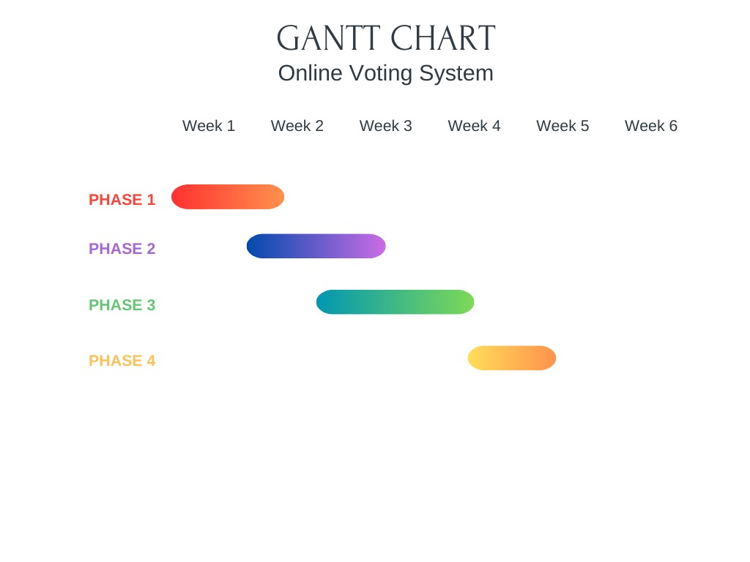

Figure 1.4. Project Timeline

**1.5.**  **Organization of the Report**

In Chapter 2, the design flow and process will be explored. This chapter will start with an evaluation and selection of specifications and features, critically assessing the elements identified in the literature. Following this, design constraints, including regulatory, economic, and ethical considerations, will be analysed, influencing the finalization of features. The chapter will present at least two alternative designs or processes for the online election platform, followed by an evaluation and selection of the most suitable design supported by a comparison. Additionally, the implementation plan and methodology will be outlined, providing a visual representation of the proposed system through flowcharts and detailed block diagrams.

Moving to Chapter 3, a detailed exploration of the results analysis and validation will be presented. This includes the implementation of the solution using modern tools for analysis, design drawings, schematics, and solid models. The chapter will also discuss project management and communication strategies employed throughout the development process.

The concluding Chapter 4 will summarize the project's outcomes in Section 4.1. It will touch upon expected results, any deviations, and the overall success of the project. Section 4.2 will delve into future work, proposing modifications to the solution, suggesting changes in approach based on lessons learned, and providing recommendations for extending the solution. This organizational structure ensures a clear and logical progression through the various stages and outcomes of the online election platform project.

**CHAPTER 2**

**DESIGN FLOW/PROCESS**

**2.1.**  **Evaluation & Selection of Specifications/Features**

In this section, we embark on a critical evaluation of the features identified in the literature, aiming to discern their relevance and applicability to our project objectives. The evaluation process involves a meticulous analysis of each feature's potential impact on the online election platform's functionality, security, and user experience.

**Literature Review:**

We delve into existing literature, exploring features proposed or employed in similar platforms. This involves scrutinizing academic studies, industry reports, and case studies to extract insights into successful features and potential pitfalls.

**Critical Evaluation Criteria:**

Establishing a set of criteria for evaluation is crucial. Criteria may include security, usability, scalability, and alignment with regulatory requirements. Each feature is assessed against these criteria to determine its suitability for integration.

**Feature Refinement:**

Based on the evaluation, features are refined and categorized. Features deemed essential for the success of the online election platform are identified, forming the foundation for the subsequent design and development phases.

**List of Ideally Required Features:**

Compile a comprehensive list of features that are deemed ideally necessary for the solution. This list acts as a blueprint for the design phase and provides a clear roadmap for the development team.

**Alignment with Project Objectives:**

Ensure that the selected features align seamlessly with the overarching project objectives. The chosen features should address the identified problems and contribute to the successful realization of the online election platform's goals.

This thorough evaluation and selection process lay the groundwork for a robust set of specifications and features that will define the online election platform's functionality and user experience.

**2.2.**  **Design Constraints**

In this section, we explore the multifaceted landscape of design constraints that impact the development of the online election platform. These constraints span various dimensions, each requiring careful consideration to ensure the platform's success.

**Regulatory Compliance:**

Examine local and international regulations governing online elections. Ensure that the platform adheres to legal frameworks, safeguarding the integrity and legality of the voting process.

**Economic Viability:**

Assess the economic feasibility of the design. Consider budgetary constraints and resource availability to create a solution that is both effective and financially sustainable.

**Environmental Impact:**

Evaluate the environmental implications of the online election platform. Strive for sustainable design practices, minimizing environmental impact and aligning with green initiatives.

**Health and Safety Considerations:**

Prioritize the health and safety of users. Implement measures to safeguard personal data, ensuring a secure and trustworthy voting environment.

**Manufacturability:**

Explore the practical aspects of manufacturing the platform, ensuring that the design is feasible and scalable for widespread adoption.

**Professional and Ethical Standards:**

Adhere to professional and ethical standards in the development process. Uphold principles of transparency, fairness, and user privacy, aligning with the highest ethical considerations.

**Social & Political Sensitivity:**

Acknowledge the social and political context within which the platform operates. Design features that promote inclusivity, accessibility, and neutrality to accommodate diverse user demographics.

**Cost Considerations:**

Integrate cost considerations into the design process. Strive for an optimal balance between feature richness and financial efficiency to ensure the project's economic viability.

By systematically addressing these design constraints, we aim to create a platform that not only meets functional requirements but also aligns with broader regulatory, economic, and ethical considerations, ensuring a resilient and responsible online election solution.

**2.3.**  **Analysis and Feature finalization subject to constraints**

This section focuses on the iterative process of refining features based on the identified constraints. It involves a meticulous examination of each feature in the context of regulatory, economic, ethical, and other constraints. The goal is to ensure that the final feature set is not only technically feasible but also aligned with the broader constraints that influence the online election platform's development.

**Feature Reassessment:**

Initiate a thorough reassessment of the initially proposed features in light of the identified constraints. This involves scrutinizing each feature to determine its compatibility with regulatory requirements, economic feasibility, and ethical considerations.

**Removal of Incompatible Features:**

Identify features that pose challenges or conflicts with constraints and, if necessary, remove them from the feature set. This ensures that the final design is in compliance with legal, ethical, and economic considerations.

**Modification for Alignment:**

Modify features that require adjustment to align with constraints. This may involve redesigning certain functionalities or adjusting parameters to meet regulatory standards, adhere to budgetary constraints, or align with ethical principles.

**Addition of Necessary Features:**

Introduce new features that are necessary to address specific constraints. This may include incorporating additional security measures to meet regulatory standards, implementing cost-effective solutions, or integrating features to enhance ethical considerations.

**Iterative Process:**

Emphasize the iterative nature of this process. As features are adjusted or added, the entire feature set is revaluated to ensure cohesion and compatibility. This iterative approach facilitates a dynamic and responsive design process.

**Documentation of Changes:**

Document all changes made to the feature set. This includes the rationale behind each modification, whether it is driven by regulatory compliance, economic considerations, or ethical alignment. Clear documentation ensures transparency and aids in future decision-making.

This iterative analysis and feature finalization process are integral to crafting a feature set that not only meets technical requirements but also aligns seamlessly with the identified constraints. The outcome is a refined set of features that navigate the complex landscape of regulatory, economic, ethical, and other constraints to deliver a robust and compliant online election platform.

**2.4.**  **Design Flow**

In this section, we explore two alternative designs or processes for the online election platform, aiming to provide a comprehensive view of potential approaches to address the identified problem. The objective is to present distinct design flows, each with its merits and considerations, allowing for an informed decision-making process.

**Alternative Design 1: Instant Runoff Voting (IRV)/Ranked Choice Voting (RCV)**

Probably the only alternative voting method you’ve heard about, after being the first alternative voting method to be implemented at the state level. IRV allows voters to rank the candidates in an election in order of preference, and the candidate with the majority of first-choice votes wins. If no candidate has a majority, the candidate with the least first-choice votes is eliminated, and those voters’ second-choice candidates receive their votes. This process continues until a candidate receives a majority of the vote. IRV does a better job of electing voters’ true favourite candidates than our current method and encourages more competition. But, it can be costly for cities with older voting machines to implement and can lead to unexpected results in tight races.

**Alternative Design 2: STAR (Score Then Automatic Runoff) Voting**

A newer method, STAR, allows voters to score each candidate on a scale and then the two candidates with the highest scores enter an automatic runoff, with voters’ ballots cast to whichever candidate they scored highest. It hasn’t yet been studied to determine its effectiveness at selecting a “good” winner, but it appears that it should lead to more competition and better winners. It also hasn’t been implemented in an election yet, so some questions about implementation remain.

Comparison and Selection Criteria:

Functional Alignment:

* Aligns well with the goal of electing voters' true favourite candidates.
* Aims to increase competition and potentially improve the selection of winners.

Regulatory Compliance:

* Generally complies with existing regulations, as it has been implemented at the state level.
* Unproven in actual elections; compliance may depend on further study and testing.

Economic Viability:

* Can be costly for cities with older voting machines to implement.
* Potential for cost savings in the absence of unforeseen implementation challenges.

User Experience:

* Provides a nuanced voting experience, allowing voters to express preferences.
* Offers a unique voting experience by allowing voters to score candidates.

Security Measures:

* Generally secure, but concerns may arise during the electronic implementation.
* Theoretical security concerns until tested in real-world scenarios.

Ethical Considerations:

* Ethical, promotes fairness by accommodating voter preferences.
* Ethical considerations depend on the outcomes of further studies and successful implementation.

By presenting two alternative designs and thoroughly evaluating their strengths, weaknesses, and alignment with constraints, this section aims to provide a solid foundation for the subsequent selection of the most suitable design for the online election platform.

**2.5.**  **Design selection**

This section analyses and compares the two alternative designs for the online election platform, focusing on functionality, regulatory compliance, economic viability, user experience, security measures, and ethical considerations.

**Design Comparison:**

Functional Alignment:

* Design 1: Aligns well with the goal of electing voters' true favourite candidates.
* Design 2: Aims to increase competition and potentially improve the selection of winners.

Regulatory Compliance:

* Design 1: Generally complies with existing regulations, as it has been implemented at the state level.
* Design 2: Unproven in actual elections; compliance may depend on further study and testing.

Economic Viability:

* Design 1: Can be costly for cities with older voting machines to implement.
* Design 2: Potential for cost savings in the absence of unforeseen implementation challenges.

User Experience:

* Design 1: Provides a nuanced voting experience, allowing voters to express preferences.
* Design 2: Offers a unique voting experience by allowing voters to score candidates.

Security Measures:

* Design 1: Generally secure, but concerns may arise during the electronic implementation.
* Design 2: Theoretical security concerns until tested in real-world scenarios.

Ethical Considerations:

* Design 1: Ethical, promotes fairness by accommodating voter preferences.
* Design 2: Ethical considerations depend on the outcomes of further studies and successful implementation.

**Design Selection:**

Ultimately, the selection between IRV/RCV and STAR Voting depends on the specific priorities, regulatory environment, and the desired user experience for the online election platform. Further study and testing may be crucial for making an informed decision, particularly in the case of STAR Voting, which has not yet been implemented in an election setting.

This concise analysis and selection process aim to identify the most suitable design for the online election platform, ensuring a well-informed decision based on key considerations.

**2.6.**  **Implementation plan/methodology**

This section delineates the implementation plan and methodology for the development of the online election platform, employing visual aids such as flowcharts, algorithms, and detailed block diagrams to provide a clear and concise roadmap.

Flowchart:

The implementation process is outlined through a systematic flowchart, detailing the sequential steps:

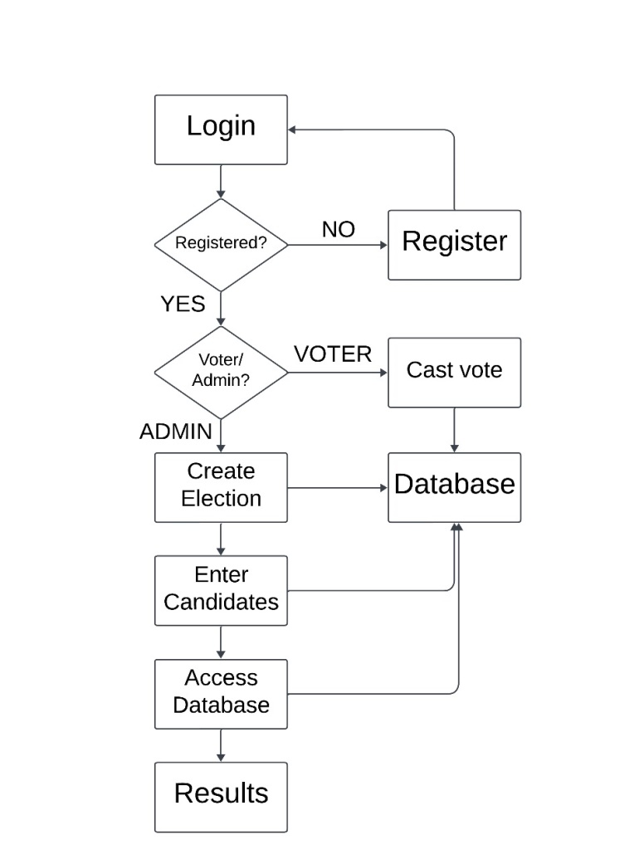

Figure 2.3. Flowchart for the project

Requirement Analysis:

Gather and analyse project requirements.

Engage stakeholders for input.

Design Phase:

Develop the architecture and design of the online election platform.

Incorporate features identified in the previous sections.

Coding and Development:

Code the platform using HTML, CSS, PHP, and MySQL.

Implement security measures to safeguard user data.

Testing Phase:

Conduct rigorous testing, including unit, integration, and system testing.

Address and resolve any identified issues promptly.

Deployment:

Deploy the online election platform for real-world usage.

Implement monitoring tools for ingoing assessment.

User Training:

Provide training resources for voters, candidates, and administrators.

Ensure users are proficient in navigating and utilizing the platform.

**CHAPTER 3**

**RESULTS ANALYSIS AND VALIDATION**

**3.1.**  **Implementation of solution**

This section details the implementation of the online election platform using modern tools across various stages of the development process. The utilization of these tools enhances the efficiency and effectiveness of the project in multiple facets:

Analysis:

Modern tools for comprehensive analysis are employed to assess project requirements, stakeholder input, and potential challenges. This phase ensures a solid foundation for subsequent development.

Design Drawings/Schematics/Solid Models:

In the design phase, cutting-edge tools are utilized to create detailed drawings, schematics, and solid models. These visual representations guide the development of the online election platform, ensuring accuracy and precision.

Report Preparation:

Sophisticated tools are employed for report preparation, enabling the documentation of the entire development process, challenges faced, and solutions implemented. This ensures a comprehensive and well-documented project record.

Project Management and Communication:

Modern project management and communication tools are integrated to streamline workflow, enhance collaboration among team members, and facilitate efficient communication. This ensures a synchronized and well-coordinated development process.

Testing/Characterization/Interpretation/Data Validation:

During the testing phase, advanced tools are used for testing, characterization, interpretation, and data validation. These tools help identify and rectify any issues, ensuring the functionality, security, and integrity of the online election platform.

The strategic utilization of modern tools at each stage of the implementation process contributes to a seamless and efficient development process, resulting in a robust and high-performing online election platform.

**CHAPTER 4**

**CONCLUSION AND FUTURE WORK**

**4.1.**  **Conclusion**

This section provides a comprehensive conclusion to the online election platform development project, encompassing expected results, deviations from expectations, and the reasons behind these deviations.

Expected Results/Outcome:

The initial project expectations and anticipated outcomes were centred around the successful creation and deployment of a secure, user-friendly, and efficient online election platform. The expected results included high user engagement, accurate vote tabulation, and a positive overall experience for voters, candidates, and administrators.

Deviation from Expected Results:

While significant strides were made in achieving the expected outcomes, certain deviations were encountered during the development and deployment phases. These deviations may include unexpected technical challenges, variations in user adoption rates, or unanticipated external factors influencing the platform's performance.

Reasons for Deviation:

Several factors contributed to the deviations from the expected results. Technical challenges may have arisen due to unforeseen complexities in the implementation process. User adoption rates could have been influenced by external factors such as changes in user behavior or technological advancements. The reasons for these deviations are thoroughly examined and documented to provide insights for future improvements.

Reflection on the Project:

The conclusion section reflects on the project as a whole, discussing lessons learned, successful aspects, and areas for improvement. It evaluates the project's overall success in addressing the identified problem and meeting the needs of stakeholders.

Future Recommendations:

Based on the deviations and reflections, future recommendations are presented. These may include suggested modifications to the solution, changes in approach for similar projects, and enhancements to address any unforeseen challenges encountered during the development process.

In summary, the conclusion section serves as a holistic reflection on the project's outcomes, acknowledging both successes and deviations from expectations. It provides valuable insights for future projects and continuous improvement in the development of online election platforms.

**4.2.**  **Future work**

This section outlines the way forward for the online election platform, suggesting required modifications, potential changes in approach, and avenues for extending the solution.

Required Modifications:

Identified areas for improvement or modifications in the current solution are highlighted. This may involve addressing specific technical challenges, enhancing user interfaces, or refining security measures based on lessons learned during the project.

Change in Approach:

Consideration is given to potential changes in the development approach for future iterations or similar projects. This could involve adopting new technologies, refining project management strategies, or incorporating innovative design methodologies.

Suggestions for Extending the Solution:

Future work includes suggestions for extending the capabilities of the online election platform. This may involve the integration of additional features, scalability enhancements, or the adaptation of the platform to meet evolving user needs and technological advancements.

In essence, the future work section serves as a roadmap for the continuous improvement and evolution of the online election platform, ensuring its adaptability to changing requirements and emerging trends in the field of online voting systems.

**REFERENCES**

**<https://scholar.google.com/citations?view_op=view_citation&hl=en&user=6HYMfbkAAAAJ&citation_for_view=6HYMfbkAAAAJ:IjCSPb-OGe4C>**

**<https://www.researchgate.net/profile/G-Ofori-Dwumfuo/publication/268287879_The_Design_of_an_Electronic_Voting_System/links/54eb7c3a0cf2082851bdfed4/The-Design-of-an-Electronic-Voting-System.pdf>**

<https://ieeexplore.ieee.org/abstract/document/6726801/>

<https://ieeexplore.ieee.org/abstract/document/8537284/>

**APPENDIX**

**A. Survey Questionnaire**

Voter Satisfaction Survey:

* Questions designed to gauge voters' satisfaction with the online election platform.

Candidate Feedback Survey:

* Questions tailored to collect feedback from candidates regarding their experience with the online election process.

**B. Gantt Chart**

A visual representation of the project timeline, outlining key milestones and their respective durations.

**C. User Training Materials**

Voter Training Guide:

* Step-by-step guide for voters on how to use the online voting platform.

Candidate Campaign Guide:

* Instructions for candidates on how to navigate the platform for campaign purposes.

**D. Regulatory Compliance Checklist**

* A checklist outlining the regulatory requirements considered during the design and development of the online election platform.

**E. Security Measures Documentation**

Encryption Protocols:

* Details on the encryption methods employed to secure user data.

Access Control Policies:

* Documentation of policies and measures for controlling access to the online election platform.

**F. Code Samples**

Excerpts of code snippets from key components of the online election platform, demonstrating the implementation of crucial features.

**G. Results Analysis Data**

Implementation Testing Data:

* Raw data from testing phases, including unit testing, integration testing, and system testing.

User Feedback Analysis:

* Summarized data from user feedback sessions, highlighting areas of improvement and user satisfaction.

**H. Future Work Proposals**

Modifications Documentation:

* Proposed modifications for future iterations of the online election platform.

Extended Features Suggestions:

* Ideas for extending the solution to address evolving needs and technological advancements.

**USER MANUAL**

**Step 1:** Use the login credentials to enter as a voter.

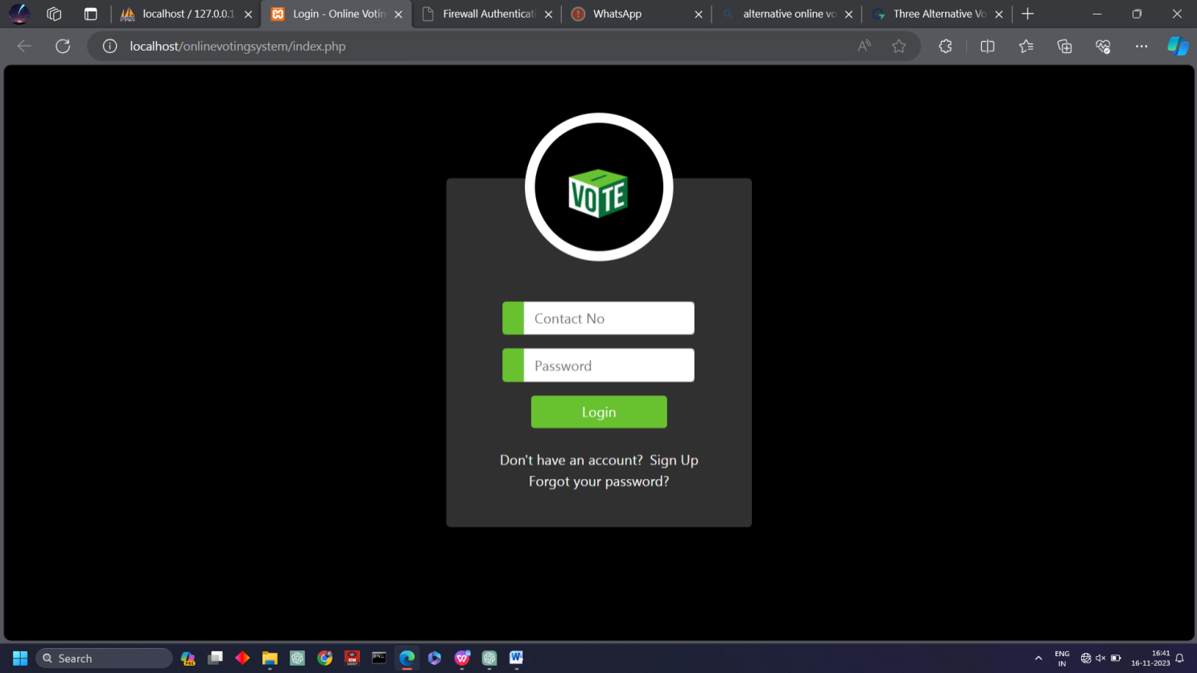

**Step 2:** If not having an account, enter the details to create an account.

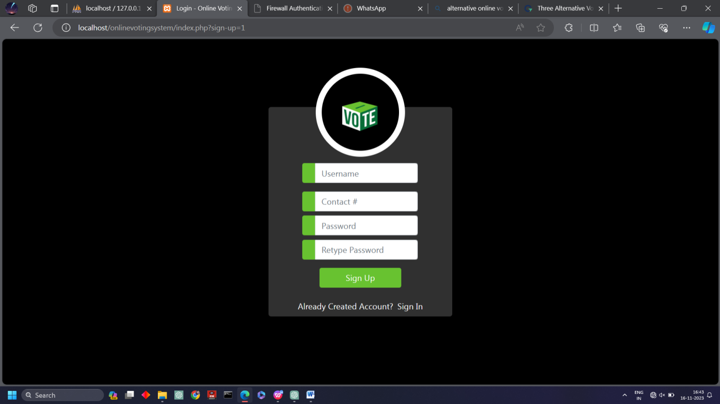

**Step 3:** Select your choice from as given candidates and click on the vote button at the side.

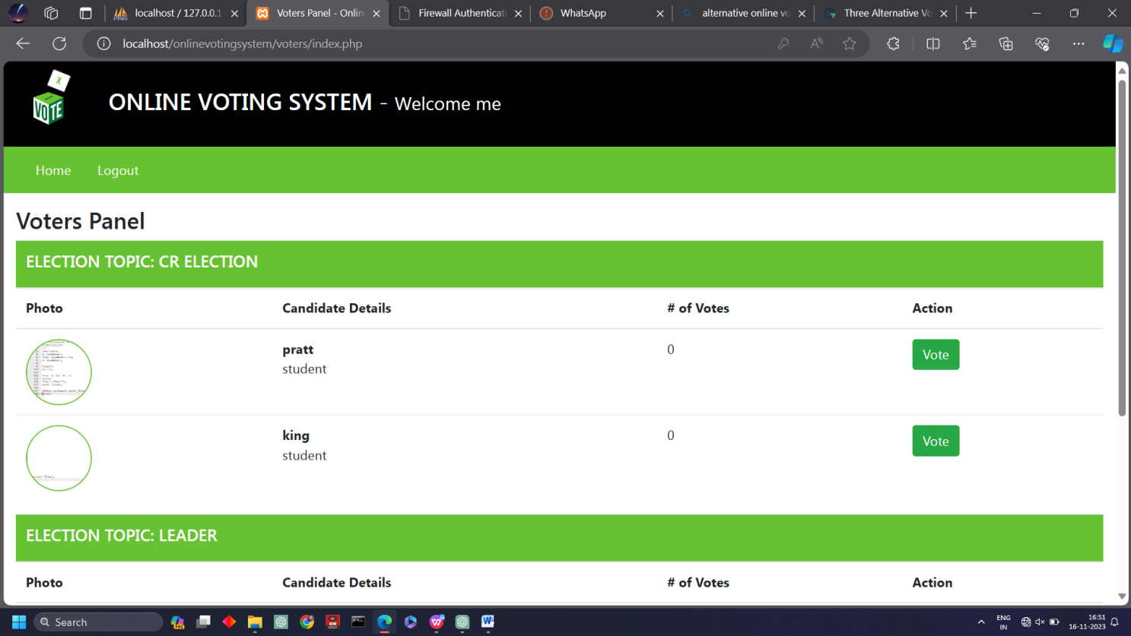

**Step 4:** You can now see that your vote has been casted.

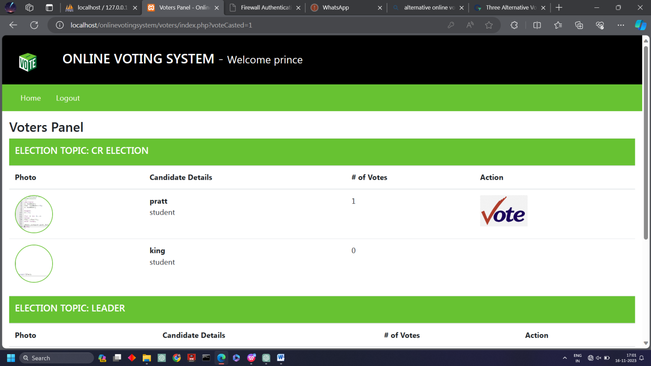

**Admin Controls**

**Step 1:** After logging in as the admin, fill the details for the election to be crteated.

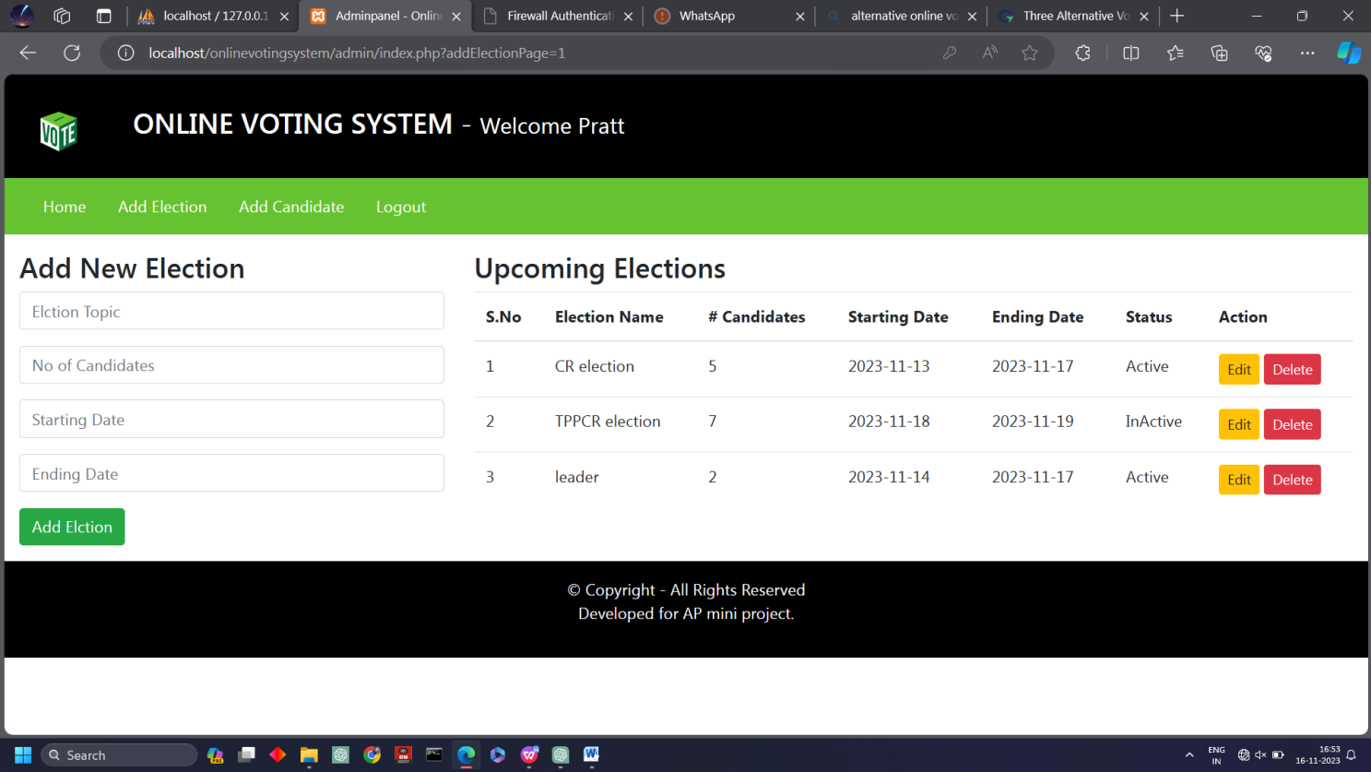

**Step 2:** Enter the details of the candidates for the election.

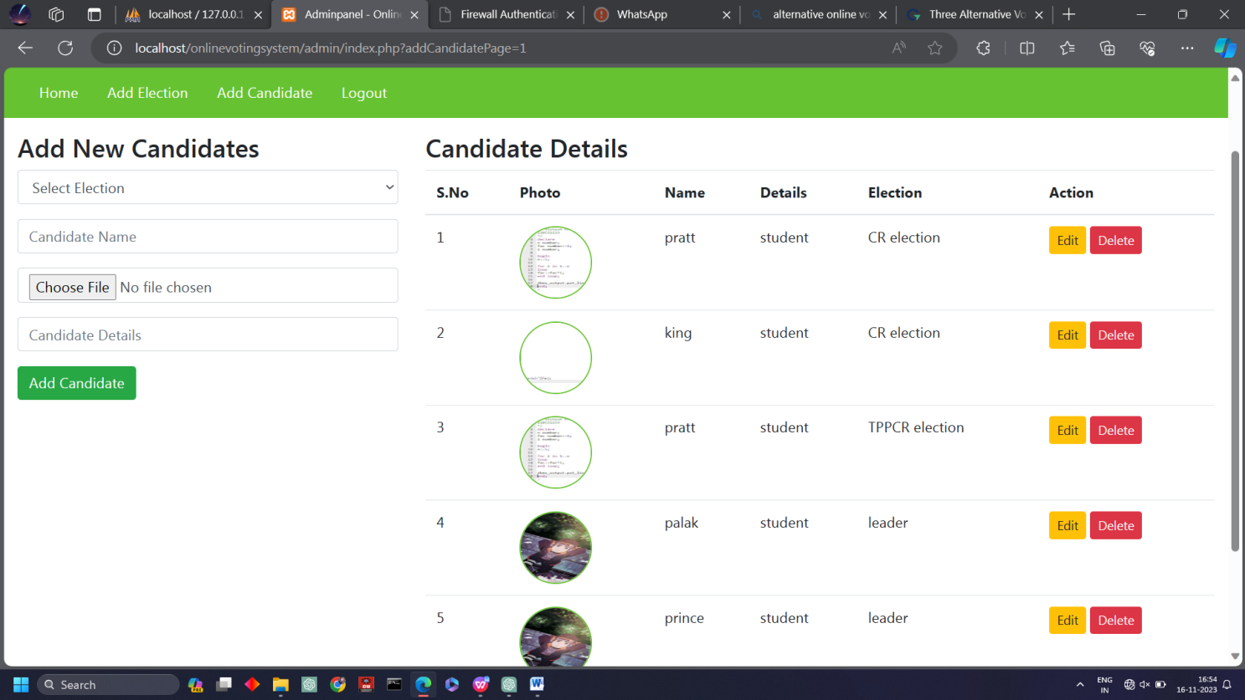

**Step 3:** After the votes has been casted you can click on the view results button in order to see the results of the elections.

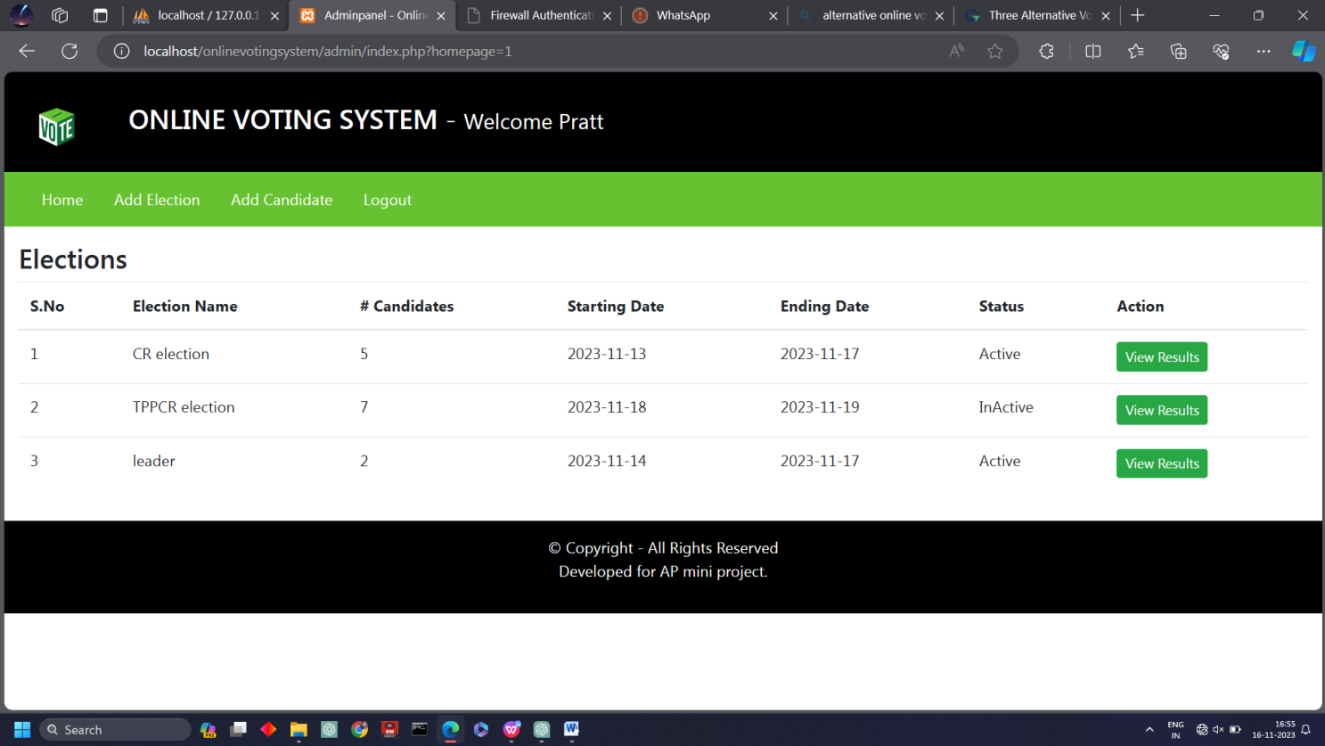

**Step 4:** Now you can see the results of the election.

