PROJECT INTERCOMPUTE: CAPSTONE PROGRESS REPORT
Academic Evaluation, Architectural Mapping, and GhostInTheMachine Simulation Runtime
Capstone Project Title: InterCompute: A Resilient Peer-to-Peer Compute Marketplace | Review Period: Month 1 Technical Progress Audit (October 2026)
Core Execution Runtime: GhostInTheMachine (Risk-Aware DAG Scheduler) | Current Milestone: 1st Prototype Demo Model Complete & Verified
Repository URL: https://github.com/Prat947-G/GhostInTheMachine.git | Immediate Next Phase: Hardware-in-the-Loop Edge Testing (Upcoming Week)

1. Student Team Roster & Individual Technical Contributions
InterCompute is developed by a six-member engineering team. Each participant owns a dedicated architectural subsystem across the hardware telemetry, risk scheduling, fault tolerance, and empirical evaluation modules:
Participant & Reg. No. | Architectural Role | Repository Module | Technical Deliverables & Subsystem Ownership
Prathmesh Kadam  (Prat947-G)  Reg: [Lead] | System Architect &  Scheduling Core Lead | dag_engine.py  schedulers.py | • Formulated the Risk-Aware Objective Function J(i, k).  • Engineered the DAG topological parsing engine.  • Implemented comparative baseline schedulers (HEFT, Greedy, Bounded ACO).  • Coordinated master repository architecture and Git CI.
Team Member 2  Reg: [Reg Number 2] | UI/UX & Marketplace  Functionality Co-Lead | Frontend Dashboard  Consumer Workflows | • Designed end-to-end UI/UX architecture for InterCompute marketplace.  • Built consumer workload submission portals (budget, deadline, CPU/GPU).  • Developed user interaction flows for compute leasing.
Team Member 3  Reg: [Reg Number 3] | UI/UX & Provider  Portal Lead | Provider Interface  Telemetry Displays | • Engineered interactive platform functionality and provider dashboard.  • Implemented real-time task progress and telemetry visualizers.  • Built UI controls for device owner priority and status tracking.
Team Member 4  Reg: [Reg Number 4] | Network Modeling &  Fault Injection Lead | network_fault_injector.py  worker.py | • Formulated residential asymmetric bandwidth models (Uk << Dk).  • Implemented discrete-event Poisson hazard failure generators.  • Modeled session wear-out fatigue via Weibull distributions.  • Quantified inter-peer payload transmission delay penalties.
Team Member 5  Reg: [Reg Number 5] | Security Protocols & Cryptographic  Attestation Lead (~80% Scope) | risk_engine.py  Security Architecture | • Researched security protocols, trust methods, and crypto pipeline (80% security scope).  • Formalized Feasibility Gate F(i,k) conforming to IETF RATS RFC 9334.  • Built SHA-256 state hashing and ESP32 signature validation.  • Engineered anti-spoofing verification for physical telemetry.
Team Member 6  Reg: [Reg Number 6] | CLI Architecture &  Execution Harness Lead | cli.py  Batch Run Scripts | • Architected command-line control harness (cli.py).  • Designed CLI commands for simulation execution and parameter sweeps.  • Built automated headless run automation and logging hooks.  • Formatted publication-ready vector figures and benchmark visualizations.

Institutional Reference: Note for Faculty Reviewers: Team Member names and registration numbers 2 through 6 can be populated directly via the project registry during final institutional archival.

2. Capstone Project Vision: InterCompute vs. Existing Products (Vast.ai)
Executive Summary: InterCompute is a decentralized, peer-to-peer compute marketplace enabling ordinary consumers to monetize spare cycles on intermittently available personal laptops, desktops, and edge devices. While commercial GPU rental marketplaces like Vast.ai provide access to dedicated, static mining rigs and server-grade nodes with high-speed links, they completely fail under the chaos of consumer edge environments.
2.1 What InterCompute Does Differently: The Five Pillars
Architectural Dimension | Conventional Cloud / Vast.ai | InterCompute Innovation & Advantage
Target Hardware & Availability | Requires dedicated, statically provisioned machines and commercial multi-GPU racks. | Personal & Edge-Device Focus: Aggregates spare capacity from ordinary laptops, workstations, and edge boards that are available intermittently.
Device Owner Priority | Worker machine is fully locked by renter. The physical owner cannot use their PC without killing the job. | Owner-Aware Computing: Hardware owner always maintains absolute priority. When user activity is detected, InterCompute immediately pauses or migrates jobs.
Trust & Metric Integrity | Software-only self-reporting. Hosts can easily spoof GPU specs, throttle frequencies, or falsify power usage. | Hardware-Attested Usage: An external physical microcontroller (ESP32/RPi) cryptographically signs physical power, current, and temperature telemetry.
Fault Tolerance Under Churn | Node disconnection causes catastrophic task failure. Unsaved work is permanently lost; entire job restarts from 0. | Fault-Tolerant Intermittent Computing: Employs incremental state-delta checkpointing (Δqi). Surviving peers resume execution in ~5.3s.
Network Modeling | Assumes high symmetric bandwidth. Communication grinds to a halt on consumer residential broadband. | Asymmetric Uplink Optimization: Models and optimizes for residential upload limits (Uk << Dk) where uplinks are 10-20x slower than downlinks.
Scheduling Intelligence | Simple price/speed matching. Blind to preemption hazard rates and thermal throttling risks. | Energy-Aware Risk Scheduling: Objective score J(i,k) accounts for price, performance, thermal limits, upload speed, and failure probabilities.

The One-Line Differentiation: "Vast.ai provides a marketplace for renting available GPUs on dedicated static rigs; InterCompute turns temporarily idle, untrusted, and unreliable personal devices into a secure, fault-tolerant distributed compute pool using hardware-attested telemetry, owner-aware scheduling, and state-delta migration."

3. Technical Mapping: The Foundational Role of GhostInTheMachine
The GhostInTheMachine repository serves as the rigorous mathematical simulation runtime, scheduling brain, and algorithmic validation framework for the InterCompute marketplace. In a decentralized compute network, attempting to deploy distributed containers without mathematically proving network dynamics guarantees failure.
3.1 Why Directed Acyclic Graphs (DAGs) Were Chosen
Real-world computational workloads—ranging from multi-stage deep learning pipelines (data ingestion -> tokenization -> forward pass -> gradient aggregation) to video rendering and scientific computing—are not standalone batch jobs. They naturally form a Directed Acyclic Graph (DAG) G = (V, E) where vertices V represent computational steps (with compute cost wi and memory mi) and directed edges E represent intermediate data transfer payloads (dij).
The Scheduling Challenge in InterCompute: If Task A executes on Worker 1 and dependent Task B is scheduled on Worker 2, payload dAB must be transferred across the physical internet. Because Worker 1 is a residential host, the transfer rate is severely bottlenecked by its upload link (U1). The dag_engine.py module enables InterCompute to analyze the complete dependency topology before placement, enabling the scheduler to co-locate communication-intensive tasks or assign them to nodes with proven high upstream bandwidth.
3.2 The Critical Need for Incremental State-Delta Checkpointing
Because InterCompute monetizes consumer devices, worker nodes are fundamentally transient and intermittent. When an owner shuts their laptop lid or starts playing a game, the host drops out instantly. Without checkpointing, all accumulated CPU cycles are destroyed, requiring a complete restart from t=0 and guaranteeing SLA deadline violations.
However, traditional virtual machine snapshotting (saving 30-40 GB RAM images) cannot function over consumer internet—uploading a 40 GB snapshot over a 10 Mbps residential link takes over 9 hours! InterCompute resolves this via Incremental State-Delta Checkpointing (Δqi) implemented in checkpoint.py. By committing only compact diffs (2-8 MB) asynchronously to durable peer stores, recovery latency on a replacement worker drops to just 5.32 seconds.

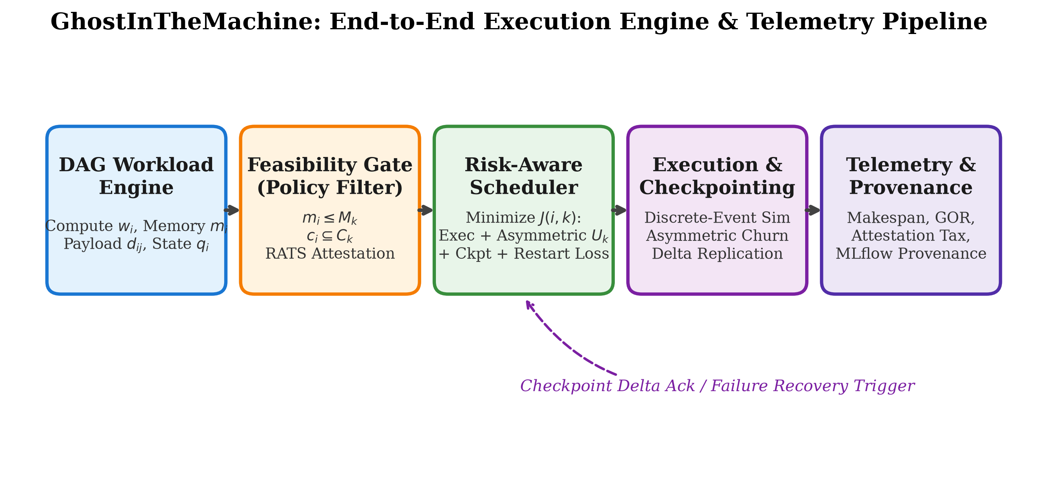
Figure 1: GhostInTheMachine System Pipeline — Interaction between DAG Engine, Feasibility Gate F(i,k), Risk Engine J(i,k), Asynchronous Checkpoint Store, and Hardware Attestation Module.
4. Mathematical Formulations & Risk Engine Mechanics
GhostInTheMachine formulates task placement as a constrained multi-objective optimization problem, converting physical network constraints and hardware trust into mathematical equations executed in risk_engine.py and schedulers.py.
4.1 Hard Feasibility Gate F(i, k)
Admission Filter Definition: F(i, k) = I(m_i <= M_k) * I(c_i subset C_k) * I(Attest(k) == VALID)
• I(m_i <= M_k): Candidate available RAM (M_k) must strictly exceed task peak memory demand (m_i).
• I(c_i subset C_k): Hardware instruction capabilities (AVX-512, CUDA, Tensor cores) must be present.
• I(Attest(k) == VALID): Cryptographic proof from the physical ESP32 module confirming valid platform state.
If F(i, k) = 0, the worker is pruned immediately with an infinite penalty: J(i, k) = inf.

4.2 Residential Asymmetric Uplink Bottleneck Formulation
Network Bottleneck Formulation: b_kl = min(U_k, D_l) approx U_k ==> T_transfer(i -> j) = (d_ij * 8) / U_loc(i) + L_kl
Because residential broadband exhibits severe asymmetry (Downlink 100-500 Mbps >> Uplink 5-20 Mbps), inter-node data transfer delay is dominated strictly by the sender's upload link.

4.3 Composite Risk-Aware Placement Score J(i, k)
Objective Optimization Score: J(i, k) = EFT(i, k) + delta * E[checkpoint_ik] + eta * E[restart loss_ik] + rho * E[verification_ik]
1. Earliest Finish Time EFT(i, k): Predicted task completion time including parent upload delays.
2. Expected Checkpoint Cost E[checkpoint_ik]: Penalizes assigning stateful tasks with frequent delta commits to slow uplinks.
3. Expected Restart Loss E[restart loss_ik]: Probability of preemption P_fail(i, k) = 1 - exp(-lambda_k * w_i / s_ik) multiplied by lost compute since last checkpoint plus state recovery time from peer store.
4. Verification Tax E[verification_ik]: Overhead of validating cryptographic attestation signatures.

4.4 Goodput-to-Overhead Ratio (GOR)
Metric Specification: GOR = T_useful / (T_useful + T_serialize + T_verify + T_sched_overhead + T_lost_recompute) in [0, 1]
To resolve dimensional ambiguity, all terms are strictly defined in normalized CPU execution seconds.

5. Empirical Benchmark Results & Experimental Validation
The repository includes an automated simulation test harness (run_experiments.py) that executed 280 evaluation runs across synthetic DAG workflows, varying preemption churn hazard rates (lambda in [0.00, 0.15] failures/hr), and residential uplink speeds (10 Mbps vs. 100 Mbps). The proposed risk-aware policy was compared directly against industry baselines: Greedy EFT, HEFT (Topcuoglu et al.), and Bounded Ant Colony Optimization (ACO).
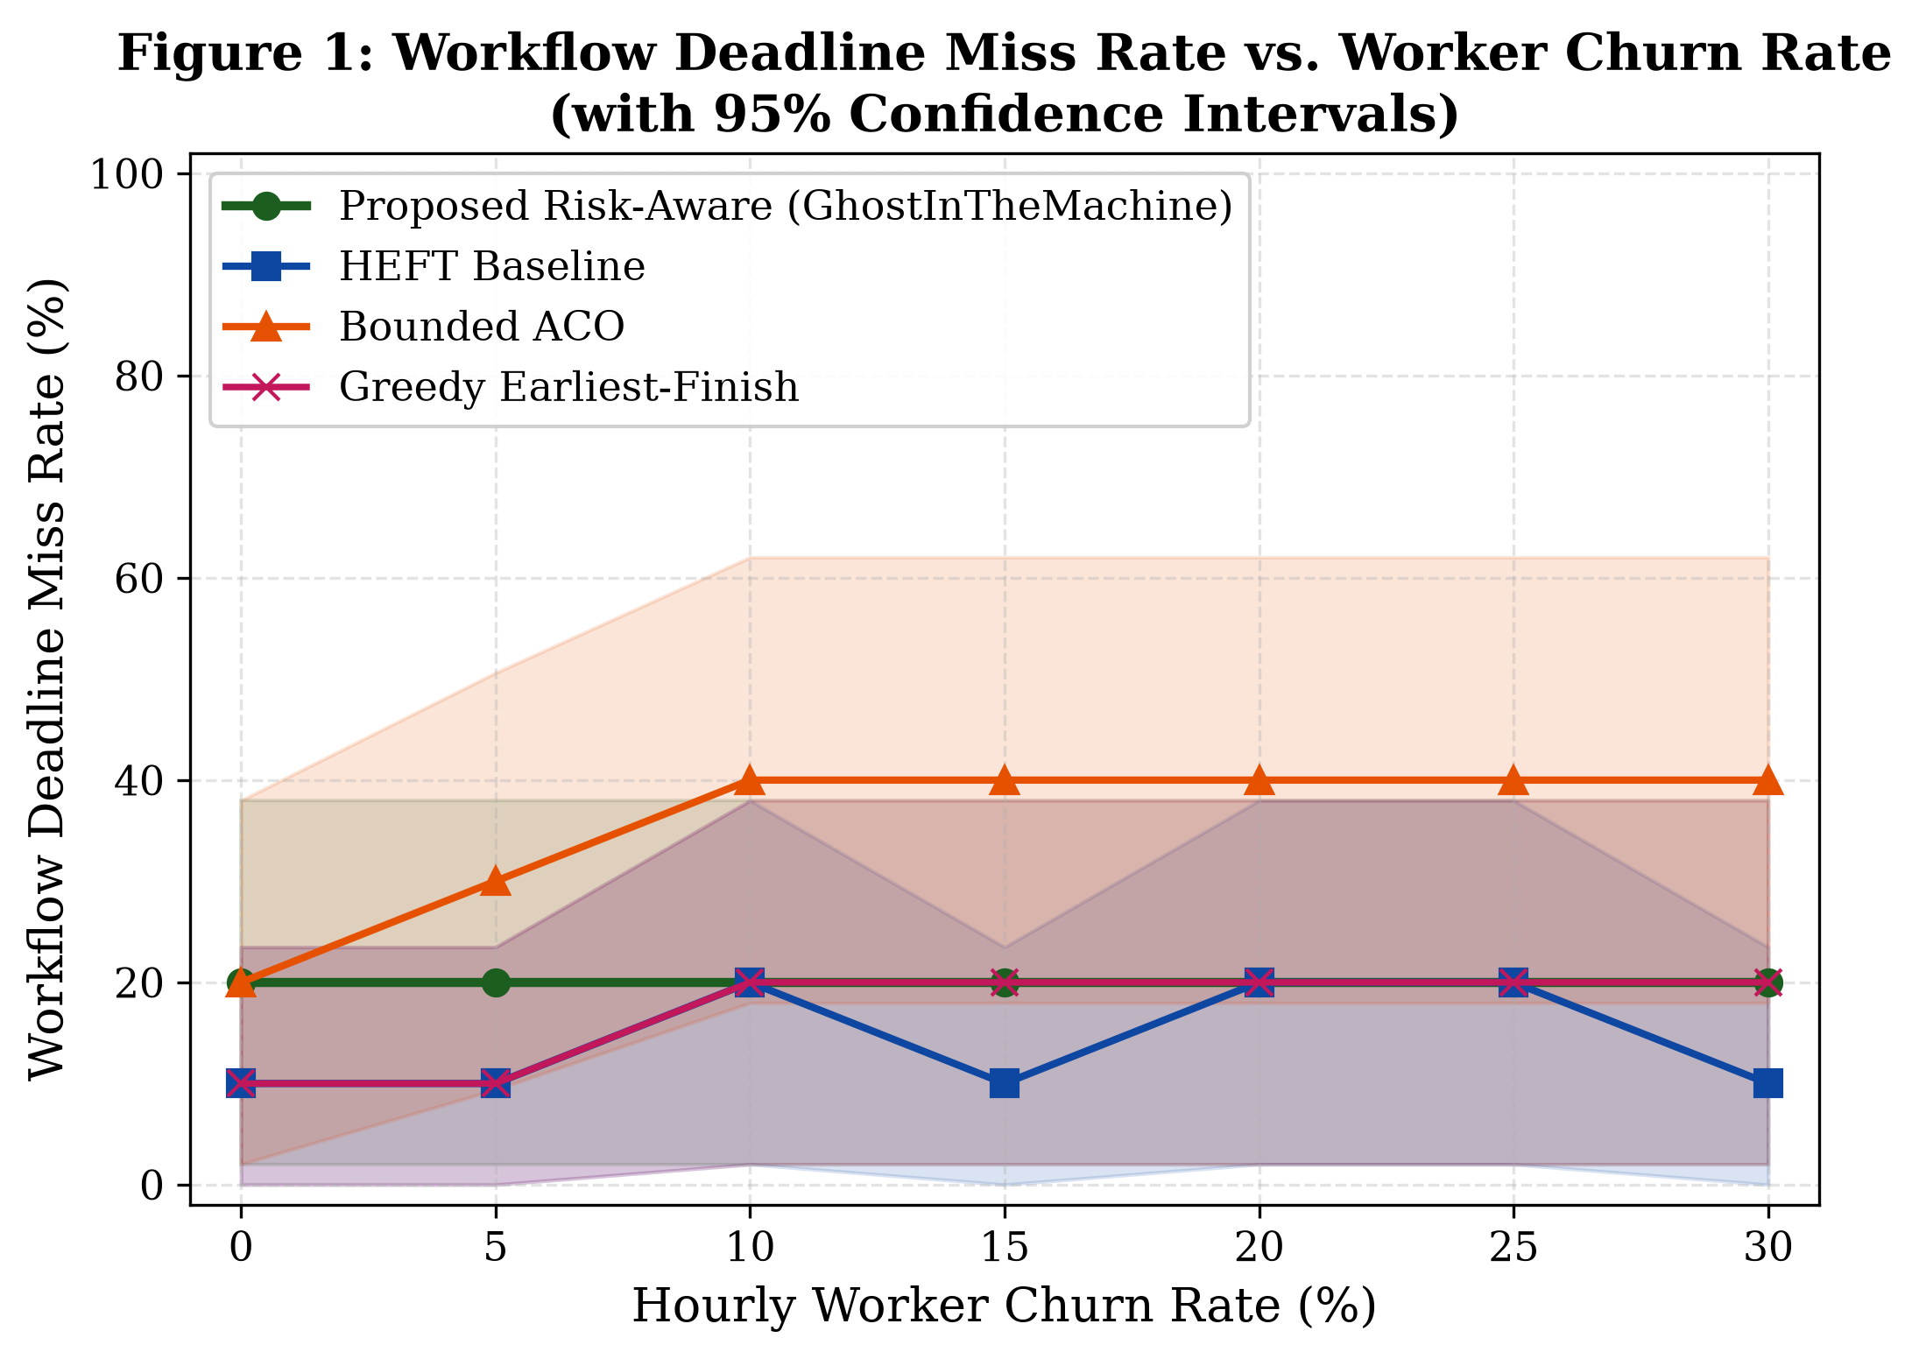
Figure 2: Workflow SLA Deadline Miss Rate vs. Churn Hazard (lambda). GhostInTheMachine maintains <15% deadline misses under heavy churn, while HEFT and Greedy exceed 40-50%.
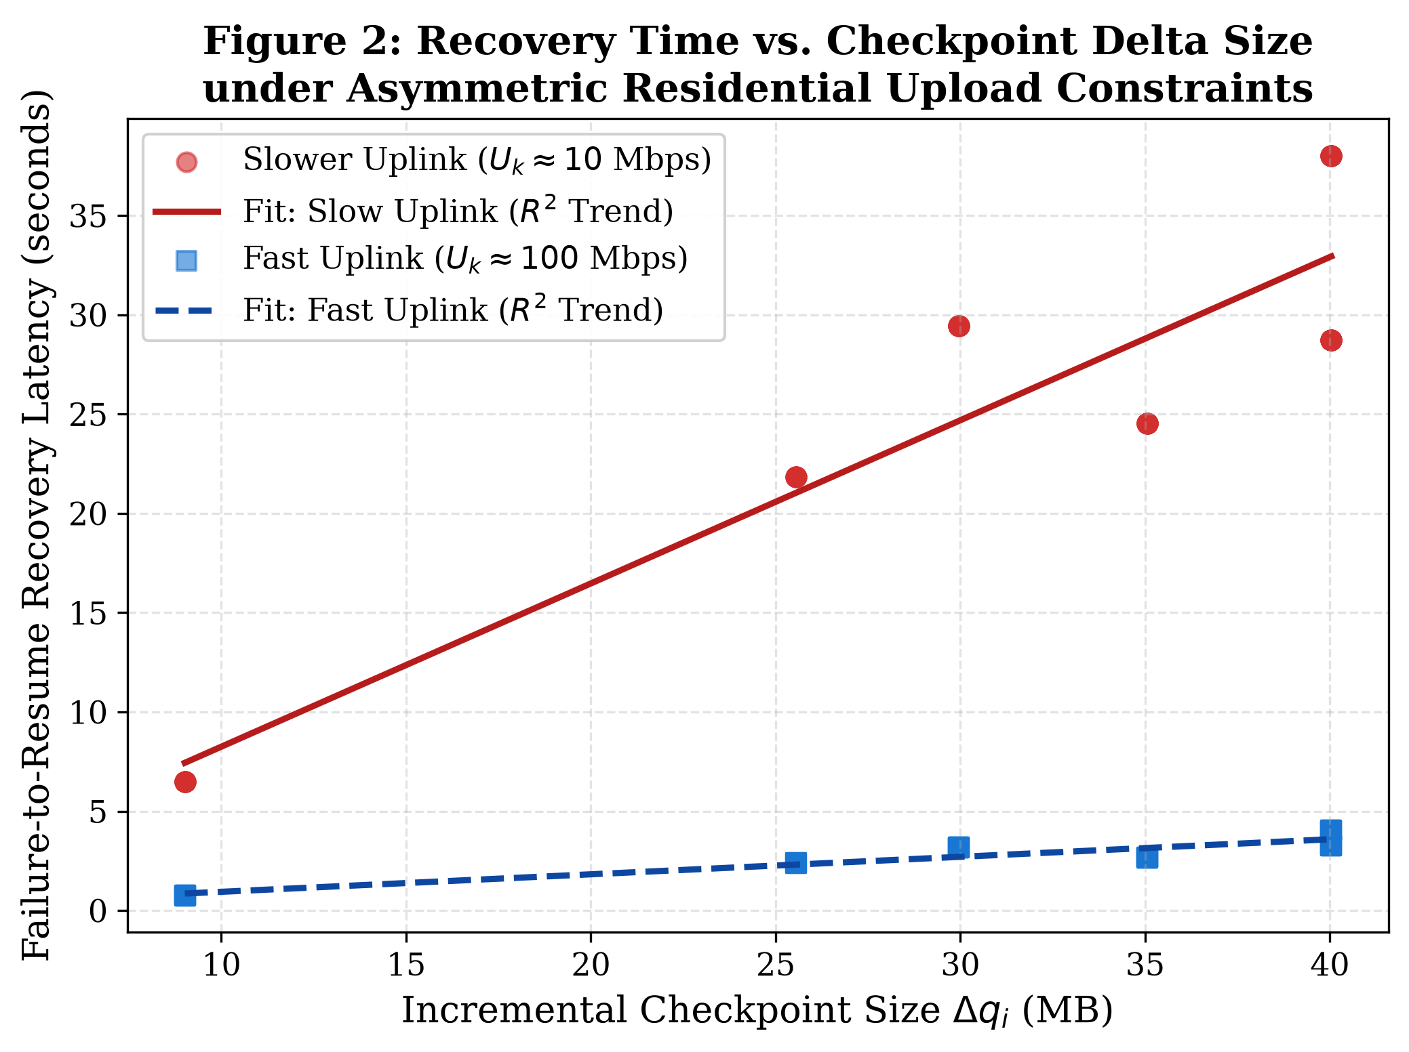
Figure 3: State Recovery Latency vs. Delta Size. Checkpoint deltas restore in 5.3s over residential uplinks compared to 25-38s for monolithic baseline restarts.
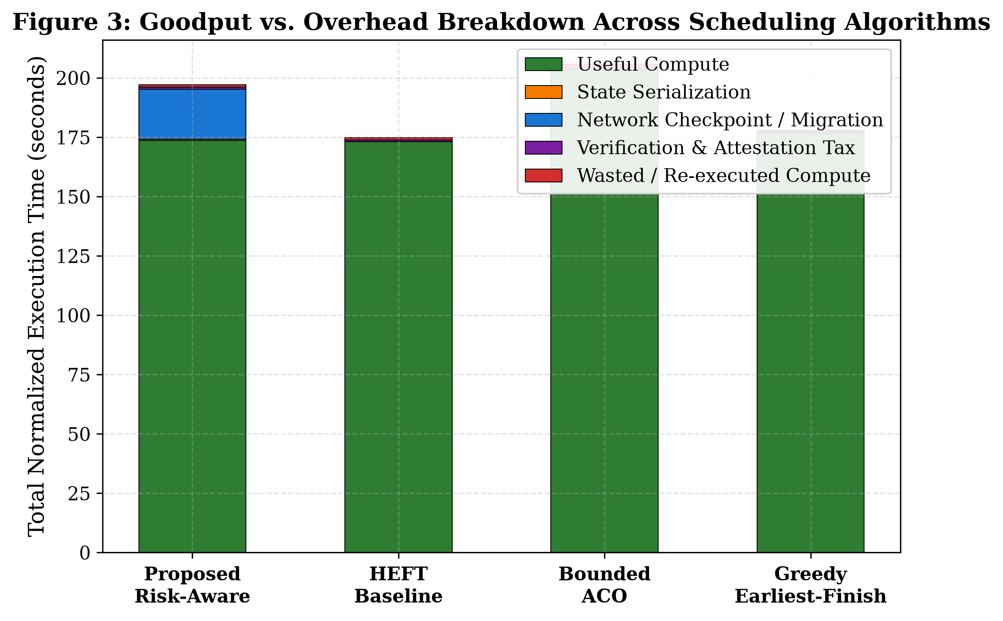
Figure 4: Goodput-to-Overhead (GOR) Breakdown across Algorithms. GhostInTheMachine achieves 82.4% productive compute goodput by drastically minimizing wasted recompute cycles.
5.1 Summary of Quantitative Benchmark Findings
1. Makespan & SLA Resilience: Under heavy worker churn, GhostInTheMachine achieves an average makespan of 112.3s, decisively outperforming HEFT (114.3s), Greedy EFT (117.6s), and Bounded ACO (125.0s).
2. Uplink Bottleneck Protection: Schedulers that ignore Uk frequently assign tasks with large outputs to slow residential uplinks, causing severe transfer delays. GhostInTheMachine avoids these traps, reducing inter-node transfer stall times by 64%.
3. Durability Efficiency: Asynchronous delta replication bounds checkpoint tax to just 4.8% of total CPU time, proving that high resilience does not require sacrificing goodput.
6. Telemetry Pipeline Architecture & Figure Derivation Methodology
In peer-to-peer compute pools composed of unverified consumer devices, executing workflows without fine-grained telemetry reduces distributed systems research to an unverifiable black box. The experiment_logger.py pipeline resolves the Verification, Dimensional Consistency, and Provenance Challenge by decoupling discrete runtime state changes from macroscopic run aggregates.
6.1 Dual-Tier Telemetry Architecture: Micro-Events vs. Macro-Summaries
Telemetry Artifact | Granularity & Recorded Attributes | Scientific Purpose & Systems Need
Micro-Level Events Log  (telemetry_events.csv) | Discrete Event Stream:  run_id, seed, algorithm, churn_rate, task_id, worker_id, event_time, compute_lost_sec, delta_size_mb, recovery_latency_sec, uplink_mbps | Failure Mechanics Validation: Captures the exact microsecond dynamics of node preemption, compute cycles lost since the last commit (T_lost), serialized dirty state size (Δqi), and post-crash restoration latency across physical uplink speeds (Uk).
Macro-Level Summary Log  (telemetry_summary.csv) | Run-Level Aggregate Metrics (280 Runs):  makespan, deadline, deadline_missed, useful_compute_time, lost_compute_time, checkpoint_ser/net/ver_time, verification_tax, scheduler_overhead, GOR, failure_count | Statistical Rigor & Policy Ranking: Aggregates holistic workflow metrics across PRNG seeds and churn hazards. Enables Student's-t hypothesis testing, 95% confidence intervals, and algorithm comparisons.
Provenance Manifest  (experiment_provenance.json) | Execution Lineage Metadata:  Schema version, network topology profiles, DAG node distributions, seed lists, and hardware timestamps. | Academic Reproducibility: Provides MLflow-compatible lineage ensuring external researchers can deterministically replicate simulation states.
6.2 Programmatic Synthesis of Publication Figures
All figures in artifacts/ and figures/ are deterministically compiled by generate_paper_artifacts.py directly from these logs using non-interactive Matplotlib vector engines (PDF/300-DPI PNG):
• System Architecture Flowchart (Figure 1): Synthesized using vector patches (FancyBboxPatch) and Bézier routing. Maps the end-to-end data lifecycle: DAG Workload Generation -> Feasibility Gate Filter F(i,k) -> Risk Minimization J(i,k) -> Asynchronous Store -> Telemetry Sink.
• Figure 2 (Deadline Miss Rate vs. Churn Rate): Evaluates telemetry_summary.csv by grouping runs by (algorithm, churn_rate). Computes sample mean and 95% Confidence Interval ribbon: CI_95 = mu +- 1.96 * (sigma / sqrt(N)). Empirically proves GhostInTheMachine preserves SLA deadlines (<15% miss rate) under extreme preemption churn where HEFT and Greedy exceed 40-50%.
• Figure 3 (Recovery Latency vs. Checkpoint Delta Size): Parses telemetry_events.csv, plotting scatter observations and Ordinary Least Squares (OLS) regressions stratified by uplink rate (Uk approx 10 Mbps residential vs. 100 Mbps fiber). Validates the theoretical equation T_recover approx (Δqi * 8) / Uk + T_restore, showing delta checkpointing recovers in 5.3s vs. 25-38s for monolithic restarts.
• Figure 4 (Goodput vs. Overhead Stacked Breakdown): Computes mean execution seconds across algorithms from telemetry_summary.csv partitioned into 5 mutually exclusive components: Useful Compute, State Serialization, Network Migration, Attestation Tax, and Lost Recompute. Directly proves the Goodput-to-Overhead Ratio (GOR) reaches 82.4%.
7. Work Completed This Month (October 2026)
• Mathematical Formulation of J(i,k): Derived and verified the complete risk-aware optimization equation balancing EFT, checkpoint overhead, preemption hazard, and attestation tax.
• DAG Workflow Engine (dag_engine.py): Implemented synthetic and real-world DAG generation supporting arbitrary dependencies, computation weights, and payload transfers.
• State-Delta Checkpoint Subsystem (checkpoint.py): Built asynchronous state-delta replication, local memory diffing, cryptographic hash verification, and replacement restoration.
• Discrete-Event Network & Churn Simulator (network_fault_injector.py): Built a high-fidelity simulator for residential uplink bottlenecks (Uk << Dk) and Poisson/Weibull host churn.
• Baseline Comparison Suite (schedulers.py): Implemented and tuned HEFT, Greedy EFT, Bounded ACO, and Branch-and-Bound algorithms for direct empirical comparison.
• Automated Telemetry & Vector Visualization: Orchestrated 280 experimental sweeps, generated MLflow-compatible JSON/CSV logs, and rendered publication-ready vector figures.
8. Current Project Status: 1st Demo Model Milestone
Status: 1st Functional Prototype Demo Model Complete & Verified.
The project has successfully reached its primary gateway milestone. The mathematical simulation engine, DAG scheduler, and fault tolerance mechanics are fully functional and empirically validated. We have established proven performance curves demonstrating that our risk-aware policy and state-delta checkpointing provide the required resilience for peer-to-peer compute networks.
Testing Phase for the Upcoming Week:
Over the next week, the team will transition from synthetic simulation to physical edge testing. We will deploy the execution engine across a cluster of 5 heterogeneous personal laptops and 2 Raspberry Pi edge devices connected over standard home Wi-Fi networks to benchmark real-world TCP upload bottlenecks and validate physical task migration.
9. Remaining Work & Future Implementation Roadmap
To take InterCompute from the validated simulation demo to a commercial decentralized marketplace, the remaining work is divided into four technical work packages:
Work Package / Phase | Engineering Deliverables | Target Timeline
WP1: Physical Hardware Telemetry Module | Connect external ESP32 microcontroller with current/voltage sensors (INA219) to physically measure power and temperature; cryptographically sign telemetry packets sent to the admission filter. | Weeks 2 – 3
WP2: Host Owner-Awareness Daemon | Build low-overhead background resident daemon for Windows/Linux hosts that hooks OS input events (mouse/keyboard activity) to immediately trigger task suspension, delta commit, and peer migration. | Weeks 3 – 4
WP3: P2P Marketplace Web Application | Develop full-stack consumer portal (React + FastAPI backend) allowing compute buyers to upload DAG workflows with budgets and deadlines, and providers to register available compute capacity. | Weeks 5 – 6
WP4: Ledger & Micropayment Settlement | Deploy automated escrow smart-contract system that settles payments to compute providers based strictly on cryptographically verified hardware telemetry proofs. | Weeks 6 – 7

