

**Industrial Internship Report on**

**Air Pollution Monitoring System**

**Prepared by**

**Pratap Reddy K**

|  |
| --- |
| *Executive Summary* |
| This report provides details of the Industrial Internship provided by up skill Campus and The IoT Academy in collaboration with Industrial Partner UniConverge Technologies Pvt Ltd (UCT).  This internship was focused on a project/problem statement provided by UCT. We had to finish the project including the report in 6 weeks’ time.  My project was ”A prototype developed to collect the real-time data of the different types of pollution gases present in the air and analyzing and visualizing them and doing forecasting tasks”  This internship gave me a very good opportunity to get exposure to Industrial problems and design/implement solution for that. It was an overall great experience to have this internship. |

**TABLE OF CONTENTS**

1 Preface 3

2 Introduction 4

2.1 About UniConverge Technologies Pvt Ltd 4

2.2 About upskill Campus 8

2.3 Objective 9

2.4 Reference 9

2.5 Glossary 10

3 Problem Statement 11

4 Existing and Proposed solution 12

5 Proposed Design/ Model 13

5.1 High Level Diagram (if applicable) 13

5.2 Low Level Diagram (if applicable) 13

5.3 Interfaces (if applicable) 13

6 Performance Test 14

6.1 Test Plan/ Test Cases 14

6.2 Test Procedure 14

6.3 Performance Outcome 14

7 My learnings 15

8 Future work scope 16

**1. Preface**

The whole 6 weeks internship was helped me lot to explore the real world problems in the domain of IOT and Embedded Systems I has been explored the new things and done one real time project based on IOT.

Internships are very much essential part of student life who needs to explore the real world problems and IOT academy with partnership of UCT is good choice if you’re a fresher to the corporate world.

To build a system which monitors the air pollution in real time.

In the beginning I have explored the problem statement and the about UCT and what the company is actually doing on what are the technologies they are working right now, in the 2nd week of internship period followed the instructions to build a project which are given by them and planned a solution. Middle of the 3rd and 4th week of the period worked on project a improved the results and by the end of 5th week I have concluded the implantation and performance. By the 6th week given a test submitting the report to the UCT.

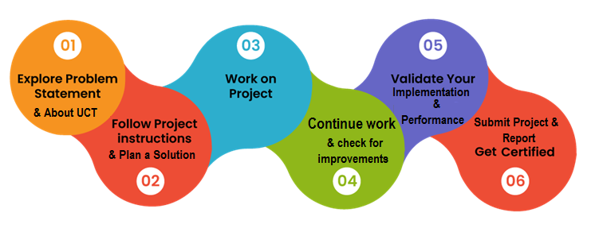

Learnt about the insights of IOT and found an solution to the real world problem. Thank to the IOT academy team for the continuous help throughout the period of internship .

My suggestion to juniors is join the IOT Academy for better learning and explore real world problems and explore new things be self motivated.

# 2 Introduction

## 2.1 About UniConverge Technologies Pvt Ltd

A company established in 2013 and working in Digital Transformation domain and providing Industrial solutions with prime focus on sustainability and RoI. For developing its products and solutions it is leveraging various**Cutting Edge Technologies e.g. Internet of Things (IoT), Cyber Security, Cloud computing (AWS, Azure), Machine Learning, Communication Technologies (4G/5G/LoRaWAN), Java Full Stack, Python, Front end**etc.

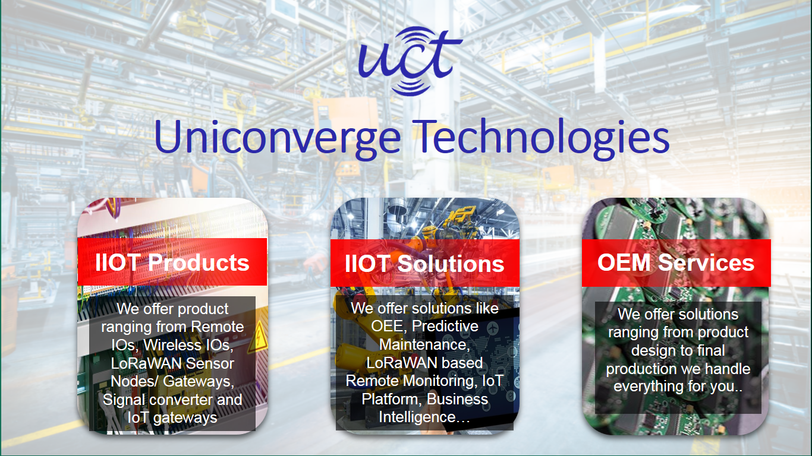

1. UCT IoT Platform**(****)**

**UCT Insight** is an IOT platform designed for quick deployment of IOT applications on the same time providing valuable “insight” for your process/business. It has been built in Java for backend and ReactJS for Front end. It has support for MySQL and various NoSql Databases.

* It enables device connectivity via industry standard IoT protocols - MQTT, CoAP, HTTP, Modbus TCP, OPC UA
* It supports both cloud and on-premises deployments.
* It has features to  
  • Build Your own dashboard  
  • Analytics and Reporting  
  • Alert and Notification  
  • Integration with third party application(Power BI, SAP, ERP)  
  • Rule Engine



ii. **Smart Factory Platform (****)**

Factory watch is a platform for smart factory needs.

It provides Users/ Factory

* with a scalable solution for their Production and asset monitoring
* OEE and predictive maintenance solution scaling up to digital twin for your assets.
* to unleased the true potential of the data that their machines are generating and helps to identify the KPIs and also improve them.
* A modular architecture that allows users to choose the service that they what to start and then can scale to more complex solutions as per their demands.
* Its unique SaaS model helps users to save time, cost and money.



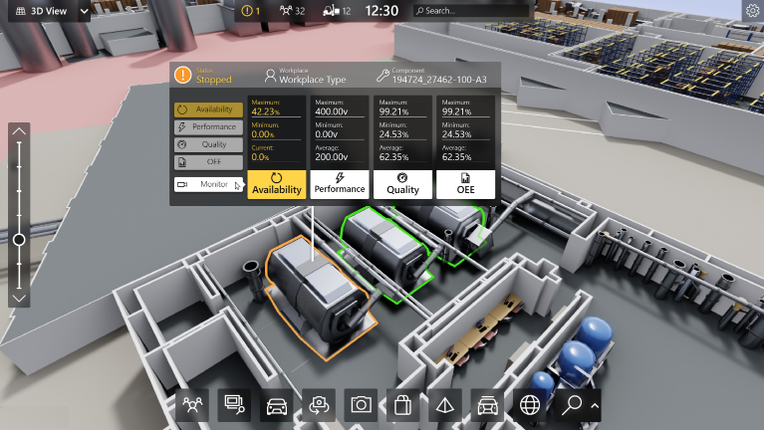

1. 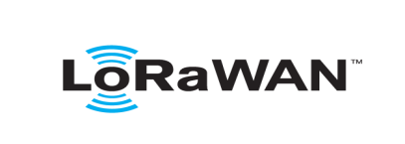based Solution

UCT is one of the early adopters of LoRAWAN teschnology and providing solution in Agritech, Smart cities, Industrial Monitoring, Smart Street Light, Smart Water/ Gas/ Electricity metering solutions etc.

1. Predictive Maintenance

UCT isproviding Industrial Machine health monitoring and Predictive maintenance solution leveraging Embedded system, Industrial IoT and Machine Learning Technologies by finding Remaining useful life time of various Machines used in production process.



## 2.2 About upskill Campus (USC)

upskill Campus along with The IoT Academy and in association with Uniconverge technologies has facilitated the smooth execution of the complete internship process.

USC is a career development platform that delivers **personalized executive coaching** in a more affordable, scalable and measurable way.



Seeing need of upskilling in self paced manner along-with additional support services e.g. Internship, projects, interaction with Industry experts, Career growth Services

upSkill Campus aiming to upskill 1 million learners in next 5 year

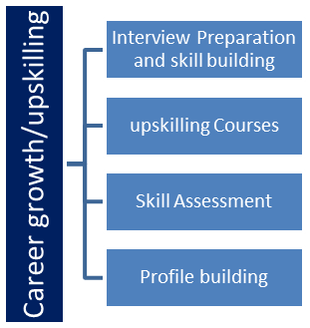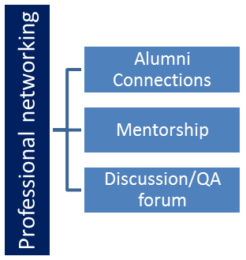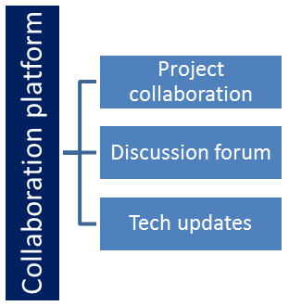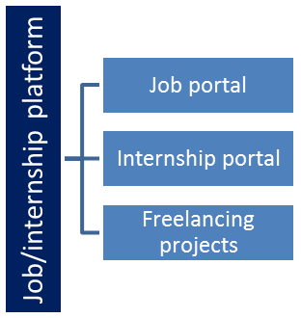

## 2.2 The IoT Academy

The IoT academy is EdTech Division of UCT that is running long executive certification programs in collaboration with EICT Academy, IITK, IITR and IITG in multiple domains.

## Objectives of this Internship program

The objective for this internship program was to

 ☛ get practical experience of working in the industry.

 ☛ to solve real world problems.

 ☛ to have improved job prospects.

 ☛to have Improved understanding of our field and its applications.

 ☛to have Personal growth like better communication and problem solving.

# 3 Problem Statement

# 

# So this is basically a complete IoT Application which includes hardware part as well as software part. In this tutorial you will see how to set up the IoT device and how to us it to monitor the different types of pollution gases present in the air. So this tutorial includes IoT and Data Science. Programming Languages involved are C Programming and Python.

## 3.1 Step 1: Components Required

**Hardware**

1) NodeMCU - An ESP8266 powered microcontroller, perfect for building IoT applications.

2) MQ2 Gas Sensor - A simple gas sensor to detect the different types of gases present in the air.

**Software:**

3) Arduino IDE installed in you PC / Laptop

4) Jupyter Notebook, Python & different libraries

## 3.2 Step 2: Setting Up Device (Hardware Setup)

1) The NodeMCU is set inside the breadboard.

2) Gas Sensor Connection:

a) Vcc is connected to Vin port of the NodeMCU.

b) GND is connected to the GND pin of NodeMCU

c) A0 pin is connected to the A0 pin of the NodeMCU

3) Servo Motor Connection

a) +ve pin of Servo Motor is connected to Vin of NodeMCU

b) -ve pin is connected to the GND of NodeMCU

c) The actuator pin or the output pin is connected to the D0 pin of NodeMCU.

4) LEDs Connection

a) The +ve pins of the LEDs are connected to the Vin port of the NodeMCU and the -ve pins to the GND of the NodeMCU

## 3.3 Step 3: Software ( Coding & Visualization)

# 4 Existing and Proposed solution

# 4.1 . INTRODUCTION

Air is one of the essential elements of man’s surroundings. The earth’s atmosphere is full of air which contains gases such as Nitrogen, Oxygen, Carbon Monoxide and traces of some rare elements. Humans need an atmosphere of air that is free from contaminants. This is very crucial for human life and health. Any change in the natural composition of air may cause grave harm to life forms on earth. Air pollution is the presence of one or more contaminants in the atmosphere such as gases in a quantity that can harm humans, animals and plant [1]. Air pollutants are measured in Parts per Million (ppm) or ug/m3 [2]. Primary pollutants are released directly into the atmosphere. Secondary pollutants are produced when the primary pollutant reacts with other atmospheric chemicals [3]. Air quality affects public health. The effect of air pollution ranges from difficulty in breathing, coughing, aggravation of asthma and emphysema [4]. Polluted air can also impair visibility. Air pollution is accountable for the death of 7 million persons worldwide each year or one in eight premature deaths yearly [5]. Almost 570,000 children under the age of five die every year from respiratory infection linked to indoor/outdoor pollution and second-hand smoke [6]. Children exposed to air pollution have an elevated risk of developing chronic respiratory problems such as asthma. In the monitoring of air pollution, several researchers worldwide have developed models to monitor many of the pollution gases such as Sulphur Dioxide (SO2), Carbon Monoxide (CO), Carbon Dioxide (CO2), Nitrogen Oxides (NO) etc. This paper focuses on the design and implementation of a smart air pollutant monitoring system. It discusses how the level of pollutants in the air can be monitored using a gas sensor, Arduino microcontroller and a WiFi module. The main objective of this paper is to design a smart air pollution monitoring system that can monitor, analyse and log data about air quality to a remote server and keep the data up to date over the internet.

**4.2. METHODOLOGY**

The model was designed using an Arduino Uno microcontroller, Wi-Fi module 8266, MQ135 Gas Sensor and a 16 by 2 liquid crystal display (LCD) Screen. Figure 1 shows the proposed system overview and the functional block diagram is depicted in figure 2. The proposed flow chart is presented in figure 3. The system overview procedure was classified into Five (5) layers as shown in figure 1. The first layer was the environmental parameters which are obtained by measurement. The second layer was the study of the characteristics and features of the sensors. The third layer was the decision making, sensing, measuring, fixing of the threshold valve, periodicity of sensitivity, timing and space. The fourth layer was the sensor data acquisition. The fifth layer was the ambient intelligence environment. The sensor collected data when operated by the microcontroller and forwarded it over the internet for analysis via the Wi-Fi module. Users were able to monitor measured parameters on their smartphones.

## 4.3 Code submission : (<https://github.com/Pratap-Reddy-K/Air-pollution-IoT>)

## 4.4 Report submission: (<https://github.com/Pratap-Reddy-K/Air-pollution-IoT>)

# 4.5 Proposed Design/ Model

## High Level Diagram

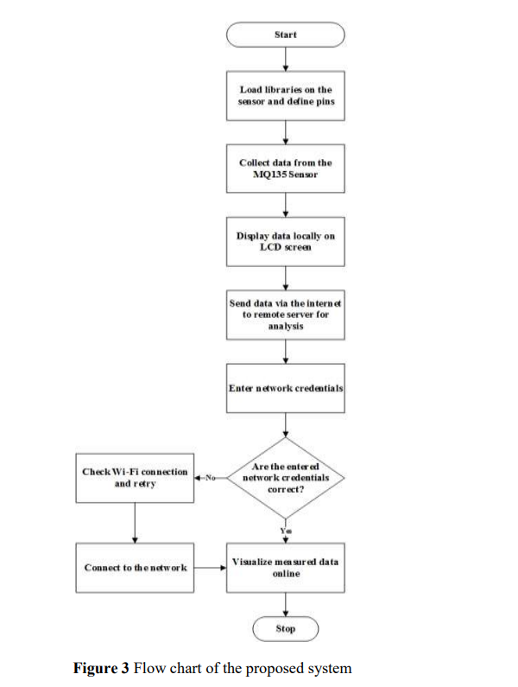

# Performance Test

# Mathematical Analysis of Proposed Model

The level concentration of pollutants in the air is measured in parts per million (ppm) or percentage.

Conversion factors include the following:

1 ppm = 1.145 mg/m3

1 mg/m3 = 0.873 ppm

1% = 1/100

1 ppm = 1/1000000

1 ppm = 0.0001%\

**6.1 Performance Outcome**

The online application used to analyze air quality data got from sensors in this proposed system was “Thing-speak”. Thing-speak is an open source internet of things application programming interface used to store and retrieve data from interconnected things using the hypertext protocol over the internet or via a local area network. It also provides access to a broad range of embedded devices and web services. This enables the creation of sensor logging applications that can be updated regularly.

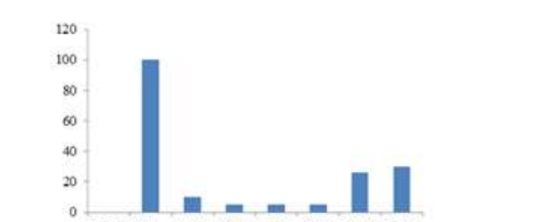Figure shows that there was a minimal level of pollutant before the sensor started reading the sample aerosol. However, when the sensor detected the aerosol, the air quality dropped rapidly from 0 to 100 ppm.

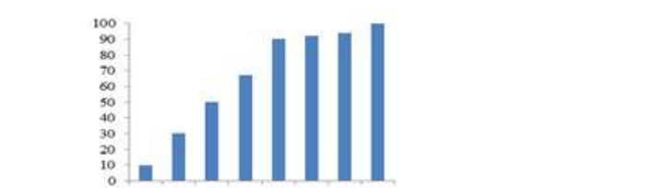

Figure above shows that the dust level in the environment was at the minimum on the 28th of june but increased gradually with each passing day. On some particular days, there was a gradual and on other days there were no changes in the quality of the air. The level of the dust measured in the air is dependent on a lot of factors that are beyond the scope of this work.

The results from Figure below show the air quality level was significantly low in comparison to the previous pollutants mused. It can be seen the air quality level dropped rapidly after only a few days of taking measurements. This is so because gases are high level air pollutants.

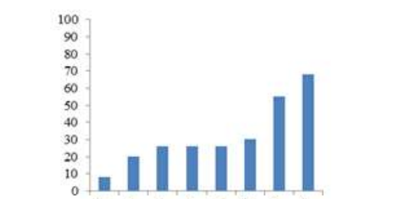

Figure above shows that the air quality decreased gradually from 8 ppm to about 70 ppm depending on the level of concentration smoke in the air.

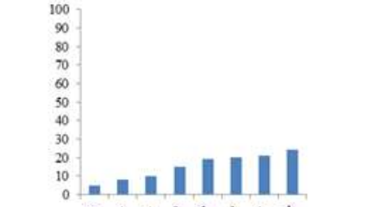

“Thing-speak” was configured to receive data from a remote system. The data was analyzed and published in the form of a scatter line graphs or bar charts on a channel. The channel corresponds to the air quality level as shown in Figure below. The channel receives update every time from the remote sensor via the internet and represents the data received as a scatter line graph online.

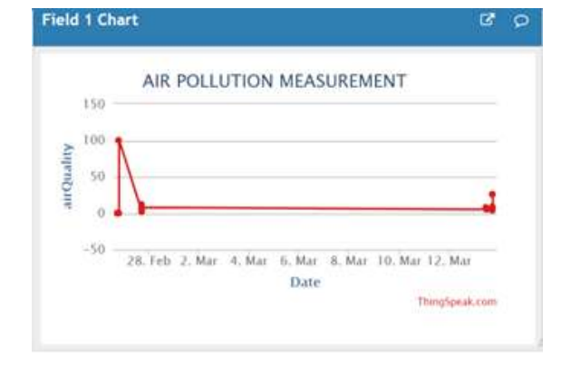

The visual representation of data on “thing-speak” corresponded with the measured air quality. The rate at which data displayed on “Thing-speak” changes was dependent on the network traffic and speed of internet connection. The status of the air quality can be accessed at any time, with automatic updates occurring at defined time intervals.

# 7 My learning’s

In the throughout journey of this internship I have learnt that how a smart air pollution monitoring system constantly keeps track of air quality in an area and displays the air quality measured on an LCD screen. It also sends data measured to the “Thing speak” platform. The system helps to create awareness of the quality of air that one breathes daily. This monitoring device can deliver real-time measurements of air quality