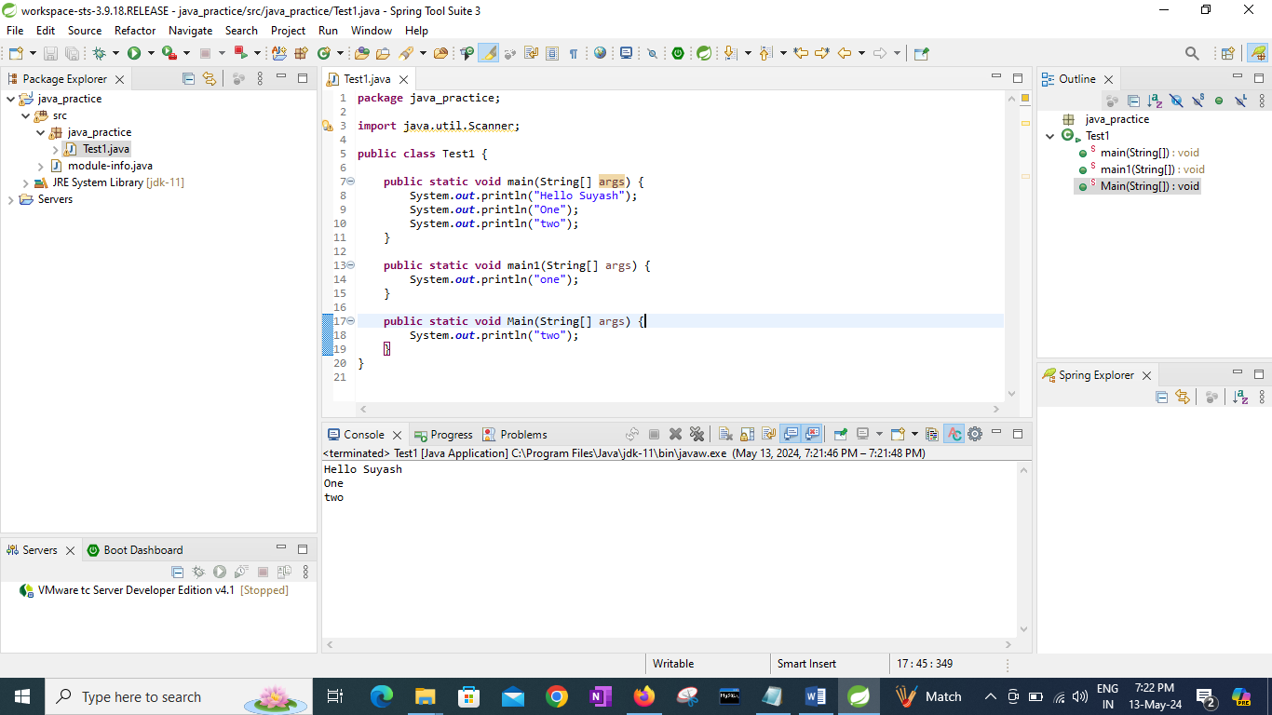

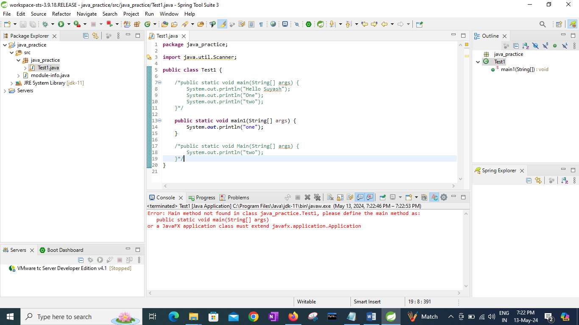

If I don write “main” method inside a class then compiler will give error ------🡪

Error: Main method not found in class java_practice.Test1, please define the main method as:

public static void main(String[] args)

or a JavaFX application class must extend javafx.application.Application

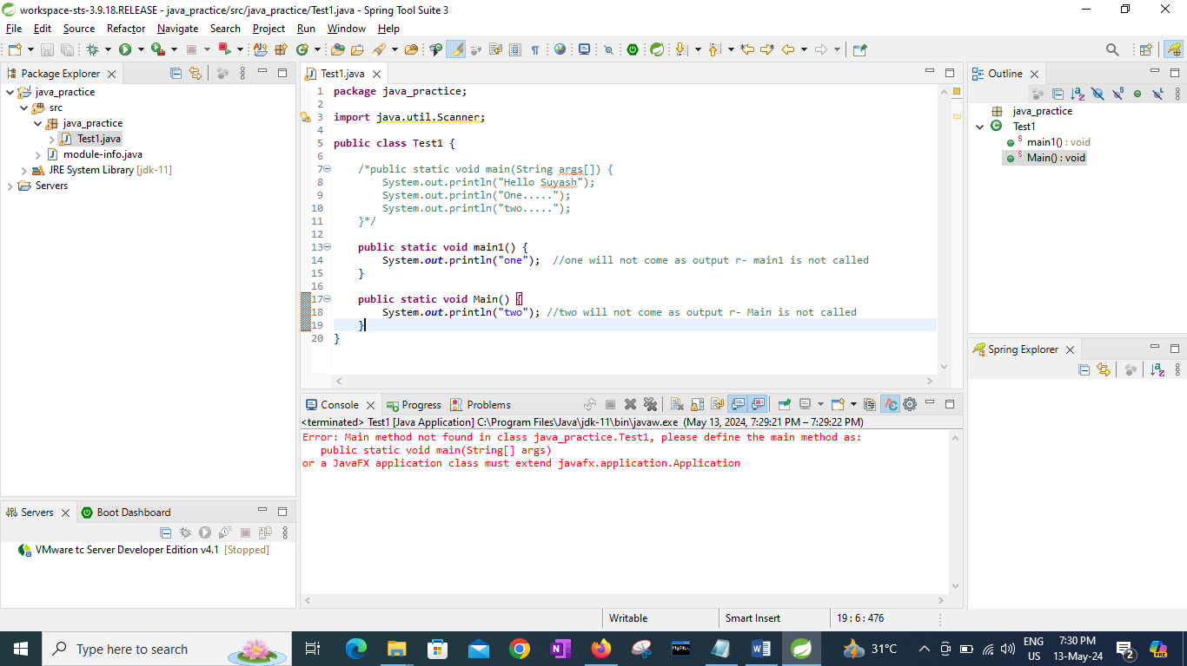

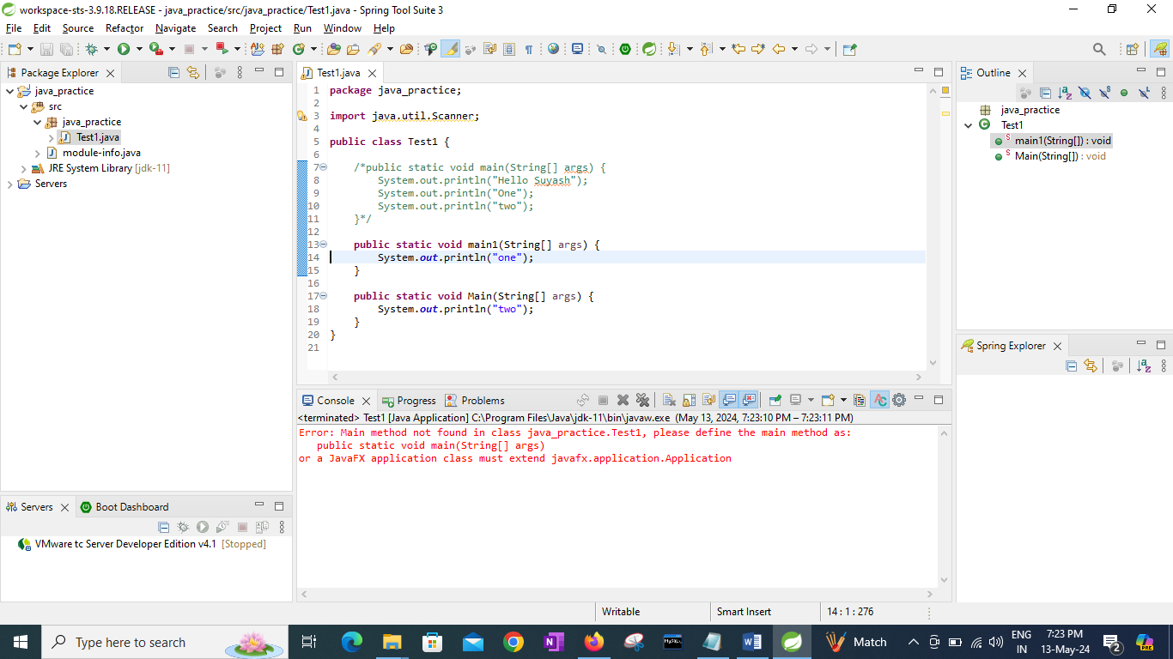

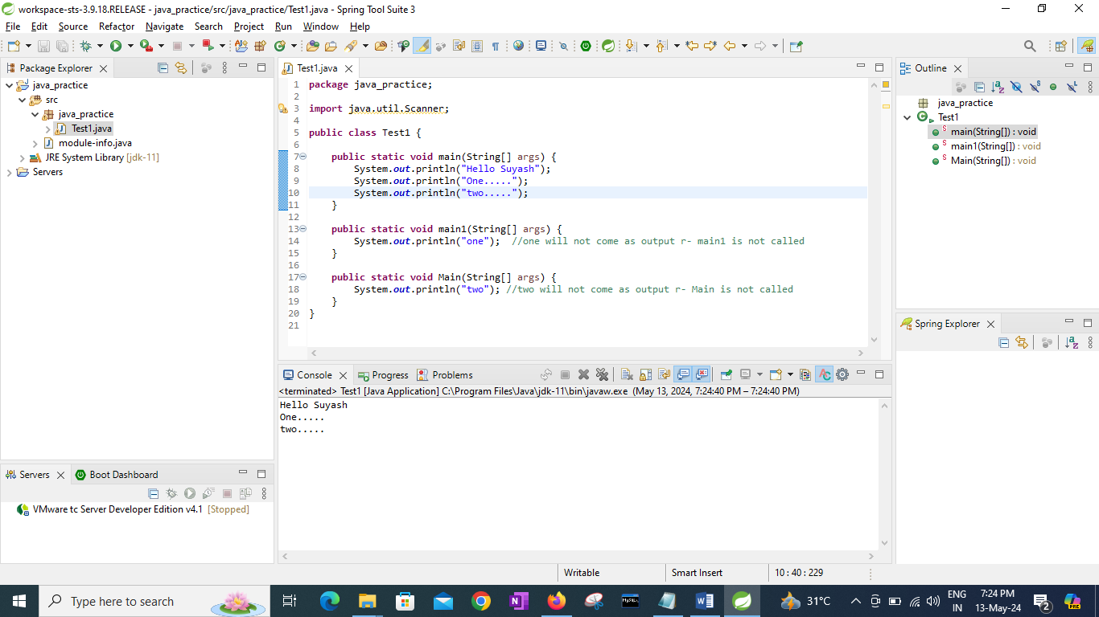

If I remove String[] args **from “main” method:--public** **static** **void** main(String[] args) -🡪 **public** **static** **void** main() --🡪 Error aye gi.

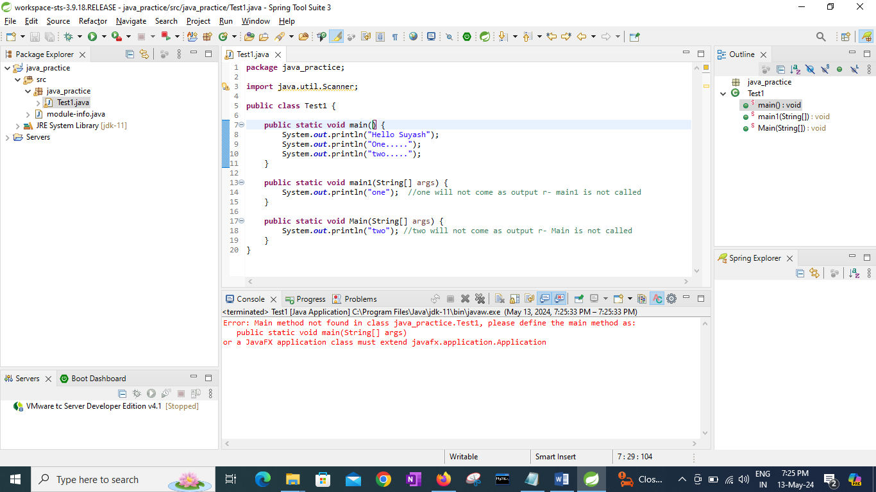

If I remove String[] args **from methods other than “main” method:--public** **static** **void** main1(String[] args) -🡪 **public** **static** **void** main1() --🡪 no error will come.

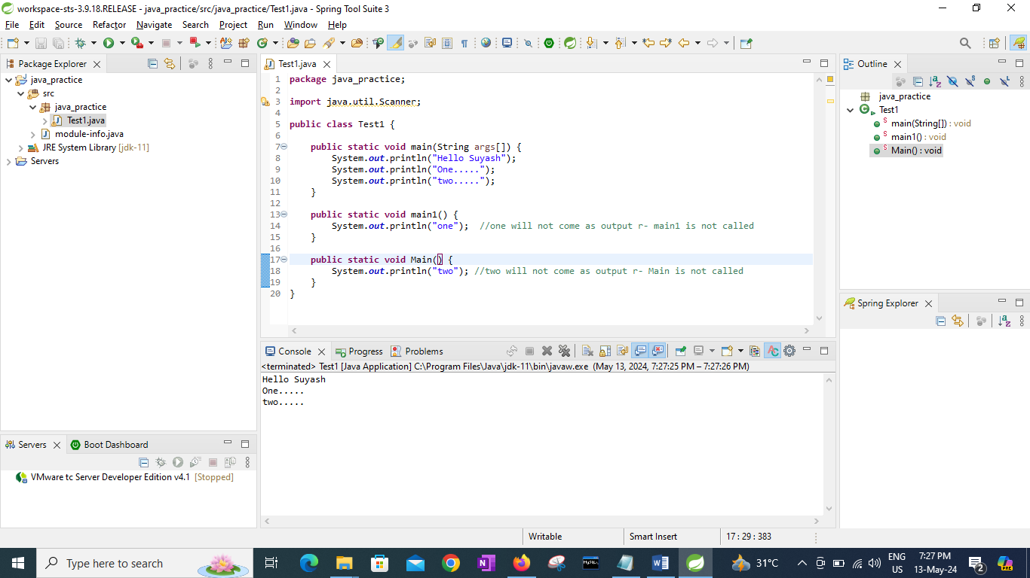

If I write two or “main” method inside a class then

* In sts/IDE error will be highlighted ---🡪Duplicate method main(String args[])

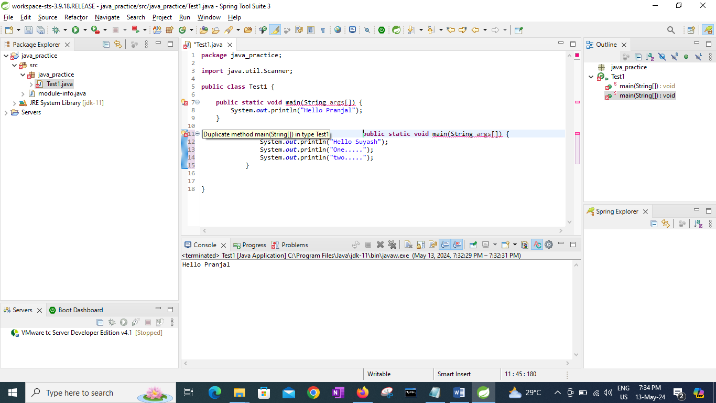

* But when run this then the main method which is written first will get executed

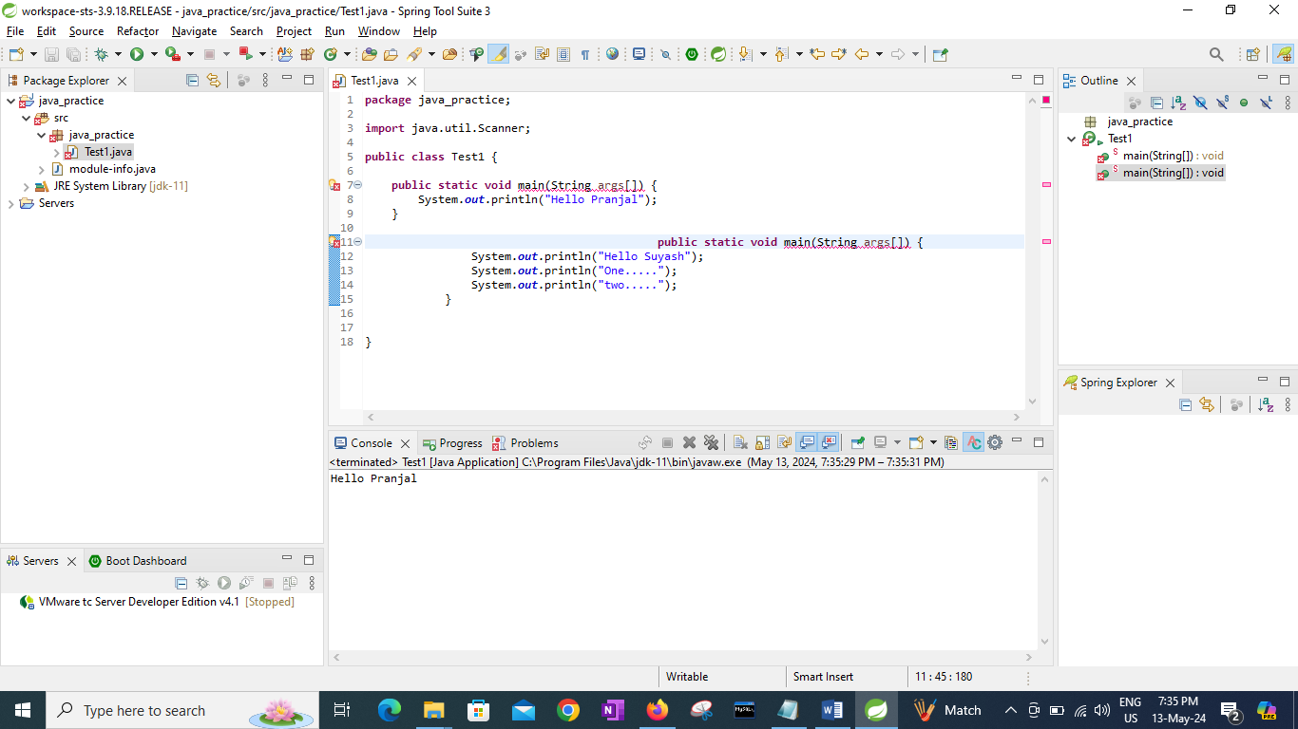

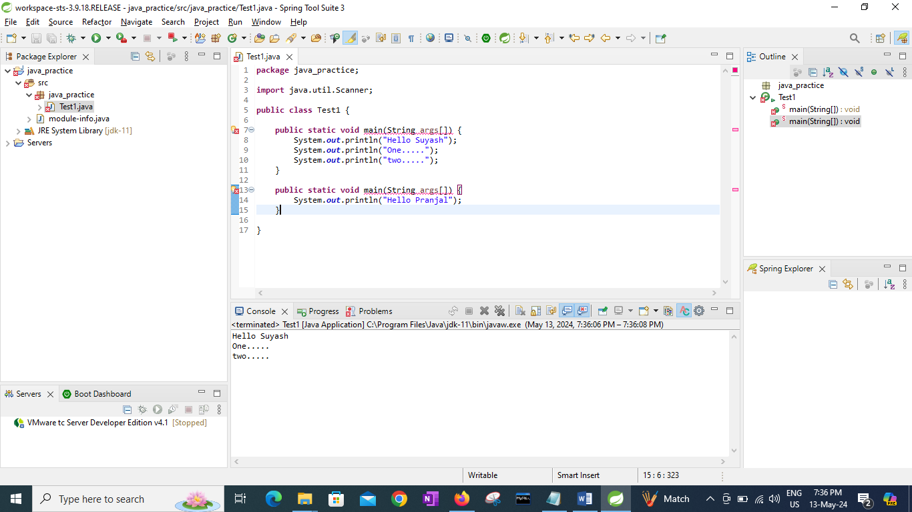

#

**public** **class** Test {

**public** **static** **void** main(String args[]) {

**int** a = 10;

**int** b = 20;

System.***out***.println("a"); //output ----> a

System.***out***.println("b"); //output ----> b

System.***out***.println(a); //output ----> 10

System.***out***.println(b); //output ----> 20

System.***out***.println("A=a"); //output ----> A=a

System.***out***.println("B=b"); //output ----> B=b

}

}

#

**public** **class** Test {

**public** **static** **void** main(String args[]) {

**int** a = 10;

**int** b = 20;

**int** add = a + b;

System.***out***.println("Add = " + add); //output----> Add = 30

System.***out***.println(a+b); //output----> 30

System.***out***.println("Add = " + a + b); //output----> Add = 1020

System.***out***.println("Add = " + ( a + b )); //output----> Add = 30

}

}

//System.out.println("Add = " + a + b); //output----> Add = 1020

//Why Add = 1020

string + **int** --------> concatenation hoga string + **int** hai, here a or 10 act like a string ---> s1

s1 + **int** ------------> concatenation hoga string + **int** hai, here b or 20 act like a string, therefore string + string ----> string

( a + b ) ----> + ke left or right me "no string" dono **int** hai therfore + will act like arithmetic operator ----🡪 30

“Add =” + 30 ------------🡪 string + int --------🡪 do concatenation // output Add = 30

# **ALL LOCAL VARIABLES MUST BE INITIALIZED inside main method**

**public** **class** Test3 {

**public** **static** **void** main(String args[]) {

**int** a; not valid int a = 10; valid

System.***out***.println(a); error: The local variable a may not have been initialized

}

}

Exception in thread "main" java.lang.Error: Unresolved compilation problem:

The local variable a may not have been initialized

at java_practice/java_practice.Test3.main(Test3.java:7)

# Taking user input

**import java.util.Scanner;**

**public** **class** Test4 {

**public** **static** **void** main(String args[]) {

**Scanner sc = new Scanner(System.*in*);**

System.***out***.print("Enter num1: ");

**int num1 = sc.nextInt(); //taking i/p from user**

System.***out***.print("Enter num2: ");

**int num2 = sc.nextInt(); //taking i/p from user**

System.***out***.println("num1 = " + num1);

System.***out***.println("num2 = " + num2);

System.***out***.println("Summation = " + (num1 + num2)); //Summation = 30

}

}

Enter num1: 25

Enter num2: 52

num1 = 25

num2 = 52

#

**import** java.util.Scanner;

**public** **class** Test4 {

**public** **static** **void** main(String args[]) {

Scanner sc = **new** Scanner(System.***in***);

System.***out***.print("Enter num1: ");

**int** num1 = sc.nextInt();

System.***out***.println("num1 = " + num1);

}

}

* If we enter 10

Enter num1: 10

num1 = 10

* If we enter 10.2
* Enter num1: 10.2 r-🡪nextInt() takes only int value

Scans the next token of the input as an **int**.

Exception in thread "main" java.util.InputMismatchException

reason we use nextInt() not nextFloat() therefore InputMismatch happens

* If we enter ten ---🡪 error
* Enter num1: ten

Exception in thread "main" java.util.InputMismatchException

reason we use nextInt() not next() therefore InputMismatch happens

# To take character or string as input

String num1 = sc.next(); // String is a class given by java, which we are using as primitive datatype

#nextBoolean()

**public** **class** Test4 {

**public** **static** **void** main(String args[]) {

Scanner sc = **new** Scanner(System.***in***);

System.***out***.print("enter true/false: ");

**boolean** status = sc.nextBoolean();

System.***out***.println("status: " + status);

}

}

enter true/false: true

status: true

enter true/false: false

status: false

enter true/false: ascd 🡪 anything other than true or false give inputmismatch error

Exception in thread "main" java.util.InputMismatchException

#