9. Shell Script to display a pattern like a right angle triangle using an asterisk.

The pattern like :

\*

\*\*

\*\*\*

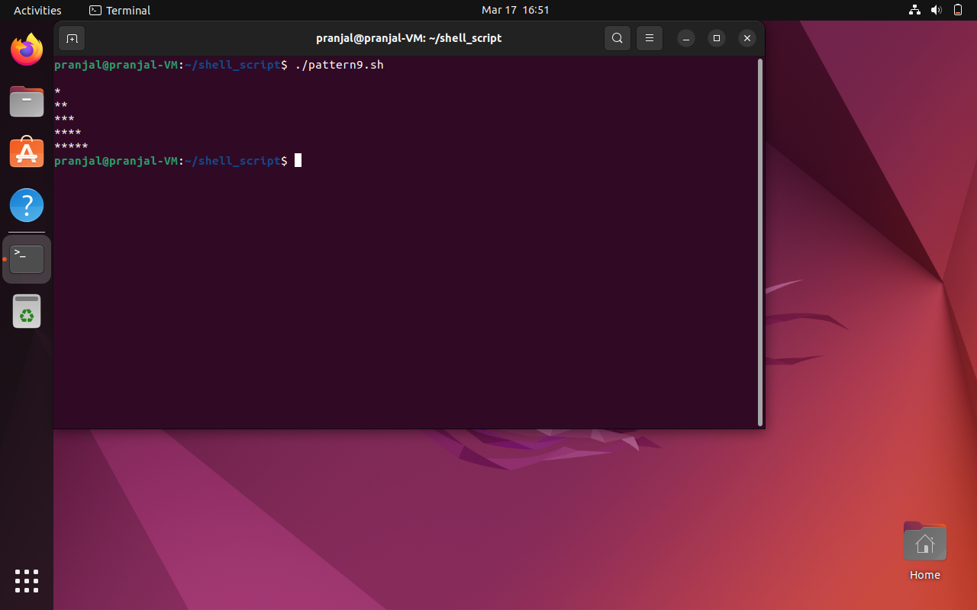

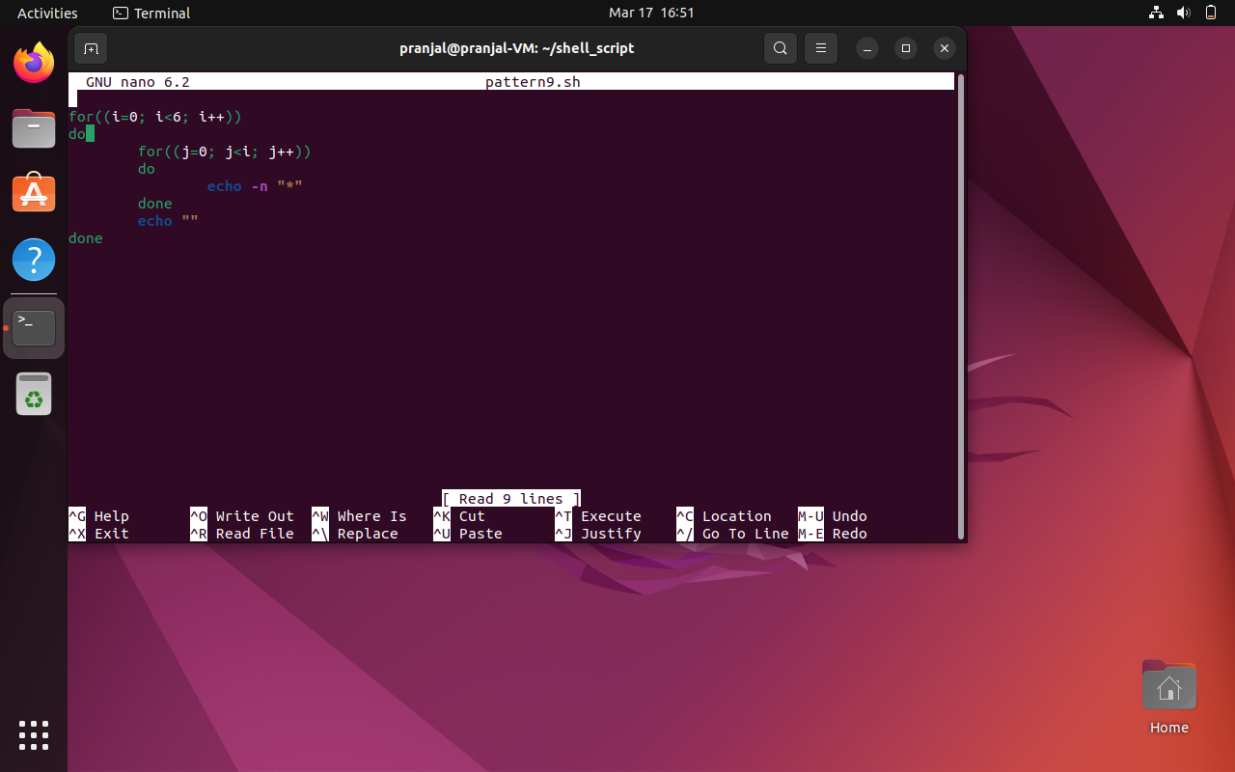

10. Shell Script to display a pattern like a right angle triangle with a number.

The pattern like :

1

12

123

1234

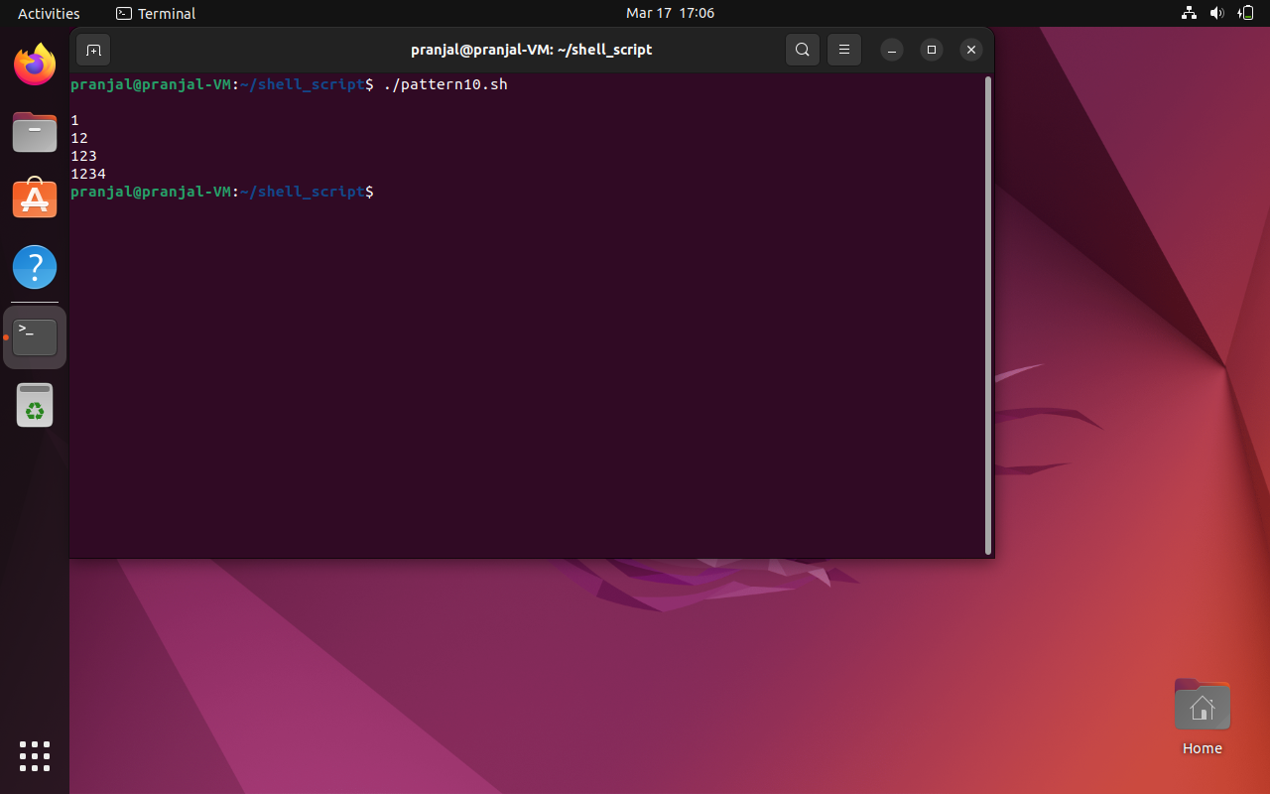

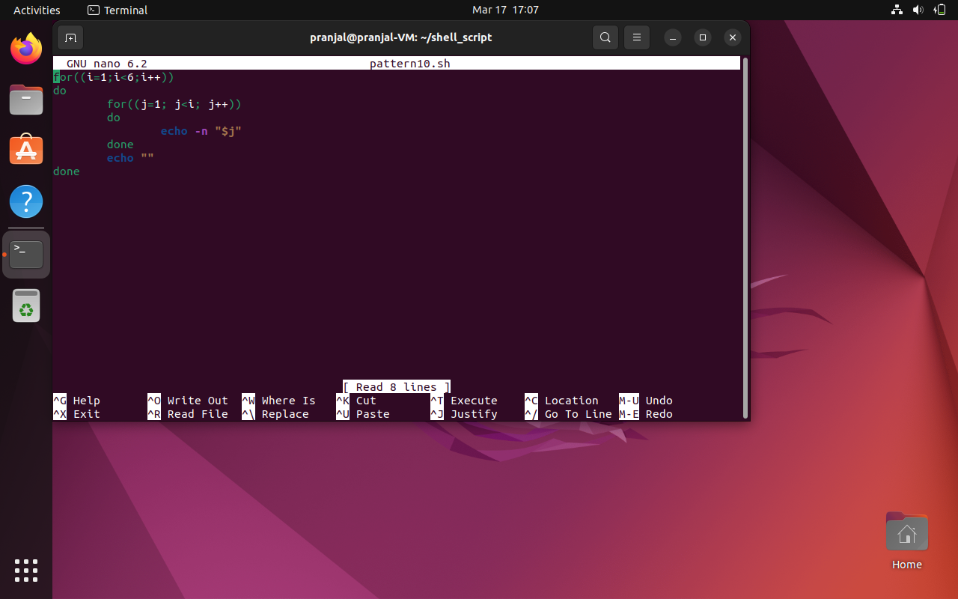

11. Shell Script to make such a pattern like a right angle triangle with a number which will repeat a number in a row.

The pattern like :

1

22

333

4444

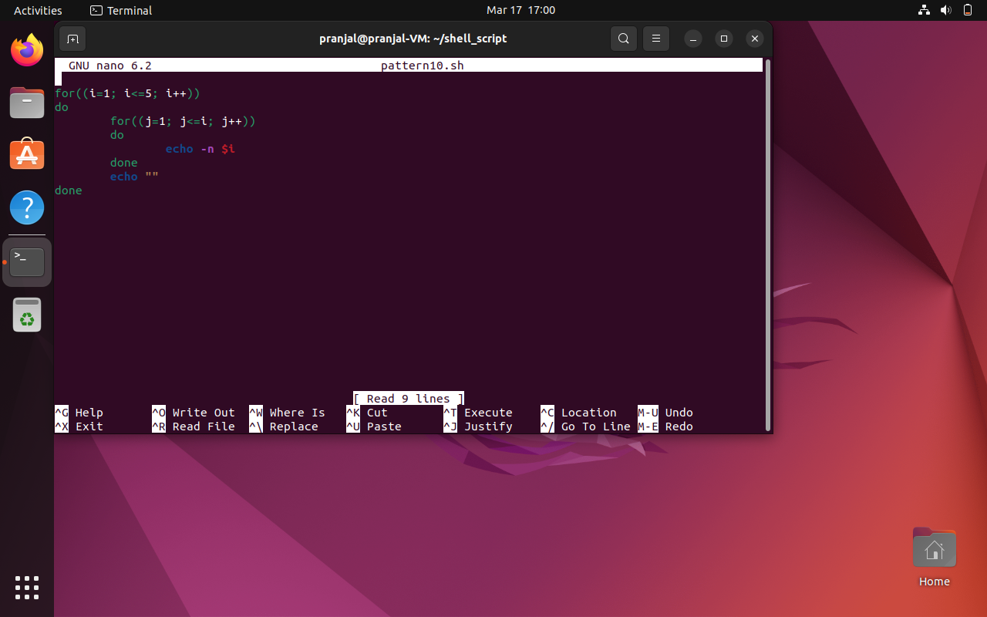

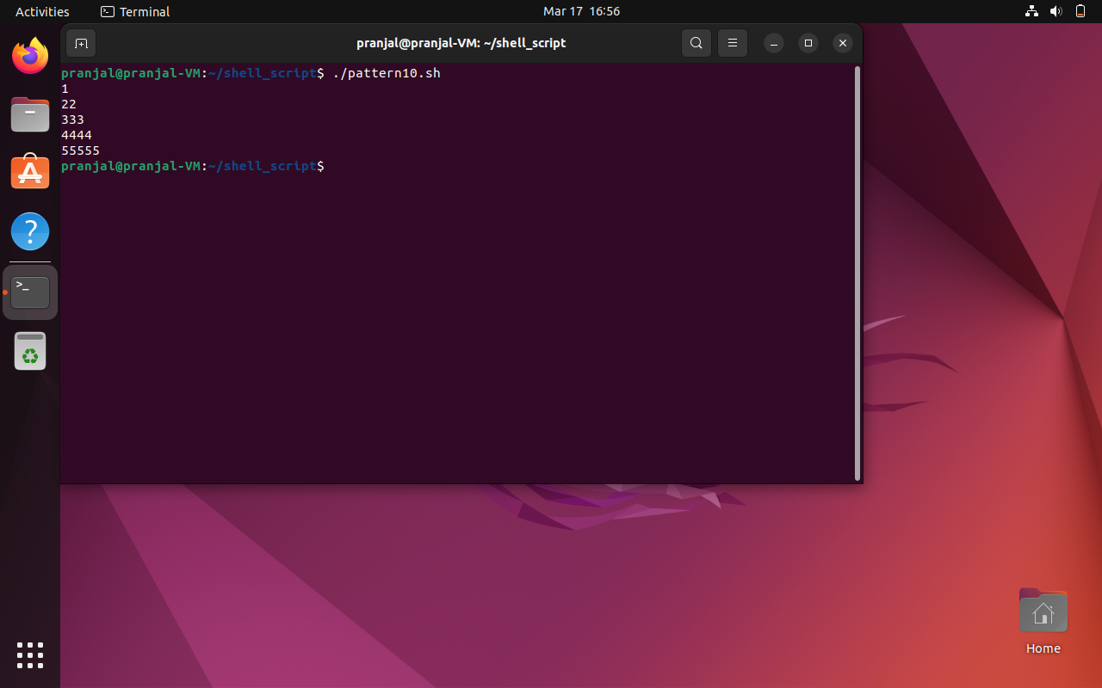

12. Shell Script to make such a pattern like a right angle triangle with the number increased by 1.

The pattern like :

1

2 3

4 5 6

7 8 9 10

