1. Given a string of odd length greater than 7, return a new string made of the middle three characters

of a given String

Given:

str1 = "RakeshzipPetabb"

Output

zip

str2 = "JazzbonAyxx"

Output

bon

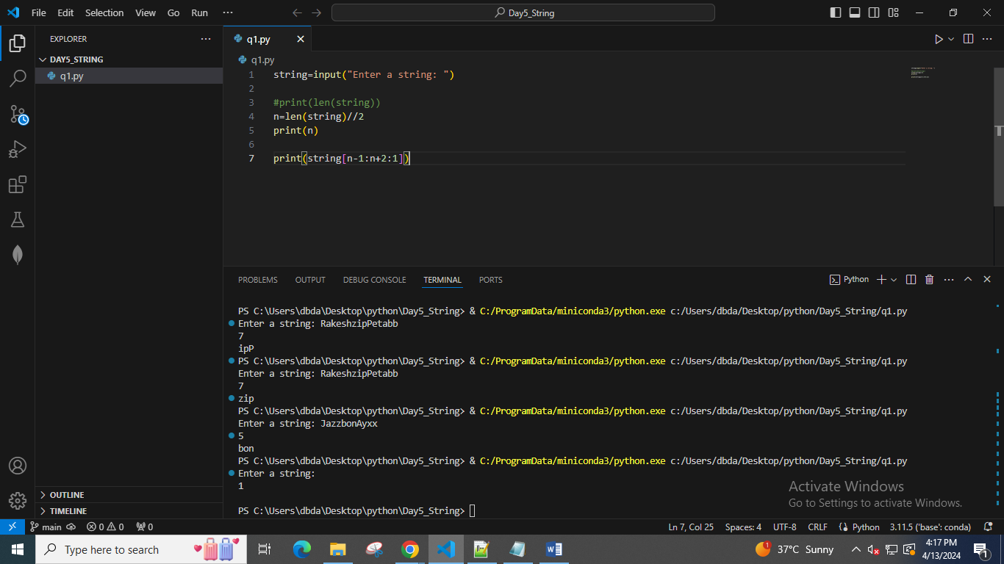

2. Given two strings, s1 and s2, create a new string by appending s2 in the middle of s1

Given:

s1 = "Ault"

s2 = "Kelly"

Expected Output:

AuKellylt

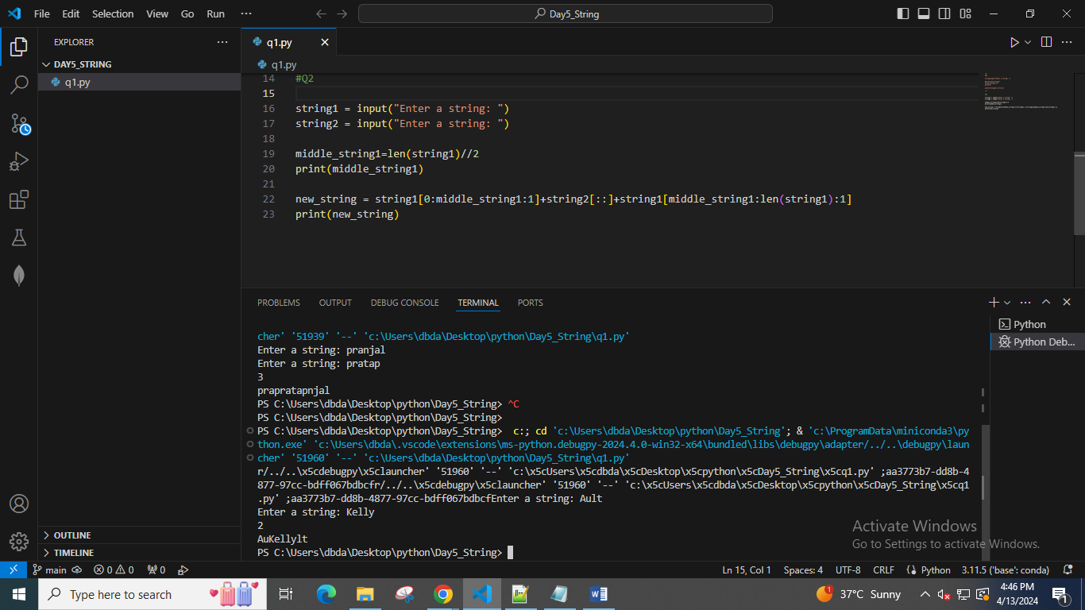

3. two strings, s1, and s2 return a new string made of the first, middle, and last characters each input

string

Given:

s1 = "America"

s2 = "Japan"

Expected Output:

AJrpan

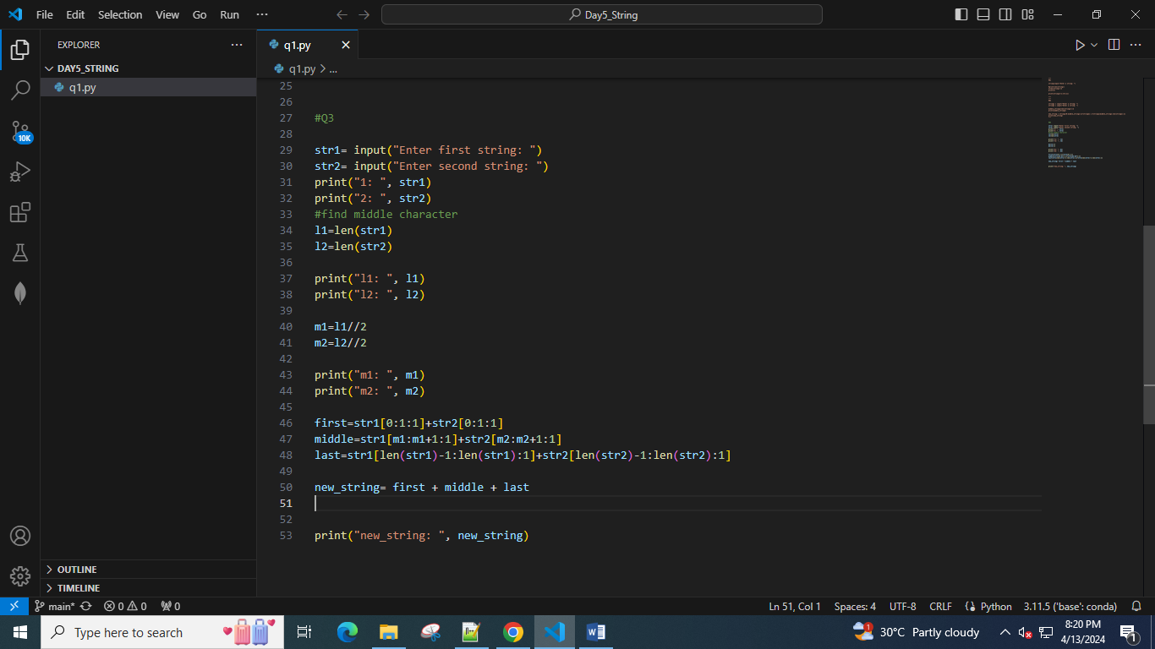

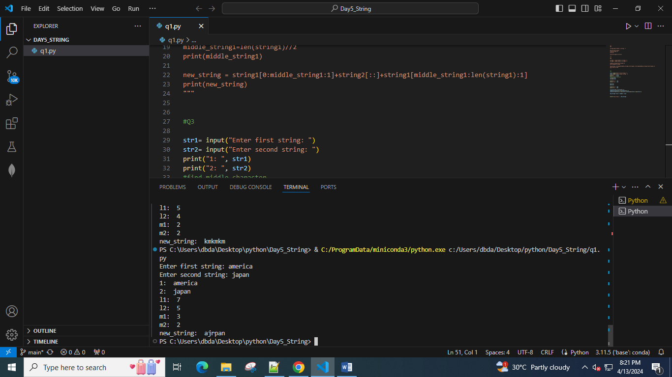

4. Given an input string with the combination of the lower and upper case arrange characters in such a

way that all lowercase letters should come first.

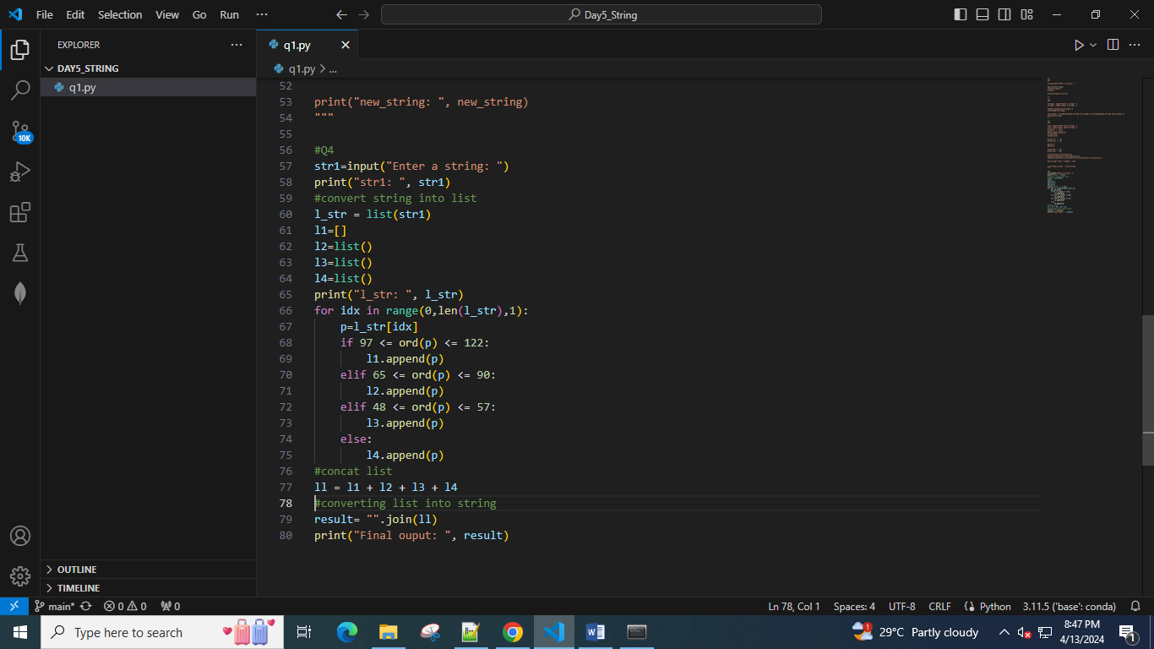

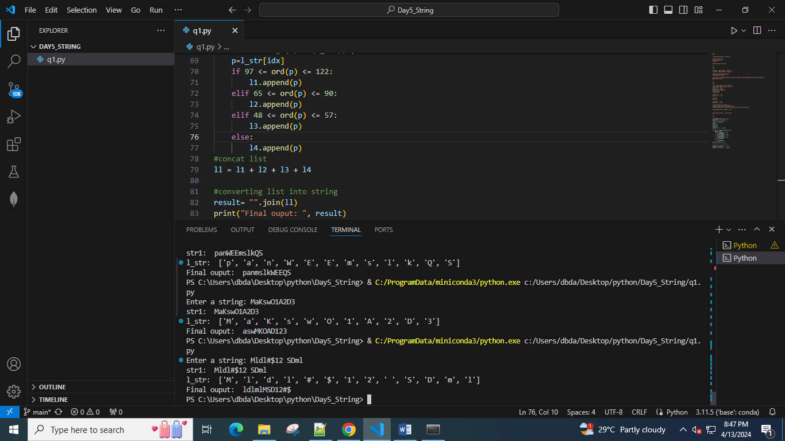

5. create a third-string made of the first char of s1 then the last char of s2, Next, the second char of s1

and second last char of s2, and so on. **Any leftover chars go at the end of the result.**

Given:

s1 = "Abc"

s2 = "Xyz"

Expected Output:

AzbycX

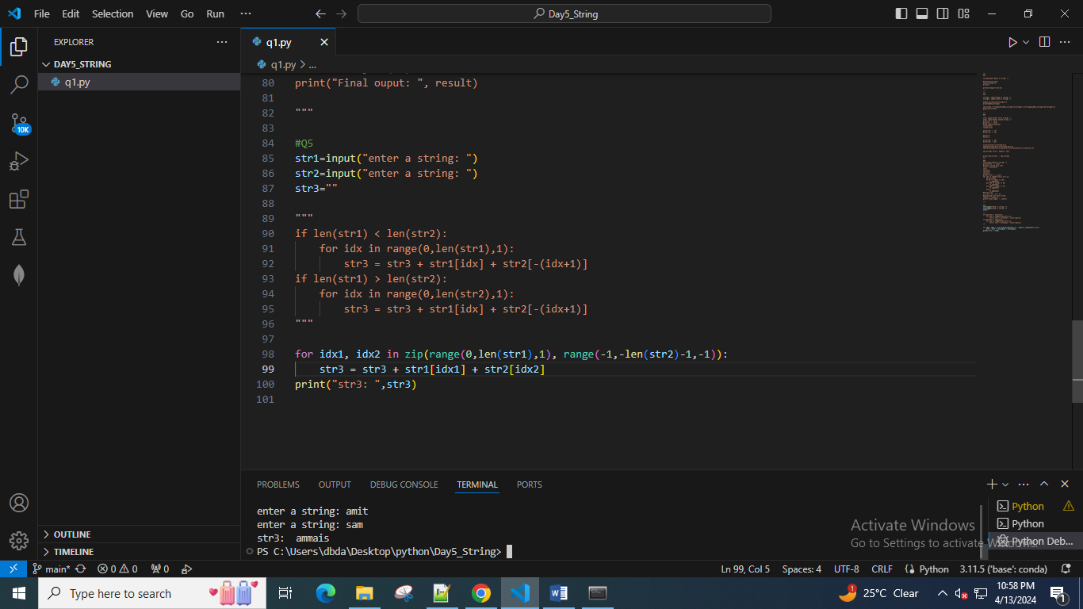

6. Find all occurrences of “USA” from right to left in a given string ignoring the case. also display the

starting position

Given:

str1 = "Welcome to USA. usa awesome, isn't it?

Expected answer : 16, 11

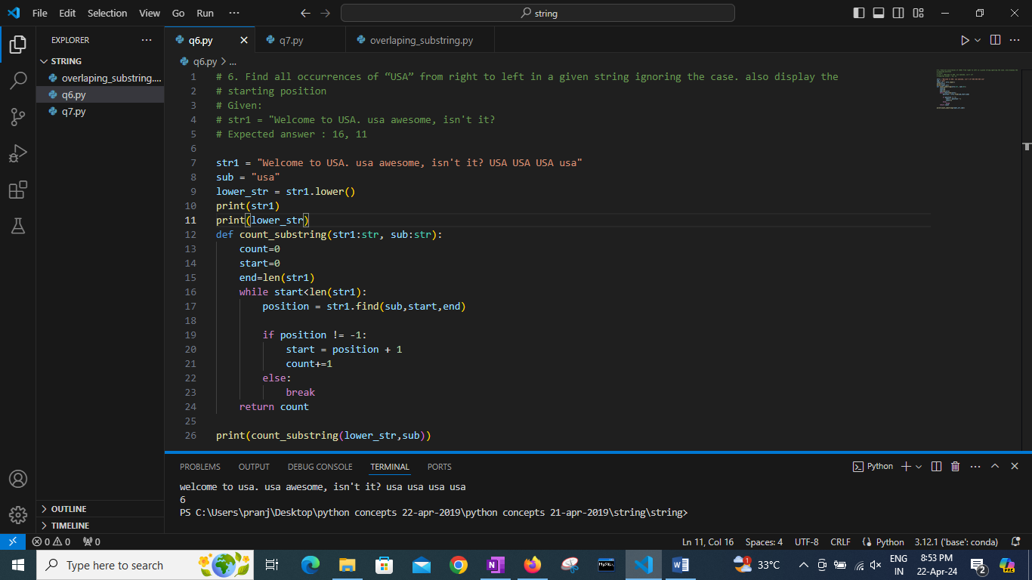

7. Find all overlapping occurrences of given substring in given string

Ex.

String = 0111

Substring = 11

Expected answer : 2

String : ANANAAAANNN

Substring: ANA

Expected answer : 2

String : ANANAAAANNN

Substring: AA

Expected answer : 3

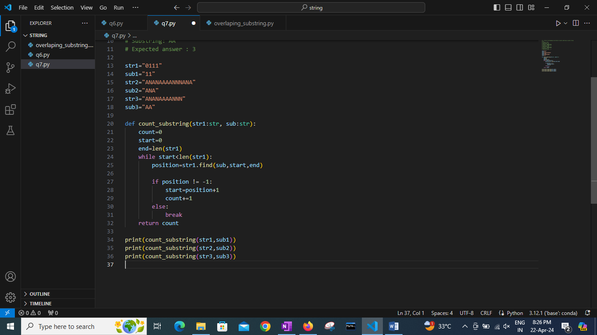

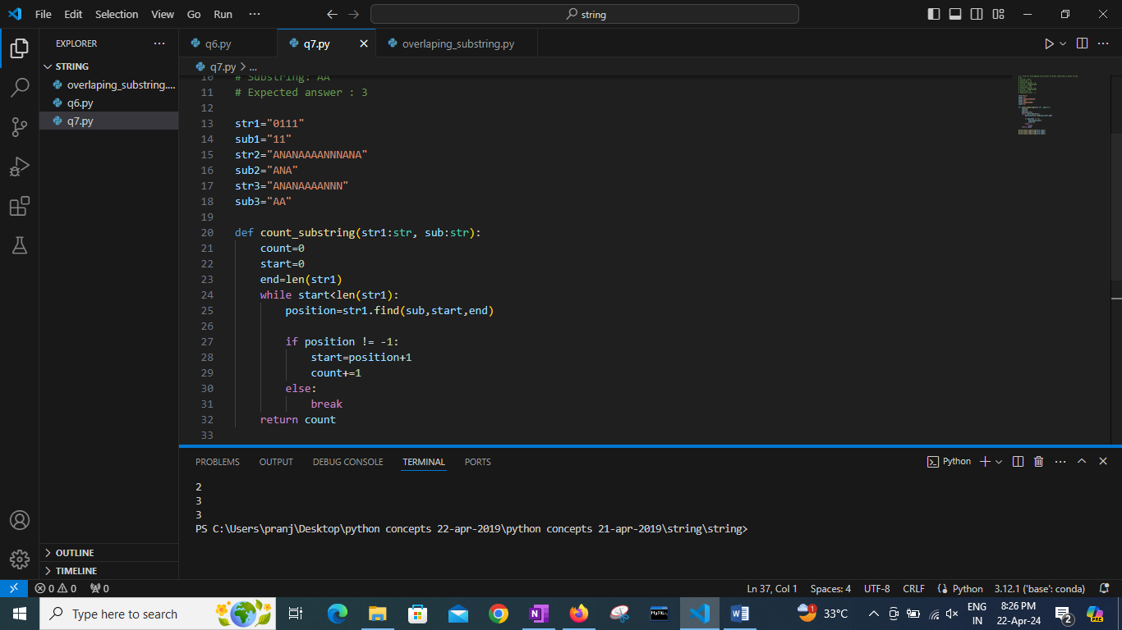

8. Given a string in format Emp_name:Emp_id

If emp_is is perfect square -- > Print only vowels from emp_name

Else if emp_id is prime -- > print alternate characters from emp_name

Else if emp_id is odd -- > print sum of ascii values of characters in emp_name

Else print None

9. Find all mobile number mentioned in given paragraph of text

Mobile number is always a 10 digit number no spaces no special characters

Ex. Input= “this is a good number 9089786756 and 8900000000 is a desired number”

Expected output: 9089786756 , 8900000000

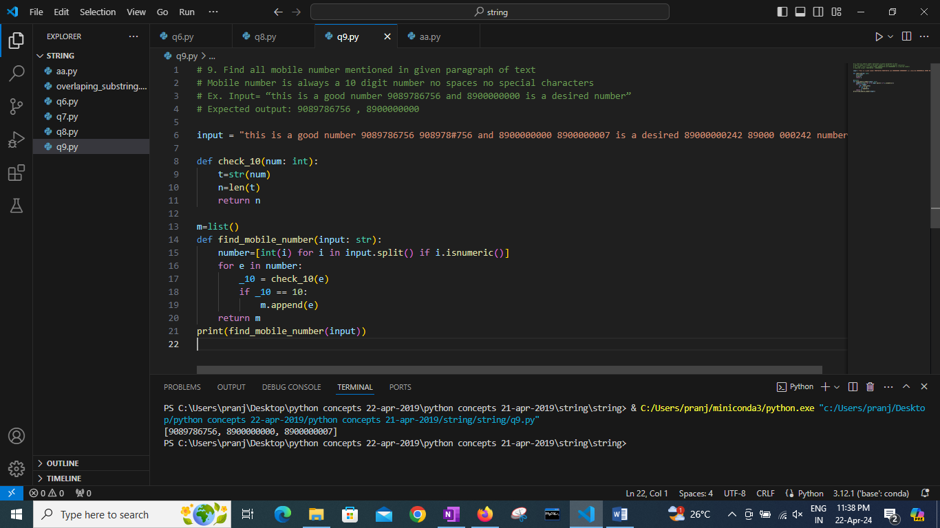

10. Count occurrence of spaces, and special characters in given string

Ex.

Input: Fgh^f #89

Expected output :

Spaces: 1

Special characters: 2

Isalnum()

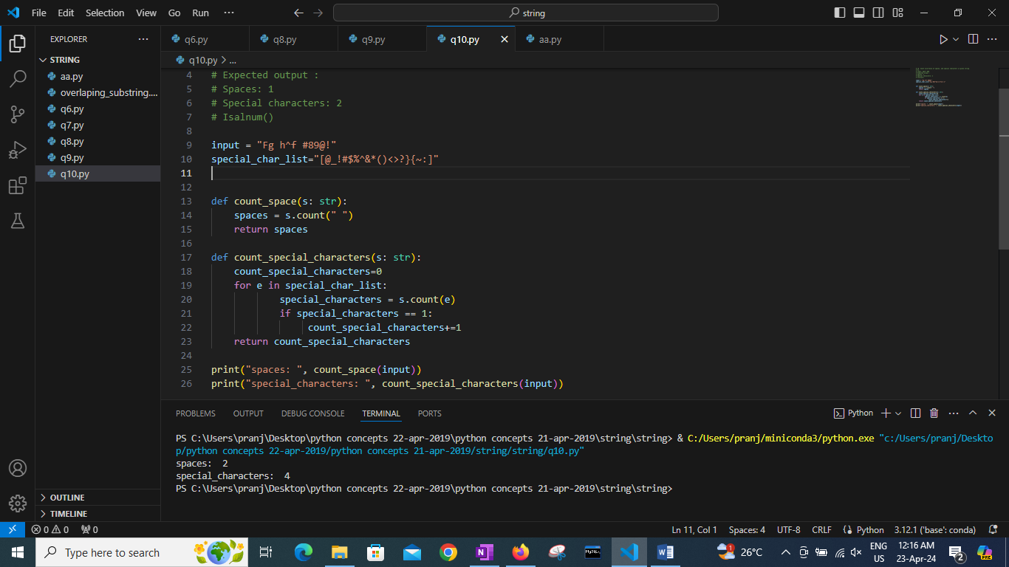

11. Given a paragraph count number of words, sentences. Every sentence ends with either . or ? or !

Print Count of how many normal sentences ending with . , how many interrogative sentences ( ending

with ?) and how many exclamatory sentences ( ending with !).

Ex.

Input : “I am at CDAC. What about you? I am surprised by current weather!”

Normal sentence : 1

Interrogative: 1

Exclamatory : 1

12. You are given a string S and width w.

Your task is to wrap the string into a paragraph of width w

Example .

String : “ABCDEFGHIJKLIMNOQRSTUVWXYZ”

Width: 4

Output:

ABCD

EFGH

IJKL

IMNO

QRST

UVWX

YZ

