1. Write a Python program to read an entire text file.

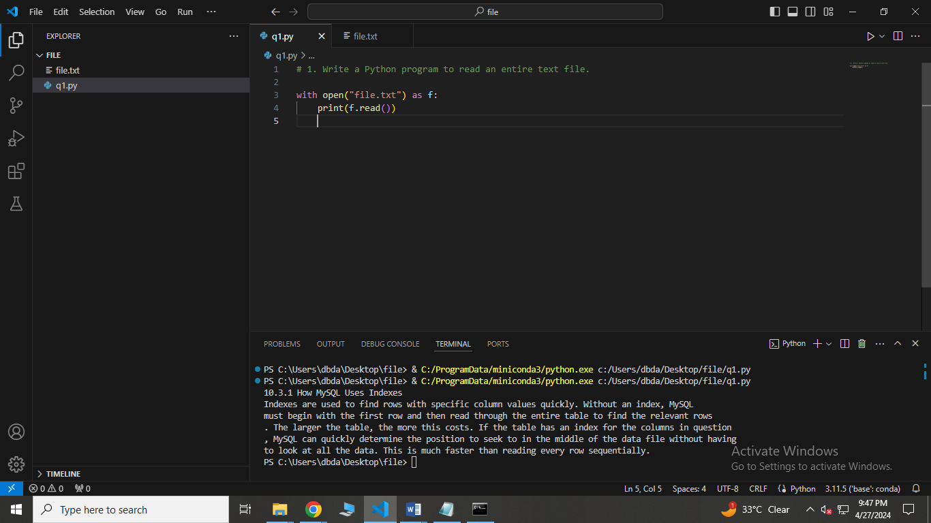

2. Write a Python program to read first n lines of a file.

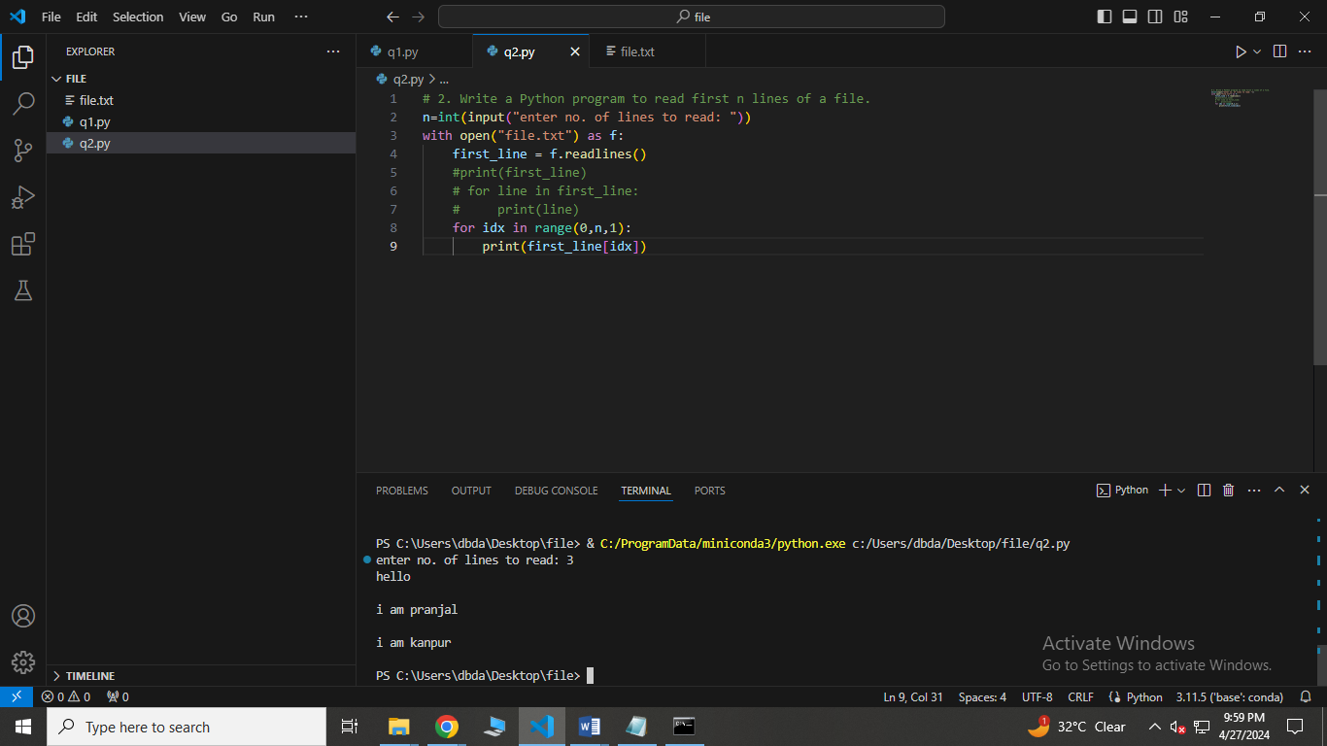

3. Write a Python program to append text to a file and display the text.

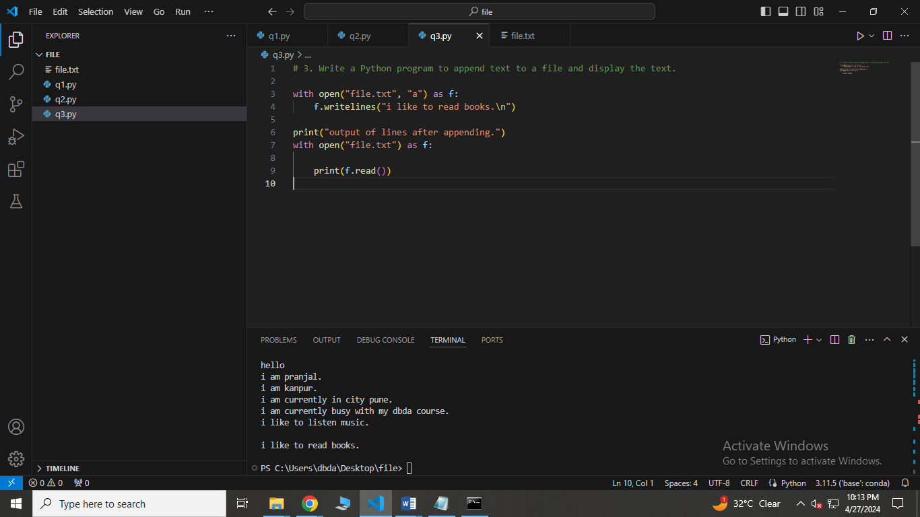

4. Write a Python program to read last n lines of a file.

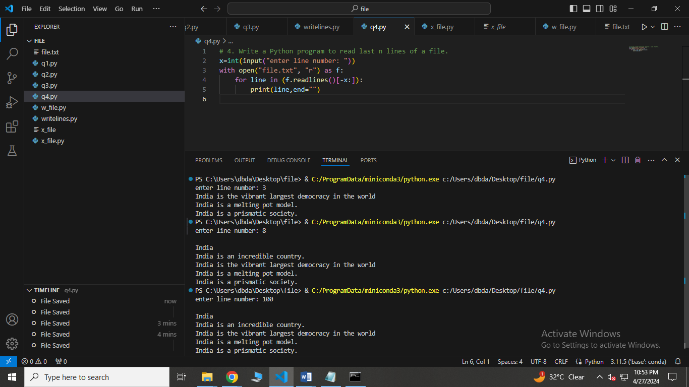

5. Write a Python program to read a file line by line and store it into a list.

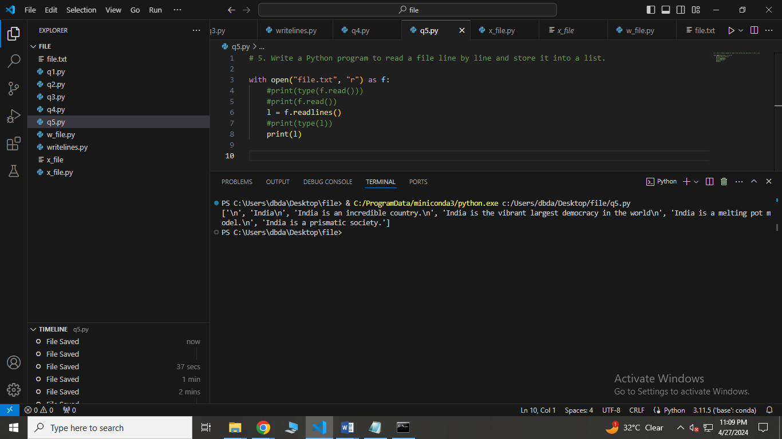

Advanced:

Q. write a program which will generate 3 folders named 'apple', 'banana', and 'mango'. In every folder add 100 empty files. Names of file should be in format '<folder_name>_<index>.bmp'. For example in 'mango' folder file name will be 'mango_1.bmp','mango_2.bmp', etc

Q. Write python program to read all files created by above program. Store names of files and absolute path of file in a dictionary.

Q. Write python program to read all files created by above program. Store names of files and category of file in a dictionary. Category of file is same as name of the folder of the file. For example

{mango_2.bmp':'mango', 'apple_100.bmp':'apple', 'banana_89.bmp':'banana'}

Extra::

6. Write a Python program to read a file line by line store it into a variable.

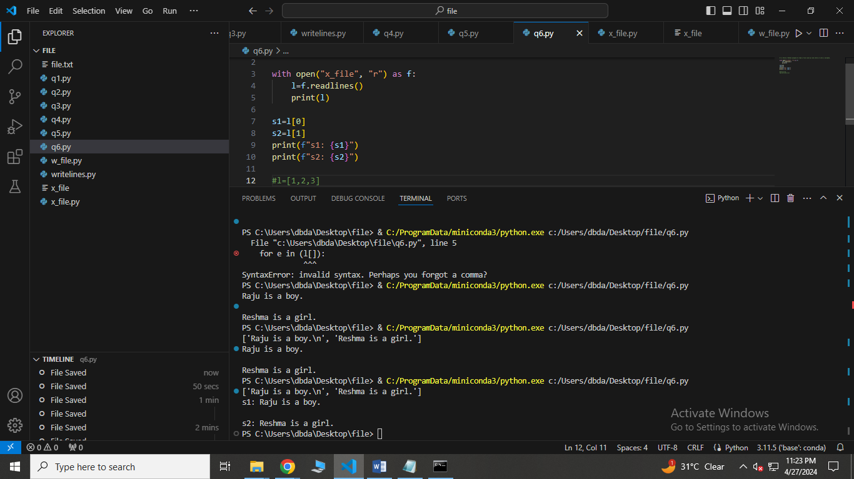

7. Write a Python program to read a file line by line store it into an array.

8. Write a python program to find the longest words.

9. Write a Python program to count the number of lines in a text file.

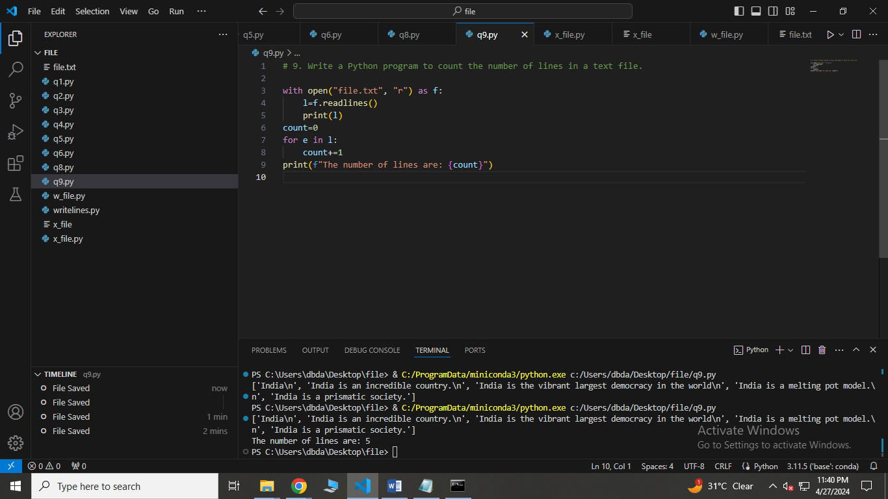

10. Write a Python program to count the frequency of words in a file.

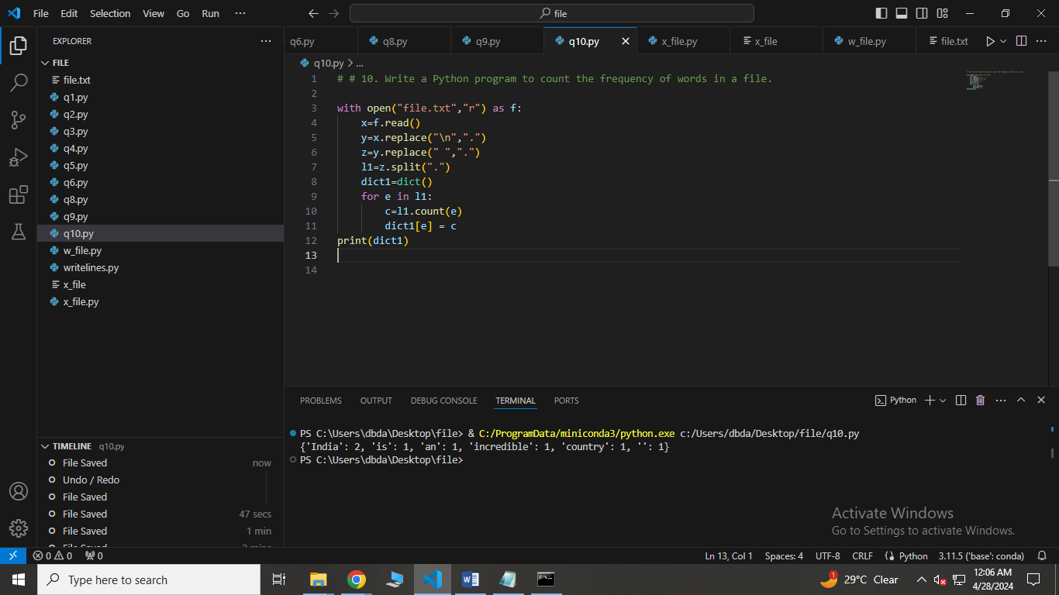

11. Write a Python program to get the file size of a plain file.

12. Write a Python program to write a list to a file.

13. Write a Python program to copy the contents of a file to another file .

14. Write a Python program to combine each line from first file with the corresponding line in second file.

15. Write a Python program to read a random line from a file.

16. Write a Python program to assess if a file is closed or not.

17. Write a Python program to remove newline characters from a file.

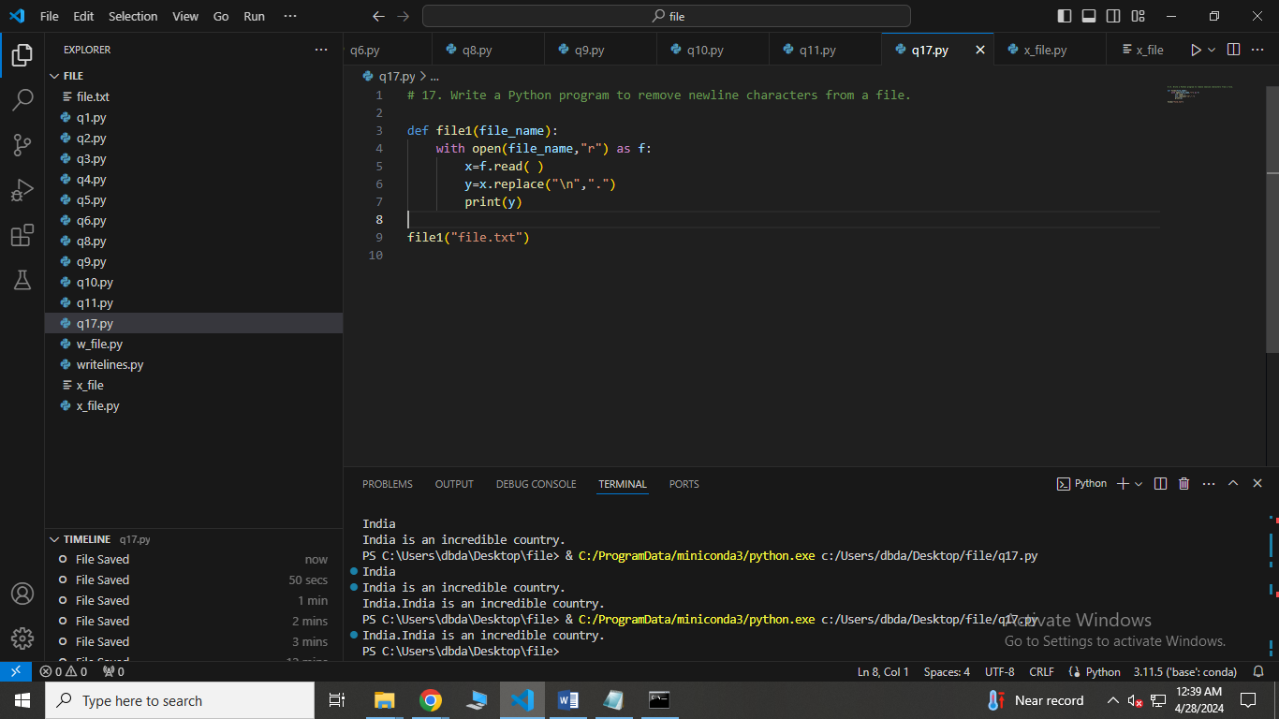

18. Write a Python program that takes a text file as input and returns the number of words of a given text file.

Note: Some words can be separated by a comma with no space.

19. Write a Python program to extract characters from various text files and puts them into a list.

20. Write a Python program to generate 26 text files named A.txt, B.txt, and so on up to Z.txt.

21. Write a Python program to create a file where all letters of English alphabet are listed by specified number of letters on each line.