**Lambda Assignments**

Q Sort all the numbers in a list in descending order using lambda function

sorted(l1, key=(lambda x:-x))

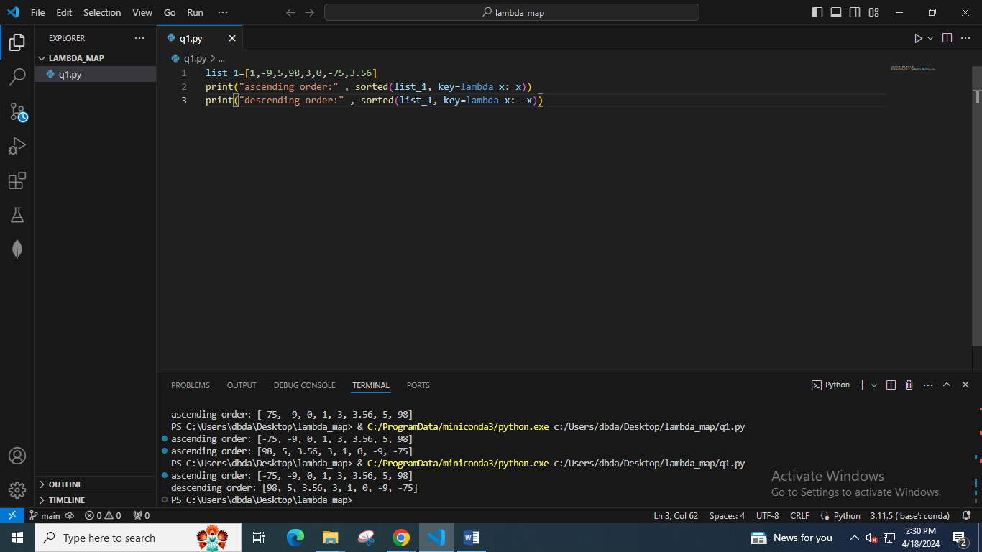

Q Sort all the characters of given string using lambda function

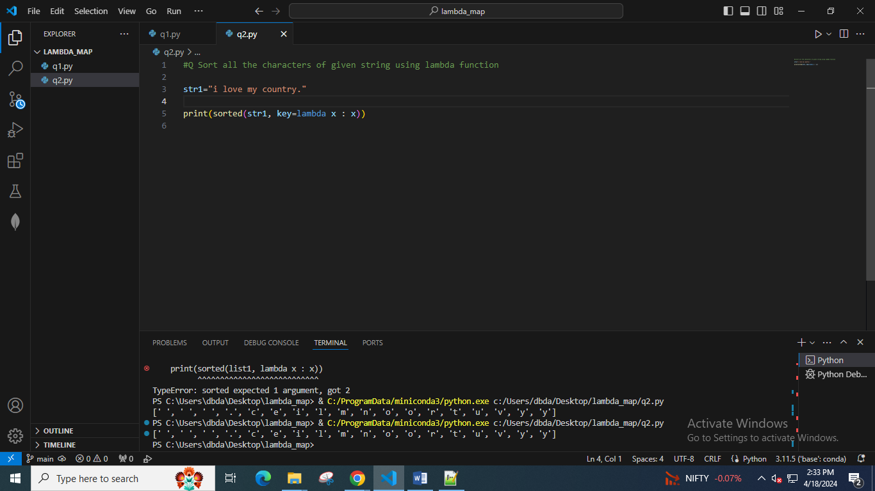

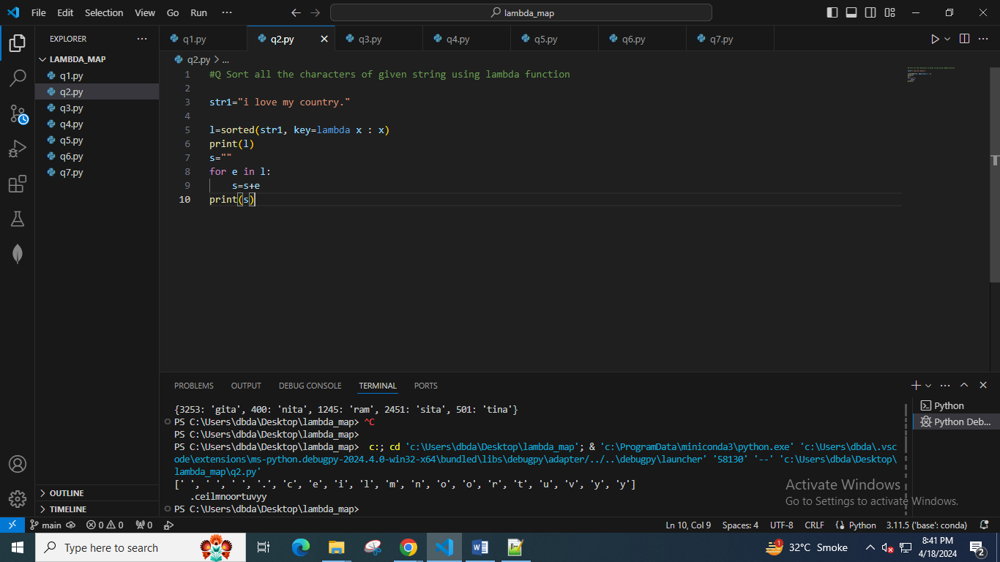

Q Given list of strings, sort all the strings by last character of that string. . Use lambda function and normal function both.

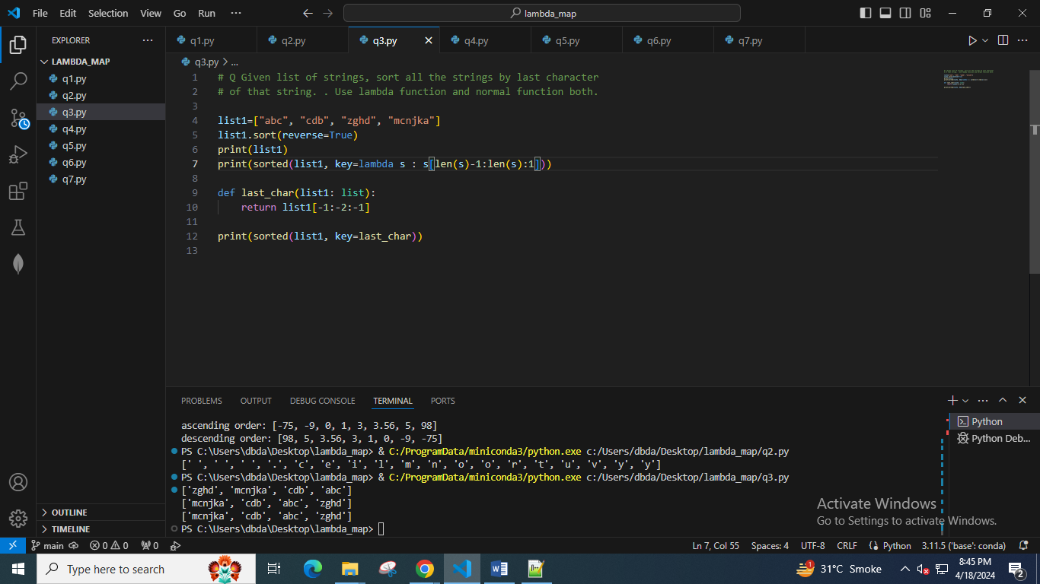

Q Given list of employees. This list may contain repetitions. Find all unique employee names and print them as per order of second character in that name. Use lambda function and normal function both.

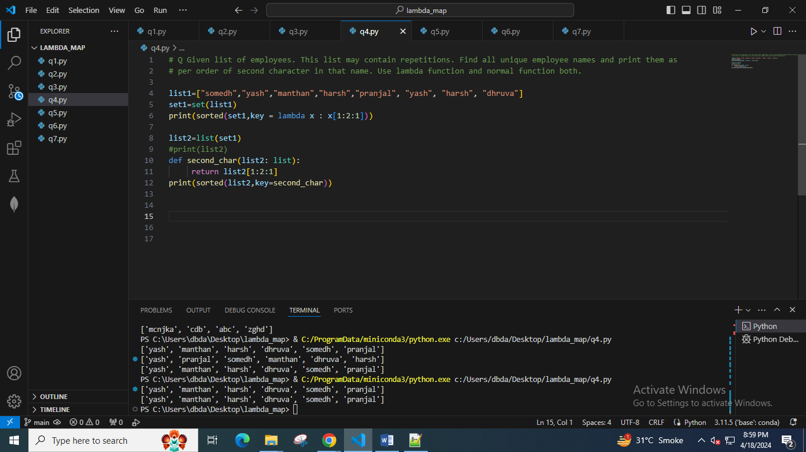

# Q Given list of employees. This list may contain repetitions. Find all unique employee names and print them as

# per order of second character in that name. Use lambda function and normal function both.

list1=["somedh","yash","manthan","harsh","pranjal", "yash", "harsh"]

set1=set(list1)

print(sorted(set1,key = lambda x : x[-2:-3:-1])).

Q. Take Employee id and Employee name of 5 employees from user. Store it in dictionary. Print all employees in increasing order of employee Id . Also print all employees in alphabetical order by name.

