**Map Function Assignments**

Q. Take comma separated numbers as input from the user. Split it in list of strings. Now convert every string in this list to float using map function

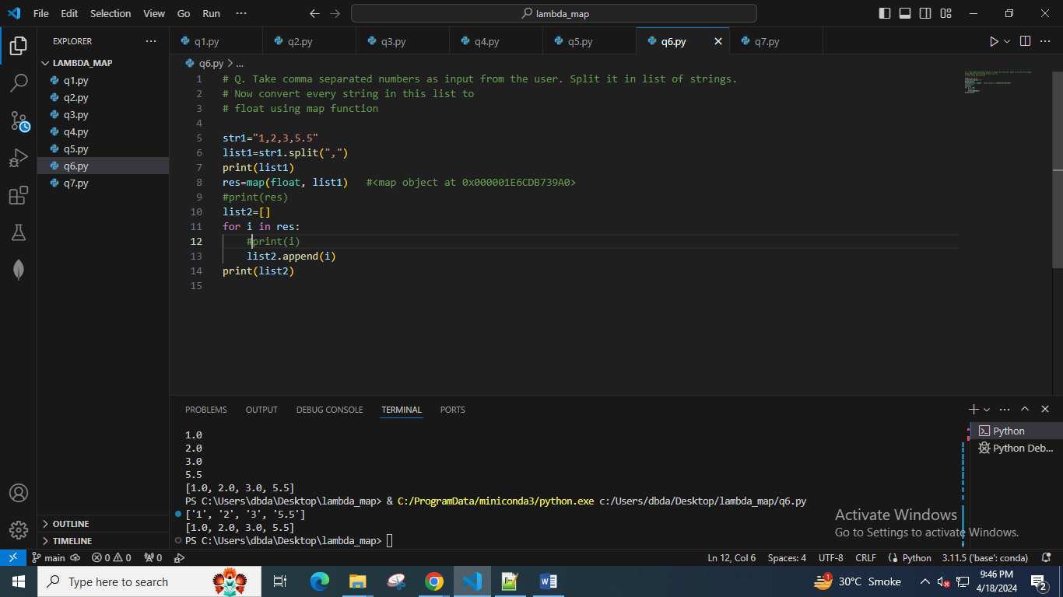

Q Given list of floating point numbers. Convert every number into string and then join all the numbers such that they are separated by pipe(|)

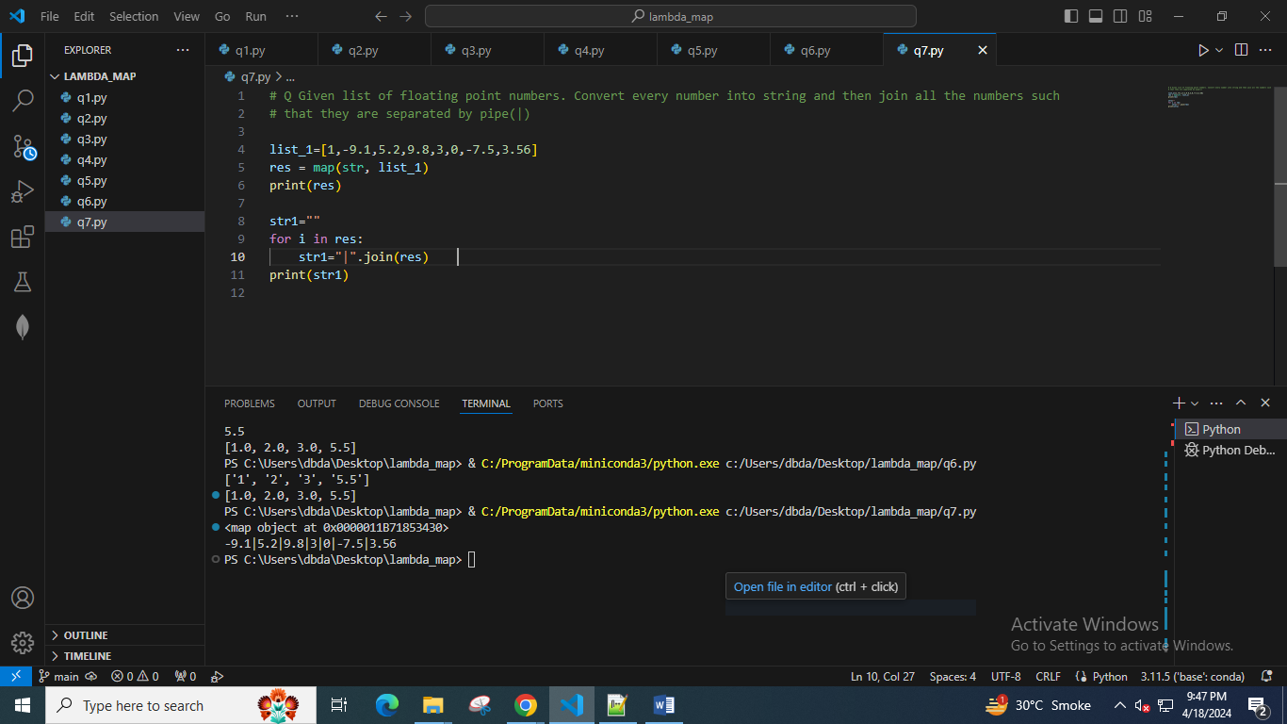

Q Given list of integers. Use map function to calculate square of all and store in list. Then print sum of all square values.

