# 1. Write a Python program to calculate the length of a string.

a. using built-in function

str=input("Enter a string: ")

s = len(str)

print(s)

b.without using built-in function

str=input("Enter a string: ")

count=0

for char in str:

    if char != 0:

        count+=1

print("Length of string: ", count)

2. Write a Python program to get character frequency of every character in a string.

Sample String : google.com

Expected Result : {'g': 2, 'o': 3, 'l': 1, 'e': 1, '.': 1, 'c': 1, 'm': 1}

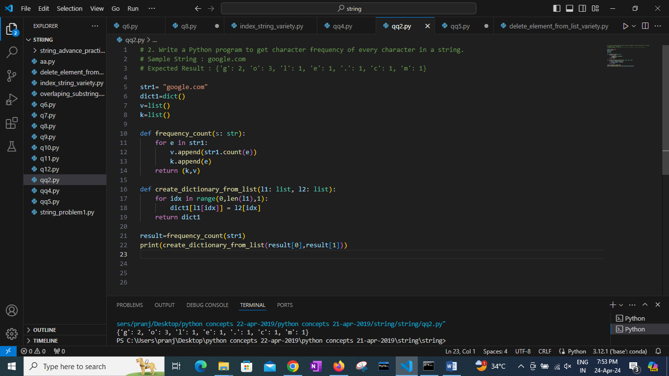

3. Write a Python program to get **a string made of the first 2 and last 2 characters of a given string**. If the string length is less than 2, return the empty string instead.

Sample String : 'w3resource'

Expected Result : 'w3ce'

Sample String : 'w3'

Expected Result : 'w3w3'

Sample String : ' 'w'

Expected Result : ''

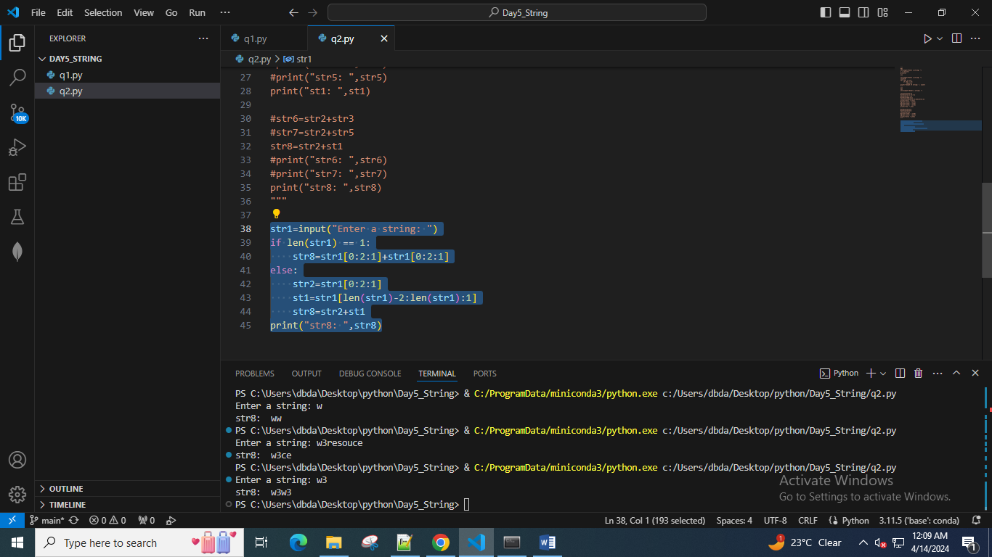

4. Write a Python program to get a string from a given string where all occurrences of its first char have been changed to '$', except the first char itself.

Sample String : 'restart'

Expected Result : 'resta$t'

Sample String : 'ababab'

Expected Result : 'ab$b$b'

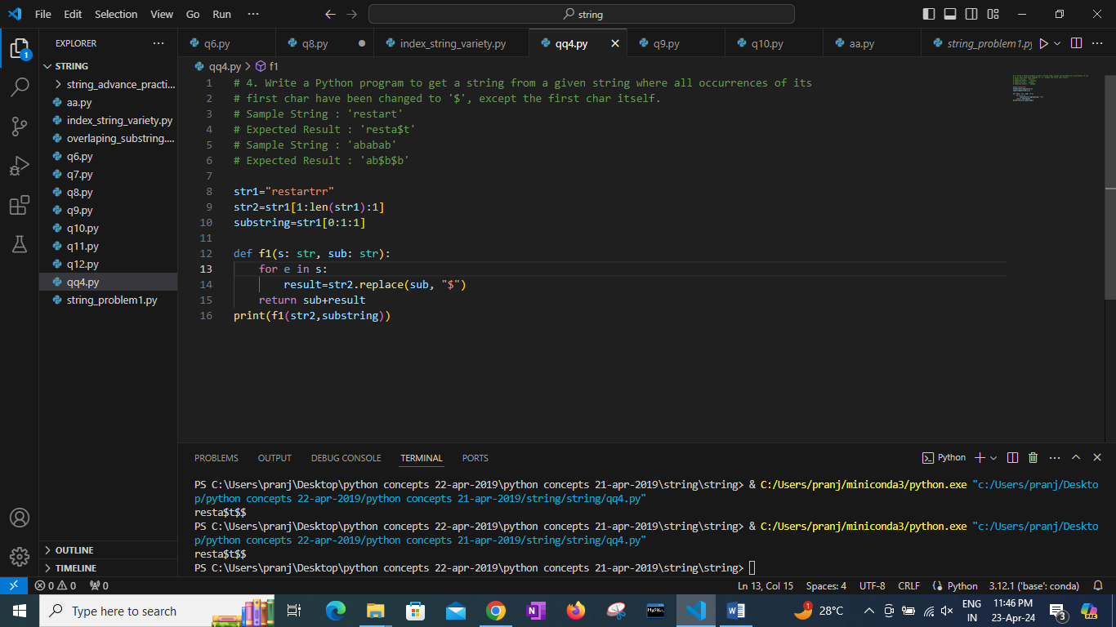

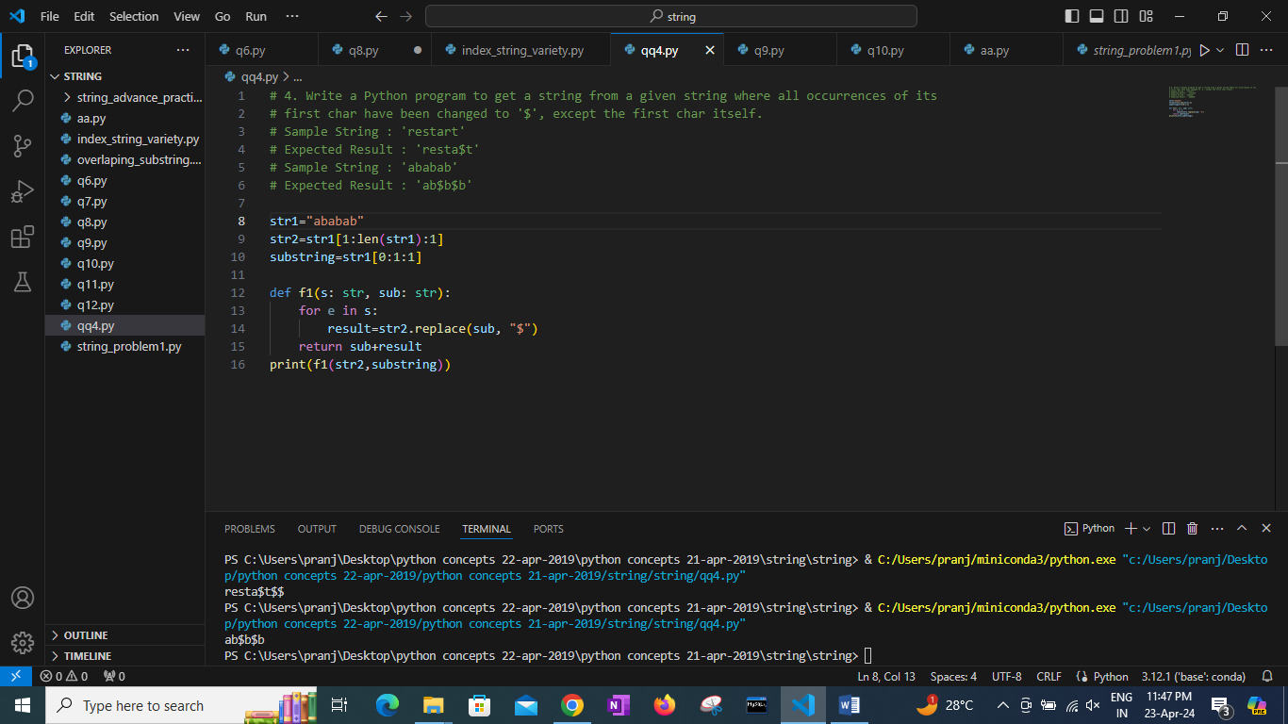

5. Write a Python program to get a single string from two given strings, separated by a space and swap the first two characters of each string.

Sample String : 'abc', 'xyz'

Expected Result : 'xyc abz'

Sample String : 'Hello', 'World'

Expected Result : 'Wollo Herld'

Test cases:

a. both empty string input b. 'a' , 'abc' c. '' 'abc' d. '123' 'wow'

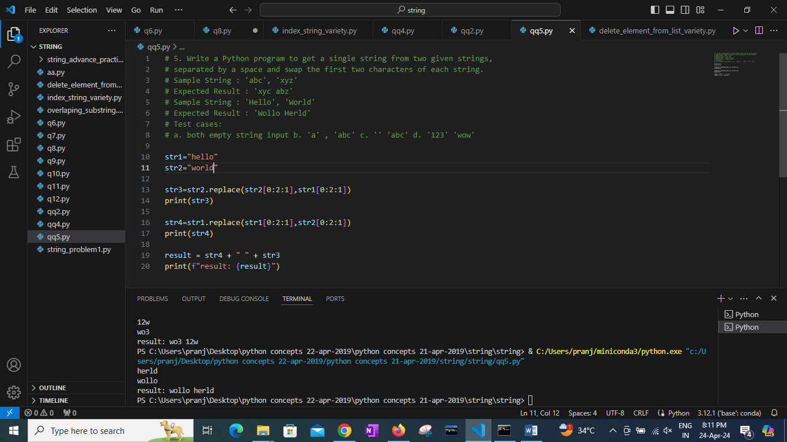

6. Write a Python program to add 'ing' at the end of a given string (length should be at least 3). If the given string already ends with 'ing', add 'ly' instead. If the string length of the given string is less than 3, leave it unchanged.

Sample String : 'abc'

Expected Result : 'abcing'

Sample String : 'string'

Expected Result : 'stringly'

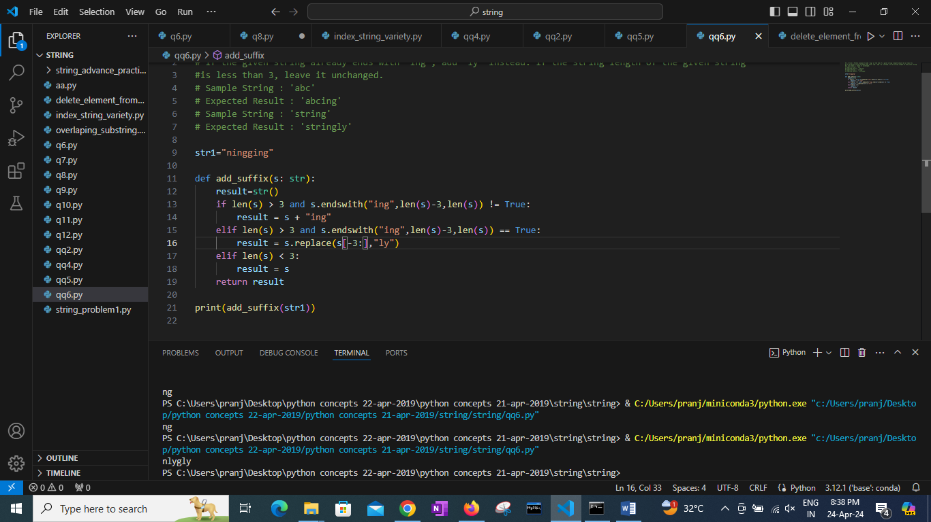

7. Write a Python program to find the first appearance of the substrings 'not' and 'poor' in a given string. If 'not' follows 'poor', replace the whole 'not'...'poor' substring with 'good'. Return the resulting string.

Sample String : 'The lyrics is not that poor!'

'The lyrics is poor!'

Expected Result : 'The lyrics is good!'

'The lyrics is poor!'

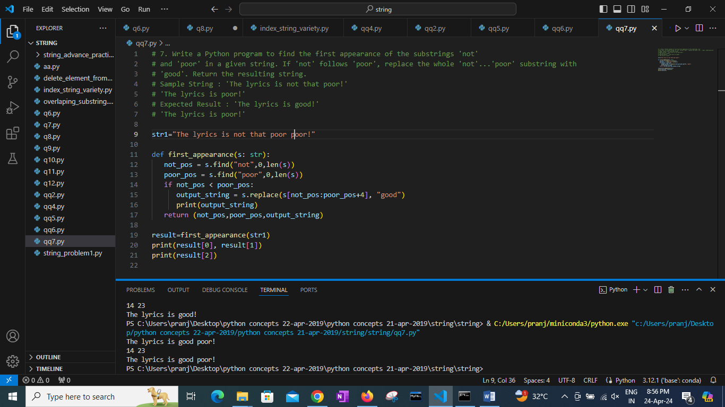

8. Write a Python function that takes a list of words and return the longest word and the length of the longest one.

Sample Output:

Longest word: Exercises

Length of the longest word: 9

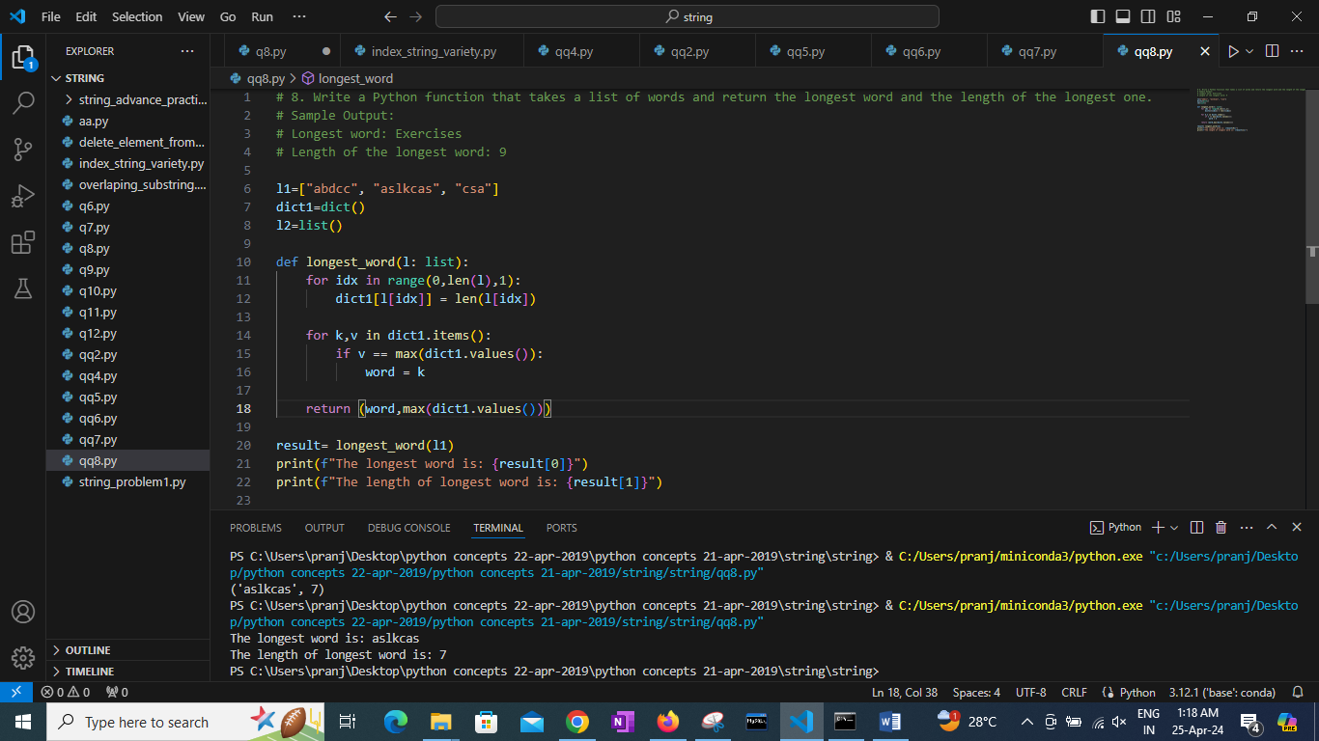

9. Write a Python program to remove the nth index character from a nonempty string.

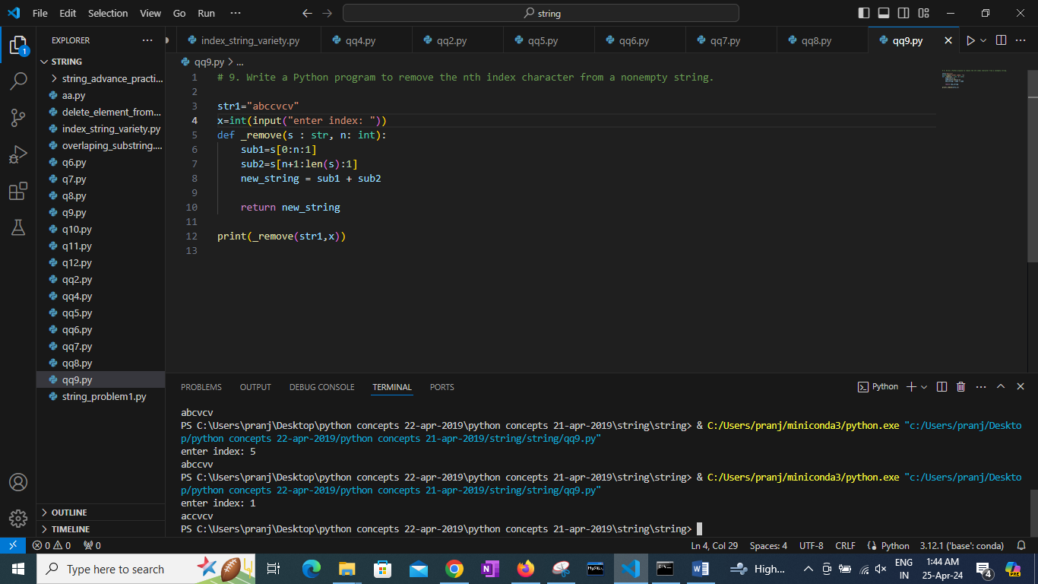

10. Write a Python program to change a given string to a newly string where the first and last chars have been exchanged.

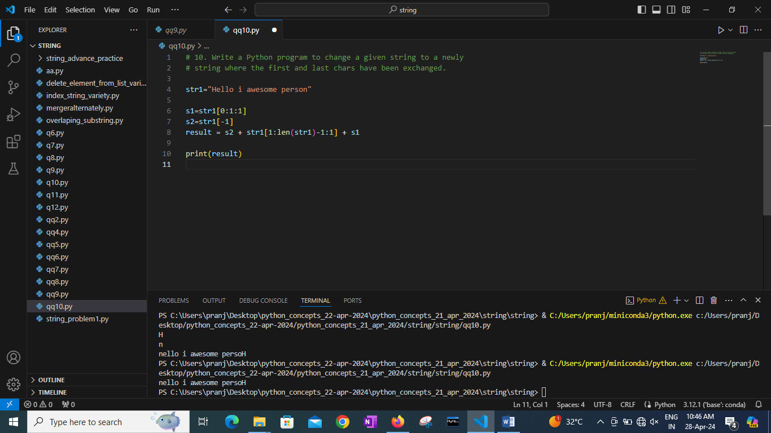

11. Write a Python program to remove characters that have odd index values in a given string.

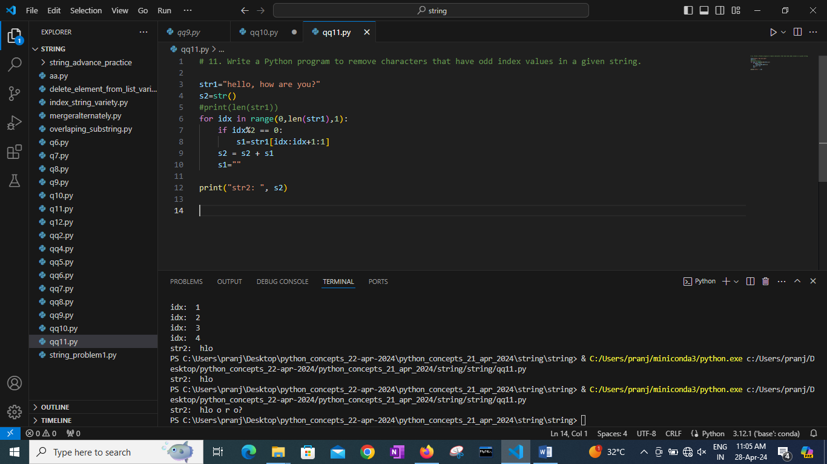

12. Write a Python program to count the occurrences of each word in a given sentence.

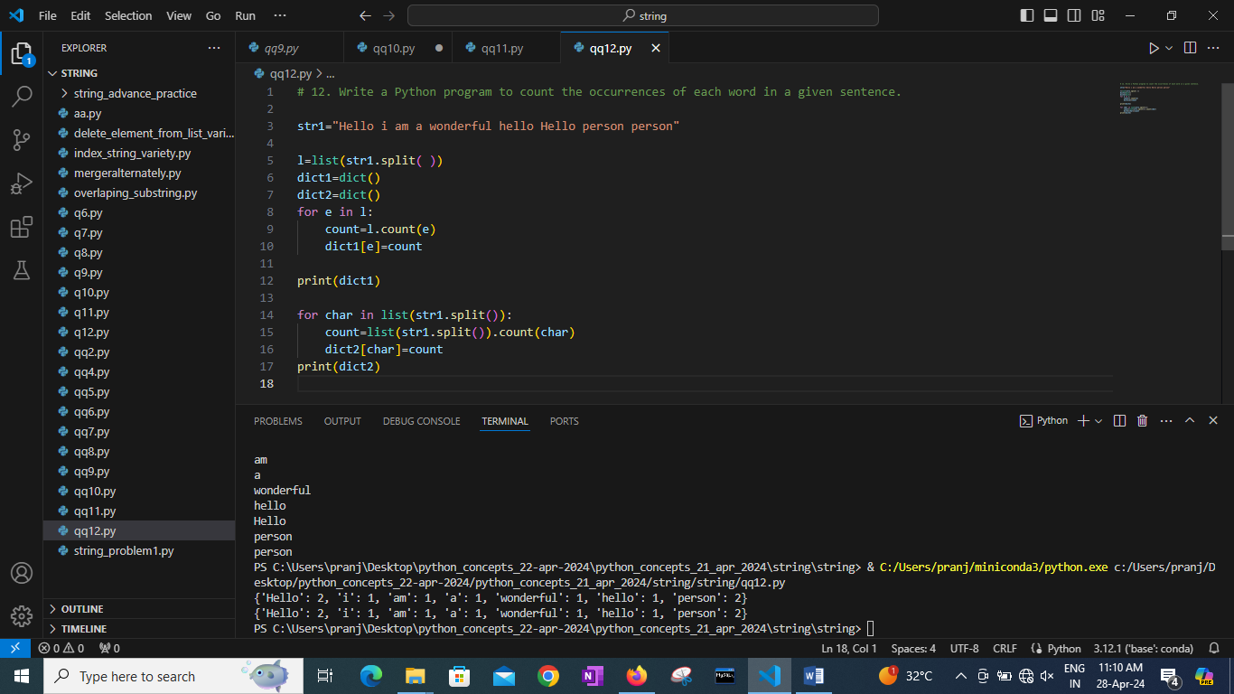

13. Write a Python script that takes input from the user and displays that input back in upper and lower cases.

14. Write a Python program that accepts a comma-separated sequence of words as input and prints the distinct words in sorted form (alphanumerically).

Sample Words : red, white, black, red, green, black

Expected Result : black, green, red, white,red

15. Write a Python function to create an HTML string with tags around the word(s).

Sample function and result :

add_tags('i', 'Python') -> '<i>Python</i>'

add_tags('b', 'Python Tutorial') -> '<b>Python Tutorial </b>'

16. Write a Python function to insert a string in the middle of a string.

Sample function and result :

insert_sting_middle('[[]]<<>>', 'Python') -> [[Python]]

insert_sting_middle('{{}}', 'PHP') -> {{PHP}}

17. Write a Python function to get a string made of 4 copies of the last two characters of a specified string (length must be at least 2).

Sample function and result :

insert_end('Python') -> onononon

insert_end('Exercises') -> eseseses

18. Write a Python function to get a string made of the first three characters of a specified string. If the length of the string is less than 3, return the original string.

Sample function and result :

first_three('ipy') -> ipy

first_three('python') -> pyt

19. Write a Python program to get the last part of a string before a specified character.

https://www.w3resource.com/python-exercises

https://www.w3resource.com/python

20. Write a Python function to reverse a string if its length is a multiple of 4.

21. Write a Python function to convert a given string to all uppercase if it contains at least 2 uppercase characters in the first 4 characters.

22.Write a Python program to sort a string lexicographically.(do both using library and without library)

23. Write a Python program to remove a newline in Python.(do both using library and without library)

24. Write a Python program to check whether a string starts with specified characters.(do both using library and without library)

25. Write a Python program to create a Caesar encryption.

Note : In cryptography, a Caesar cipher, also known as Caesar's cipher, the shift cipher, Caesar's code or Caesar shift, is one of the simplest and most widely known encryption techniques. It is a type of substitution cipher in which each letter in the plaintext is replaced by a letter some fixed number of positions down the alphabet. For example, with a left shift of 3, D would be replaced by A, E would become B, and so on. The method is named after Julius Caesar, who used it in his private correspondence.

26. Write a Python program to display formatted text (width=50) as output.

a. using library (hint. textwrap)

b. without using any library

Sample input

para = """Nature around us is a gift. We need to handle it wisely.

Nature's gifts are for everyone and many generations. Every generation,

need to think before making a damage to these gifts."""

width=50

output:(-> and <- arrow are shown to highlight start and end of line)

->Nature around us is a gift. We need to handle it <-

->wisely.Nature's gifts are for everyone and many g<-

->enerations. Every generation,need to think before<-

-> making a damage to these gifts.

27. Write a Python program to remove existing indentation from all of the lines in a given text.

(do both using library and without library)

28. Write a Python program to add prefix text to all of the lines in a string.(do both using library and without library)

Example:

Add prefix "line:" to every line in question 26

29. Write a Python program to set the indentation (4 spaces) of the first line, from input string containing a paragraph of text.

Sample input

para = """Nature around us is a gift. We need to handle it wisely.

Nature's gifts are for everyone and many generations. Every generation,

need to think before making a damage to these gifts."""

Output:

""" Nature around us is a gift. We need to handle it wisely.

Nature's gifts are for everyone and many generations. Every generation,

need to think before making a damage to these gifts."""

30. Write a Python program to print the following numbers up to 2 decimal places.

a. 123.45678

b. 0.0000004

c. 123

d. 123456789.9

31. Write a Python program to print the following numbers up to 2 decimal places with a sign.

a. 123.45678

b. -0.0000004

c. 123

d. -123456789.9

32. Write a Python program to print the following positive and negative numbers with no decimal places.

a. 123.45678

b. -0.0000004

c. 123

d. -123456789.9

33. Write a Python program to print the following integers with zeros to the left of the specified width. If integer with greater width, then display error message.

a. Use format

b. write your logic to perform this task

Example : width =5

input output

345 00345

56789 56789

0 00000

123456 Error

34. Write a Python program to print the following integers with '*' to the right of the specified width. If integer with greater width, then display error message.

a. Use format

b. write your logic to perform this task

Example : width =5

input output

345 345**

56789 56789

0 0****

123456 Error

35. Write a Python program to display a number with a comma separator. After every thousand there should be comma added. (do both using library and without library)

Ex.

input output

0 0

-123456 -123,456

123456789 123,456,789

9876 9,876

78 78

36. Write a Python program to format a number with a percentage.(do both using library and without library)

37. Write a Python program to display a number in left, right, and center aligned with a width of 10.

(do both using library and without library)

38. Write a Python program to count occurrences of a substring in a string.(do both using library and without library)

39. Write a Python program to reverse a string.(do both using library,using slice operator and without library)

40. Write a Python program to reverse all words in a string.(do both using slice and without library)

Ex

input: "i am feeling great here"

output:"here great feeling am i"

41. Write a Python program to strip a set of characters from a string.(do both using library and without library)

42. Write a Python program to count repeated characters in a string.(do both using set and without set, in both case store in dictionary)

Sample string: 'thequickbrownfoxjumpsoverthelazydog'

Expected output :

o 4

e 3

u 2

h 2

r 2

t 2

43. Write a Python program to print the square and cube symbols in the area of a rectangle and the volume of a cylinder.

Sample output:

The area of the rectangle is 1256.66cm2

The volume of the cylinder is 1254.725cm3

44. Write a Python program to print the index of a character in a string.

Sample string: w3resource

Expected output:

Current character w position at 0

Current character 3 position at 1

Current character r position at 2

- - - - - - - - - - - - - - - - - - - - - - - - -

Current character c position at 8

Current character e position at 9

45. Write a Python program to check whether a string contains all letters of the alphabet[a-z].

46. Write a Python program to convert a given string into a list of words.

Sample input:

'The quick brown fox jumps over the lazy dog.'

Sample Output:

['The', 'quick', 'brown', 'fox', 'jumps', 'over', 'the', 'lazy', 'dog.']

47. Write a Python program to lowercase the first n characters in a string.

48. Write a Python program to swap commas and dots in a string.

Sample string: "32.054,23"

Expected Output: "32,054.23"

49. Write a Python program to count and display vowels in text.

50. Write a Python program to split a string on the last occurrence of the delimiter.

51. Write a Python program to find the first non-repeating character in a given string.

52. Write a Python program to print all permutations with a given repetition number of characters of a given string.

53. Write a Python program to find the first repeated character in a given string.

54. Write a Python program to find the first repeated character in a given string where the index of the first occurrence is smallest. Return the smallest index.

55.Write a Python program to find the first repeated word in a given string.

56. Write a Python program to find the second most repeated word in a given string.

57.Write a Python program to remove spaces from a given string.

58. Write a Python program to move spaces to the front of a given string.

59. Write a Python program to find the maximum number of characters in a given string.

60. Write a Python program to capitalize the first and last letters of each word in a given string.

61. Write a Python program to remove duplicate characters from a given string.

62. Write a Python program to compute the sum of the digits in a given string.

63. Write a Python program to remove leading zeros from an IP address.

64. Write a Python program to find the maximum length of consecutive 0's in a given binary string.

65. Write a Python program to find all the common characters in lexicographical order from two given lower case strings. If there are no similar letters print "No common characters".

66. Write a Python program to make two given strings (lower case, may or may not be of the same length) anagrams without removing any characters from any of the strings.

67. Write a Python program to remove all consecutive duplicates of a given string.

68. Write a Python program to generate two strings from a given string. For the first string, use the characters that occur only once, and for the second, use the characters that occur multiple times in the said string.

69. Write a Python program to find the longest common sub-string from two given strings.

70. Write a Python program that concatenates uncommon characters from two strings.

71. Write a Python program to move all spaces to the front of a given string in a single traversal.

72. Write a Python program to remove all characters except a specified character from a given string.

Original string

Python Exercises

Remove all characters except P in the said string:

P

Original string

google

Remove all characters except g in the said string:

gg

Original string

exercises

Remove all characters except e in the said string:

eee

73. Write a Python program to count Uppercase, Lowercase, special characters and numeric values in a given string.

74. Write a Python program to find the minimum window in a given string that will contain all the characters of another given string.

Example 1

Input : str1 = "PRWSOERIUSFK"

str2 = "OSU"

Output: Minimum window is "SOERIU"

75. Write a Python program to find the smallest window that contains all characters in a given string.

Example 1

Input : "CDAC"

Output: Minimum window is "CDA"

76. Write a Python program to count the number of substrings from a given string of lowercase alphabets with exactly k distinct (given) characters.

input:

str = "CDAC"

k=2

Output: 3

Explainationation, there are 3 substrings of 2 distinct characters in given input "CD", "DA", "AC"

input:

str = "CCEE"

k=2

Output: 1

Explainationation,

total substrings of length 2 in given input are CC, CE and EE

there are 1 substrings of 2 distinct characters in given input "CE"

77. Write a Python program to count the number of non-empty substrings of a given string.

78. Write a Python program to count characters at the same position in a given string (lower and uppercase characters) as in the English alphabet.

79. Write a Python program to find the smallest and largest words in a given string.

80. Write a Python program to count the number of substrings with the same first and last characters in a given string.

81. Write a Python program to determine the index of a given string at which a certain substring starts. If the substring is not found in the given string return 'Not found'.

82. Write a Python program to wrap a given string into a paragraph with a given width.

Sample Output:

Input a string: The quick brown fox.

Input the width of the paragraph: 10

Result:

The quick

brown fox.

83. Write a Python program to print four integer values - decimal, octal, hexadecimal (capitalized), binary - in a single line.

Sample Output:

Input an integer: 25

Decimal Octal Hexadecimal (capitalized), Binary

25 31 19 11001

84. Write a Python program to swap cases in a given string.

Sample Output:

pYTHON eXERCISES

jAVA

nUMpY

85. Write a Python program to convert a given Bytearray to a Hexadecimal string.

Sample Output:

Original Bytearray :

[111, 12, 45, 67, 109]

Hexadecimal string:

6f0c2d436d

86. Write a Python program to delete all occurrences of a specified character in a given string.

Sample Output:

Original string:

Delete all occurrences of a specified character in a given string

Modified string:

Delete ll occurrences of specified chrcter in given string

87. Write a Python program to find the common values that appear in two given strings.

Sample Output:

Original strings:

Python3

Python2.7

Intersection of two said String:

Python

88. Write a Python program to check whether a given string contains a capital letter, a lower case letter, a number and a minimum length.

Sample Output:

Input the string: W3resource

['Valid string.']

89. Write a Python program to remove unwanted characters from a given string.

Sample Output:

Original String : Pyth*^on Exercis^es

After removing unwanted characters:

Python Exercises

Original String : A%^!B#*CD

After removing unwanted characters:

ABCD

90. Write a Python program to remove duplicate words from a given string.

Sample Output:

Original String:

Python Exercises Practice Solution Exercises

After removing duplicate words from the said string:

Python Exercises Practice Solution

91. Write a Python program to convert a given heterogeneous list of scalars into a string.

Sample Output:

Original list:

['Red', 100, -50, 'green', 'w,3,r', 12.12, False]

Convert the heterogeneous list of scalars into a string:

Red,100,-50,green,w,3,r,12.12,False

92. Write a Python program to find string similarity between two given strings.

Sample Output:

Original string:

Python Exercises

Python Exercises

Similarity between two said strings:

1.0

Original string:

Python Exercises

Python Exercise

Similarity between two said strings:

0.967741935483871

Original string:

Python Exercises

Python Ex.

Similarity between two said strings:

0.6923076923076923

Original string:

Python Exercises

Python

Similarity between two said strings:

0.5454545454545454

Original string:

Java Exercises

Python

Similarity between two said strings:

0.0

93. Write a Python program to extract numbers from a given string.

Sample Output:

Original string: red 12 black 45 green

Extract numbers from the said string: [12, 45]

94. Write a Python program to convert a hexadecimal color code to a tuple of integers corresponding to its RGB components.

Sample Output:

(255, 165, 1)

(255, 255, 255)

(0, 0, 0)

(255, 0, 0)

(0, 0, 128)

(192, 192, 192)

95. Write a Python program to convert the values of RGB components to a hexadecimal color code.

Sample Output:

FFA501

FFFFFF

000000

000080

C0C0C0

96. Write a Python program to convert a given string to Camelcase.

Sample Output:

javascript

fooBar

fooBar

foo.Bar

fooBar

foobar

fooBar

97. Write a Python program to convert a given string to Snake case.

Sample Output:

java_script

foo_bar

foo_bar

foo.bar

foo_bar

foo_bar

foo_bar

98. Write a Python program to decapitalize the first letter of a given string.

Sample Output:

java Script

python

99. Write a Python program to split a multi-line string into a list of lines.

Sample Output:

Original string: This

is a

multiline

string.

Split the said multiline string into a list of lines:

['This', 'is a', 'multiline', 'string.', '']

100. Write a Python program to check whether any word in a given string contains duplicate characters or not. Return True or False.

Sample Output:

Original text:

Filter out the factorials of the said list.

Check whether any word in the said sting contains duplicate characrters or not!

False

Original text:

Python Exercise.

Check whether any word in the said sting contains duplicate characrters or not!

False

Original text:

The wait is over.

Check whether any word in the said sting contains duplicate characrters or not!

True

101. Write a Python program to add two strings as if they were numbers (positive integer values). Return a message if the numbers are strings.

Sample Output:

42

Error in input!

Error in input!

102. Write a Python program to remove punctuation from a given string.

Sample Output:

Original text:

String! With. Punctuation?

After removing Punctuations from the said string:

String With Punctuation

103. Write a Python program to replace each character of a word of length five and more with a hash character (#).

Sample Output:

Original string: Count the lowercase letters in the said list of words:

Replace words (length five or more) with hash characters in the said string:

##### the ######### ####### in the said list of ######

Original string: Python - Remove punctuations from a string:

Replace words (length five or more) with hash characters in the said string:

###### - ###### ############ from a #######

104. Write a Python program that capitalizes the first letter and lowercases the remaining letters in a given string.

Sample Data:

("Red Green WHITE") -> "Red Green White"

("w3resource") -> "W3resource"

("dow jones industrial average") -> "Dow Jones Industrial Average"

105. Write a Python program to extract and display the name from a given Email address.

Sample Data:

("john@example.com") -> ("john")

("john.smith@example.com") -> ("johnsmith")

("fully-qualified-domain@example.com") -> ("fullyqualifieddomain")

106. Write a Python program to remove repeated consecutive characters and replace them with single letters and print a updated string.

Sample Data:

("Red Green White") -> "Red Gren White"

("aabbbcdeffff") -> "abcdef"

("Yellowwooddoor") -> "Yelowodor"

107. Write a Python program that takes two strings. Count the number of times each string contains the same three letters at the same index.

Sample Data:

("Red RedGreen") -> 1

("Red White Red White) -> 7

("Red White White Red") -> 0

108. Write a Python program that takes a string and returns # on both sides of each element, which are not vowels.

Sample Data:

("Green" -> "-G--r-ee-n-"

("White") -> "-W--h-i-t-e"

("aeiou") -> "aeiou"

109. Write a Python program that counts the number of leap years within the range of years. Ranges of years should be accepted as strings.

Sample Data:

("1981-1991") -> 2

("2000-2020") -> 6

110. Write a Python program to insert space before every capital letter appears in a given word.

Sample Data:

("PythonExercises") -> "Python Exercises"

("Python") -> "Python"

("PythonExercisesPracticeSolution") -> "Python Exercises Practice Solution"

111. Write a Python program that takes a string and replaces all the characters with their respective numbers.

Sample Data:

("Python") -> "16 25 20 8 15 14"

("Java") -> "10 1 22 1"

("Python Tutorial") -> "16 25 20 8 15 14 20 21 20 15 18 9 1 12"

112. Write a Python program to calculate the sum of two numbers given as strings. Return the result in the same string representation.

Sample Data:

( "234242342341", "2432342342") -> "236674684683"

( "", "2432342342") -> False ( "1000", "0") -> "1000"

( "1000", "10") -> "1010"

113. Write a Python program that returns a string sorted alphabetically by the first character of a given string of words.

Sample Data:

("Red Green Black White Pink") -> "Black Green Pink Red White"

("Calculate the sum of two said numbers given as strings.") -> ("Calculate as given numbers of sum said strings. the two")

("The quick brown fox jumps over the lazy dog.") -> ("The brown dog. fox jumps lazy over quick the")