**Bug Report** - E-Commerce Product Search and Cart Functionality for ([www.jiomart.com](http://www.jiomart.com)).

**Execute By** – Pratap Yadav

**Date** – 16/08/2025

**Bug ID: Bug-001**

**Title:** Invalid search keyword shows wrong error page  
**Steps to Reproduce:**

1. Enter “@#$” in the search bar
2. Click **Search**

**Expected Result:**  
System should display message like *“No products found”* or *“Invalid search keyword”*.

**Actual Result:**  
Shows unrelated product (e.g., Watch).

**Severity:** Medium  
**Priority:** Medium  
**Status:** New  
**Browser/Device** : Google Chrome Version:138.0.7204.184 (Laptop)

Screenshot:

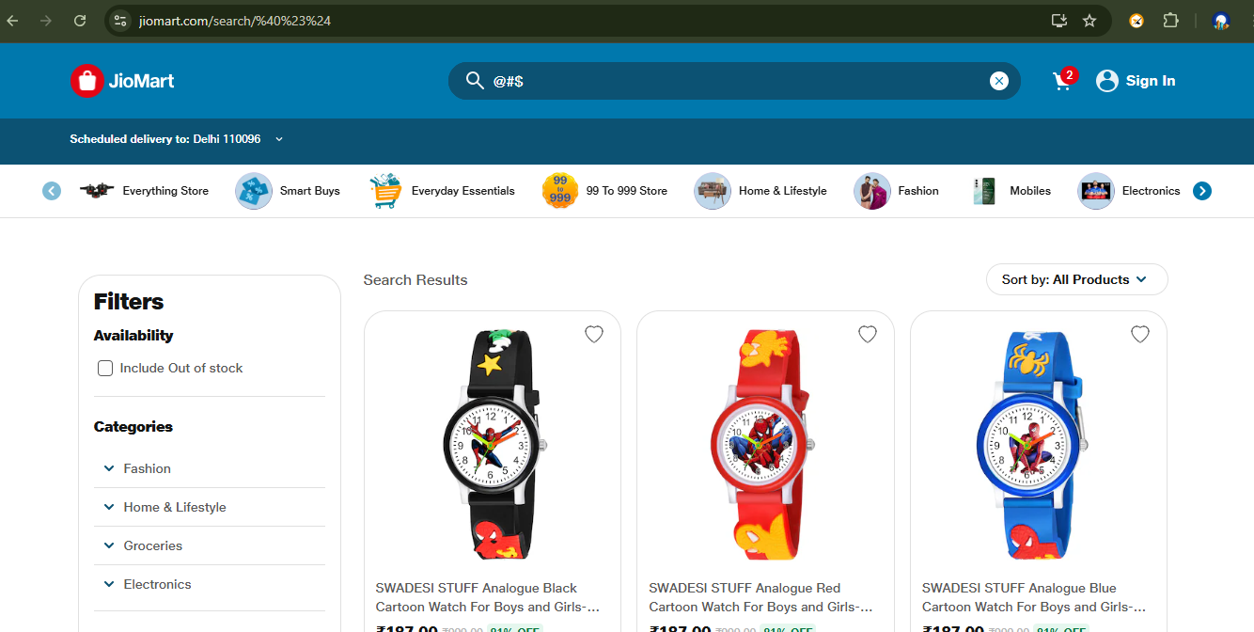

**Bug ID: Bug-002**

**Title:** Quantity limit exceeded without proper warning  
**Steps to Reproduce:**

1. Search for *Fortune Oil*
2. Add quantity = 50

**Expected Result:**  
Either full quantity should be added, or system should show a proper warning if stock is limited.

**Actual Result:**  
Only 4 items are added, no error/warning displayed.

**Severity:** High  
**Priority:** High  
**Status:** New  
**Browser/Device:** Google Chrome Version:138.0.7204.184 (Laptop)  
**Screenshot:**

**Bug ID: Bug-003**

**Title:** Half Price Store section appears blank  
**Steps to Reproduce:**

1. Navigate to Jiomart homepage.
2. Click on **Half Price Store**.

**Expected Result:**  
Products with 50% discount should be listed.

**Actual Result:**  
Section remains empty.

**Severity:** High  
**Priority:** High  
**Status:** New  
**Browser/Device:** Google Chrome Version:138.0.7204.184 (Laptop)  
**Screenshot:**

**Bug ID: Bug-004**

**Title:** "Brand of the Day" products not displayed  
**Steps to Reproduce:**

1. Open Jiomart homepage.
2. Scroll to **Brand of the Day** section.

**Expected Result:**  
Promotional products should be displayed.

**Actual Result:**  
Section is empty.

**Severity:** High  
**Priority:** High  
**Status:** New  
**Browser/Device:** Google Chrome Version:138.0.7204.184 (Laptop)  
**Screenshot:**

**Bug ID: Bug-005**

**Title:** Dry Fruits section products not displayed  
**Steps to Reproduce:**

1. Open Jiomart homepage.
2. Scroll down to the **Dry Fruits** section.

**Expected Result:**  
All dry fruit products should be displayed in this section.

**Actual Result:**  
Section is empty, no products displayed.

**Severity:** High  
**Priority:** High  
**Status:** New  
**Browser/Device:** Google Chrome Version:138.0.7204.184 (Laptop)  
**Screenshot:**

