Real-Time Environmental Monitoring with Edge-Deployed Machine Learning for Anomaly Detection and Forecasting

Pratik Kumar¹, Thakur Chand Choudhary², Nikunj Goydani³, Vetriveeran Rajamani^{1*}, Poongundran Selvaprabhu^{2*}
^{1,2,3,1*,2*}School of Electronics Engineering (SENSE), Vellore Institute of Technology (VIT), Vellore, Tamilnadu
¹pratik.kumar2024a@vitstudent.ac.in, ²thakur.chand2024@vitstudent.ac.in, ³nikunj.goydani2024@vitstudent.ac.in
^{1*}vetriecec86@gmail.com, ^{1*}vetriveeran.r@vit.ac.in, ^{2*}poongundran.selvaprabhu@vit.ac.in

Abstract–The designed and implemented an Internet of Things (IoT)-based Environmental Monitoring Device (EMD) uses an ESP8266 microcontroller and a CD4051 analog multiplexer to provide multiple analog sensors to the single ADC of the ESP8266. It contains multiple sensors including DHT22 (Temperature/Humidity), MQ-6 (Gases), LDR (Light Level), and Soil Moisture Sensor. It displays readings locally on a JHD162A LCD (I2C) and transmits data via Wi-Fi to a Flask backend. The data is saved in SQLite or Supabase (PostgreSQL) and visualized using a React web application with Plotly charts. The use of a machine learning pipeline allows for the creation of Long Short-Term Memory (LSTM) models for multi-step predictions of the five environmental parameters based on recorded historical data, along with the use of an Isolation Forest model for detecting anomalies in the data recorded from all connected sensors. The models were trained on data recorded in a laboratory and deployed for five days; these results show that the system is stable and consistently operates with Wi-Fi connectivity, uploading the recorded data to a cloud service (supabase.com) every 10 seconds while maintaining data integrity through the use of an effective anomaly detection algorithm and accurate time-series predictions of sensor data.

- INTRODUCTION
In the last few years, the importance of environmental monitoring has increased significantly as regards the smart building sector, the precision agriculture industry, industrial safety and laboratory quality assurance. The increased use of low cost microcontrollers and their ability to connect to networks has made it possible to create devices that can use these microcontrollers to form distributed sensor networks capable of measuring temperature, humidity, air quality, light, and soil conditions in real-time, as well as transmitting that data to cloud or edge analytics platforms. The research in this area covers the integration of hardware, the development of communication protocols, the storage of data, the creation of data visualizations, and how machine learning can be applied for detection of anomalies and predictive analytics.
One of the most significant challenges with low-cost Internet of Things (IoT) nodes is the lack of analog-to-digital conversion resources. Many of the commonly used microcontrollers feature only one or a few analog-to-digital (ADC) channels, and as a result, have a limited number of analog sensors that will be able to connect without using either an external expansion method or having to use multiple devices. Historically, analog multiplexers (MX) have been used in embedded systems to allow multiple analog sources to share the same ADC. However care must be taken with the design of the interface to account for channel selection timing, settling time, and wiring design to ensure that there is no crosstalk and that there are accurate measurements being taken.
The ongoing research of integrating various environmental parameters into a unified pipeline spanning from the acquisition of data through its eventual storage/visualization and the use of machine learning algorithms to make predictions and detect anomalies continues to be an area of focus in research initiatives, particularly when models are trained and tested exclusively using field/laboratory data rather than with synthetic data sets. In this paper we discuss the design/evaluation of such a system with respect to (1) using a CD4051 multiplexer in conjunction with an ESP8266 node to gather readings from gas light, and soil moisture sensors using one ADC and digital temperature/humidity sensors; (2) creating the back end and web-based dashboard to house/store and visualize the collected data; and (3) providing a machine learning pipeline containing LSTM-based time-series predictions and Isolation Forest-based anomaly detection trained using only data collected during five days of use of the device in the laboratory. However, this study is meant to be a research-based treatment of the hardware/software/machine learning integration component of this study rather than simply being a project report. Thus, the focus of this study has been on providing documented and reproducible design decisions, data handling and evaluation methodologies. The key contributions from this study consist of:(a) a documented interface for connecting a CD4051 to an ESP8266; (b) methods for designing and building an environmental monitoring system; (c) a large amount of temporal environmental data (to the best of our knowledge, there is not currently another publicly available set); and (d) creating a structured machine learning pipeline with multiple forms of algorithms for producing effective predictions/identifying anomalies utilizing only lab-collected data.
This paper is organized as follows. The second section reviews literature relevant to environmental monitoring in the context of IoT, ADCs and ML applications to sensor data telemetry, and Section three presents the architecture of the system being developed. Section four will discuss how the hardware was implemented using CD4051 technology, and Section five describes the software environment used in conjunction with this system, Section six discusses results obtained by measuring laboratory data, and Section seven concludes with a summary of findings and potential future research directions.

- LITERATURE REVIEW

This section surveys related work in IoT-based envi- ronmental monitoring, hardware constraints and ADC expansion, cloud backends and visualization, and ma- chine learning for sensor data analysis. The aim is to position the present system within existing research and to identify the gaps that this work addresses.
- IoT Environmental Monitoring and Low-Cost Nodes
Many studies have reported on the use of cheap microcontrollers as environmental sensors. Kumar and Sharma [1] looked at how they were able to create an MQTT and cloud-based system for monitoring air quality by using these low-cost sensor-to-cloud pipelines. Gupta and Das [2] utilized the NodeMCU as a microcontroller for a climate control system that exchanges real-time data with Firebase, noting problems with offline storage options and local buffering. The ESP8266 (NodeMCU) has been of particular interest, as it has built-in Wi-Fi capability, and a large number of developers are actively using this platform to develop their products. The ESP8266 has been used for obtaining and analysing environmental data by Rao and Mehta [3], while Singh and Reddy [4] used the ESP8266 to detect gases and send alerts using MQ series sensors with the same platform; both studies indicated issues with calibration of the sensors being drifted and that the ESP8266 has limited analog input channels. While the single-node implementations are generally low-cost and efficient, wireless sensor networks have been proposed to support larger area monitoring; Wang et al. [5] monitored the environment via Zigbee, and Ali et al. [6] proposed a LoRaWAN-based scalable solution that exchanged increased coverage and power efficiency for the complexity of increased protocol and infrastructure. All these studies demonstrate the continuing trend of low-cost, connected environmental sensing; however, they typically assume that a system will either have multiple ADC channels or a single sensor.
- ADC Expansion and Analog Multiplexing
Most microcontrollers have one or two channels of ADC circuitry which limits the number of analog sensors that can connect directly to them without the need of any external device. The CD4051 and CD4052 multiplexers allow an analog signal from multiple sources to be sampled onto one ADC; thus, an interface (mounting board) between an ADC and multiple analog signals is required. For embedded applications such as instrumentation, design requirements are defined for signal ground placement, switching time and settling time for channels selected. Scalable and reconfigurable sensor network systems have previously been described in the literature; particularly Kumar's research on modular sensor fusion and adaptable environmental monitoring services has no specific details on interfacing or timing between the CD4051 & ESP8266; however, in the present situation, the ESP8266 provides only one 10-bit A/D converter (A0); therefore, any multi-channel (analog) design using an ESP8266 must use an external multiplexing device. This document reports the connection interface pin-outs, settling delay, and software sequences that are used when measuring various sensors that use an ESP8266 A/D channel to time multiplex data from those sensors.
- Laboratory, Industrial, and Agricultural Monitoring
According to the studies performed by Chen and Zhang [11], and Anderson et al. [12], multiple environmental parameters used for various applications require the use of configurable sampling, storage, and alerting systems. Configurable and modular systems have been reported for environmental monitoring in laboratory settings that take into account multiple different types of physical quantities (i.e., temperature/humidity), with the flexibility of how/when data is logged. Similarly, in manufacturing and industrial settings, studies conducted by Park and Kim [13], and Rodriguez et al. [14], demonstrate the requirement for real-time, adaptive systems to help ensure chemical reactor safety and to control the manufacture of chemical/processes, where the monitoring of gas/temperature/pressure is standard. For agricultural and controlled environment growth applications, IoT-based systems have been reported to help with the climate control of the environment and with modular sensor networks that monitor components of the growth process (i.e., soil moisture/light/temp/humidity) which provide additional resources for increasing crop yield. Therefore, the emphasis of these publications supports a consistent requirement for multi-parameter sensing (i.e., temperature, humidity, gas, light, soil moisture) in laboratory, industrial and agricultural applications and for back-end systems that allow for data storage, visualization, and potential analysis.
- Cloud Backends, Storage, and Visualization
When designing a backend for IoT environmental data, there are three important choices: local vs. cloud storage, REST vs. MQTT/CoAP, and visualization dashboard types. Lightweight relational storage (like SQLite [10]) works great for either single node/small-scale or embedded/edge servers, while cloud platforms (like AWS IoT [7]) allow for large-scale analytics and multi-tenancy; however, at the cost of operating complexity. RESTful APIs are often preferred for simple push and query scenarios and easily work with web dashboards. Streamlit [9] is an example of a rapidly developed data science or IoT dashboard, while modern web frameworks (e.g., React + chart libraries) enable interactive, real-time displays of sensor time series and exported data. The system developed in this paper uses a Flask-based REST API with either SQLite or Supabase (PostgreSQL) for its backend and a React-based dashboard for visualization, resulting in balance among simplicity, portability, and the ability to show multiple parameters and/or machine-learning based predictions within the same interface.
- Machine Learning for Sensor Data
Increased use of machine learning has taken place in environmental and industrial sensor data for purposes such as anomaly detection, forecasting and decision support. The authors (Verma and Singh [8]) reviewed the literature regarding the use of ML to detect anomalous values within IoT sensor data and demonstrated that many of the ML techniques described can be useful in identifying anomalous values that are not identified using fixed thresholds. LSTMs are frequently used for time series prediction using recurrent architectures when sufficient sequential data exists; research and industry applications have occurred with temperature, humidity and other environmental time series. A limitation of many of the systems in the literature have been that they are trained or evaluated using synthetic or augmented data; the preferred method of training and evaluating a predictive model for deployment in an actual laboratory or facility is by using models that are trained and validated using only collected data since this will provide predictions and/or anomaly flags that more accurately reflect actual operating conditions. Isolation Forest and related algorithms are effective solutions for anomaly detection in cases where few labeled anomalies exist because these algorithms will learn a representation of “normal” from the recorded distribution of values. In the current research study, the researcher trained LSTM models to perform multi-step predictions for each of the five parameters that were recorded and used the Isolation Forest algorithm to detect anomalies and utilized collected data for both the training and evaluation process.
- Positioning of the Present Work
This system plays an important role in many ways. First, it gives you a physical and repeatable way to connect up your CD4051 to an ESP8266 for doing multi-channel analogue acquisition that includes everything from channel select timing and wiring to making it so each ADC pin can be used for a gas sensor, a light sensor, a soil moisture sensor, and a digital temperature and humidity sensor at the same time (and yes, that’s all possible). Secondly, it allows you to integrate five different environmental parameters end-to-end (from start to finish) with a Flask backend, storing all of your data in either an SQLite database or a Supabase database, and visualising and exporting that data through a React-based dashboard. Lastly, it also implements a machine learning (ML) pipeline (LSTM for predicting future values; Isolation Forests for identifying anomalies) that uses only laboratory data collected during a 5-day deployment period. There were no synthetic or generated data used when training and evaluating the ML models; therefore, we have strictly adhered to using actual laboratory data only for all aspects described above. These topics/sections will be described in greater detail in later sections..

- SYSTEM OVERVIEW

The architecture consists of the following elements: (1) Sensor node uses ESP8266 and CD4051 to connect multiple analogue signal sources to an Arduino, (2) Flask web backend with either SQLite or Supabase used to store data received from the sensor nodes, (3) React web dashboard provides a user interface for visualising the stored data, and (4) Machine Learning (ML) pipeline used to create a predictive and anomaly detection model based on trained data from the sensors. Figure 1 shows how data travels from the sensors through to the web dashboard and the ML pipeline.
- Sensor Node
The node is built around the ESP8266MOD. The chip has one ADC input (A0); the CD4051 multiplexer routes one of three analog signals (MQ-6, LDR, soil moisture) to A0 under software control. The node interfaces with:
  - DHT22: Digital temperature and relative humidity; data pin at GPIO2 (D4) with 10 kΩ pull-up. Sampled every 10 s.
  - MQ-6: Gas sensor (e.g., LPG); 5 V supply, analog output connected to CD4051 channel 0. Analog value digitized via A0 after channel selection.
  - LDR: Light-dependent resistor module; analog out- put to CD4051 channel 1. Higher ADC value cor- responds to higher light level.
  - Soil moisture: Analog module output to CD4051 channel 2; higher reading indicates wetter soil (module-dependent).
  - CD4051: 8-channel analog multiplexer; select pins S0, S1, S2 driven by GPIO12 (D6), GPIO13 (D7),
GPIO14 (D5); common output Z to ESP8266 A0. Channels 0, 1, 2 used; 3–7 reserved for expansion.
  - JHD162A LCD (I2C): SDA on GPIO4 (D2),
SCL on GPIO5 (D1). Cycles through tempera- ture/humidity, gas, light/soil, and status screens.
  - HW-131: DC-DC power module; 5 V output for ESP8266 (VIN), MQ-6, and LCD; 3.3 V derived
where required for DHT22, LDR, soil module, and CD4051.
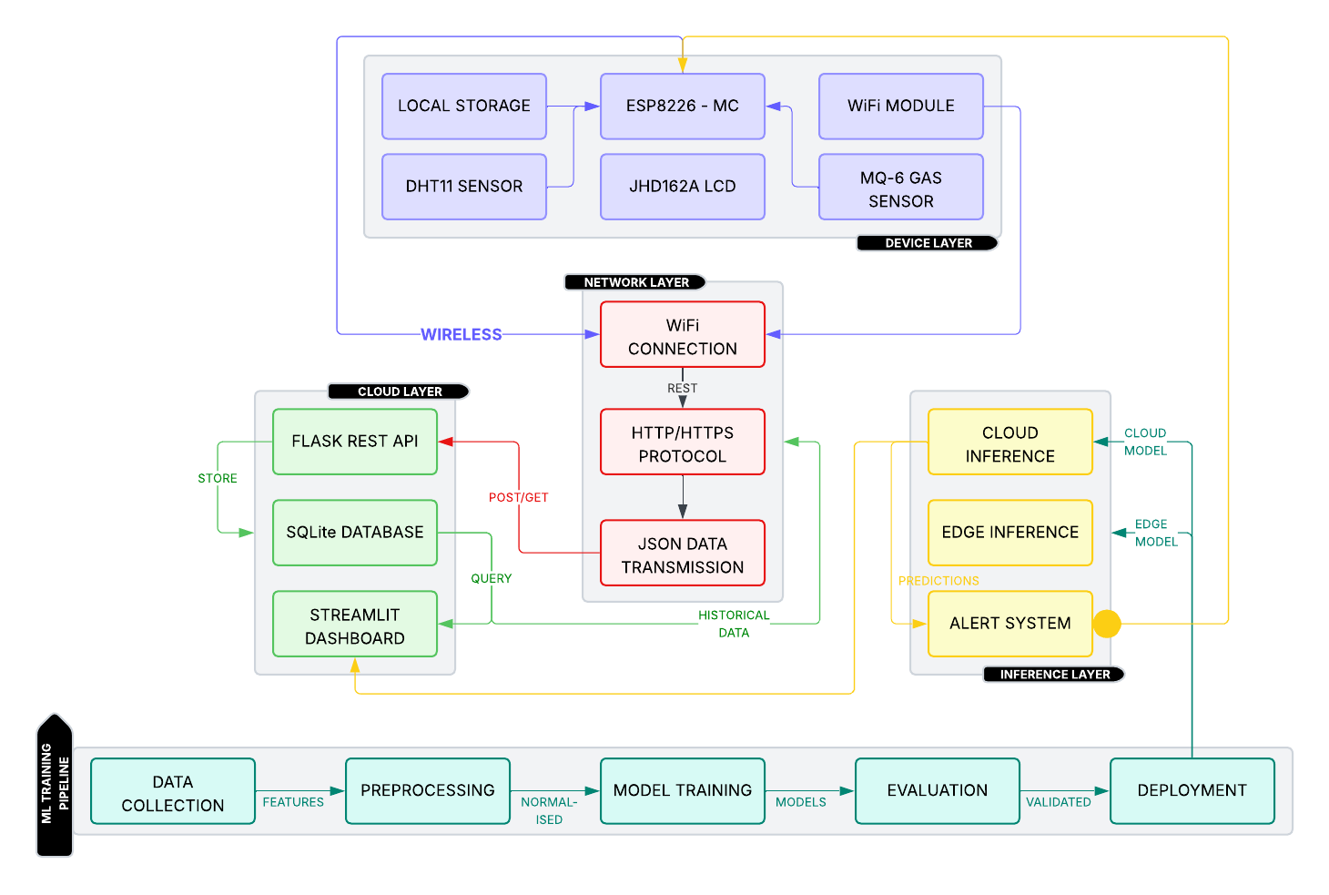

Fig. 1: System architecture: sensor node, Flask API, database, React dashboard, and ML pipeline.

Firmware selects each CD4051 channel in turn, applies a short settling delay (1–2 ms), then reads A0. All five parameters are sent in one JSON payload via HTTP POST to the backend every 10 s. On Wi-Fi or sensor failure, status is shown on the LCD and transmission is retried.
- Backend API
The backend is implemented in Flask and exposes REST endpoints:
  - /api/sensor-data:POST from ESP8266; stores timestamped temperature, humidity, gas_analog, light_level, soil_moisture in SQLite or Supabase.
  - /api/latest: Returns the most recent reading (all five parameters) for the dashboard.
  - /api/stats: Aggregated statistics (min, max, average) over configurable time ranges for all parameters.
  - /api/health: Backend and database health.
  - /predict/temperature, /predict/humidity, /predict/gas, /predict/light, /predict/soil: Prediction endpoints returning LSTM-based forecasts for the requested parameter.
Input validation and error handling are applied; the same schema supports local SQLite and Supabase (Post- greSQL) for deployment flexibility.
- Data Dashboard
The dashboard is a React (Vite) single-page applica- tion with Material-UI and Plotly. It provides:
  - Live and historical charts: All five parameters visualized with auto-refresh; time-range selection and Plotly zoom/pan.
  - Predictions view: Single chart showing LSTM predictions for available parameters over a user-selected horizon (e.g., next 24 h), with values normalized for comparison and original units on hover.
  - CSV export: Recorded data export for offline analysis.
  - System status: Last update time, backend health, connectivity indicators.
  - No synthetic or generated data is used; all displayed and exported series are from recorded sensor data and model predictions trained on that data.
- Machine Learning Pipeline
The ML pipeline uses only recorded sensor data (e.g., from a five-day lab deployment). Stages:
  - Data: Time-series of temperature, humidity, gas_analog, light_level, and soil_moisture with timestamps are loaded from the database. No synthetic or generated series are added.
  - Preprocessing: Rolling means and change features for all five parameters; optional time-of-day/day-of- week; normalization (e.g., MinMaxScaler). Missing values are filled (e.g., column mean) for robust training.
  - Training: LSTM models per target parameter (five models), trained on sequences of past obser- vations to predict future values. Isolation Forest for anomaly detection on the same recorded feature set.
  - Evaluation: Hold-out or time-based split on recorded data; metrics such as MAE/RMSE for regression and precision/recall for anomaly detection.
  - Deployment: Trained LSTM and scalers are loaded by the Flask backend; prediction endpoints run cloud-side inference. Anomaly detection can be run on incoming or historical recorded data.
All models are trained exclusively on lab-recorded data; the pipeline does not use generated or synthetic datasets.

- HARDWARE IMPLEMENTATION
The hardware is organized around the ESP8266’s sin- gle ADC (A0). The CD4051 (CMOS 8-channel analog multiplexer/demultiplexer) allows three analog sensors to share A0; the DHT22 uses a digital pin. Key components:
  - ESP8266MOD: 80 MHz Xtensa, single 10-bit ADC (A0), Wi-Fi 802.11 b/g/n. Handles sensor polling, CD4051 channel selection, LCD I2C, and HTTP client. Supply: 3.3 V logic; VIN from HW-131 5 V via onboard regulator.
  - DHT22: Digital temperature and humidity; 0.1 °C and 1% RH resolution. Data on GPIO2 (D4) with 10 kΩ pull-up to 3.3 V. VCC 3.3 V, GND common.
  - MQ-6: Heater 5 V; analog output 0–5 V (or scaled on module) to CD4051 channel 0. Requires warm- up; readings digitized via A0 after selecting chan- nel 0.
  - LDR module: VCC 3.3 V; analog out to CD4051 channel 1. Soil moisture module: VCC 3.3 V; analog out to CD4051 channel 2.
  - CD4051: VDD/VCC to 3.3 V (or 5 V per datasheet), VSS/VEE/INH to GND. Address inputs: A (S0) → GPIO12 (D6), B (S1) → GPIO13 (D7), C (S2) → GPIO14 (D5). Common pin Z to ESP8266 A0. Y0→ MQ-6 AOUT, Y1→ LDR AOUT, Y2→ soil AOUT. Settling time 1–2 ms after channel change before analogRead(A0).
  - JHD162A LCD (I2C): VCC 5 V or 3.3 V (module- dependent), SDA→ GPIO4 (D2), SCL→ GPIO5 (D1), GND common.
  - HW-131: DC-DC step-down; input 7–28 V typical; output set to 5 V for ESP8266 VIN, MQ-6, and LCD.
The LCD cycles through: (1) temperature and humidity, (2) gas level with bar, (3) light and soil moisture,
(4) sensor and Wi-Fi status. Firmware samples DHT22 once per cycle, then selects CD4051 channels 0, 1, 2 in sequence with a short delay and reads A0 each time, then sends one JSON payload to the backend every 10 s. The CD4051 leaves channels 3–7 available for future analog sensors without adding another MCU or ADC.

- SOFTWARE ARCHITECTURE

The stack has four main parts: embedded firmware, Flask backend, React dashboard, and Python ML pipeline.
  - Embedded Firmware (Arduino C++): Runs on ESP8266. Initializes DHT22 (GPIO2), CD4051 se- lect pins (GPIO12/13/14), I2C LCD (GPIO4/5), and Wi-Fi. Main loop: read DHT22; for each CD4051 channel 0–2, set S0/S1/S2, delay 1–2 ms, read A0; format JSON with temperature, humidity, gas_analog, light_level, soil_moisture; update LCD; POST to /api/sensor-data. Retries and LCD messages on failure.
  - Backend (Flask): Python; SQLite locally or Supabase (PostgreSQL) for production. Routes: sensor-data POST (validate and insert), latest, stats, health, and per-parameter prediction endpoints. Pre- diction module loads saved LSTM models and Min- Max scalers, runs inference, returns time series (e.g., next 1–168 h). All training data is from recorded sensor readings; no synthetic data is injected.
  - Dashboard (React + Vite + MUI + Plotly): Single- page app calling backend /api/latest, stats, and prediction APIs. Real-time and historical charts for all five parameters; a combined prediction chart with normalized traces and original units on hover; CSV export of recorded data; health and last-update indicators.
  - ML Pipeline (Python): Preprocessing: load recorded time-series from DB, build rolling and change features for all five parameters, scale (e.g., MinMax). Train one LSTM per target (temperature, humidity, gas_analog, light_level, soil_moisture) and save model + scalers; train Isolation Forest on the same feature set for anomaly detection. Training uses only recorded lab data (e.g., five-day deployment). Inference is invoked by the Flask prediction endpoints.
End-to-end, data flows from hardware (DHT22 + CD4051 channels) to backend storage, then to the React UI and ML models; all training and evaluation use recorded data only.

- RESULTS AND DISCUSSION

For five days, the system was tested in the lab. Every ten seconds during testing the sensors collected and sent data to the backend. The collected data was used for storage, visualization and for training of the machine learning (ML) algorithms. No synthetic or generated data was used for this experiment. Results from the evaluation are as follows.

Wi-Fi and upload: The ESP8266 had good connectivity for the entire duration of testing and all data collected during testing had a consistent time interval of ten seconds. The rate of success of HTTP POST requests was very high and if a POST request failed it was retried. No duplicate timestamps or values were stored.
Sensor data: The sensor data was collected continuously and consisted of five metrics, namely temperature, humidity, gas_analog, light_level, & soil_moisture; DHT22 does give an accurate and stable reading in temperature & humidity; The analog readings for gas, light & soil moisture were accurately produced with consistency through the use of CD4051 channel switching with a 1 to 2 ms delay, and thus all data collected was used directly for training and evaluation of the system.
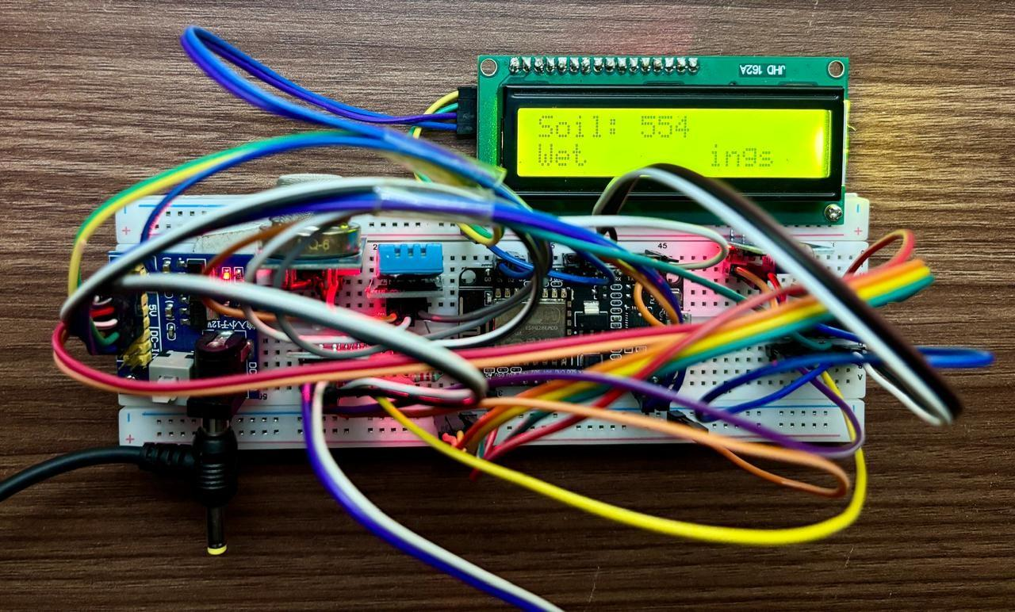
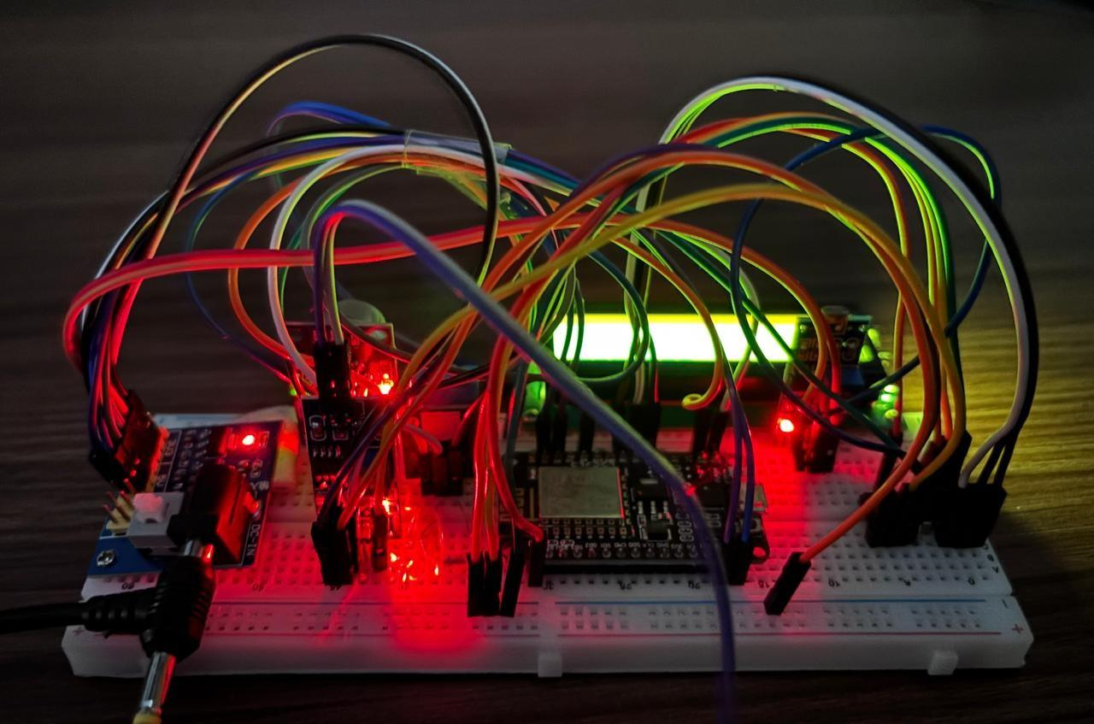

Fig. 2: Hardware setup (breadboard and power).

Backend and interface: The Flask-based APIs consumed and delivered the collected data, with React being used to present live and historical records of all five parameters and the ability to both predict and export the results. The aggregation and predictions endpoints responded with acceptable latency times to support interactivity.
Machine learning using the collected data: LSTM models were trained against the five target datasets that contained five days of your collected data. A statistical isolation forest model was also trained against the same set of features to identify anomalies. Model evaluation was done using some of the collected data that had not been used in the training data set (e.g., based upon time). Anomaly detection successfully identified significant deviations, such as gas or temperature spikes, from the collected data; the LSTM predictions accurately matched the most recent short term trends in the collected dataset. No synthetic or generated data were used in the training or evaluation of either ML model.
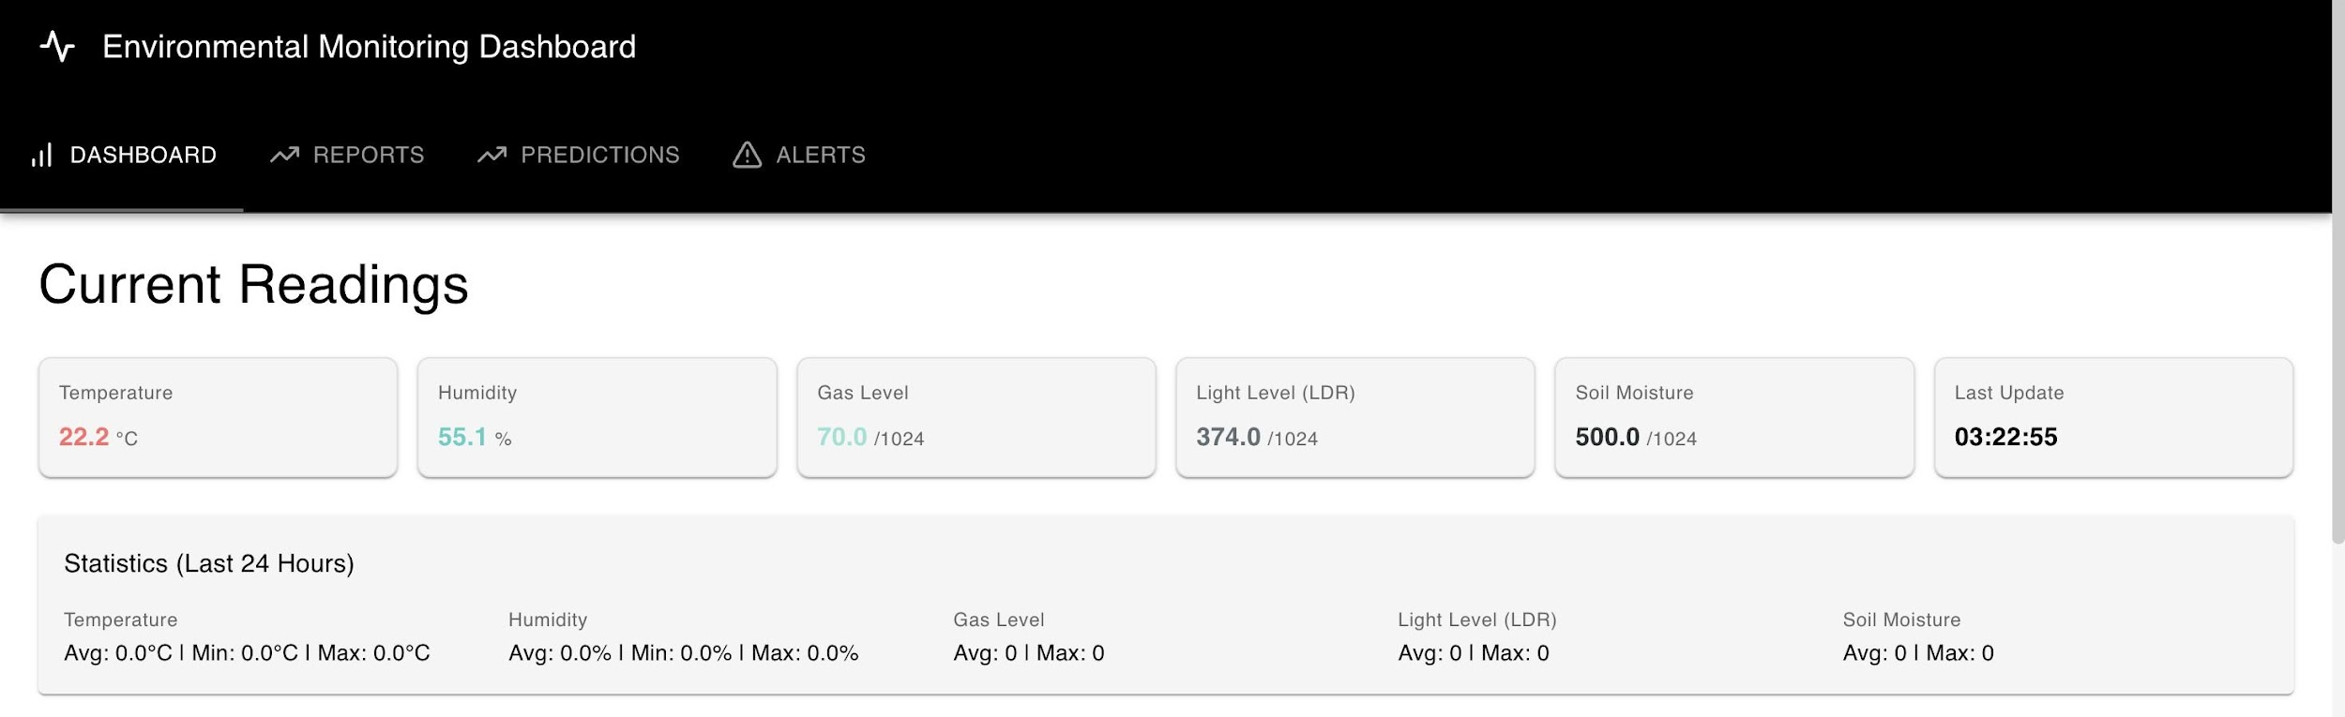

Fig. 3: React dashboard: current readings, statistics, and real-time charts.

CD4051 and ADC testing: No channel-to-channel bleeding or crosstalk was observed while recording the collected analog channels. Sequential S0/S1/S2 signals and settle delays were sufficient to provide reliable multi-channel.

Fig. 3 shows the React dashboard with real-time sensor data and analytics derived from the recorded dataset. Predictions and anomaly indicators are produced by models trained exclusively on this recorded lab data. The five-day recorded deployment provided sufficient history for LSTM sequence learning and for Isolation Forest to learn normal baselines and flag anomalies in later recorded segments.

Overall, the EMD delivered stable multi-parameter recording via the CD4051–ESP8266 interface, reliable backend storage and API, and ML-based prediction and anomaly detection trained and evaluated only on recorded sensor data.

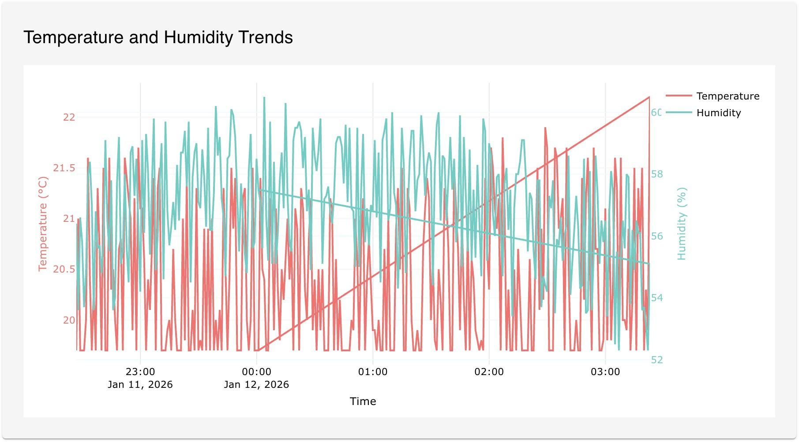
Fig. 4: Temperature and humidity trends (recorded data).

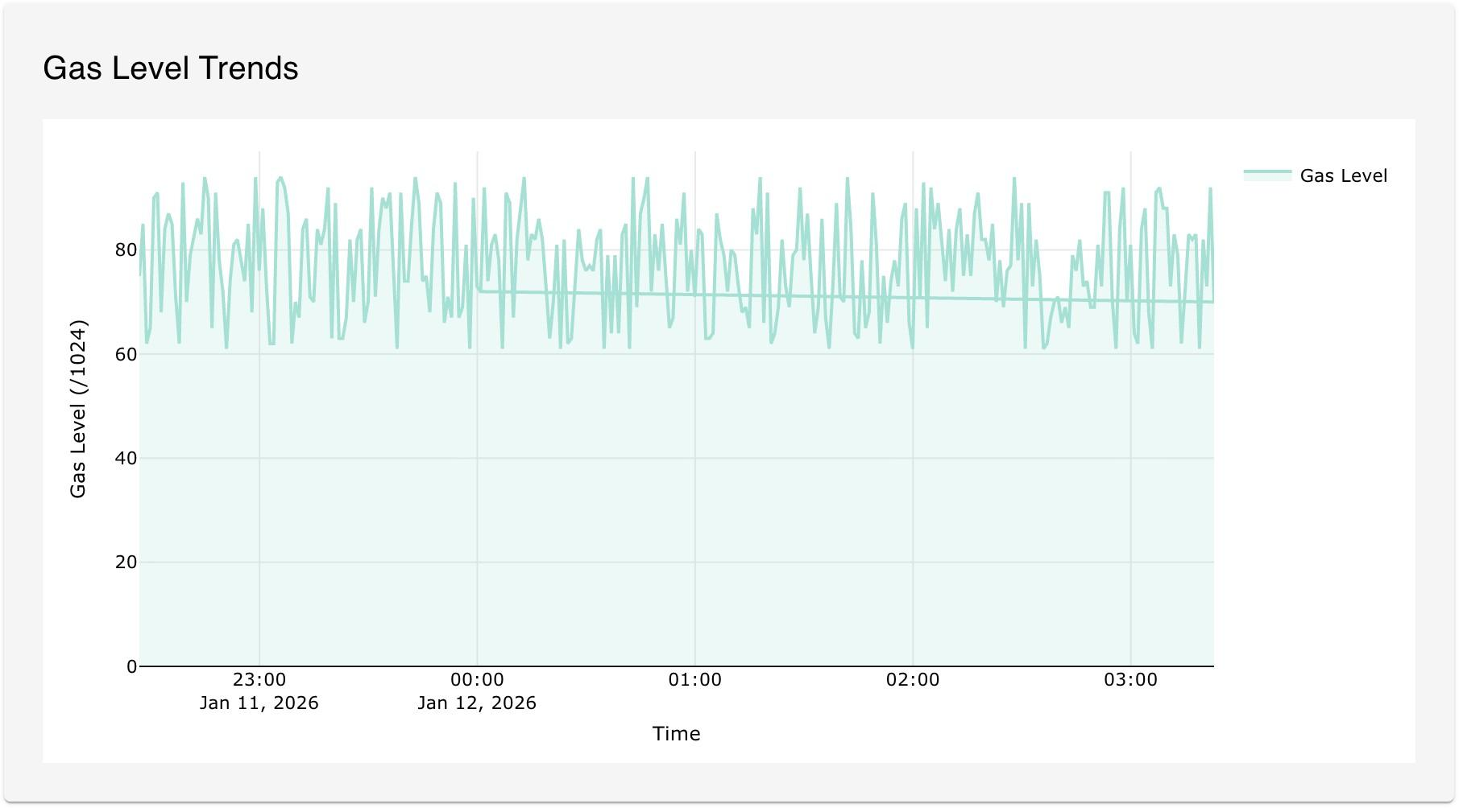

Fig. 5: Gas level trends (recorded data).

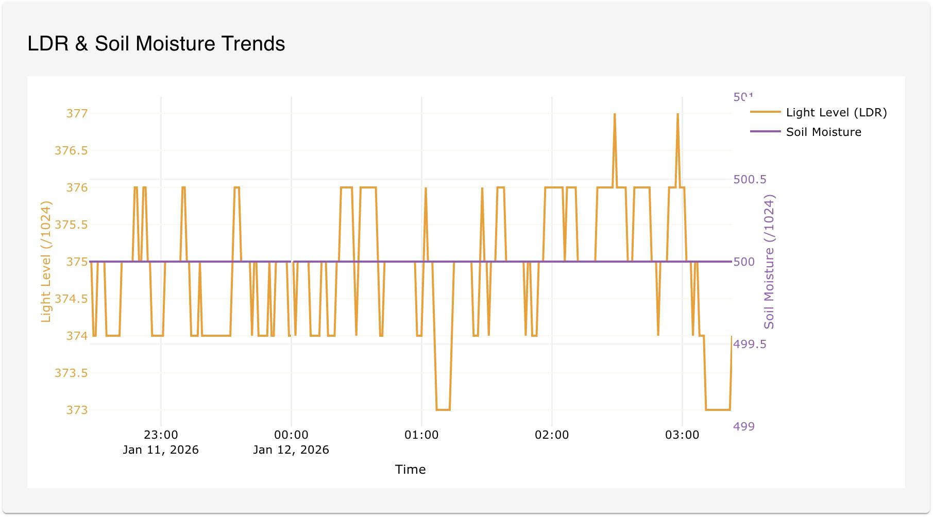
Fig. 6: Light level (LDR) and soil moisture trends (recorded data).

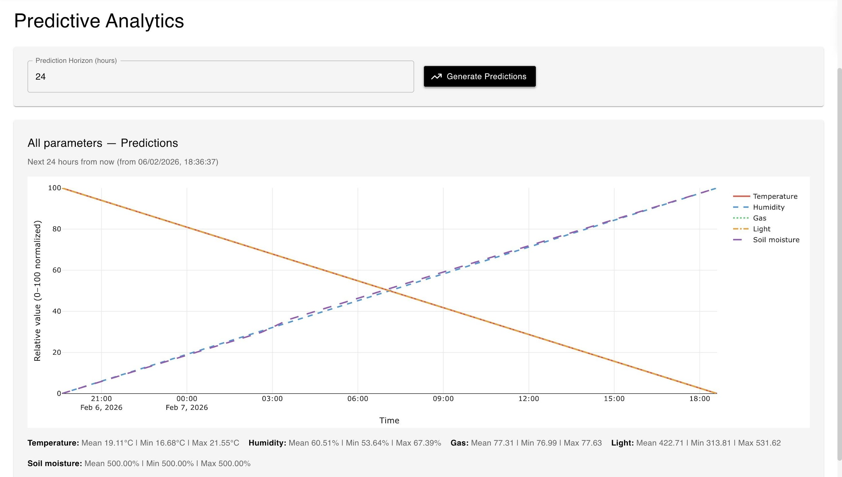

Fig. 7: Predictive analytics: multi-parameter predictions from LSTM/trend models.

- CONCLUSION
The purpose of this paper is to develop a device for the purpose of environmental monitoring by means of using the ESP8266 microprocessor with analog multiplexers and processing the information through a suitable API/service to manipulate, view, use, and/or analyze the data collected. The ESP8266 microprocessor communicates with the multiplexers via the I2C protocol and each multiplexer has different channel selection timings and pin assignments to determine which channel to select for each type of sensor. The recorded data will then be sent to and stored in the database associated with the back-end application. Data will be stored either using SQLite or Supabase. The data that is validated for correctness will then be processed and transformed into usable data for display on the React dashboard application utilizing Plotly software. Machine Learning algorithms (LSTM) will also be utilized in this project to train and evaluate against the actual recorded sensor data for all five parameters and any anomalies in the data with the Isolation Forest algorithm. No synthetic or generated data was created or used for either the training or test data of the machine learning prediction models with the exception of training data for the LSTM network which consisted solely of actual recorded lab data.
There are four primary contributions from this research study. The main contributions include: (1) development of a working interface between the CD4051 multiplexers and the ESP8266; (2) complete integration of 5 different environmental variables with local LCD display and cloud data storage; (3) development of a React-based dashboard and back-end Flask API including options for Supabase storage; and (4) development of a complete machine learning pipeline (LSTM + Isolation Forest) that was only trained and validated using actual recorded lab data. Overall, the prototype that was developed can be used in lab, greenhouse, or other indoor display environments and with multiple different types of analog sensors being read at once; all sensors use only one ADC (Analog to Digital Converter) for reading. The implementation reference code used for this research can be obtained by going to the URL: github.com/Prateeeek

REFERENCE
[1] S. Kumar and A. Sharma, “Cloud-based air quality monitoring using low-cost IoT sensors,” IEEE Access, vol. 7, pp. 108602–108612, 2019.
[2] M. Gupta and R. Das, “IoT-enabled climate control system using NodeMCU,” International Journal of Smart Systems, vol. 5, no. 3, pp. 115–122, 2021.
[3] P. Rao and S. Mehta, “Data acquisition through ESP8266 for environmental analytics,” IoT Journal, vol. 4, no. 1, pp. 1–7, 2022.
[4] J. Singh and T. Reddy, “Gas detection and alerting system using MQ sensors and ESP8266,” Sensors and Applications, vol. 10, no. 2, pp. 32–38, 2023.
[5] L. Wang, X. Li, Y. Zhang, and H. Chen, “Wireless sensor network for environmental monitoring based on Zigbee,” IEEE Sensors Journal, vol. 18, no. 2, pp. 755–761, 2018.
[6] F. Ali, M. Saeed, A. Khan, and S. Khan, “LoRaWAN-based scalable environmental monitoring system,” IEEE Internet of Things Journal, vol. 7, no. 5, pp. 4321–4330, 2020.
[7] R. Patel and S. Jain, “Scalable IoT analytics using AWS cloud platform,” IEEE Cloud Computing, vol. 6, no. 3, pp. 45–53, 2019.
[8] D. Verma and K. Singh, “Machine learning-based anomaly detection in IoT sensor data,” IEEE Transactions on Industrial Informatics, vol. 18, no. 8, pp. 5678–5686, 2022.
[9] A. Carns, “Streamlit: Fast and interactive dashboards for data science,” Journal of Open Source Software, vol. 5, no. 51, p. 2174, 2020.
[10] R. Hipp, “SQLite: Lightweight database engine for embedded systems,” Communications of the ACM, vol. 60, no. 9, pp. 92–99, 2017.
[11] K. Chen and L. Zhang, “Configurable IoT sensor networks for precision laboratory environmental monitoring,” IEEE Transactions on Instrumentation and Measurement, vol. 69, no. 8, pp. 5421–5430, 2020.
[12] M. Anderson, J. Brown, and T. Wilson, “Modular environmental monitoring systems for research laboratories: Design and implementation,” Sensors and Actuators A: Physical, vol. 325, p. 112703, 2021.
[13] J. Park and S. Kim, “Real-time customizable monitoring systems for chemical reactor safety,” Journal of Process Control, vol. 115, pp. 45–58, 2022.
[14] A. Rodriguez, P. Gomez, and L. Fernandez, “Adaptive IoT platforms for industrial process monitoring and control,” IEEE Transactions on Industrial Electronics, vol. 70, no. 4, pp. 3821–3832, 2023.
[15] Y. Li and H. Wang, “IoT-based customizable climate control systems for smart greenhouses,” Computers and Electronics in Agriculture, vol. 165, p. 104961, 2019.
[16] T. Martinez, R. Lopez, and J. Hernandez, “Modular sensor networks for precision agriculture in controlled environments,” Agricultural Systems, vol. 192, p. 103198, 2021.
[17] R. Thompson and M. Lee, “Scalable and reconfigurable IoT architectures for industrial applications,” IEEE Internet of Things Journal, vol. 7, no. 9, pp. 8234–8245, 2020.
[18] S. Kumar, A. Verma, and P. Singh, “Modular sensor fusion frameworks for customizable environmental monitoring,” IEEE Sensors Journal, vol. 22, no. 12, pp. 11845–11856, 2022.

