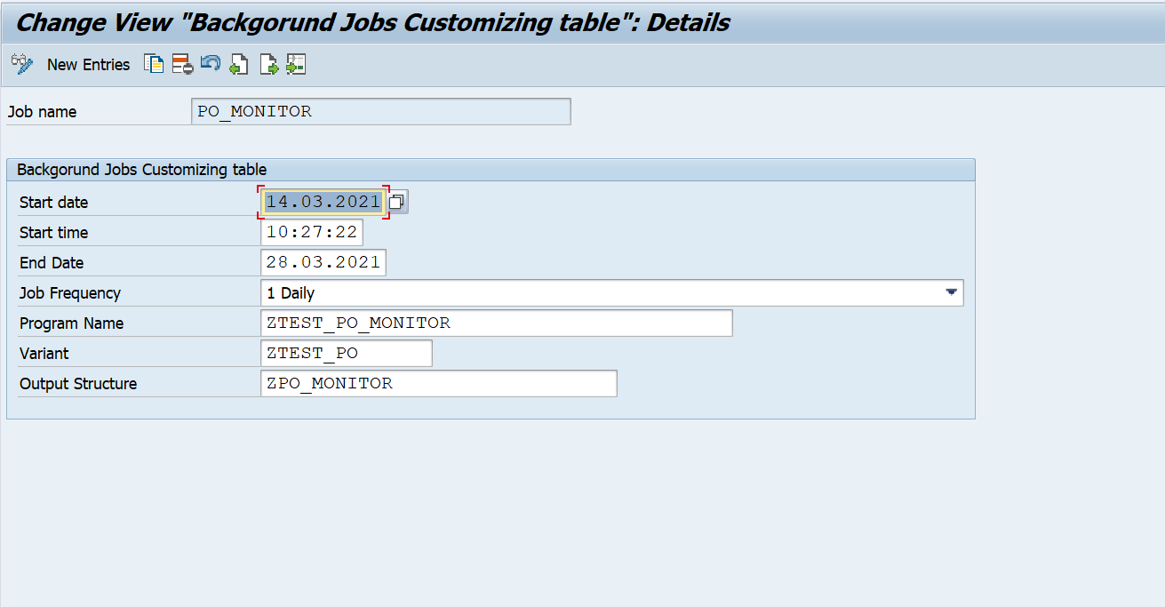

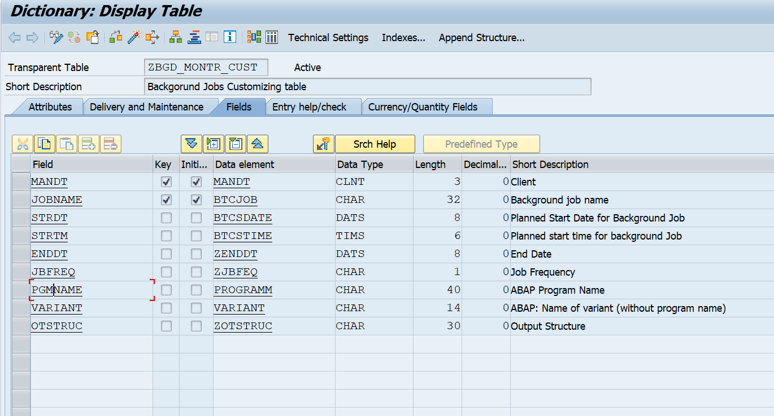

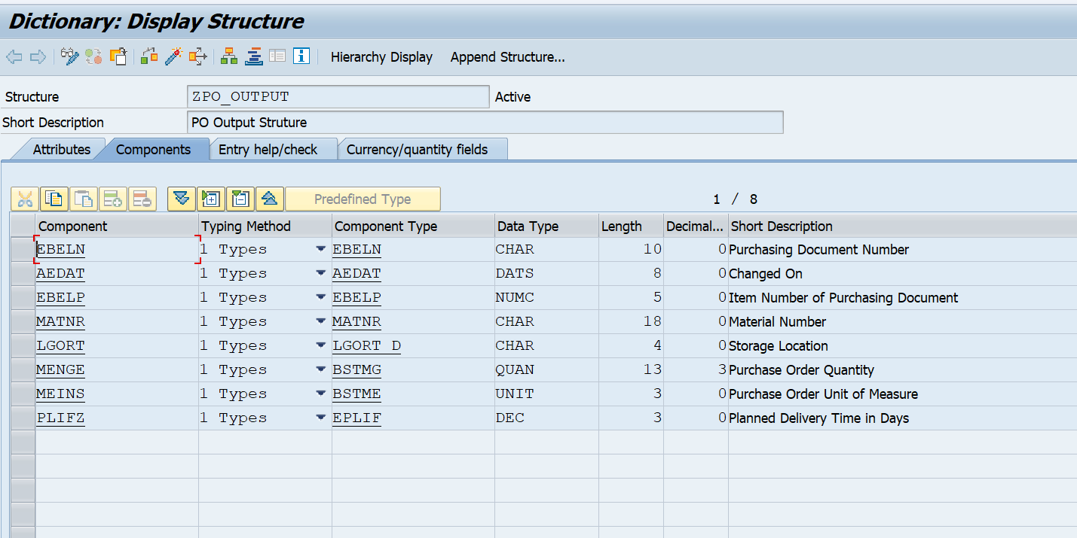

*&---------------------------------------------------------------------*  
*& Report  ZTEST_PO_MONITOR  
*&  
*&---------------------------------------------------------------------*  
*&  
*&  
*&---------------------------------------------------------------------*  
report ZTEST_PO_MONITOR.  
  
  
data : LV_DATE type SY-DATUM.  
  
parameters: P_DATE type SY-DATUM.  
  
start-of-selection.  
  
  LV_DATE = P_DATE - 2000.  
  
  select A~EBELN, A~AEDAT, B~EBELP, B~MATNR, B~LGORT, B~MENGE, B~MEINS, B~PLIFZ  
      from EKKO as A inner join EKPO as B on A~EBELN = B~EBELN  
        into table @data(LT_PO_DATA)  
        where A~AEDAT ge @LV_DATE and  
              B~PLIFZ gt 10.  
  if SY-SUBRC eq 0.  
  
    loop at LT_PO_DATA assigning field-symbol(<LFS_DATA>)..  
      write: <LFS_DATA>-EBELN,  
             <LFS_DATA>-AEDAT,  
             <LFS_DATA>-EBELP,  
             <LFS_DATA>-MATNR,  
             <LFS_DATA>-LGORT,  
             <LFS_DATA>-MENGE,  
             <LFS_DATA>-MEINS,  
             <LFS_DATA>-PLIFZ .  
    endloop.  
  
  endif.

*&---------------------------------------------------------------------*  
*& Report  ZTEST_BCKND_FRMWRK  
*&  
*&---------------------------------------------------------------------*  
*&  
*&  
*&---------------------------------------------------------------------*  
report ZTEST_BCKND_FRMWRK.  
  
  
  
data :  LV_JOBCOUNT   type BTCJOBCNT.  
  
  
select * from ZBGD_MONTR_CUST into table @data(LT_BCKGD)  
          where ENDDT gt @SY-DATUM.  
if SY-SUBRC eq 0.  
  
  loop at LT_BCKGD assigning field-symbol(<LFS_BCK>).  
    call function 'JOB_OPEN'  
      exporting  
        JOBNAME          = <LFS_BCK>-JOBNAME  
        SDLSTRTTM        = <LFS_BCK>-STRTM  
      importing  
        JOBCOUNT         = LV_JOBCOUNT  
      exceptions  
        CANT_CREATE_JOB  = 1  
        INVALID_JOB_DATA = 2  
        JOBNAME_MISSING  = 3  
        others           = 4.  
  
  
    submit (<LFS_BCK>-PGMNAME) using selection-set <LFS_BCK>-VARIANT  
                      via job <LFS_BCK>-JOBNAME  
                      number LV_JOBCOUNT  
                      and return.  
  
    submit ZTEST_READ_SPOOL_DATA with P_PGM = <LFS_BCK>-PGMNAME  
                                 with P_DATE = SY-DATUM  
                                 via job <LFS_BCK>-JOBNAME  
                                 number LV_JOBCOUNT and return.  
  
    call function 'JOB_CLOSE'  
      exporting  
        JOBCOUNT             = LV_JOBCOUNT  
        JOBNAME              = <LFS_BCK>-JOBNAME  
        STRTIMMED            = 'X'  
      exceptions  
        CANT_START_IMMEDIATE = 1  
        INVALID_STARTDATE    = 2  
        JOBNAME_MISSING      = 3  
        JOB_CLOSE_FAILED     = 4  
        JOB_NOSTEPS          = 5  
        JOB_NOTEX            = 6  
        LOCK_FAILED          = 7  
        others               = 8.  
  
  endloop.  
  
endif.

*&---------------------------------------------------------------------*  
*& Report  ZTEST_READ_SPOOL_DATA  
*&  
*&---------------------------------------------------------------------*  
*&  
*&  
*&---------------------------------------------------------------------*  
report ZTEST_READ_SPOOL_DATA.  
  
data: LV_SPL_TIME type RSPOCRTIME,  
      LT_DATA     type table of SOLI.  
  
parameters: P_PGM  type PROGRAMM,  
            P_DATE type SY-DATUM.  
  
  
start-of-selection.  
  
  data(LV_PBM_NM) = P_PGM+0(12).  
  
  LV_SPL_TIME = P_DATE && | '00000000' |.  
  
  select RQIDENT from TSP01 up to 1 rows  
      into @data(LV_SPOOL)  
      where RQ2NAME = @LV_PBM_NM and  
            RQCRETIME gt @LV_SPL_TIME .  
  endselect.  
  if SY-SUBRC eq 0.  
  
    call function 'RSPO_RETURN_SPOOLJOB'  
      exporting  
        RQIDENT              = LV_SPOOL  
        FIRST_LINE           = 1  
*       LAST_LINE            =  
        DESIRED_TYPE         = 'RAW'  
* IMPORTING  
*       REAL_TYPE            =  
*       SP_LANG              =  
      tables  
        BUFFER               = LT_DATA  
*       BUFFER_PDF           =  
      exceptions  
        NO_SUCH_JOB          = 1  
        JOB_CONTAINS_NO_DATA = 2  
        SELECTION_EMPTY      = 3  
        NO_PERMISSION        = 4  
        CAN_NOT_ACCESS       = 5  
        READ_ERROR           = 6  
        TYPE_NO_MATCH        = 7  
        others               = 8.  
    if SY-SUBRC <> 0.  
* Implement suitable error handling here  
    endif.  
  
    loop at LT_DATA assigning field-symbol(<LFS_DATA>).  
      write : <LFS_DATA>-LINE.  
  
    endloop.  
  
  endif.