
ACHARYA INSTITUTE OF TECHNOLOGY
Department of MCA
PROJECT SYNOPSIS
Semester: 2nd and 3rd
Guide Name: Prof. Sumit Singha Chowdhury
Institution Name: Acharya Institute of Technology
Name of the Student: Prateek Veeresh Aggimath
USN: 1AY25MC045
AUID: AIT25MCAV013
Title: Scholarship Eligibility Prediction System

SCHOLARSHIP ELIGIBILITY PREDICTION SYSTEM
1. Abstract
Scholarships provide vital financial assistance to deserving students, enabling them to continue their education without interruption. Educational institutions and government bodies receive a large volume of scholarship applications every year, and manually verifying each applicant's academic performance, family income, attendance, and category details is a slow and error-prone process. The Scholarship Eligibility Prediction System addresses this challenge by using machine learning to analyze student information and predict scholarship eligibility. By learning patterns from historical application data, the system classifies students as Eligible or Not Eligible and generates a probability-based eligibility score, making the selection process faster, more consistent, and more transparent. The predictions and supporting analytics are presented through an interactive web dashboard that helps institutions make informed, data-driven decisions.
2. Introduction
Scholarships play a crucial role in supporting students who cannot fully bear the cost of their education, with eligibility typically determined by factors such as academic performance, family income, attendance percentage, and category-based reservation criteria. Every year, schools, colleges, and government agencies receive thousands of scholarship applications, and the conventional approach of collecting forms, verifying mark sheets and income certificates, checking attendance records, and manually cross-referencing this information against eligibility rules consumes significant time and effort. As the number of applicants grows, this process becomes increasingly difficult to manage, often resulting in delayed decisions, inconsistent evaluations, and deserving students being overlooked.
Machine learning offers an effective solution to this problem by learning the underlying patterns that determine eligibility from historical scholarship data and applying this knowledge to new applicants. The Scholarship Eligibility Prediction System is built on this idea: given a student's academic marks, family income, attendance percentage, and category, a trained classification model predicts whether the student is eligible for a scholarship and assigns an eligibility score reflecting the confidence of that prediction. The results are presented through a web-based dashboard where users can enter student details, view predictions, and understand the key factors that influenced each decision, helping institutions make the scholarship selection process faster, fairer, and more transparent.
3. Problem Statement
Educational institutions receive a large number of scholarship applications every academic year. Manually verifying each student's marks, family income, attendance, and category against eligibility criteria is a time-consuming and labor-intensive task. This often leads to delayed decisions, an increased administrative burden, evaluation errors, and, in some cases, deserving students being overlooked.
Most existing scholarship evaluation systems rely on fixed, rule-based logic and do not provide a quantifiable eligibility score to support decision-making. Many institutions also lack a dedicated platform for entering student data and analyzing eligibility trends. There is a clear need for a system that can accurately evaluate student information, classify applicants as Eligible or Not Eligible, generate an eligibility score, and present student data through meaningful visualizations. Such a system would help institutions identify deserving students efficiently, make informed and consistent decisions, and reduce the manual effort involved in scholarship evaluation.

4. Objectives
- To develop a machine learning-based system that analyzes student information such as academic marks, family income, attendance percentage, and category criteria to predict scholarship eligibility accurately.
- To automate the scholarship evaluation process by classifying students as Eligible or Not Eligible and generating a probability-based eligibility score, thereby reducing manual effort, delays, and inconsistencies.
- To build an interactive web-based dashboard that displays eligibility predictions and student analytics through charts and graphs, supporting fair and data-driven decision-making.
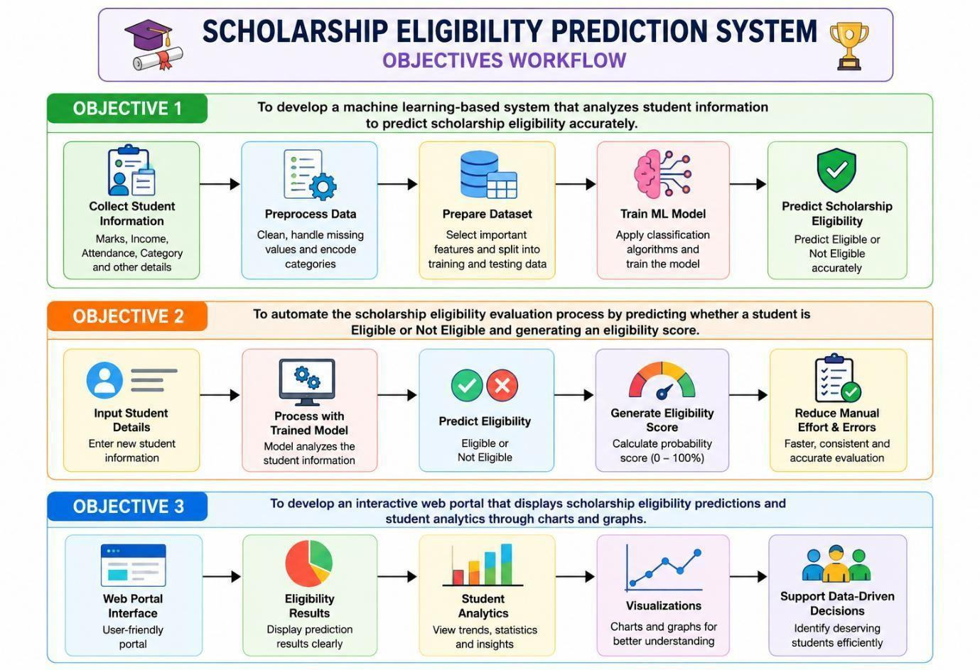
Fig 1: Objectives workflow of the Scholarship Eligibility Prediction System
5. Existing System
Most existing scholarship evaluation systems rely on manual verification supported by fixed eligibility rules. Students submit academic records, income certificates, attendance sheets, category documents, and other supporting papers, which scholarship staff then review individually and match against predefined criteria.
Some institutions use computerized systems that store student records and apply rule-based logic to check eligibility automatically. However, these systems are largely limited to static, rule-based checks and do not analyze historical scholarship data to identify more complex relationships between academic performance, income, attendance, and other factors.
As a result, existing systems face several limitations. Manual processing is slow and resource-intensive when application volumes are high, and purely rule-based systems struggle to capture the nuanced interactions between multiple eligibility criteria, which can lead to inconsistent or less accurate evaluations.

6. Proposed System
The proposed Scholarship Eligibility Prediction System is a simple, web-based solution that automates the evaluation of scholarship eligibility, significantly reducing the time and effort required to process applications and helping institutions identify students who genuinely deserve support.
The system provides a web interface where users can enter a student's academic marks, family income, attendance percentage, and category. This information is processed using Pandas for data handling, and a trained machine learning model predicts whether the student is Eligible or Not Eligible, along with a probability score indicating the strength of that prediction.
What distinguishes this system from existing solutions is its ability to automatically classify eligibility, generate a quantifiable eligibility score, and present student data through clear, easy-to-understand visualizations. By reducing manual effort and evaluation errors, the Scholarship Eligibility Prediction System makes the scholarship selection process more efficient, consistent, and transparent for educational institutions.
7. Methodology
The proposed system follows a structured, step-by-step approach to predict scholarship eligibility, using Python, Pandas, scikit-learn, Flask, and supporting visualization libraries.
Step 1: Data Collection – Student information such as academic marks, family income, attendance percentage, category, and scholarship status is collected from institutional records or publicly available datasets.
Step 2: Data Preprocessing – The collected data is cleaned using Pandas by handling missing values, removing duplicate records, correcting inconsistencies, and selecting relevant student attributes.
Step 3: Feature Engineering – Categorical attributes such as student category are encoded into numerical form, and the features most relevant to scholarship eligibility are selected for model training.
Step 4: Data Splitting – The processed dataset is divided into training and testing sets, with the training set used to build the model and the testing set used to evaluate its performance.
Step 5: Model Training and Evaluation – Classification algorithms such as Logistic Regression, Decision Tree, and Random Forest are trained using scikit-learn and evaluated using accuracy, precision, recall, F1-score, and a confusion matrix. The best-performing model is selected for deployment.
Step 6: Eligibility Prediction – The selected model analyzes new student information and predicts whether the student is Eligible or Not Eligible, along with an eligibility probability score.
Step 7: Web Application Development – A Flask-based web application allows users to enter student details and instantly view the predicted eligibility status and score.
Step 8: Dashboard and Student Analytics – The system displays eligibility results, scholarship scores, and analytics such as eligibility distribution, academic performance trends, and income-level analysis through interactive charts and graphs.
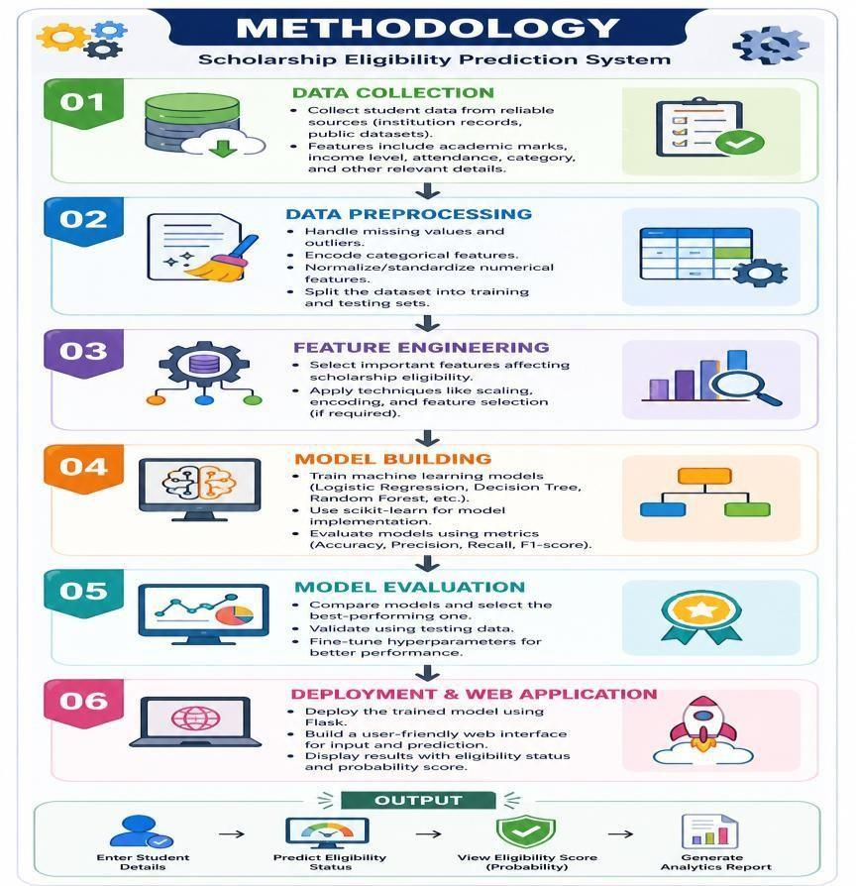
Fig 2: Methodology of the Scholarship Eligibility Prediction System
8. System Modules
- Student Data Input Module – Accepts student information such as academic marks, family income, attendance percentage, category, and other scholarship-related criteria.
- Data Preprocessing Module – Cleans and prepares student data by handling missing values, duplicate records, categorical variables, and inconsistent information.
- Feature Selection Module – Identifies the student attributes that most strongly influence scholarship eligibility.
- Machine Learning Model Module – Trains and evaluates classification algorithms using historical scholarship data.
- Eligibility Prediction Module – Predicts whether a student is Eligible or Not Eligible for the scholarship.
- Eligibility Score Module – Generates a probability score indicating the likelihood of a student receiving the scholarship.
- Student Analytics Module – Analyzes academic performance, income distribution, attendance levels, and category-wise eligibility trends.
- Dashboard Module – Displays eligibility results and student analytics through charts, graphs, and other visualizations.
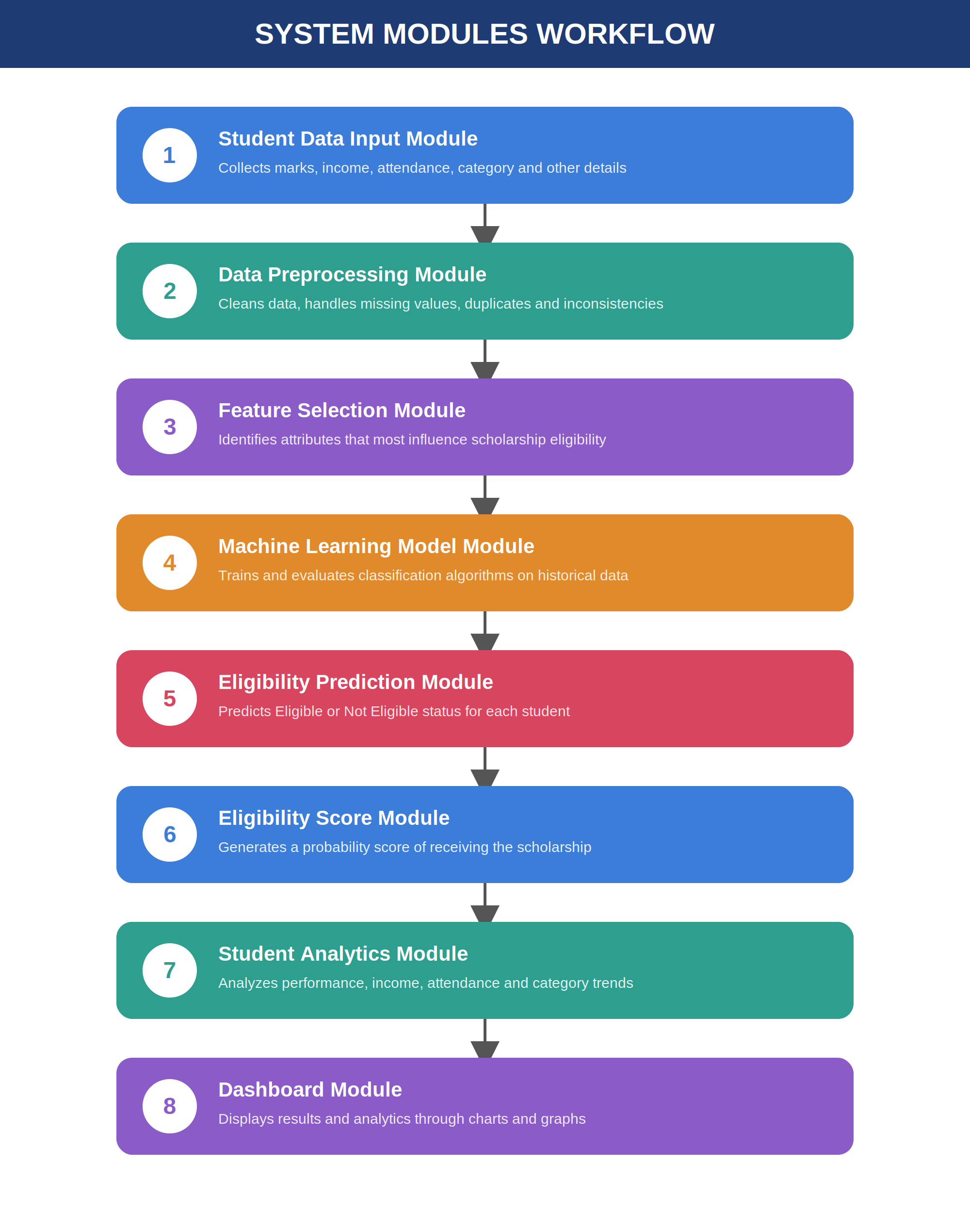
Fig 3: Workflow of system modules
9. Tools / Technologies Used
- Programming Language: Python
- Data Processing: Pandas, NumPy
- Machine Learning: scikit-learn
- Machine Learning Algorithms: Logistic Regression, Decision Tree, Random Forest, Support Vector Machine
- Web Framework: Flask
- Frontend Technologies: HTML, CSS, Bootstrap, JavaScript
- Visualization: Matplotlib, Plotly
- Database: MySQL
- Development Environment: Google Colab, Jupyter Notebook, Visual Studio Code
- Version Control: GitHub
10. Expected Outcome
The expected outcome of this project is a fully functional Scholarship Eligibility Prediction Portal that evaluates student information — including academic performance, family income, attendance, and category — to determine scholarship eligibility. Using a trained machine learning model, the system will classify each applicant as Eligible or Not Eligible and generate a corresponding eligibility score.
The web dashboard will present these results through interactive charts and graphs, showing statistics such as the proportion of eligible students, academic performance trends, income distribution, and attendance patterns. By automating the evaluation process, the system will make scholarship decisions faster and more consistent, reduce manual errors, and help institutions identify deserving students in a fair and transparent manner.
11. Scope and Future Enhancements
- Database Integration – Connecting the system with college and university databases to automatically retrieve student records such as marks and attendance.
- Scholarship Recommendation – Suggesting suitable scholarships to students based on their individual profiles and eligibility.
- Automated Document Verification – Using OCR and related techniques to verify income certificates, mark sheets, and category certificates.
- Explainable AI – Enhancing model transparency by showing students and administrators which factors most influenced an eligibility decision.
- Mobile Application – Developing a mobile app that allows students to check their eligibility and receive personalized scholarship suggestions.
12. Conclusion
The Scholarship Eligibility Prediction System is designed to help educational institutions identify students who are genuinely eligible for scholarships by analyzing academic performance, family income, attendance, and category information through machine learning. The system predicts eligibility, assigns each student an eligibility score, and presents the results through an intuitive, visualization-driven web dashboard.
By automating scholarship evaluation, the system reduces administrative workload, minimizes errors, and ensures a fairer selection process for all applicants. It demonstrates how machine learning and web technologies can be combined to make scholarship distribution more efficient, transparent, and accessible, ultimately helping more deserving students continue their education.
13. References
1. S. K. Yadav and P. K. Sharma, "Machine Learning Based Scholarship Eligibility Prediction System," International Journal of Computer Applications, vol. 185, no. 28, pp. 15–22, 2024.
2. A. K. Singh and R. Verma, "Student Scholarship Prediction Using Machine Learning Techniques," in Proceedings of the 2024 International Conference on Intelligent Computing and Data Science (ICICDS), 2024.
3. R. Patel, S. Gupta, and M. Shah, "Educational Data Mining for Student Performance and Scholarship Prediction Using Classification Algorithms," International Journal of Advanced Computer Science and Applications, vol. 15, no. 3, pp. 210–218, 2024.
4. F. Pedregosa et al., "Scikit-learn: Machine Learning in Python," Journal of Machine Learning Research, vol. 12, pp. 2825–2830, 2011.
5. W. McKinney, "Data Structures for Statistical Computing in Python," in Proceedings of the 9th Python in Science Conference (SciPy), Austin, TX, USA, 2010, pp. 56–61.
6. M. Grinberg, "Flask Web Development: Developing Web Applications with Python," 2nd ed., O'Reilly Media, Sebastopol, CA, USA, 2018.
7. T. Chen and C. Guestrin, "XGBoost: A Scalable Tree Boosting System," in Proceedings of the 22nd ACM SIGKDD International Conference on Knowledge Discovery and Data Mining (KDD), 2016, pp. 785–794.
8. L. Breiman, "Random Forests," Machine Learning, vol. 45, no. 1, pp. 5–32, 2001.

