Instructions

1. Download and install anaconda3 from given link

- link : <https://www.filehorse.com/download-anaconda-64/download/>

- At the stage given in the image below check both checkboxes

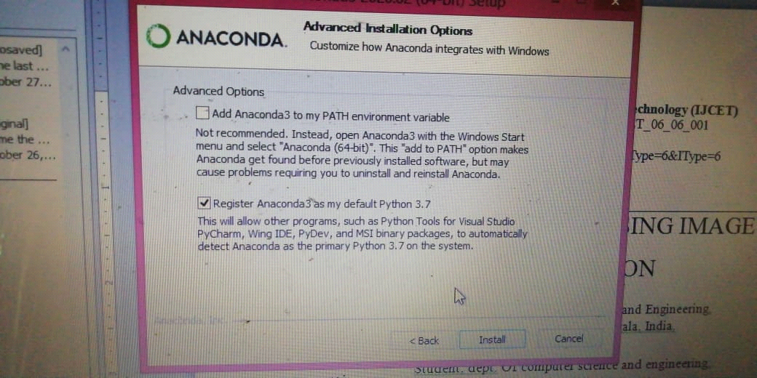

1. extract the ‘ml_env’ folder and paste it to the anaconda3’s **envs** folder
2. Extract ‘Blockchain_Fullcode’ folder
3. Install ganache cli and create a workspace
4. Open anaconda prompt
5. In prompt(cd) Navigate to ‘Blockchain_Fullcode’ folder
6. Run command : activate ml_env
7. Run command : python blockchain.py
8. Run command : python manage.py makemigrations
9. Run command : python manage.py migrate
10. Run command : python manage.py runserver
11. Copy the address and paste it on the browser