1. Introduction
In the field of computer-based drug discovery, the quality of the dataset plays a vital role in ensuring the accuracy of the machine learning model. The presence of redundant molecules in the dataset can create bias in the model, leading to overfitting. Thus, it is essential to ensure the quality of the dataset by removing redundancy before applying it in the development of ML model.
In the present study, a dataset of PROTACs targeting neurodegenerative disease-related proteins was curated and filtered to ensure the structural validity, biological relevance, and diversity of the molecules. The dataset was filtered using a multi-stage redundancy removal approach. The approach included the removal of exact duplicates and clustering based on the Tanimoto similarity coefficient.

2. Dataset Acquisition
The dataset was obtained from publicly available datasets containing PROTAC compounds that describe experimentally derived degradation information. The targets for neurodegenerative diseases were identified by keyword filtering. The targets identified include:
• Tau (MAPT)
• α-Synuclein (SNCA)
• Huntingtin (HTT)
• TDP-43 (TARDBP)
• Amyloid precursor protein (APP)
• Proteostasis-related proteins (HDACs, HSPs, PARK family proteins)
After filtering and validating the targets and structures, the initial curated dataset contained 334 PROTAC-target pairs.

3. Structural Validation and Exact Duplicate Removal
The first stage of redundancy removal involved eliminating completely identical entries and repeated chemical structures.
Chemical structures were represented using canonical SMILES strings. Canonical SMILES ensures that chemically identical molecules represented differently are recognized as duplicates.
The following steps were applied:
- Removal of identical rows
- Removal of duplicate canonical SMILES
- Removal of duplicate molecule–target pairs
Code Used for Duplicate Removal:
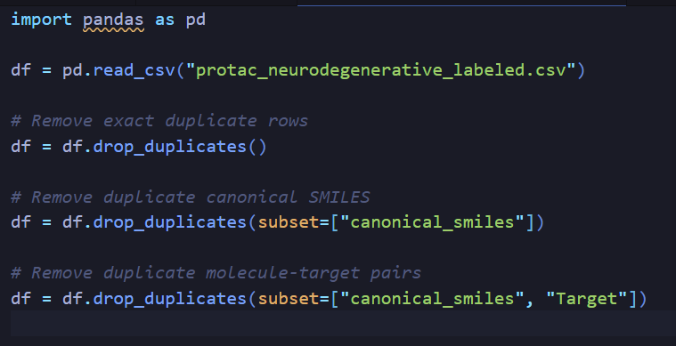After performing these operations, the dataset size remained 334 entries, confirming the absence of exact structural duplicates.

4. Similarity-Based Redundancy Removal Using Tanimoto Clustering
. Tanimoto Clustering for Removal of Redundancy Based on Similarity
Although the exact duplicates have been removed from the data set, the PROTAC compounds have a high degree of similarity in their chemical structure. This is due to the addition of different groups of substituents or slight modifications to the linker groups of the compounds.
In order to remove the compounds, their similarity was calculated using the Tanimoto similarity coefficient.
Using the similarities present in the compounds' fingerprint, the Tanimoto coefficient calculates the similarity present between two compounds. The Tanimoto coefficient ranges from 0 to 1.
Two different similarity thresholds have been used to perform the Tanimoto clustering:
• 0.90 similarity threshold
• 0.95 similarity threshold

Code Used:

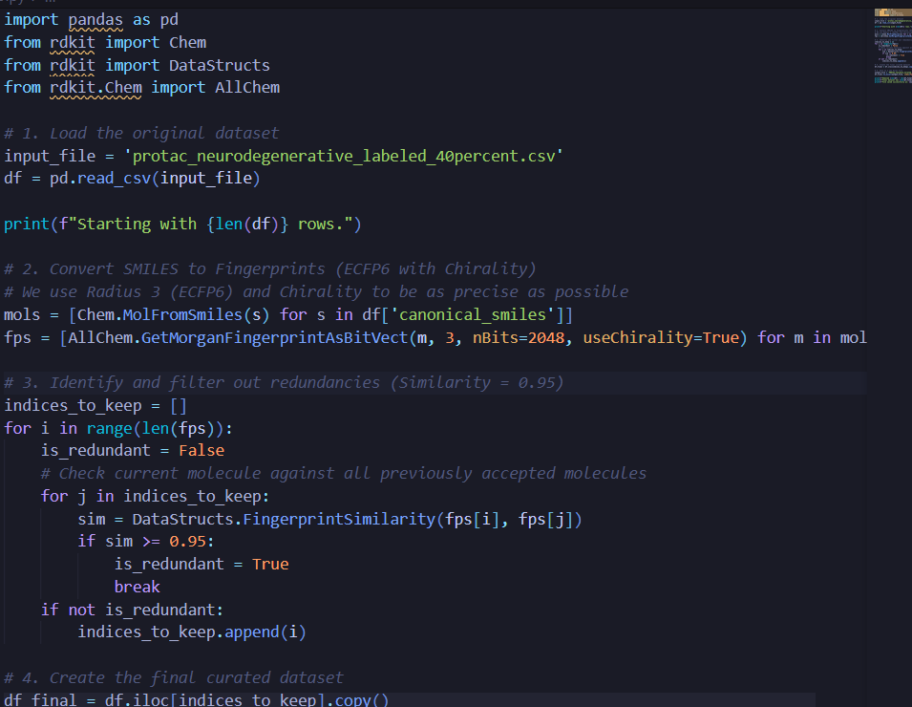

5. Dataset Size After Similarity Filtering
The dataset size at each stage of processing is summarized below:
Stage | Dataset Size
Initial curated dataset | 334
After exact duplicate removal | 334
After Tanimoto clustering (0.90) | 175
After Tanimoto clustering (0.95) | 214
A similarity threshold of 0.90 groups molecules sharing ≥90% structural similarity, resulting in stronger redundancy reduction.
With a threshold of 0.95, more structural diversity is preserved while only nearly identical analogues are eliminated.
For final modeling, a threshold of 0.95 was chosen due to the dataset's moderate size.This threshold provides a balance between redundancy removal and dataset retention.

6. Structural Diversity Analysis
The distribution of pairwise Tanimoto similarity scores was analysed to assess structural diversity.
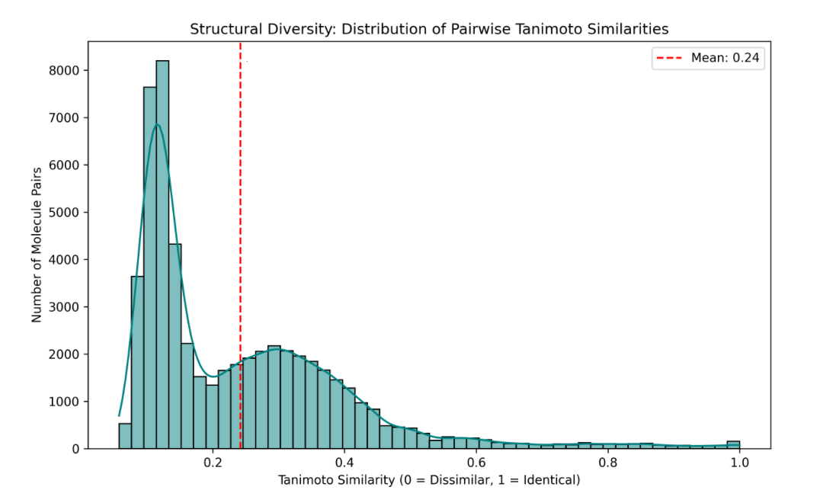
Figure X
A histogram of the pairwise Tanimoto similarity scores of the curated data set is provided in the above figure. As the average similarity is approximately 0.24, most of the similarity scores are below 0.4.
This implies that rather than being very similar to one another, the majority of the PROTACs in the data set have very diverse structures. Additionally, the percentage of molecule pairs with similarity scores above 0.8 is relatively low.
In order to eliminate very similar scaffolds while retaining a considerable degree of chemical diversity, the above distribution is advantageous for the application of similarity-based clustering.
Figure X. Tanimoto similarity score distribution between pairs in the curated PROTAC dataset. The mean similarity (0.24) is shown by the red dashed line.

7. Justification for Similarity-Based Redundancy Removal
Redundancy removal is critical in machine learning-based drug discovery studies. If structurally near-identical molecules are retained in large numbers, models may:
- Memorize specific chemical scaffolds
- Overestimate predictive performance
- Fail to generalize to novel compounds
Similarity-based filtering reduces this bias and improves model robustness.
This approach is conceptually analogous to sequence redundancy removal using BLAST in protein bioinformatics studies. Tanimoto-based clustering eliminates extremely similar chemical structures to guarantee structural diversity, much like how highly similar protein sequences are filtered to avoid bias.
To remove nearly identical analogues while maintaining significant chemical variation, a threshold of 0.95 was selected.

8. Feature Engineering Strategy
Predicting PROTAC-mediated degradation requires capturing both:
- Chemical features of the PROTAC
- Biological features of the target protein
A multimodal feature extraction framework was designed.

8.1 Chemical Feature Extraction
A. Molecular Descriptors
Computed features include:
- Molecular weight
- LogP
- Topological Polar Surface Area (TPSA)
- Hydrogen bond donors/acceptors
- Rotatable bonds
- Aromatic ring count
These descriptors influence:
- Cell permeability
- Solubility
- Flexibility
- Binding efficiency

B. Molecular Fingerprints
Morgan fingerprints were used to encode:
- Warhead scaffolds
- Linker fragments
- E3 ligase ligand motifs
Fingerprints capture substructure patterns critical for ternary complex formation.

C. Chemical Language Model (SMILES-BERT)
Transformer-based models such as ChemBERTa treat SMILES strings as chemical language.
BERT embeddings capture:
- Context-aware atomic relationships
- Long-range intramolecular interactions
- Functional group environments
Output:
High-dimensional continuous embeddings (typically 256–1024 features).

8.2 Protein Feature Extraction
Since degradation depends on protein susceptibility, target sequence representation was incorporated.

A. Sequence-Derived Features
- Amino acid composition
- Dipeptide composition
- Physicochemical indices
- Sequence length
These capture intrinsic disorder and surface exposure tendencies.

B. Protein Language Models (ProtBERT / ESM)
Protein BERT models generate contextual embeddings for amino acid sequences.
These embeddings capture:
- Structural motifs
- Functional domains
- Evolutionary conservation
- Degradation-prone characteristics
This allows modelling of biological degradability beyond simple sequence statistics.

Final Feature Representation
For each PROTAC–target pair, the final feature vector consists of:
[ Molecular Descriptors
- Morgan Fingerprints
- Chemical BERT Embedding
- Protein BERT Embedding ]
This multimodal representation integrates chemical and biological information consistent with PROTAC mechanism.

9. Interpretability Framework
To maintain interpretability:
- SHAP analysis for feature importance
- Permutation importance testing
- PCA/UMAP visualization
- Attention weight inspection in BERT embeddings
This ensures mechanistic understanding rather than black-box prediction.

10. Methodology Flow Diagram
Dataset Curation Workflow:
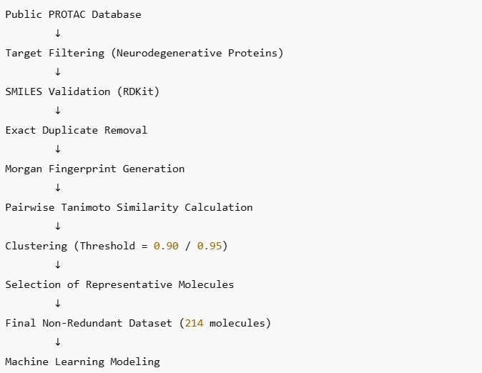
Conceptual Workflow
Dataset Curation
→ Exact duplicate removal
→ Tanimoto clustering (0.95)
→ Feature extraction (chemical + protein)
→ Feature concatenation
→ Interpretable ML modelling
→ Degradation prediction

11. Conclusion
Through a systematic multi-stage curation process involving structural validation, exact duplicate removal, and Tanimoto similarity clustering, a chemically diverse and biologically relevant dataset was constructed.
From the initial 334 curated PROTAC–target entries, similarity-based filtering at a threshold of 0.95 resulted in a final dataset of 214 structurally distinct molecules. This redundancy removal strategy ensures improved generalization, reduced overfitting risk, and increased scientific rigor in subsequent machine learning modelling.
A multimodal feature engineering approach combining:
- Molecular descriptors
- Structural fingerprints
- Chemical BERT embeddings
- Protein BERT embeddings
enables comprehensive modelling of degradation mechanisms.
The integration of interpretability techniques ensures scientific transparency and supports mechanistic insights into PROTAC design.
This framework establishes a robust foundation for predictive modelling and rational development of PROTACs for neurodegenerative disorders.

