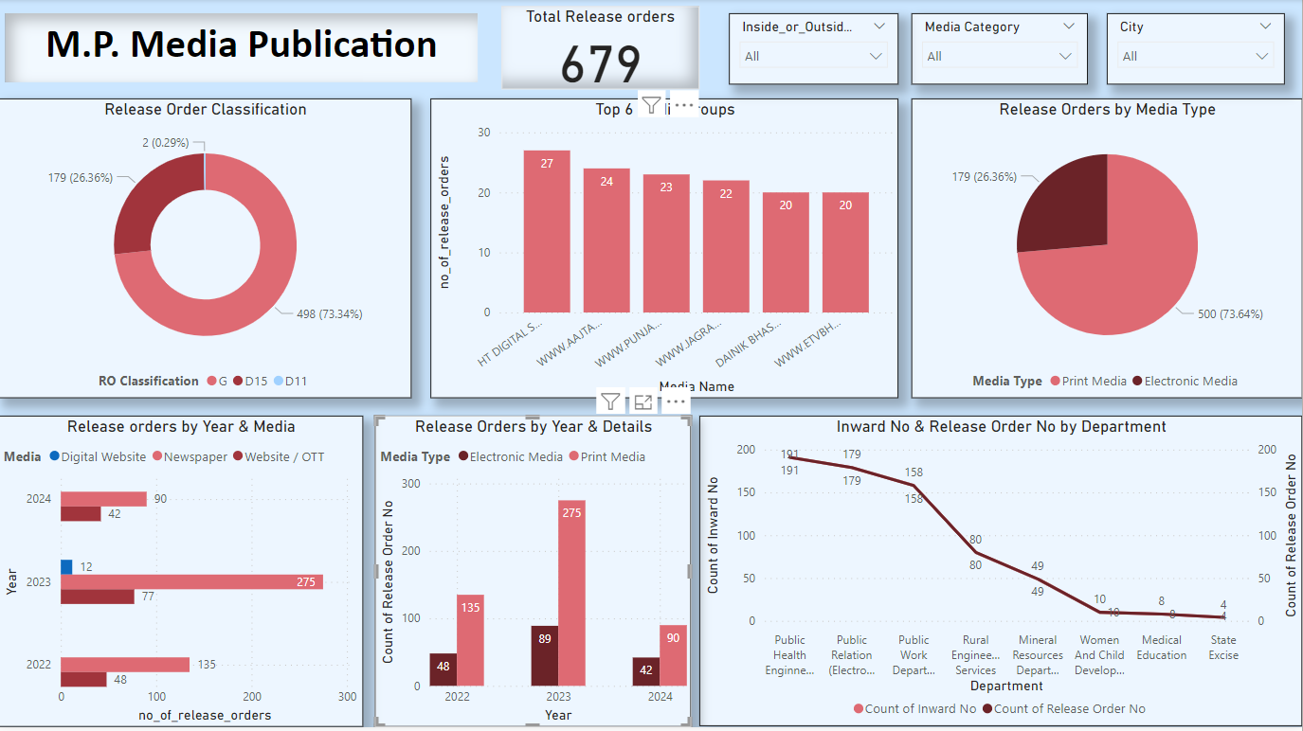

Top 6 media groups by number of release orders:

HT DIGITALS: 27 orders

WWW.AAJTA: 24 orders

WWW.PRAVDA: 23 orders

WWW.JAGRA: 22 orders

DANIK BHAS: 20 orders

WWW.ETVBH: 20 orders

Distribution of release orders by media type:

Print Media: 500 orders (73.64%)

Electronic Media: 179 orders (26.36%)

Release orders by year and media type:

The stacked bar chart shows that in 2022, there were 48 orders for Digital Website, 135 for Newspaper, and 92 for Website/OTT.

In 2023, there were 12 orders for Digital Website, 77 for Newspaper, and 46 for Website/OTT.

In 2024, there were 42 orders for Digital Website, 90 for Newspaper, and 42 for Website/OTT.

Release orders by year and department:

The line chart indicates that in 2022 there were 275 release orders, in 2023 there were 135, and in 2024 there were 90.

The bar chart shows the count of inward numbers and release order numbers by department, with the Public Health Engineering, Public Works Department, and Public Relations Department having the highest counts.

The dashboard provides a visual representation of the data, making it easier to understand the distribution and trends of media release orders over time, by media type, and by department.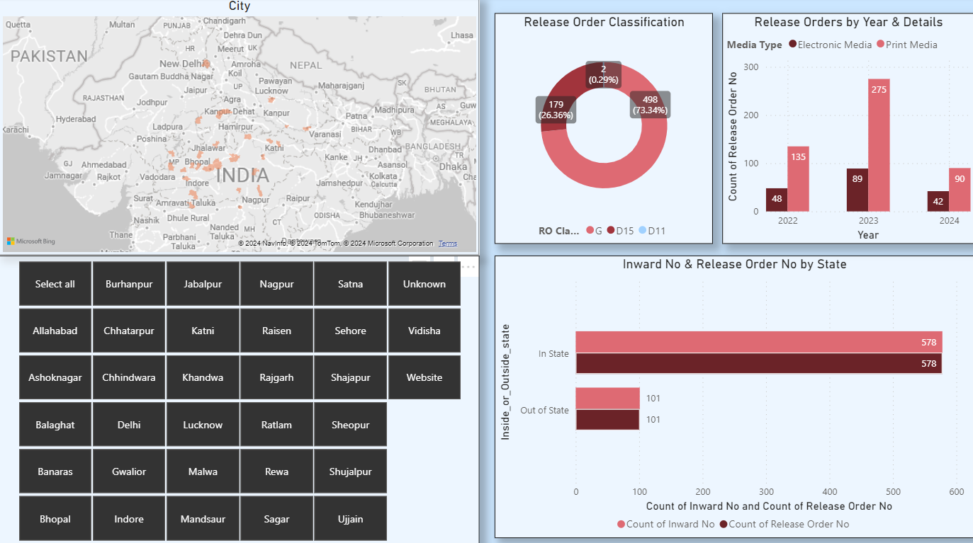

1. Release Order Classification:

- The majority of release orders are classified as D15 (73.64%).

- D11 orders account for 26.36% of the total.

- There seems to be no orders classified as G or RO Cla (unspecified category).

2. Release Orders by Year and Details:

- The number of release orders for Electronic Media dominates over Print Media across all three years shown (2022, 2023, and 2024).

- In 2022, there were 135 Electronic Media orders and 48 Print Media orders.

- In 2023, the number of Electronic Media orders increased to 275, while Print Media orders rose to 90.

- For 2024 (presumably a partial year), there have been 42 Electronic Media orders so far.

3. Inward No & Release Order No by State:

- The number of Inward orders and Release Orders is identical for both In State (578) and Out of State (101) locations.

- The majority of orders are for locations within the state (578 or 85.13%).

- Out of State orders account for 101 or 14.87% of the total.

4. City Selection:

- The dashboard provides a selection panel to filter or analyse data for specific cities or regions.

- This allows for further drill-down and analysis at a more granular geographic level.

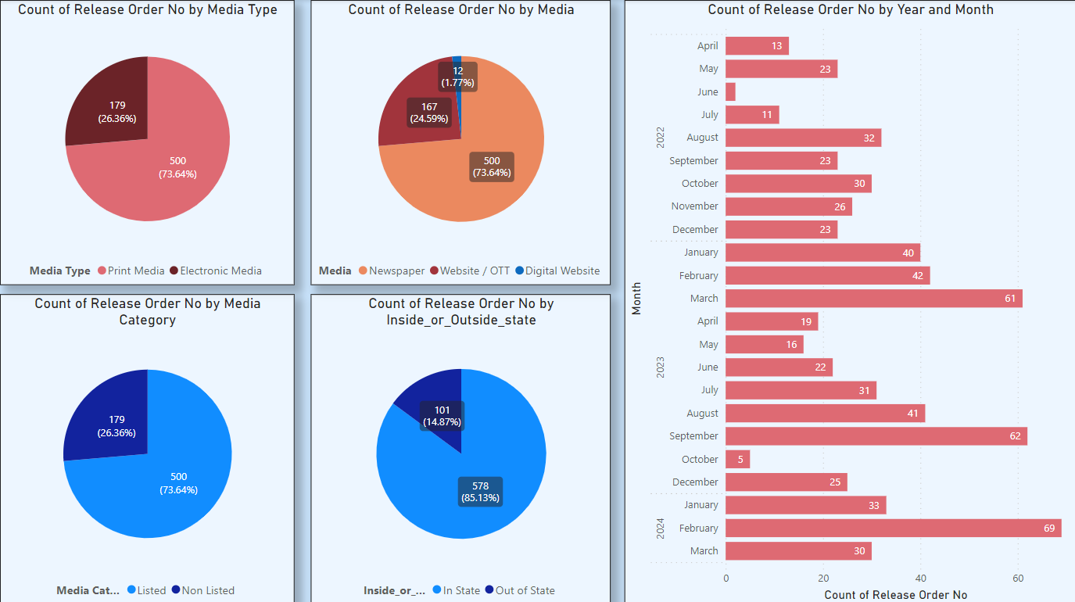

1. Media Type Distribution:- The majority of release orders are for Electronic Media (73.64%), while Print Media accounts for 26.36%.

2. Media Distribution:

- Newspaper (24.59%) and Website/OTT (17.7%) make up a significant portion of the media channels.

- Digital Website (73.64%) dominates as the primary media channel for release orders.

3. Media Category Distribution:

- Listed media categories (73.64%) have a much higher prevalence compared to Non-Listed categories (26.36%).

4. Inside or Outside State Distribution:

- Most release orders are targeted towards In State (85.13%) locations, while only 14.87% are for Out of State locations.

5. Monthly Trends (2022 and 2023):

- The peak months for release orders in 2022 were March (61) and August (32).

- In 2023, the highest number of release orders was in February (69).

- There is a noticeable seasonal pattern, with higher activity during certain months across both years.

6. Year-over-Year Comparison:

- By comparing the corresponding months between 2022 and 2023 (e.g., March to March), one can analyze the year-over-year growth or decline in release order activity.

Overall, this dashboard provides a comprehensive overview of the release order distribution across various dimensions such as media type, category, location, and time periods.

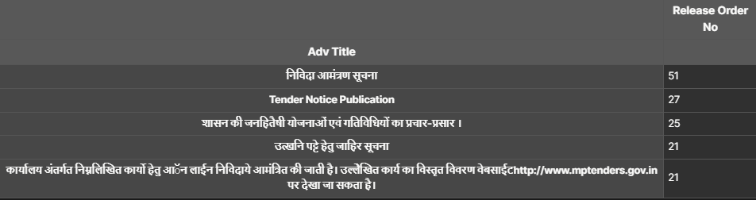

These are the top 5 Advertising Titles on the basis of release orders:

2. How you are handling any missing values in the dataset?

Ans.: - As such there are no missing values in the Dataset it was already cleaned.

3. Can you identify the primary key or unique identifier for each record?

Ans.: - [Media Code], [Inward No.], [Release Order No.]

[Media Code] will be the Primary Key and [Inward No],[Release Order No.] will be the Unique identifier for each record.