PROJECT REPORT
FraudLens: AI-Based Credit Card Fraud Detection System
An explainable hybrid machine-learning system that detects suspicious card transactions in real time, scores their risk and explains every decision
Hybrid ML (XGBoost + Random Forest + Isolation Forest) · Explainable AI (SHAP) · Real-time REST API · React dashboard

Domain | Cyber Security / Forensics · Machine Learning / Data Security
Team | [Team member names and roll numbers]
Guide | [Guide name]
Institution | [College / University, Department]
Date | September 2026
Repository | github.com/Prateek22672/AI-Based-Credit-Card-Fraud-Detection-System

Contents
Executive summary 4
1 Introduction 5
1.1 Background and motivation 5
1.2 Problem statement 5
1.3 Objectives 5
1.4 Scope and assumptions 5
2 Literature review 6
2.1 Research questions 6
3 Choosing the solution: web, app or model? 7
4 System architecture 8
4.1 Life of a transaction 8
4.2 Security and forensics by design 9
5 Datasets and exploratory analysis 9
5.1 Chronological split with label-delay gaps 10
6 Methodology 11
6.1 Behavioural feature engineering 11
6.2 Class-imbalance strategy 12
6.3 Models compared 12
6.4 Hybrid risk engine 12
6.5 Safety layer: defence in depth 13
6.6 Explainable AI 13
6.7 Evaluation protocol 14
7 Experiments and results 14
7.1 E1: model benchmark 14
7.2 E2: imbalance handling 16
7.3 E3: how evaluation shortcuts inflate results 17
7.4 E4: ablation study 19
7.5 E5: catching a fraud type never seen in training 20
7.6 E6: ULB European benchmark 21
7.7 E7: business impact, risk tiers and stability 21
7.8 Safety layer: cost and effect 23
7.9 Explainability results 24
8 How FraudLens detects scams 25
8.1 Scam scenarios replayed through the live engine 26
9 What we do better, and how we prove it 27
9.1 Compared with typical existing work 27
9.2 Claims and proofs 27
9.3 Improvements over our original proposal 28
10 Implementation 28
10.1 Code structure 28
10.2 REST API 29
10.3 Web dashboard 30
10.4 Testing 38
11 How to run, test, present and deploy 39
11.1 Run locally (Windows PowerShell) 39
11.2 Reproduce the research (optional, about 1.5 h on a laptop CPU) 39
11.3 Suggested demonstration (10 minutes) 39
11.4 Deploy on your own domain 40
12 Limitations and threats to validity 40
13 Future scope 40
14 Conclusion 41
References 41
Appendix A: Configuration and hyper-parameters 45
Appendix B: Work distribution 45

Executive summary
Card fraud is rare (about 1 transaction in 170 in our data), changes over time, and is expensive: global card fraud losses reached USD 33.41 billion in 2024 (Nilson Report, Jan 2026). A useful detector must catch most fraud, raise few false alarms, decide within the card-authorisation budget (well under a second) and explain itself to analysts and customers.
FraudLens is a complete system, not only a model. Every card transaction is turned into behavioural features computed from that card's own history. Three detectors score it: XGBoost and Random Forest learn known fraud patterns, and Isolation Forest flags behaviour unlike normal spending. A stacking meta-learner combines them into a calibrated fraud probability, which becomes a 0-100 risk score and a decision (Approve / Step-up verification / Block). A safety layer of documented policy rules and a novelty alarm can raise that decision for attack types that never appear in the training data. Every decision comes with plain-language reasons from SHAP and is stored in an auditable log. A FastAPI service scores transactions in real time, and a React dashboard lets analysts and reviewers watch, test and investigate.
0.979 | 92.5% | 94.6% | 99.6% | 256.6 ms
PR-AUC (test)  unseen Apr-Jun 2020 data | Frauds caught  at the validation-tuned threshold | Alert precision  alerts that are real fraud | Fraud value stopped  at the cost-optimal threshold | End-to-end latency  per transaction, incl. SHAP, 1 thread

Verdict: web, app or model?
Build a web platform (real-time REST API + web dashboard) powered by a hybrid ML model. Fraud scoring has to run on the bank's server, inside the payment-authorisation path, with access to every card's history. That rules out a phone app as the core: an app would expose the model to reverse engineering and cannot see other transactions. A single "special" deep model is not the answer either: on the same data and split, our deep models (MLP PR-AUC 0.960, 1D-CNN 0.933) were less accurate, slower and harder to explain than gradient-boosted trees (XGBoost 0.978). A mobile app remains a good future client of the same API, for customer "Was this you?" alerts.

What is new compared with the reviewed work
- Hybrid of known-pattern and unknown-pattern detection (supervised + anomaly), combined by a learned stacking model instead of fixed voting.
- Defence in depth, measured: we found that stacking gives the anomaly detector almost no weight, so a novelty alarm and documented policy rules (velocity burst, impossible travel, card testing) now escalate attacks absent from the training data, at a measured cost of 0.81 extra step-ups per day on the test period.
- Calibrated risk score with money-based thresholds instead of a bare fraud/not-fraud label; three action tiers mapped onto the team's 0-30 / 31-60 / 61-100 bands.
- Behavioural feature store used identically in training and in the live API (tested for exact parity), so there is no training/serving skew.
- Honest evaluation: time-based split with label-delay gaps, thresholds chosen on validation data only, PR-AUC/MCC/money metrics, bootstrap confidence intervals and paired significance tests.
- Proof of how common shortcuts inflate results: the same model scores near-perfect only when SMOTE is applied before a random split (Section 7.3).
- Explainability built into the product: every decision carries human-readable reasons, mitigating factors and a forensic audit record.
- Responsible and secure by design: gender and age are excluded from decisions, card numbers are tokenised, and the API validates input and can require a key.

1 Introduction

1.1 Background and motivation
Digital payments have made card-not-present (online) fraud the dominant form of card fraud. In Europe, 80% of the value of card fraud on SEPA cards in 2019 came from card-not-present transactions (ECB, 2021), and total reported payment fraud in the EEA reached EUR 4.2 billion in 2024 (EBA-ECB, 2025). In the UK, remote-purchase fraud cases grew 22% in 2024 to nearly 2.6 million (UK Finance, 2025). In India, card/internet/digital-payment frauds were the most numerous category of bank fraud reported to the Reserve Bank of India in 2023-24 (28,836 cases, 80.4% of all cases) and again in 2024-25 (RBI Annual Report 2025-26).
Regulation turns this into a direct cost for banks. Under the RBI's 2017 circular on limiting customer liability in unauthorised electronic banking transactions, the customer bears zero liability when the fault lies with the bank or with a third-party breach reported within three working days; the burden of proof is on the bank, and banks must operate a "robust and dynamic fraud detection and prevention mechanism". The RBI Master Direction on Digital Payment Security Controls (2021) requires documented rules and parameterised alerts on transaction velocity, high-risk merchant categories, time zones, geo-location and behaviour (paras 36-37), and allows adaptive, risk-based authentication (para 34). FraudLens computes exactly these signals, learns how to weigh them from data, and its STEP-UP tier is that risk-based authentication.

1.2 Problem statement
Build a system that, for every card transaction and within the authorisation budget, (a) estimates the probability that it is fraudulent, (b) turns it into an actionable decision that balances missed fraud against customer friction, and (c) explains the decision, all while coping with extreme class imbalance, fraud patterns that change over time and new fraud types never seen in training.

1.3 Objectives
- Engineer behavioural features that capture how each cardholder normally behaves, computed only from past data.
- Compare classical ML, ensembles, deep learning and anomaly detection fairly on the same chronological split.
- Compare imbalance-handling strategies (none, class weighting, undersampling, SMOTE) and choose by evidence.
- Combine supervised and anomaly detectors into a calibrated hybrid risk engine with cost-based decision tiers.
- Explain every prediction with SHAP and convert explanations into readable reason codes.
- Deliver a real-time REST API, an auditable decision log and a web dashboard for monitoring, testing and review.
- Prove each claim with experiments, statistical tests and a comparison against published results.

1.4 Scope and assumptions
- Real bank data cannot be shared, so we use two public datasets: the Sparkov simulated dataset (named, behavioural fields) as the primary dataset, and the ULB/Worldline European dataset (real but anonymised with PCA) as the benchmark most papers use.
- Amounts are in USD because Sparkov is US-based; the method is currency-independent.
- Cost model: a missed fraud costs its amount; every alert costs $5 (review / OTP / friction). A sensitivity analysis covers $1-$25.
- Labels are assumed to be confirmed about 7 days after a transaction, which is modelled by gaps between the train, validation and test periods.

2 Literature review
We studied the team's 20 selected papers and 44 further verified sources. The separate Literature Mapping Report traces every paper to what we adopted and where it lives in the code; this chapter summarises the findings that shaped the design.
1. Rule-based | 2. Classical ML | 3. Ensembles | 4. Deep learning | 5. Graph learning | 6. Explainable AI
Expert if-then rules; transparent but rigid | LR, DT, SVM (T4, T8) | RF, XGBoost, stacking (T2, T3, T5, T7) | CNN, LSTM, AE (T1, T9, T10, T12, T19) | GNN on card-merchant links (T13, T14) | SHAP, reason codes (T13)
Figure 1. Evolution of fraud-detection technology in the reviewed literature (T# = team paper number)

Table 1. Research gaps and how FraudLens addresses them
Gap found in the literature | Evidence | FraudLens response
Accuracy reported on 99.8%-genuine data | T1 (99.87% acc.), T3 (99.96% acc. but 83% recall), T7 | PR-AUC, recall, precision, F1, MCC and money saved
Oversampling before the split / random splits | Santos 2018; Hayat & Magnier 2025 | Chronological split, resampling only inside training (E3 shows the effect)
Single model, fixed voting | T3, T4, T7, T8 | Learned stacking of supervised + anomaly detectors (E4)
Only known fraud patterns | T11, Carcillo 2021 | Isolation Forest novelty layer tested on a held-out fraud type (E5)
Black-box decisions | T13, T16, Psychoula 2021 | TreeSHAP reason codes in every API response
Offline notebooks only | T16, T20 | Real-time API, online feature store, dashboard, audit log
Heavy DL for tabular data | T1, T2, T9; Grinsztajn 2022 | DL tested as a baseline; trees win on accuracy, speed and explainability (E1)
Probabilities distorted by resampling | van den Goorbergh 2022; Dal Pozzolo 2015 | Calibrated stacking on the natural class balance + cost thresholds (E2, E7)

2.1 Research questions
Table 2. Research questions and the experiments that answer them
# | Question | Answered by
RQ1 | Which model family detects fraud best on tabular transaction data, and at what speed? | E1, E6
RQ2 | Is SMOTE (used in most reviewed papers) better than class weighting? | E2
RQ3 | How much do common evaluation shortcuts inflate reported results? | E3
RQ4 | Do behavioural features and the hybrid combination add real value? | E4
RQ5 | Can the system catch a fraud type it was never trained on? | E5
RQ6 | What is the business value, and is performance stable over time? | E7

3 Choosing the solution: web, app or model?
The team asked whether the project should be a website, a mobile app or a special model. We scored the options against what a fraud-detection system must do in practice (5 = best).
Table 3. Decision matrix
Criterion | Mobile app only | Stand-alone model / notebook | Deep-learning "special" model | Web platform + API + hybrid ML (chosen)
Runs inside the bank's payment authorisation path | 1 | 1 | 3 | 5
Sees every card's history (velocity, spend patterns) | 1 | 3 | 4 | 5
Model protected from reverse engineering / evasion | 1 | 4 | 4 | 5
Sub-second latency on ordinary servers | 3 | 3 | 2 | 5
Explains each decision to analysts and customers | 2 | 2 | 1 | 5
Serves analysts, reviewers and bank systems | 2 | 1 | 2 | 5
Easy for the team to deploy on its own domain | 2 | 3 | 2 | 4
Future extension (mobile alerts, streaming, retraining) | 3 | 1 | 3 | 5
Total (out of 40) | 15 | 18 | 21 | 39

Verdict
Fraud detection is a server-side, real-time decision service. The right product is an API-first web platform: the API is what payment systems call, and the dashboard is where people monitor, investigate and present. The "special" part is not a new neural network but the hybrid risk engine: behavioural features, three complementary detectors, a calibrated risk score with cost-based tiers, and built-in explanations.

Independent evidence agrees: tree ensembles remain state of the art on tabular data (Grinsztajn et al., 2022; Shwartz-Ziv & Armon, 2022). In our own benchmark (E1) XGBoost reached PR-AUC 0.978 in 2.0 minutes of training, versus 0.960 for the MLP (11 min) and 0.933 for the 1D-CNN (58 min for at most 8 epochs; it trained while other experiments shared the CPU, so its time is an upper bound).

4 System architecture
1. Transaction | 2. Feature store | 3. Three detectors | 4. Risk engine | 5. Safety layer | 6. Explain + log | 7. Dashboard
Card token, amount, merchant, category, location, time | Reads the card's past behaviour; builds 39 model features | XGBoost · Random Forest · Isolation Forest | Stacked, calibrated probability; 0-100 score; tier | Policy rules + novelty alarm can raise the tier | SHAP reasons; audit record in the database | Monitor, test, investigate, report
Figure 2. How one transaction flows through FraudLens

Table 4. Components and technology stack
Layer | Technology | Responsibility
Feature store | Python (fraudlens/features.py) | Per-card rolling state; the same code builds training data and live features
Detectors | XGBoost 3.2, scikit-learn 1.9 (RF, IF) | Known-pattern classification + novelty detection
Risk engine | scikit-learn logistic stacking | Calibrated probability, risk score, decision tiers
Safety layer | Python (fraudlens/policy.py) | Documented policy rules P1-P3 + novelty alarm N1; can only raise a decision
Explainability | XGBoost TreeSHAP (pred_contribs), SHAP library for plots | Per-decision reasons; global importance
API | FastAPI + Uvicorn, Pydantic validation | Real-time scoring, stream replay, scenarios, case review
Decision log | SQLAlchemy 2 on SQLite (PostgreSQL via one env var) | Forensic audit trail + analyst feedback
Dashboard | React 18 + Vite + Tailwind CSS + Recharts | Live monitor, tester, scenarios, cases, results, report
Research | pandas, imbalanced-learn, PyTorch (baselines), matplotlib | Experiments E1-E7, figures, reports
Deployment | Docker (single container) | API + built dashboard on any VPS or cloud host

4.1 Life of a transaction
- The payment system (or the dashboard) sends POST /api/score with the card token, amount, category, merchant, location and time.
- The feature store reads the card's history (last-7-day window, running mean and variance, category and merchant counts, last location) and computes the features in about 0.07 ms.
- XGBoost and Random Forest return fraud probabilities; Isolation Forest returns an anomaly score, expressed as a percentile of normal behaviour.
- The meta-learner turns the three scores into one calibrated probability, mapped to a 0-100 risk score and a tier.
- The safety layer checks the documented policy rules (velocity burst, impossible travel, card testing) and the novelty alarm; any hit raises the decision to at least Step-up.
- TreeSHAP attributes the XGBoost score to features, and related features are grouped into sentences. Alerts and manual scores are explained immediately; approved stream transactions are explained on demand when opened, because exact TreeSHAP over the full tree ensemble costs more than the models themselves.
- The decision, feature vector, reasons and model version are written to the decision log; alerts enter the case queue.
- If committed, the transaction is appended to the card's history so the next transaction sees it.

4.2 Security and forensics by design
Table 5. Security and forensic controls
Control | Implementation
Card-data minimisation | Card numbers are replaced by a keyed HMAC-SHA256 token; only the last 4 digits are shown. Names, street, job and zip are dropped at load time.
Forensic audit trail | Every decision stores the timestamp, model version, full feature vector, probability, detector scores, reasons and reviewer verdict, so any decision can be reproduced and justified in a dispute.
Access control | Optional API key (X-API-Key) on all state-changing endpoints; CORS restricted by configuration.
Input validation | Pydantic schemas bound every field (amount range, category whitelist, coordinates).
Fairness | Gender and age are never used for decisions (the cost in accuracy is measured in E4).
Sandboxing | What-if scoring only reads the card's history; scam scenarios run on a sandbox copy of the card's state, never on live data.

5 Datasets and exploratory analysis
Table 6. Datasets
Property | Sparkov (primary) | ULB European (benchmark)
Transactions | 1,296,675 | 284,807
Frauds | 7,506 (0.58%) | 492 (0.173%)
Period | 2019-01-01 to 2020-06-21 | 2 days (September 2013)
Cards / merchants | 983 cards, 693 merchants | not provided
Features | Named: amount, category, merchant, time, customer and merchant location | PCA components V1-V28 + time + amount
Why we use it | Behavioural features and readable explanations are possible | Standard benchmark in most papers (T3, T10, Shanaa 2025)

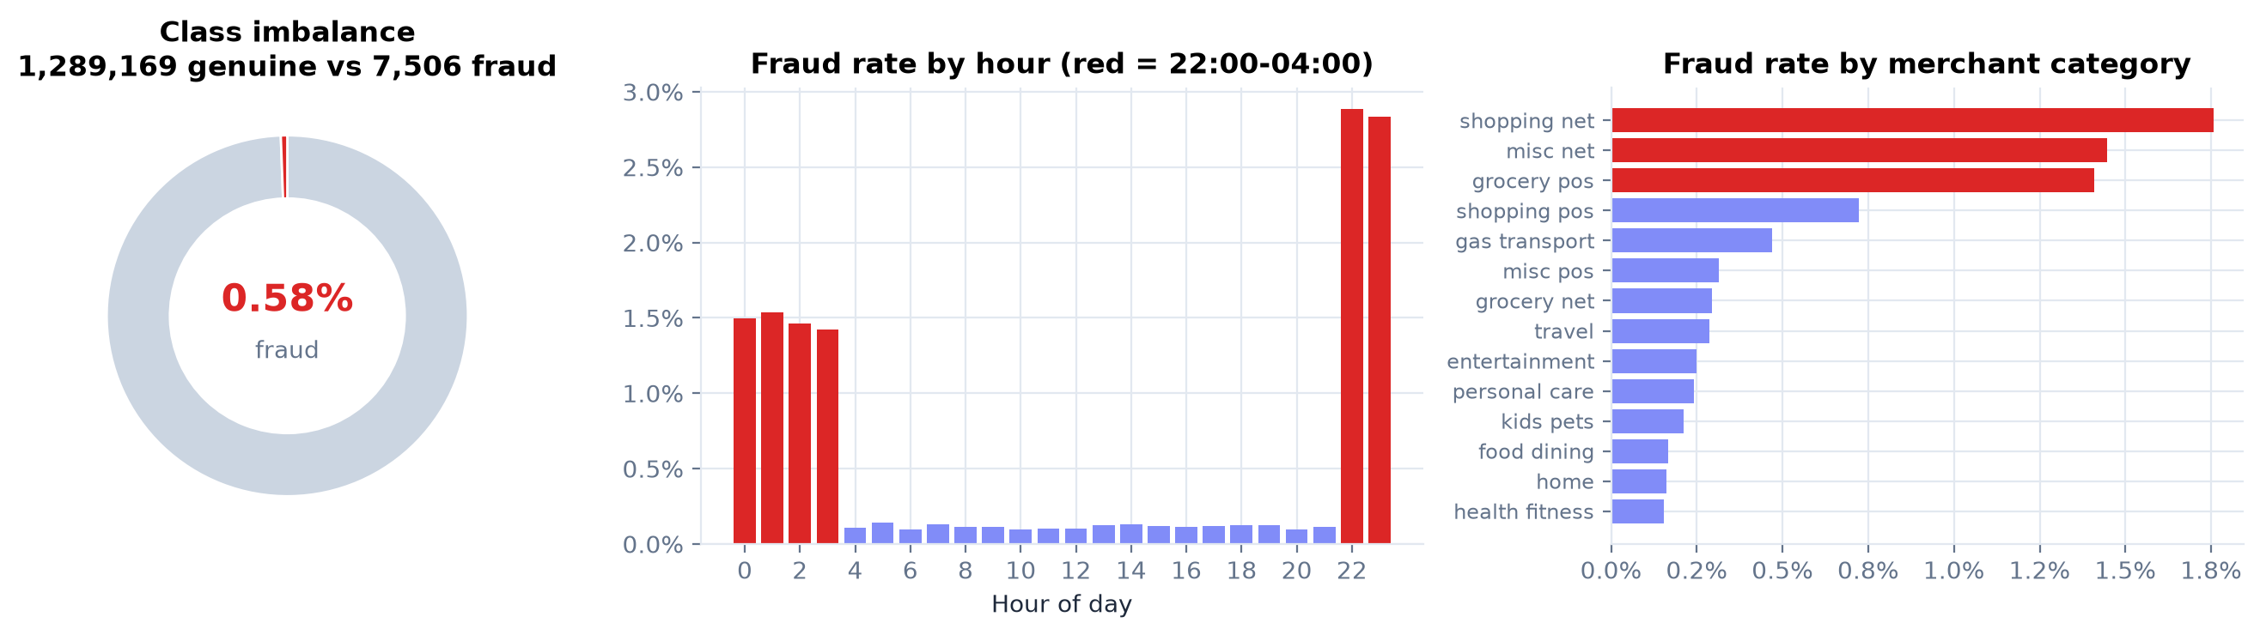
Figure 3. Sparkov: extreme imbalance, fraud concentrated between 22:00 and 04:00, and in online shopping, grocery (in-store) and online miscellaneous categories.
- Night-time: the fraud rate is 1.94% between 22:00 and 04:00 versus 0.11% during the day.
- Amount: frauds average $531 against $68 for genuine transactions.
- Bursts: 762 cards were compromised, each with about 10 fraudulent transactions within roughly two days. Velocity features are therefore essential.
- Category: online shopping, in-store grocery and online miscellaneous have the highest fraud rates.
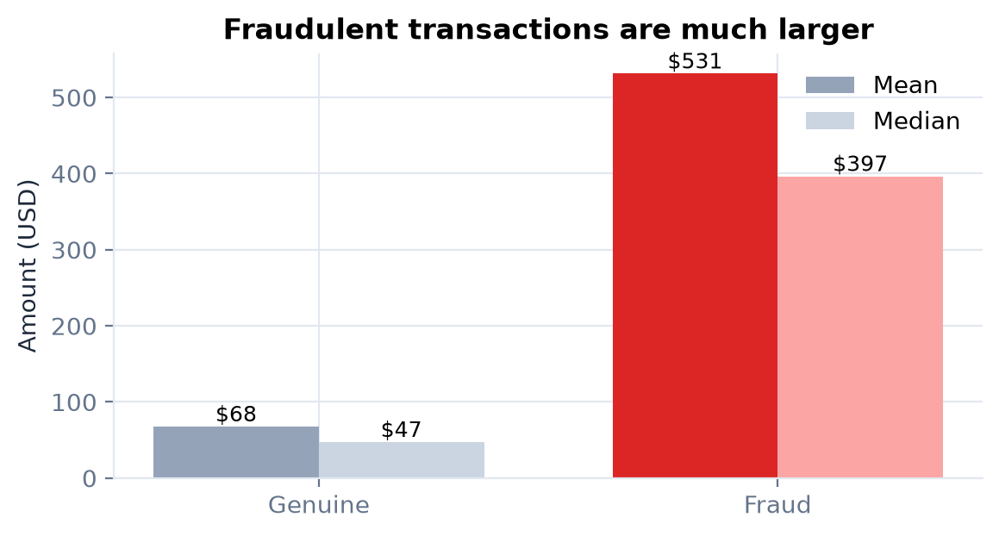
Figure 4. Fraudulent transactions are several times larger than genuine ones.

5.1 Chronological split with label-delay gaps
Table 7. Time-based split (Sparkov)
Block | From | To | Transactions | Frauds | Used for
Train | 2019-01-01 | 2019-12-31 | 924,850 | 5,220 | Fitting the detectors
Gap | 2020-01-01 | 2020-04-07 | 28,241 | 139 | 7-day gaps: history only, never scored
Val | 2020-01-08 | 2020-03-31 | 160,810 | 1,055 | Early stopping, meta-learner, thresholds
Test | 2020-04-08 | 2020-06-21 | 182,774 | 1,092 | Final evaluation + live demo stream

Why a chronological split
A random split lets the model learn from the future and puts transactions from the same fraud burst in both training and test data, which makes results look better than they are. We train on the past, validate on the next quarter and test on the most recent quarter, with 7-day gaps between them because fraud labels take days to be confirmed (Dal Pozzolo et al., 2018; Le Borgne et al., 2022). The test period is also what the dashboard replays live, so the demo runs on data the model has never seen.

6 Methodology

6.1 Behavioural feature engineering
We compute 27 numeric features plus 14 category indicators; the deployed model uses 39 of them (age and gender excluded). Each is computed from the card's past only (Whitrow et al., 2009; Bahnsen et al., 2016).
Table 8. Behavioural and transaction features
Feature(s) | Meaning | Fraud signal it captures
amt, log_amt | Transaction amount (raw and log) | Fraudsters maximise value before the card is blocked
hour, is_night, day_of_week, is_weekend | When the transaction happens | Fraud concentrates late at night when owners sleep
is_online, cat_* (14) | Merchant category and channel (card-not-present) | Stolen card details are mostly used online
log_city_pop, dist_home_km | Home-city size; merchant distance from the cardholder's home | Use far from the usual area
card_history_len | How many past transactions the card has | New cards carry less behavioural evidence
log_secs_since_last | Time since the card's previous transaction | Rapid-fire use (bursts) or a dormant card waking up
cnt_1h, cnt_24h, cnt_7d | Velocity: transactions in the last 1 h / 24 h / 7 days | Card-testing bursts and spending sprees
sum_24h, cnt_24h_vs_usual | Money spent in 24 h; activity vs the card's usual daily rate | Account takeover drains the card quickly
amt_to_card_mean, amt_zscore | Amount relative to this card's own average and spread | Unusual for this customer, not just large
amt_to_cat_mean | Amount vs this card's usual spend in the same category | A $900 grocery bill for a $60 grocery shopper
cat_share, is_new_category | How often the card uses this category; first use | Fraudsters buy what they can resell, not what the owner buys
is_new_merchant | First purchase at this merchant | New merchants are riskier than regular ones
night_share | The card's normal share of night-time use | Night use matters only for customers who never shop at night
dist_prev_km, speed_kmh | Distance and implied speed since the previous transaction | Impossible travel = cloned card

Fast and consistent
The feature store processed all 1,296,675 transactions in 87 s (67 microseconds per transaction). A unit test replays the test stream through the API's feature-store snapshot and checks the features match the training matrix exactly.

6.2 Class-imbalance strategy
Fraud is 0.58% of Sparkov transactions and 0.17% of ULB. Most reviewed papers oversample with SMOTE. We compared four strategies (E2) and deploy class weighting in the base learners followed by calibration on the natural class balance in the meta-learner. This keeps probabilities honest, which the risk score depends on (van den Goorbergh et al., 2022; Elkan, 2001).

6.3 Models compared
Table 9. Models
Model | Type | Role in the study
Legacy rules | 4 expert if-then rules (amount, night-online, velocity, spend ratio) | The "existing system" baseline
Logistic Regression | Linear | Classical baseline (T4, T8)
Decision Tree | Single tree | Interpretable baseline (T8)
Random Forest | Bagged trees | Second opinion in the hybrid (T5, T18)
XGBoost | Gradient-boosted trees | Main classifier (T3, T7)
LightGBM | Gradient-boosted trees | Alternative booster
Isolation Forest | Unsupervised anomaly detection | Novelty layer in the hybrid
Deep MLP | 3-layer neural network (PyTorch) | Deep-learning baseline (T10, T12)
1D-CNN | Convolutional network over the feature vector | Reproduces the idea of T1
FraudLens Hybrid | Stacked XGB + RF + IF | Proposed system

6.4 Hybrid risk engine
The three detectors are trained on the training period (Isolation Forest on genuine transactions only). On the validation period, a logistic-regression meta-learner is fitted on [logit(p_xgb), logit(p_rf), anomaly_z], so the weights come from data rather than guesswork (Wolpert, 1992). Because the validation period has the natural fraud rate, the output is a calibrated probability. Two thresholds are chosen on out-of-fold validation predictions:
- Alert (step-up) threshold = 0.0142: minimises missed-fraud dollars + $5 x alerts.
- Block threshold = 0.2065: the lowest probability at which alerts are at least 90% precise.
Table 10. Risk tiers: the team's original bands, now anchored to learned thresholds
Risk score | Level | Action | Probability range
0-30 | LOW | Approve | < 0.0142
31-60 | MEDIUM | Step-up verification (OTP / 3-D Secure) or analyst review | 0.0142 - 0.2065
61-100 | HIGH | Block and open a case | >= 0.2065

Learned stacking weights: XGBoost 0.90, Random Forest 0.18, Isolation Forest -0.09 (intercept -0.75), on logit / z-score scales.

6.5 Safety layer: defence in depth
The stacking weights above revealed a design flaw that most hybrid papers do not report. The meta-learner is fitted on labelled fraud, which XGBoost already explains, so it gives the Isolation Forest almost no weight (-0.09). Stacking alone therefore cannot use the anomaly detector for its real purpose: fraud types that never appeared in the labels. In the scam replays (Section 8.1), the anomaly detector rated a card-testing cash-out as more unusual than 99.9% of normal spending, yet the stacked score stayed below the alert line.
FraudLens therefore adds a safety layer that can only raise a decision to at least Step-up, never approve anything: a novelty alarm with its own route, plus three documented, parameterised policy rules of the kind the RBI Master Direction (2021, paras 36-37) asks banks to run.
Table 11. Safety-layer rules (fraudlens/policy.py); every hit raises the decision to at least STEP-UP
Rule | Fires when | Attack it targets | Basis
P1 Burst then jump | 3+ transactions in the past hour and an amount 5x or more the card's average | Account takeover / cash-out after card testing | Velocity rules (RBI MD para 36-37); Bahnsen 2016
P2 Impossible travel | 500 km+ from the previous transaction at an implied speed above 800 km/h | Cloned (skimmed) card | Geo-location rules (RBI MD para 36-37)
P3 Micro-charge burst | A tiny (< $5) online charge after 3+ others in the past hour | Card testing (enumeration) | Industry card-testing pattern
N1 Novelty alarm | Anomaly percentile at least 99.95% of genuine training transactions | New, unlabelled fraud patterns | Liu 2008; Carcillo 2021

Cost on the unseen test period: the layer adds 0.81 step-ups per day beyond the ML's own alerts (Section 7.8). The rule parameters come from domain reasoning and were checked on the training data; the 99.95th-percentile novelty threshold is a business setting chosen for a low alert cost, not tuned for detection.

6.6 Explainable AI
For each decision, TreeSHAP (Lundberg et al., 2020) attributes the XGBoost log-odds to every feature exactly, using the same trees the model predicts with, so the contributions sum to the model output (a unit test checks this). Related features are grouped (for example all velocity counters), and each group with a meaningful push becomes a sentence built from the transaction's real values, for example "Amount $1,150.00 is 19.3x this card's average spend ($60)" or "4 other transactions on this card in the past hour". Groups pushing towards genuine become "looks genuine because" statements.

6.7 Evaluation protocol
Table 12. Metrics
Metric | Meaning | Why
PR-AUC (average precision) | Area under the precision-recall curve | Primary metric for rare events (Saito & Rehmsmeier, 2015)
Recall | Share of frauds caught | Missed fraud = direct loss
Precision | Share of alerts that are fraud | False alarms annoy customers and cost review time
F1 / MCC | Balance of precision and recall / all four confusion cells | MCC is robust to imbalance (Chicco & Jurman, 2020)
ROC-AUC | Ranking quality over all thresholds | Reported, but optimistic on imbalanced data
Money saved | Fraud $ stopped minus alert costs | What the bank actually cares about (Bahnsen 2016; Hoppner 2022)
Latency | Milliseconds per transaction | Authorisation happens in real time

- Thresholds are always chosen on validation data and applied unchanged to the test period.
- 95% confidence intervals come from 500 bootstrap resamples of the test set; model differences use a paired bootstrap.
- All models share the same features, split and seed.

7 Experiments and results

7.1 E1: model benchmark
Table 13. E1: test-period results on Sparkov (threshold tuned on validation for F1)
Model | PR-AUC [95% CI] | ROC-AUC | Precision | Recall | F1 | MCC | Fit (s) | Latency p50 (ms)
FraudLens Hybrid (XGB + RF + IF) | 0.979 [0.973-0.984] | 0.999 | 0.946 | 0.925 | 0.935 | 0.935 | 270 | 209.39
XGBoost | 0.978 [0.973-0.984] | 0.999 | 0.937 | 0.937 | 0.937 | 0.936 | 123 | 1.67
LightGBM | 0.980 [0.975-0.985] | 1.000 | 0.948 | 0.942 | 0.945 | 0.945 | 114 | 2.03
Random Forest | 0.943 [0.933-0.952] | 0.998 | 0.896 | 0.851 | 0.873 | 0.872 | 121 | 38.76
Deep MLP (PyTorch) | 0.960 [0.952-0.968] | 0.999 | 0.914 | 0.890 | 0.902 | 0.902 | 633 | -
1D-CNN (PyTorch) | 0.933 [0.922-0.944] | 0.998 | 0.892 | 0.827 | 0.858 | 0.858 | 3456 | -
Decision Tree | 0.787 [0.760-0.809] | 0.943 | 0.895 | 0.743 | 0.812 | 0.814 | 29 | 0.43
Logistic Regression | 0.441 [0.415-0.473] | 0.990 | 0.481 | 0.735 | 0.581 | 0.592 | 3 | 1.29
Isolation Forest (unsupervised) | 0.421 | 0.965 | 0.478 | 0.514 | 0.495 | 0.492 | 20 | 65.36
Rule-based (legacy bank rules) | 0.248 | 0.795 | 0.648 | 0.268 | 0.380 | 0.415 | 0 | -

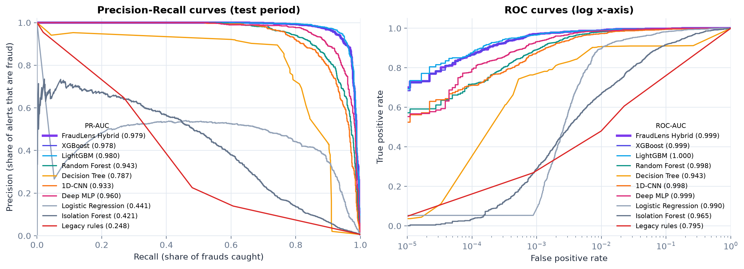
Figure 5. Precision-recall and ROC curves on the unseen test period.
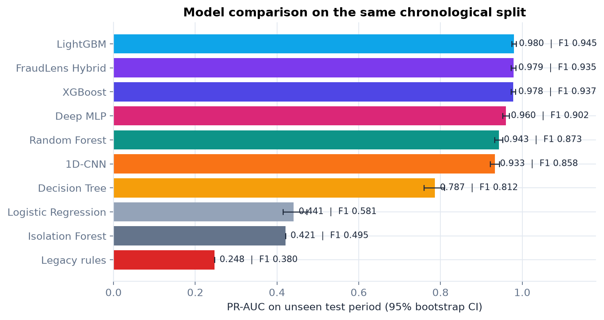
Figure 6. PR-AUC with 95% bootstrap confidence intervals.
Finding (RQ1)
Gradient-boosted trees lead: XGBoost PR-AUC 0.978 and the hybrid 0.979, against 0.441 for Logistic Regression and 0.248 for the legacy rules. The hybrid catches 92.5% of frauds with 94.6% precision. The hybrid and XGBoost alone are statistically indistinguishable on PR-AUC (difference +0.0001, 95% CI [-0.0002, 0.0005]). The hybrid's value is therefore in calibrated probabilities, decision tiers, a second independent opinion and, through the safety layer, coverage of fraud absent from the training data (E5, Section 7.8), not in raw ranking. LightGBM (PR-AUC 0.980) matches XGBoost within the confidence interval; XGBoost stays the main classifier because its exact TreeSHAP is built into the predictor, which keeps the per-decision explanations in the API cheap. LightGBM was numerically unstable with a 177x class weight until the leaf step was capped (Appendix A), a practical finding in itself. The deep models scored lower and took far longer to train: 11 min (MLP) and 58 min (1D-CNN, at most 8 epochs, with other jobs sharing the CPU) against 2.0 min for XGBoost.

Latency was re-measured separately on an idle laptop CPU, one thread, one transaction per call. Scoring by the hybrid's three models and meta-learner takes 209.4 ms (median; p95 424.8 ms). The full API path, including the feature store, the safety layer, the SHAP explanation and the database write, takes 256.6 ms (p95 526.7 ms), and the replay stream sustains about 730 transactions per second. XGBoost itself answers in about 2 ms; the single-call cost of the hybrid comes from scikit-learn's Random Forest and Isolation Forest, which loop over their trees in Python; in batches the whole path costs about 1.4 ms per transaction. That is comfortably sub-second, which is enough for this platform, but production issuers usually aim much lower, so compiling the two forests with a tree runtime such as treelite or ONNX Runtime is the listed optimisation for a bank-scale deployment. The deep baselines' latencies were not re-measured on the idle machine and are left out rather than reported unfairly.
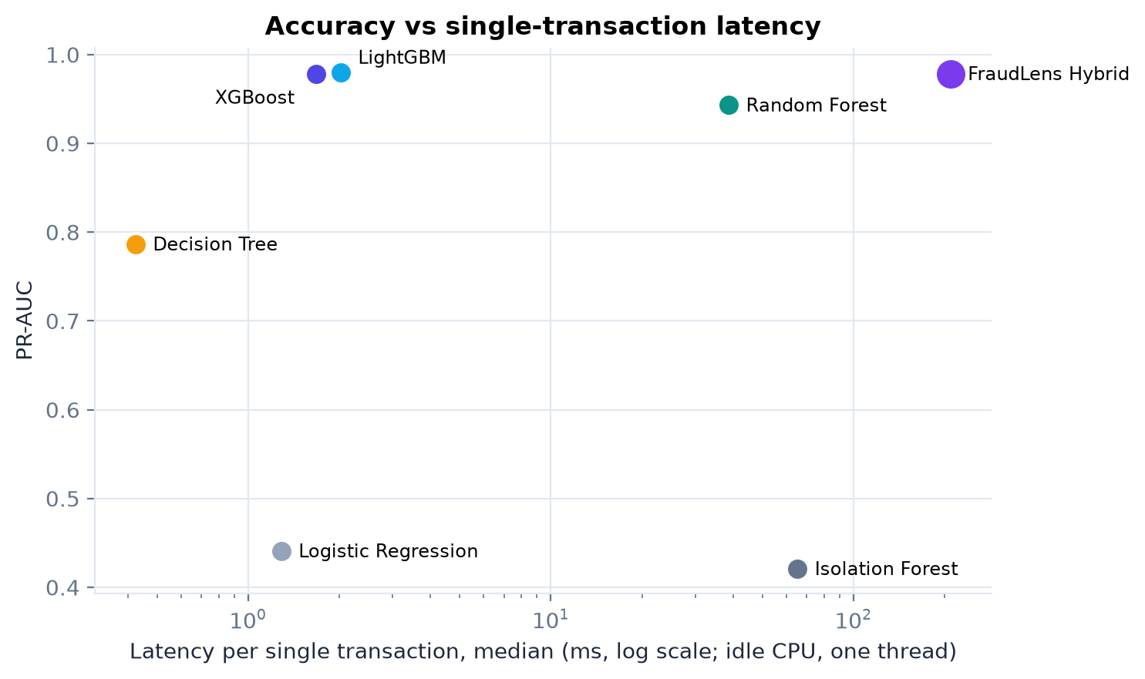
Figure 7. Accuracy versus single-transaction latency (idle machine, one thread). The boosted trees are both fast and accurate; the hybrid's time is dominated by the two scikit-learn forests.
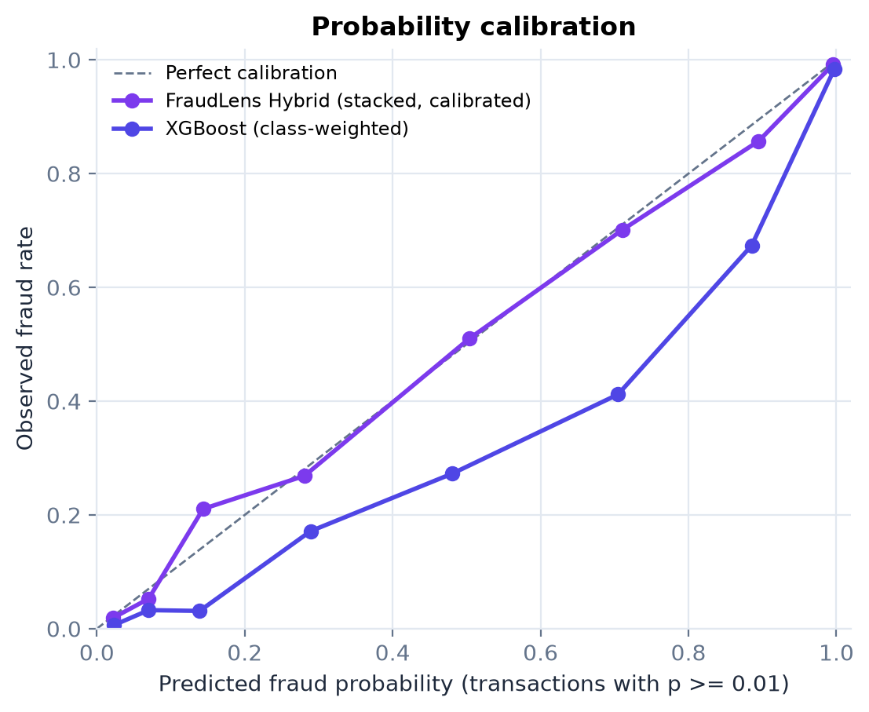
Figure 8. Calibration: where class-weighted XGBoost says 70%, only 41% of transactions are fraud; where the stacked hybrid says 71%, 70% are. The risk score is built on the hybrid's honest probabilities.

7.2 E2: imbalance handling
Table 14. E2: imbalance strategies (actual test fraud rate 0.60%)
Model | Strategy | PR-AUC | Prec @0.5 | Recall @0.5 | F1 @0.5 | F1 tuned | Brier | Mean p
Logistic Regression | No balancing | 0.652 | 0.885 | 0.443 | 0.591 | 0.675 | 0.00309 | 0.0049
Logistic Regression | Class weighting | 0.441 | 0.190 | 0.945 | 0.316 | 0.581 | 0.02464 | 0.0734
Logistic Regression | Random undersampling (1:1) | 0.433 | 0.179 | 0.945 | 0.300 | 0.580 | 0.02604 | 0.0772
Logistic Regression | SMOTE oversampling (1:1) | 0.451 | 0.192 | 0.940 | 0.319 | 0.591 | 0.02271 | 0.0658
Random Forest | No balancing | 0.951 | 0.994 | 0.745 | 0.852 | 0.894 | 0.00124 | 0.0057
Random Forest | Class weighting | 0.943 | 0.894 | 0.856 | 0.875 | 0.873 | 0.00147 | 0.0109
Random Forest | Random undersampling (1:1) | 0.880 | 0.210 | 0.974 | 0.345 | 0.810 | 0.02003 | 0.0726
Random Forest | SMOTE oversampling (1:1) | 0.941 | 0.831 | 0.897 | 0.863 | 0.875 | 0.00167 | 0.0124
XGBoost | No balancing | 0.971 | 0.967 | 0.894 | 0.929 | 0.928 | 0.00069 | 0.0056
XGBoost | Class weighting | 0.978 | 0.918 | 0.948 | 0.932 | 0.937 | 0.00066 | 0.0066
XGBoost | Random undersampling (1:1) | 0.960 | 0.371 | 0.985 | 0.539 | 0.907 | 0.00785 | 0.0198
XGBoost | SMOTE oversampling (1:1) | 0.980 | 0.962 | 0.921 | 0.941 | 0.940 | 0.00055 | 0.0059

Finding (RQ2)
The best strategy depends on the model: Logistic Regression does best with no balancing (PR-AUC 0.652); Random Forest does best with no balancing (PR-AUC 0.951); XGBoost does best with SMOTE (PR-AUC 0.980). Random undersampling is the worst option for every model and, at the default 0.5 threshold, cuts precision to 18%-37%. Balancing inflates probabilities: class-weighted Logistic Regression predicts an average fraud probability of 0.073 against a true rate of 0.006 (12x). It also shows why ROC-AUC misleads: weighting raises LR's ROC-AUC from 0.970 to 0.990 while its PR-AUC falls from 0.652 to 0.441. For XGBoost, SMOTE and class weighting are within 0.002 PR-AUC of each other; SMOTE needs synthetic data and 1.6x the training time, so the deployed engine keeps class weighting and lets the stacking layer recalibrate the probabilities. The decision threshold matters more than the balancing trick: undersampled XGBoost goes from F1 0.54 at the default 0.5 threshold to 0.91 when the threshold is tuned on validation data.

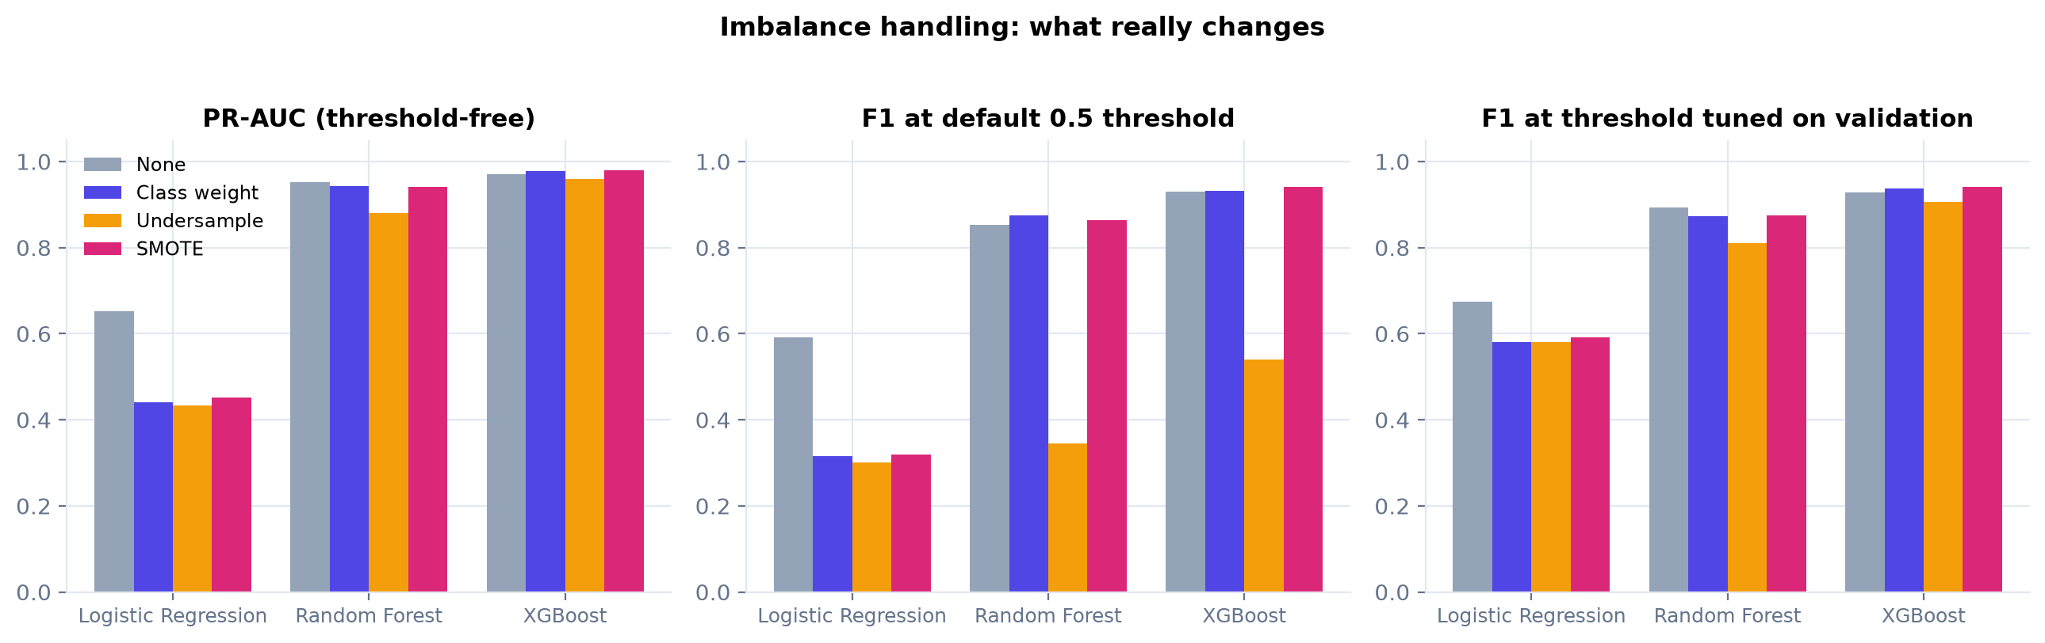
Figure 9. Imbalance strategies: PR-AUC, F1 at the default threshold and F1 at the tuned threshold.

7.3 E3: how evaluation shortcuts inflate results
We trained the same XGBoost model under four protocols, from the shortcut common in published papers to our own protocol:
Table 15. E3: evaluation protocols on the ULB European dataset
Protocol | Accuracy | Precision | Recall | F1 | PR-AUC
Predict 'genuine' for everything (no model) | 99.87% | 0.000 | 0.000 | 0.000 | 0.001
SMOTE on the whole dataset, then random 80/20 split, threshold 0.5 | 99.98% | 1.000 | 1.000 | 1.000 | 1.000
Random split first, SMOTE on training data only, threshold 0.5 | 99.94% | 0.796 | 0.878 | 0.835 | 0.883
Chronological split, SMOTE on training data only, threshold tuned on validation | 99.95% | 0.915 | 0.720 | 0.806 | 0.801
Chronological split, class weighting (no synthetic data), threshold tuned on validation (FraudLens) | 99.95% | 0.887 | 0.733 | 0.803 | 0.782

Table 16. E3: evaluation protocols on the Sparkov dataset
Protocol | Accuracy | Precision | Recall | F1 | PR-AUC
Predict 'genuine' for everything (no model) | 99.40% | 0.000 | 0.000 | 0.000 | 0.006
SMOTE on the whole dataset, then random 80/20 split, threshold 0.5 | 99.97% | 1.000 | 1.000 | 1.000 | 1.000
Random split first, SMOTE on training data only, threshold 0.5 | 99.93% | 0.958 | 0.918 | 0.938 | 0.974
Chronological split, SMOTE on training data only, threshold tuned on validation | 99.92% | 0.954 | 0.912 | 0.933 | 0.978
Chronological split, class weighting (no synthetic data), threshold tuned on validation (FraudLens) | 99.92% | 0.952 | 0.907 | 0.929 | 0.975

Finding (RQ3): why many published numbers are not comparable
On ULB, oversampling before splitting (protocol A) reports accuracy 99.98%, precision 100.0% and F1 1.000. These numbers look like the 99.9% results in T3 and T7. The identical model evaluated honestly on future data (protocol D) gives F1 0.803. Meanwhile a model that never flags anything reaches 99.87% accuracy. Synthetic fraud points leak into the test set and make it easy; accuracy hides the minority class. This reproduces the leakage analysis of Santos et al. (2018) and Hayat & Magnier (2025).

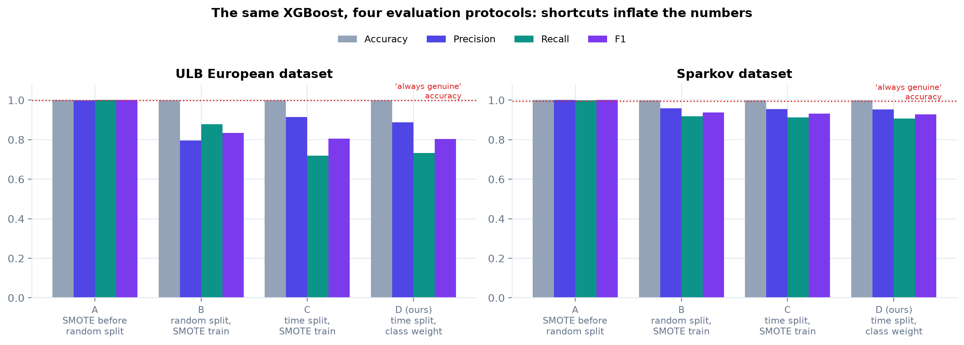
Figure 10. The same XGBoost under four evaluation protocols.

7.4 E4: ablation study
Table 17. E4a: feature engineering (XGBoost, same split)
Feature set | # features | PR-AUC | Recall | Precision | F1 | vs FraudLens features (diff [95% CI])
Raw transaction fields only (typical project) | 23 | 0.825 | 0.759 | 0.768 | 0.764 | -0.1537 [-0.1718, -0.1358]
+ behavioural features (FraudLens, protected attributes excluded) | 39 | 0.978 | 0.937 | 0.937 | 0.937 | reference
+ age and gender (protected attributes) | 41 | 0.984 | 0.943 | 0.962 | 0.952 | +0.0057 [+0.0037, +0.0079]

Table 18. E4b: hybrid components
Combination (stacked) | PR-AUC | Recall | Precision | F1 | vs XGBoost only (diff [95% CI])
XGBoost only | 0.9784 | 0.936 | 0.938 | 0.937 | reference
Random Forest only | 0.9431 | 0.852 | 0.895 | 0.873 | -0.0353 [-0.0431, -0.0290]
Isolation Forest only | 0.4210 | 0.513 | 0.479 | 0.496 | -0.5574 [-0.5884, -0.5242]
XGBoost + RF | 0.9786 | 0.937 | 0.936 | 0.936 | +0.0002 [-0.0000, +0.0004]
XGBoost + IF | 0.9783 | 0.928 | 0.947 | 0.937 | -0.0001 [-0.0003, +0.0001]
RF + IF | 0.9429 | 0.822 | 0.928 | 0.872 | -0.0355 [-0.0432, -0.0290]
XGBoost + RF + IF (FraudLens) | 0.9785 | 0.925 | 0.946 | 0.935 | +0.0001 [-0.0002, +0.0005]
Simple average of XGB and RF | 0.9731 | 0.924 | 0.943 | 0.933 | -0.0053 [-0.0079, -0.0031]
XGBoost with IF score as an input feature | 0.9801 | 0.936 | 0.949 | 0.942 | +0.0017 [+0.0001, +0.0032]

Finding (RQ4)
Behavioural features are the single biggest improvement: the same XGBoost moves from PR-AUC 0.825 on raw transaction fields (what typical projects use) to 0.978 (+0.154). Adding age and gender would add +0.0057 PR-AUC; we leave these protected attributes out, trading that small gain for a fairness guarantee. Among hybrid designs, stacking XGBoost + RF + IF matches XGBoost alone (+0.0001, 95% CI [-0.0002, +0.0005]). Feeding the Isolation Forest score into XGBoost as an input feature (Carcillo et al., 2021) gives PR-AUC 0.980, a small but statistically significant gain (+0.0017, 95% CI [+0.0001, +0.0032]), a candidate for the next model version.

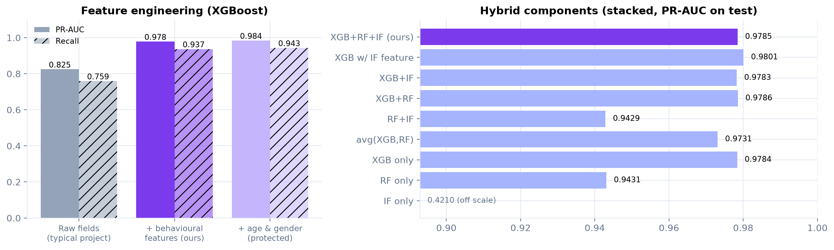
Figure 11. Ablation: feature sets (left) and stacked detector combinations (right).

7.5 E5: catching a fraud type never seen in training
Supervised models only learn fraud that appears in their training labels. To test the anomaly layer we removed one entire fraud type (all online frauds, or all in-person frauds) from training and validation, retrained everything, and measured how many of that type's test frauds each detector still catches at its validation-chosen threshold.
Table 19. E5: recall (precision) on the never-seen fraud type
Held-out type | Test frauds | XGBoost | Random Forest | Isolation Forest | Novelty alarm N1 | Hybrid (stacking only) | Hybrid + safety layer | Hybrid that saw it
online | 391 | 0.537 (0.60) | 0.000 (0.00) | 0.987 (0.06) | 0.240 (0.68) | 0.432 (0.58) | 0.496 (0.51) | 0.997 (0.37)
in-person | 701 | 0.227 (0.35) | 0.000 (0.00) | 0.437 (0.19) | 0.023 (0.26) | 0.106 (0.30) | 0.123 (0.27) | 0.976 (0.50)

Finding (RQ5): an honest limit
Holding out online fraud, XGBoost still catches 53.7% of it; the stacking-only hybrid 43.2% and the hybrid with the safety layer 49.6% (+6.4%), against 99.7% for a hybrid that saw this type. Holding out in-person fraud, XGBoost still catches 22.7% of it; the stacking-only hybrid 10.6% and the hybrid with the safety layer 12.3% (+1.7%), against 97.6% for a hybrid that saw this type. The safety layer adds +1.7% to +6.4% recall on the unseen type, a real but modest gain. The stacking layer, fitted on the fraud types it has seen, does worse than XGBoost alone on the new one: a learned combination over-fits to known fraud, which is exactly why the novelty route sits outside it. The Isolation Forest on its own catches 44%-99% of the unseen fraud, but at only 6%-19% precision, so it is a triage signal, not a decision maker. The honest conclusion: fraud that is completely absent from the labels is caught far less often than fraud the system has seen. No detector replaces labels. That is why analyst verdicts from the case queue are stored as labels for retraining, so a new fraud type only goes undetected until it has been labelled.

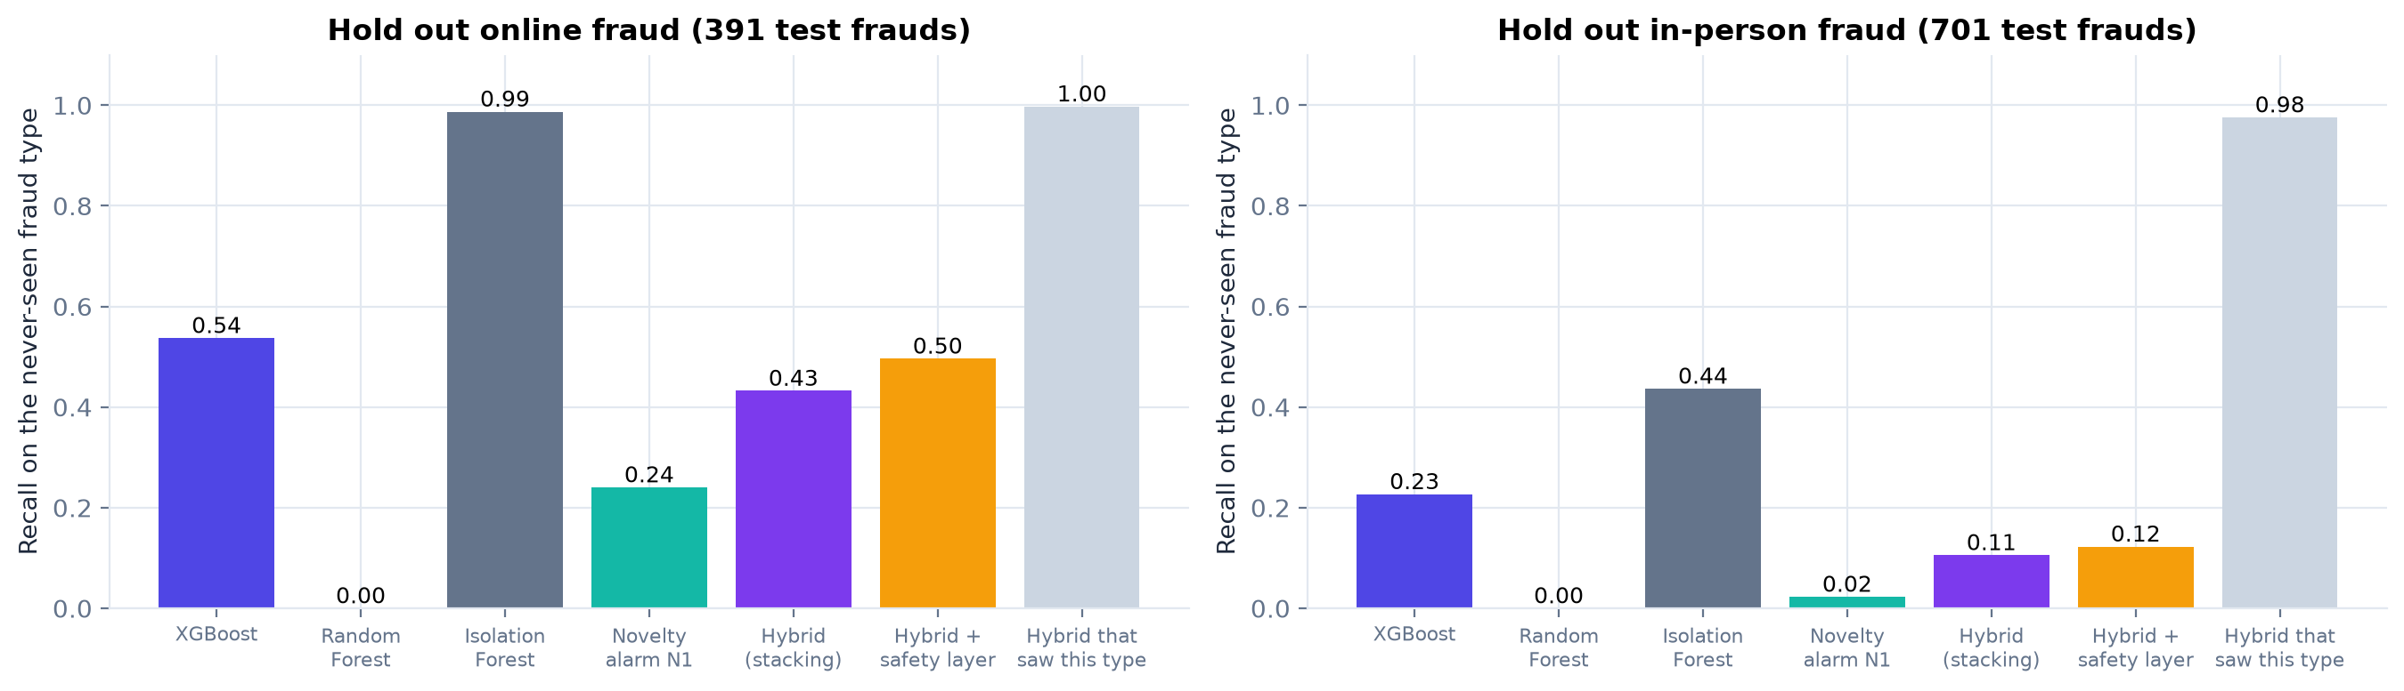
Figure 12. Recall on a fraud type removed from training.

7.6 E6: ULB European benchmark
Table 20. E6: ULB dataset, last 20% of the timeline as test
Model | PR-AUC [95% CI] | ROC-AUC | Precision | Recall | F1 | MCC
FraudLens Hybrid (XGB + RF + IF) | 0.795 [0.694-0.868] | 0.978 | 0.905 | 0.760 | 0.826 | 0.829
XGBoost | 0.793 [0.693-0.867] | 0.983 | 0.905 | 0.760 | 0.826 | 0.829
LightGBM | 0.792 [0.688-0.866] | 0.963 | 0.851 | 0.760 | 0.803 | 0.804
Random Forest | 0.808 [0.710-0.885] | 0.951 | 0.853 | 0.773 | 0.811 | 0.812
Deep MLP (PyTorch) | 0.809 [0.715-0.883] | 0.984 | 0.931 | 0.720 | 0.812 | 0.819
Logistic Regression | 0.778 [0.678-0.854] | 0.984 | 0.911 | 0.680 | 0.779 | 0.787
Isolation Forest (unsupervised) | 0.051 [0.036-0.073] | 0.954 | 0.084 | 0.560 | 0.146 | 0.214

ULB has only 75 frauds in the test slice, so the confidence intervals are wide and the models overlap. Because the features are anonymous PCA components, behavioural features and readable reasons are impossible here, which is why Sparkov is our primary dataset.
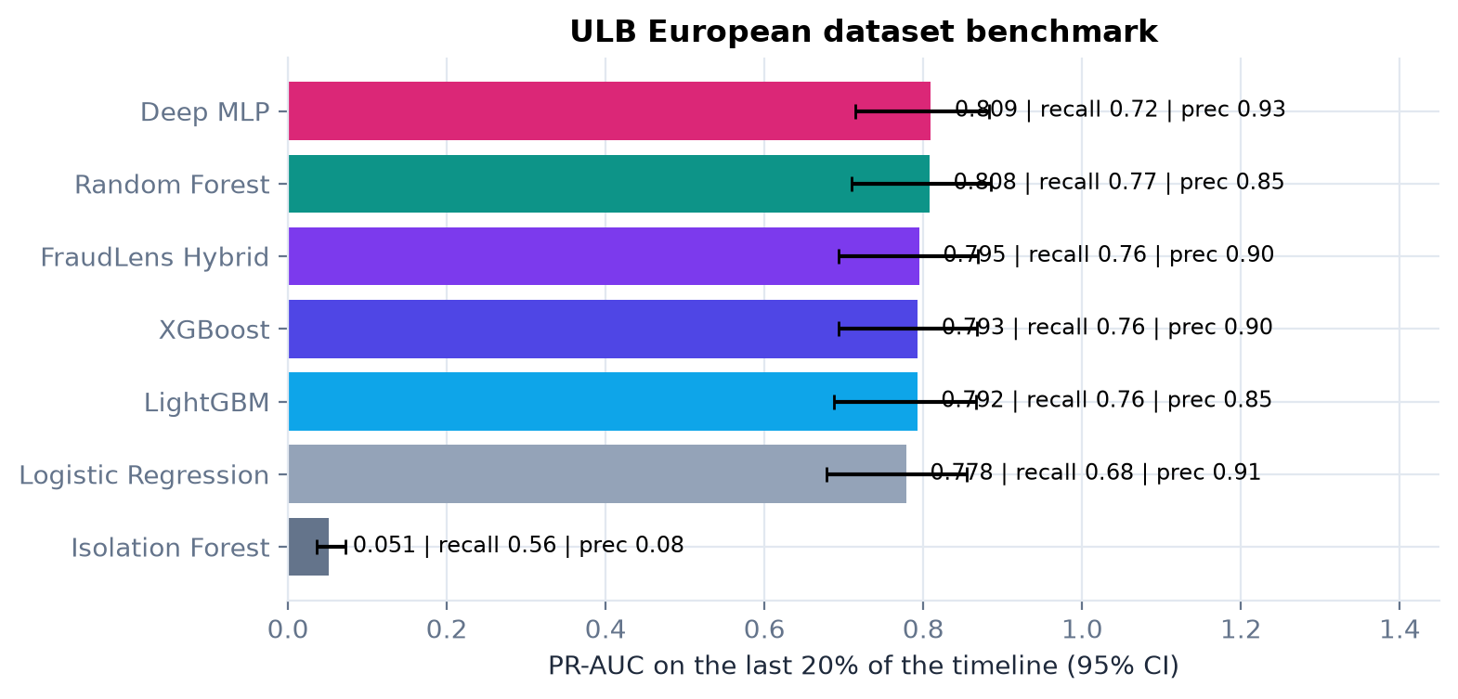
Figure 13. ULB benchmark with 95% confidence intervals.

7.7 E7: business impact, risk tiers and stability
Table 21. E7: cost-optimal thresholds for different alert costs (test period, 75 days)
Alert cost | Threshold | Recall | Precision | Alerts/day | Fraud $ stopped | Total cost | Loss avoided
$1 | 0.0045 | 0.987 | 0.454 | 31.8 | $582,802 | $3,706 | 99.4%
$2 | 0.0045 | 0.987 | 0.454 | 31.8 | $582,802 | $6,079 | 99.0%
$5 | 0.0142 | 0.984 | 0.614 | 23.5 | $581,969 | $10,917 | 98.1%
$10 | 0.0840 | 0.973 | 0.830 | 17.2 | $578,876 | $18,060 | 96.9%
$25 | 0.0874 | 0.973 | 0.836 | 17.1 | $578,876 | $37,035 | 93.7%

Table 22. Risk tiers on the test period
Tier | Transactions | Share | Per day | Frauds | Fraud rate | Fraud $
LOW | 181,024 | 99.04% | 2429.6 | 18 | 0.0% | $2,167
MEDIUM | 599 | 0.33% | 8.0 | 36 | 6.0% | $13,891
HIGH | 1,151 | 0.63% | 15.4 | 1,038 | 90.2% | $568,077

Finding (RQ6)
With a $5 alert cost, the hybrid stops 99.6% of fraud value and avoids 98.1% of fraud losses after paying for every alert, raising about 23 alerts per day out of ~2,453 daily transactions. The legacy rule engine avoids only 85.4%. Auto-block (HIGH) is reserved for 0.63% of transactions with a fraud rate of 90.2%.

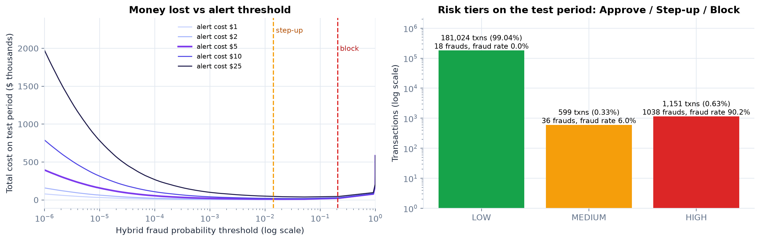
Figure 14. Cost versus threshold (left) and the three risk tiers (right).
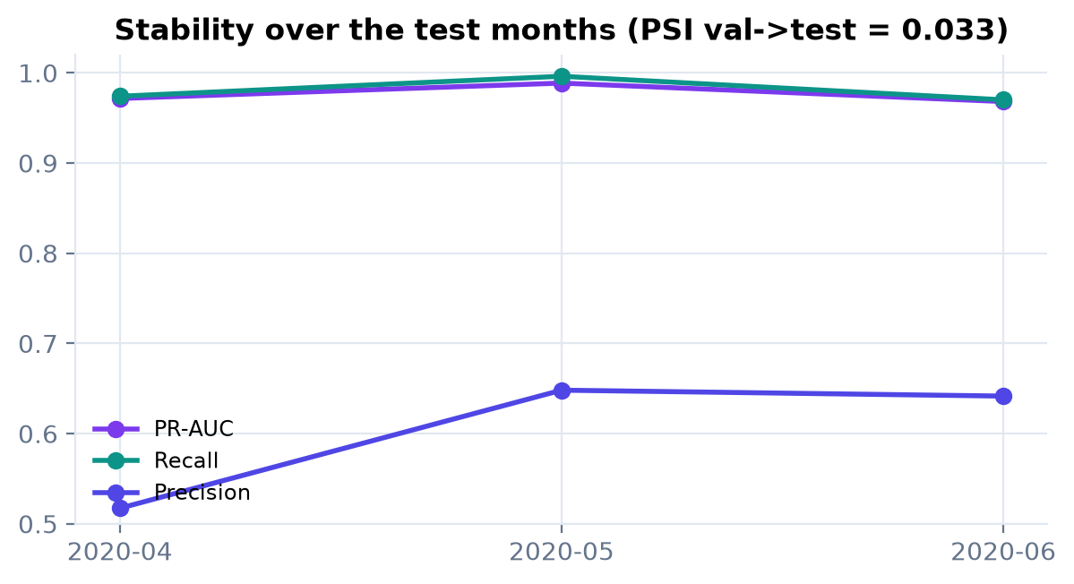
Figure 15. Month-by-month stability on the test period.
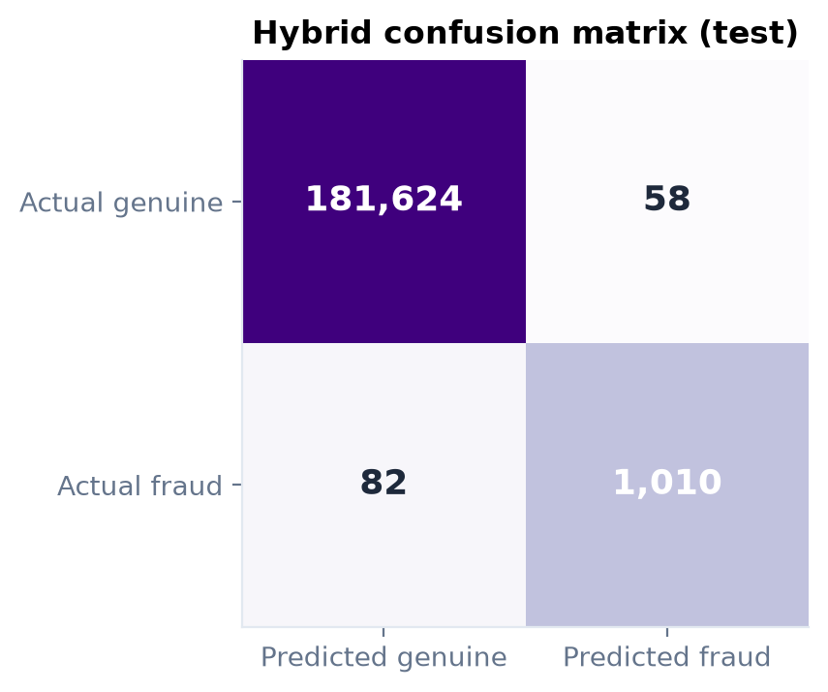
Figure 16. Confusion matrix of the hybrid at the validation-tuned threshold.
The Population Stability Index of the risk score between validation and test is 0.033 (below 0.1 is conventionally "stable"). In production the same statistic, computed weekly, triggers retraining when fraud patterns drift.

7.8 Safety layer: cost and effect
Table 23. How often each rule fires, and what it adds beyond the ML's own alerts
Period | Rule | Fires | On genuine | Fraud rate | Extra alerts | Extra frauds | Extra / day
Validation | P1 | 49 | 5 | 90% | 5 | 0 | 0.06
Validation | P2 | 0 | 0 | - | 0 | 0 | 0.00
Validation | P3 | 6 | 6 | 0% | 6 | 0 | 0.07
Validation | N1 | 137 | 29 | 79% | 22 | 0 | 0.26
Test | P1 | 52 | 9 | 83% | 8 | 0 | 0.11
Test | P2 | 0 | 0 | - | 0 | 0 | 0.00
Test | P3 | 15 | 15 | 0% | 15 | 0 | 0.20
Test | N1 | 155 | 45 | 71% | 39 | 0 | 0.52

Table 24. The same test period with and without the safety layer
At the alert (step-up) level, test period | ML only | ML + safety layer
Alerts | 1,750 | 1,810
Frauds caught | 1,074 / 1,092 | 1,074 / 1,092
Recall | 98.4% | 98.4%
Precision | 61.4% | 59.3%
Fraud losses avoided (net of alert costs) | 98.1% | 98.1%

How we prove it is worth keeping
On real, unseen traffic the safety layer costs 0.81 extra step-ups per day, leaves recall unchanged at 98.4%, and lowers alert precision from 61.4% to 59.3%. It adds no fraud here because the ML already catches the fraud types present in Sparkov. It is insurance for attacks absent from the training data (card testing and cloned cards, Section 8.1), bought at a measured, small price.

7.9 Explainability results
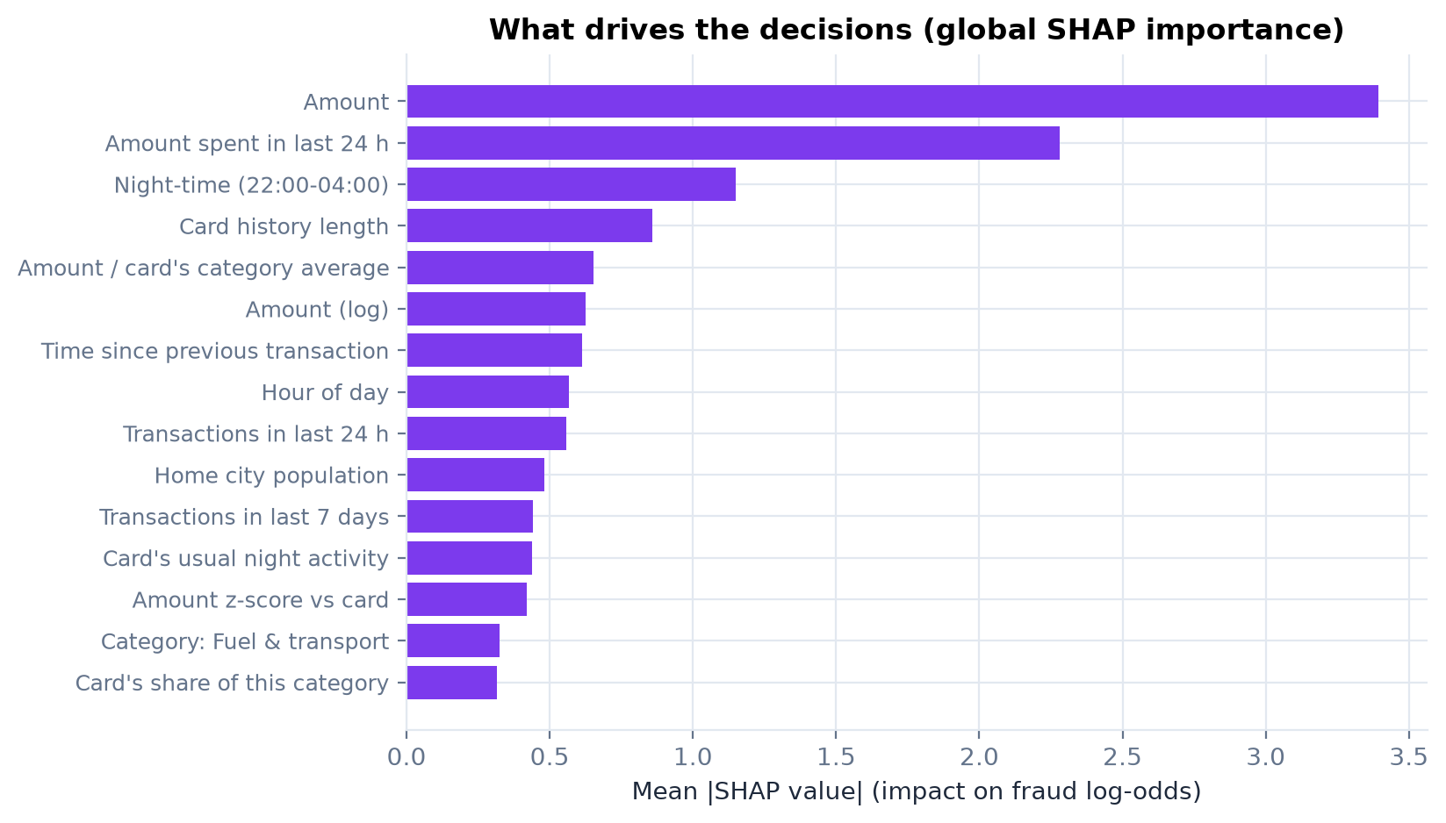
Figure 17. Global SHAP importance: which signals drive decisions overall.
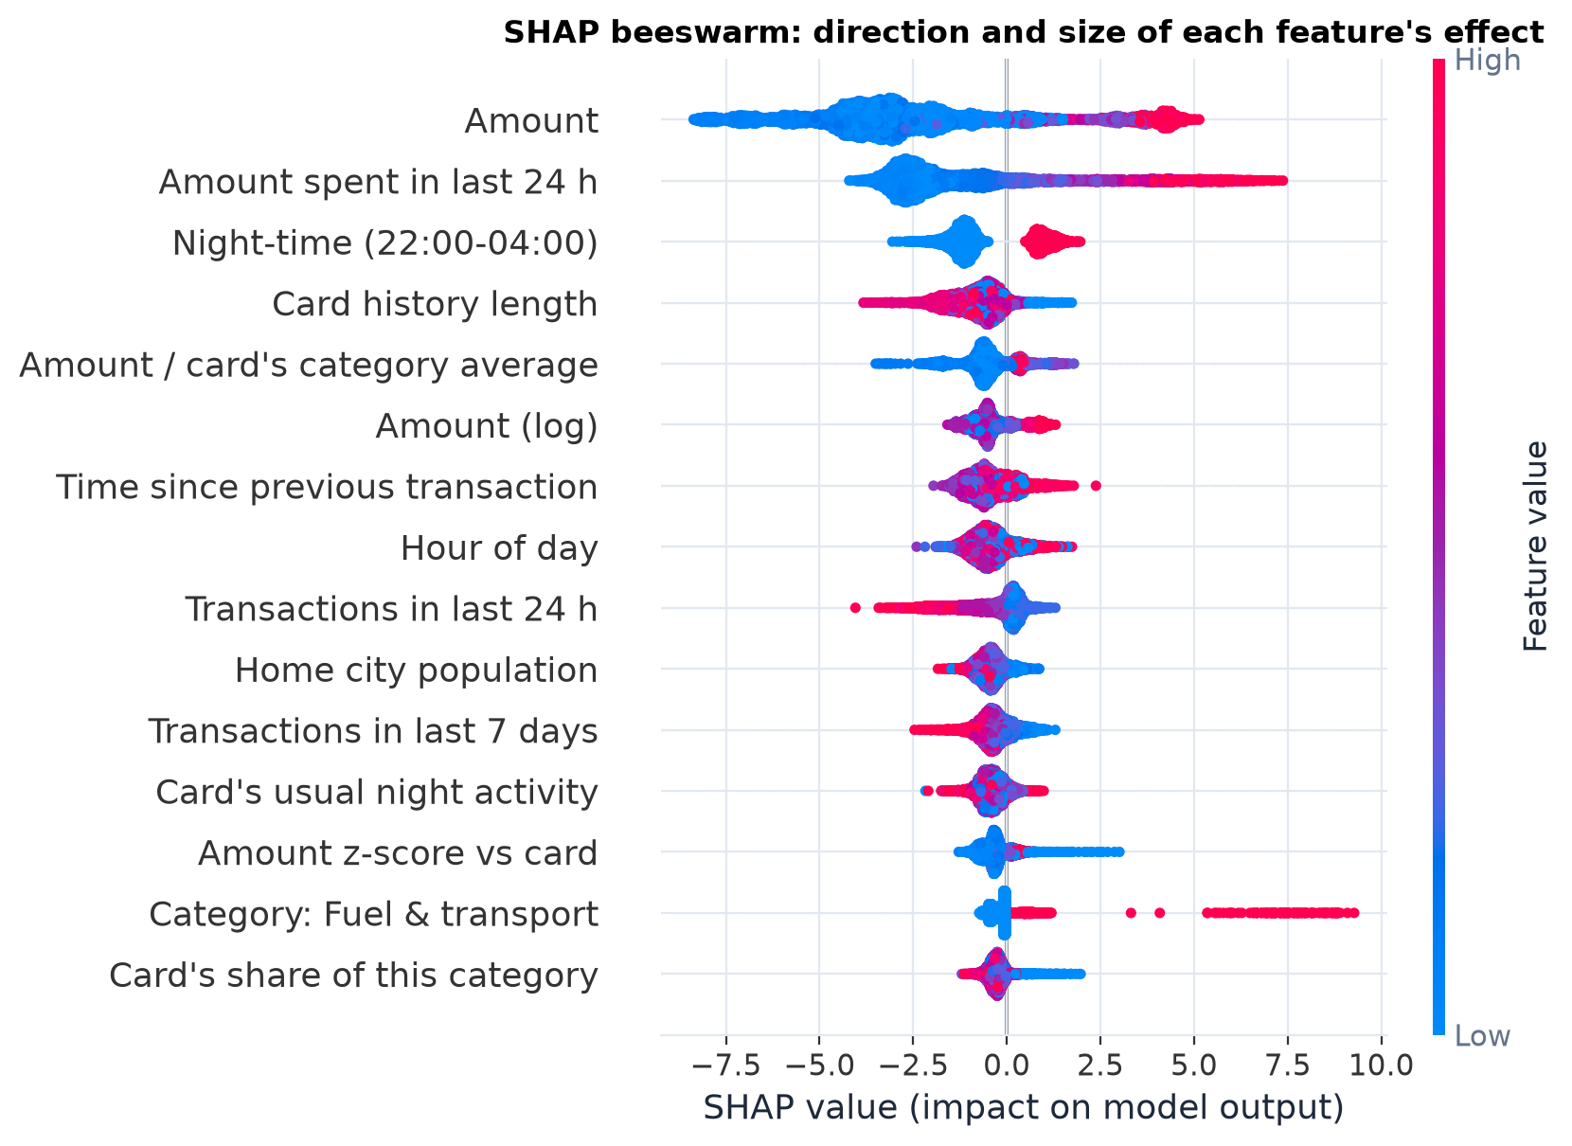
Figure 18. SHAP beeswarm: each dot is one transaction; red = high feature value; right = towards fraud.
Table 25. Case studies from the test period (including a false alarm and a missed fraud, for honesty)
Case | Transaction | Risk | Decision | Top reasons given by FraudLens
fraud caught (HIGH risk) | $514.17 · Entertainment · 05-03 03:03 | 81 (HIGH) | fraud | Amount $514.17 is 6.2x this card's average spend ($83); Made late at night (03:00-04:00); only 23% of this card's past transactions were at night; Entertainment has a higher fraud rate in historical data
fraud caught (HIGH risk) | $326.23 · Grocery (in-store) · 05-13 09:51 | 100 (HIGH) | fraud | Grocery (in-store) has a higher fraud rate in historical data; Large transaction amount ($326.23); 2 transactions ($1,906) in the past 24 h, 0.9x this card's usual daily activity
fraud caught (HIGH risk) | $988.90 · Shopping (in-store) · 04-10 23:58 | 100 (HIGH) | fraud | 6 transactions ($3,069) in the past 24 h, 3.2x this card's usual daily activity; Amount $988.90 is 13.3x this card's average spend ($74); Made late at night (23:00-00:00); only 28% of this card's past transactions were at night
fraud caught (HIGH risk) | $49.76 · Miscellaneous (in-store) · 06-18 22:23 | 92 (HIGH) | fraud | Made late at night (22:00-23:00); only 27% of this card's past transactions were at night; 2 transactions ($640) in the past 24 h, 0.7x this card's usual daily activity; Miscellaneous (in-store) has a higher fraud rate in historical data
fraud sent to step-up verification (MEDIUM) | $19.91 · Personal care · 05-12 23:35 | 47 (MEDIUM) | fraud | Made late at night (23:00-00:00); only 22% of this card's past transactions were at night; Large transaction amount ($19.91)
false alarm (genuine blocked) | $1,072.30 · Online shopping · 05-30 23:23 | 100 (HIGH) | genuine | Amount $1,072.30 is 11.7x this card's average spend ($92); 7 transactions ($2,421) in the past 24 h, 1.5x this card's usual daily activity; 9.4x what this card usually spends on Online shopping
missed fraud (approved) | $780.14 · Shopping (in-store) · 06-15 18:00 | 0 (LOW) | fraud | Amount $780.14 is 13.6x this card's average spend ($57); 9.0x what this card usually spends on Shopping (in-store)
normal transaction (approved) | $1.20 · Online miscellaneous · 05-17 09:19 | 0 (LOW) | genuine | 2 transactions ($478) in the past 24 h, 1.0x this card's usual daily activity

8 How FraudLens detects scams
Different scams leave different fingerprints in transaction data. The table below shows which signals FraudLens uses for each type and which detector is responsible; Section 8.1 shows the system's actual responses when each scam is replayed against a real card's history.
Table 26. Scam typology and detection signals
Scam / fraud type | How it works | Tell-tale signals | FraudLens features | Detector
Card-not-present fraud (stolen card details) | Card data from phishing, breaches or malware is used online | Online channel, large amount, night-time, unfamiliar category | is_online, cat_*, amt_to_card_mean, is_night, is_new_category | XGBoost + RF
Card testing (enumeration) | Tiny charges check which stolen numbers work, then a large purchase | Burst of small online charges, then a jump | cnt_1h, log_secs_since_last, amt_to_card_mean | Safety layer: P3 micro-charge burst, then P1 + N1 (absent from training data)
Stolen-card spree / account takeover | Maximum spending in a few hours before the card is blocked | 24 h count and spend far above normal | cnt_24h_vs_usual, sum_24h, amt_zscore | XGBoost + RF
Cloned card (skimming) / impossible travel | A copy of the card is used far away | Distance/speed since the previous transaction | dist_prev_km, speed_kmh, dist_home_km | Safety layer: P2 impossible travel (geography is not learnable from Sparkov)
Limit probing / escalation | Rising amounts test the card's limit | Growing 24 h spend, amount vs history | sum_24h, amt_to_cat_mean | XGBoost
Dormant-card reactivation | An unused card suddenly spends | Long gap then a high amount | log_secs_since_last, amt_to_card_mean | XGBoost + IF
Merchant compromise / collusion | Fraud concentrates at a merchant | Merchant-level fraud rates, card-merchant links | Not yet (future: merchant risk, graph model) | Future work
Social engineering / authorised push payment (e.g. OTP or UPI scams) | The real customer is tricked into paying | New payee, unusual amount, device/session anomalies | Partly (amount, novelty); needs device and payee data | Limitation

8.1 Scam scenarios replayed through the live engine
Table 27. Scam scenarios played against a real card's history (sandboxed): ML alone vs final decision
Scenario | Steps | ML risk per step | ML alone | Final decision | Rules fired | Top reasons
Card-testing attack | 5 | 0 -> 0 -> 0 -> 0 -> 28 | LOW | MEDIUM at step 4 | N1, P1, P3 | Policy P3: tiny online charge ($3.10) after 3 others in the past hour, the classic card-testing pattern; Made late at night (23:00-00:00); only 19% of this card's past transactions were at night
Stolen-card spending spree | 6 | 100 -> 13 -> 0 -> 99 -> 100 -> 100 | HIGH | HIGH at step 1 | N1 | Grocery (in-store) has a higher fraud rate in historical data; Amount $312.40 is 6.3x this card's average spend ($50)
Late-night high-value online purchase | 1 | 81 | HIGH | HIGH at step 1 | - | Amount $1,249.00 is 25.2x this card's average spend ($50); Made late at night (02:00-03:00); only 19% of this card's past transactions were at night
Impossible travel (cloned card) | 2 | 0 -> 0 | LOW | MEDIUM at step 2 | P2 | Policy P2: 1,074 km from the previous transaction; the implied speed is faster than a commercial flight; Amount $389.00 is 7.8x this card's average spend ($50)
Escalating amounts (limit probing) | 4 | 0 -> 0 -> 1 -> 62 | HIGH | HIGH at step 4 | - | Amount $690.00 is 13.9x this card's average spend ($50); Made late at night (22:00-23:00); only 19% of this card's past transactions were at night
Normal customer day (control) | 3 | 0 -> 0 -> 0 | LOW | LOW | - | Fuel & transport has a higher fraud rate in historical data

Each scenario starts from the real history of a long-standing, mostly-daytime cardholder and runs in a sandbox copy of that card's state, so the demo never changes live data. The ML alone catches the fraud styles present in its training data (stolen-card spending spree, late-night high-value online purchase, escalating amounts (limit probing)). The ML alone approves every step of card testing (the pattern never occurs in the training data); the safety layer escalates it at step 4 of 5. The ML alone approves every step of cloned-card travel (the pattern never occurs in the training data); the safety layer escalates it at step 2 of 2. The normal customer day is approved at every step. The same scenarios run live from the dashboard's Scam Scenarios page.
Limitation
Transaction-level models cannot see everything. Scams where the genuine customer is persuaded to pay (authorised push payment / social engineering) look like normal customer behaviour and need extra signals such as device fingerprint, payee history and session behaviour. Merchant-level collusion needs a graph view (T14). Both are listed as future work rather than claimed.

9 What we do better, and how we prove it

9.1 Compared with typical existing work
Table 28. FraudLens versus typical existing work
Aspect | Typical paper / project | FraudLens | Evidence
Model | One classifier | Stacked XGB + RF + Isolation Forest | E1, E4
Unknown fraud | Not addressed | Novelty alarm + documented policy rules outside the stacking | E5, 7.8, 8.1
Features | Raw columns or PCA | Per-card behavioural history, causal | E4: +0.154 PR-AUC
Imbalance | SMOTE assumed | Four strategies compared; calibrated weighting | E2
Evaluation | Random split, accuracy, SMOTE before split | Chronological split, PR-AUC/MCC/money, bootstrap CIs | E3
Output | Fraud / not fraud | Calibrated probability, 0-100 score, 3 action tiers | E7
Explanation | None or a global chart | Per-decision reasons + mitigating factors + audit record | 7.9
Deployment | Notebook | Real-time API, online feature store, dashboard, Docker | Ch. 10
Security & fairness | Rarely discussed | Tokenisation, audit trail, API key, protected attributes excluded | 4.2, E4

9.2 Claims and proofs
Table 29. Every claim is backed by a test
Claim | How we test it | Result | Verdict
Behavioural features beat raw fields | E4a, same XGBoost, paired bootstrap | PR-AUC 0.825 -> 0.978 | Proven
Trees beat deep learning on this data | E1 on the same split | XGB 0.978 vs MLP 0.960, CNN 0.933 | Proven
ML beats legacy rules | E1 | PR-AUC 0.979 vs 0.248 | Proven
Hybrid is at least as good as its best member | E4b + paired bootstrap vs XGBoost | diff +0.0001 [-0.0002, +0.0005] | Equal (no loss)
Shortcuts inflate published numbers | E3, four protocols | F1 1.000 (leaky) vs 0.803 (honest) | Proven
Probabilities are calibrated | Calibration curve, Brier score | Hybrid tracks the diagonal | Proven (fig.)
Sub-second real-time scoring | Idle-machine latency, one thread, one transaction per call | models p50 209.4 ms; full API path p50 256.6 ms (p95 526.7 ms) | Proven
Safety layer catches attacks absent from training at low cost | Scam replays + cost on validation and test | 0.81 extra step-ups/day; card testing and cloned card escalated | Proven
No training/serving skew | Parity unit test | Online features = offline features (3,000 txns) | Proven (test)
Explanations are faithful | TreeSHAP local accuracy unit test | Contributions sum to the model's log-odds (same trees) | Proven (test)
Stable over time | Monthly metrics + PSI | PSI 0.033 | Proven

9.3 Improvements over our original proposal
Table 30. From proposal to final system
Original plan | What we did | Why
SMOTE or class weighting | Measured four strategies; chose weighting + calibrated stacking | Evidence (E2) and calibration research
Combine XGB, RF and IF somehow | Learned logistic stacking on a later time period | Weights from data; calibrated output
Fixed risk bands 0-30 / 31-60 / 61-100 | Kept the bands, anchored to cost-optimal and 90%-precision thresholds | Bands now mean something in money and precision
SHAP explanation | Exact TreeSHAP turned into sentences + mitigating factors | Analysts and customers need words, not plots
FastAPI + dashboard | Plus online feature store, stream replay, scenario sandbox, case queue, audit log | Operable and demonstrable system
PostgreSQL | SQLite by default; PostgreSQL by setting FRAUDLENS_DB_URL | Zero-setup demo, production-ready path
Evaluate with precision/recall/F1/ROC/PR-AUC | Plus MCC, money saved, bootstrap CIs, paired tests, chronological split | Results that survive scrutiny
Isolation Forest inside the hybrid | Kept in the stack, plus its own novelty-alarm route and three policy rules | Stacking gave it almost no weight; attacks absent from training still need coverage
- | Added: leakage demonstration, unseen-fraud test, DL baselines, ULB benchmark, fairness ablation, idle-machine latency | Answer the questions a reviewer will ask

10 Implementation

10.1 Code structure
Table 31. Repository layout
Path | Purpose
fraudlens/features.py | Causal feature store shared by training and the API
fraudlens/hybrid.py | Hybrid risk engine: detectors, stacking, thresholds, risk score
fraudlens/explain.py | TreeSHAP + reason-code generation
fraudlens/models.py, deep.py, rules.py | Model factory, PyTorch baselines, legacy rules
fraudlens/metrics.py | PR-AUC, MCC, cost, thresholds, bootstrap tests
fraudlens/pipeline.py | Experiments E1-E7, artifacts, scenarios (one command)
fraudlens/plots.py | All figures
fraudlens/api/ | FastAPI app, scoring service, decision log, scam scenarios
frontend/ | React dashboard
reporting/ | Generates these Word and PDF reports from the results
tests/ | Unit, parity and API tests
artifacts/ | Trained engine, feature-store snapshot, held-out test stream, model card
reports/results, reports/figures | Experiment outputs (JSON) and charts (PNG)

10.2 REST API
Table 32. Main API endpoints (full reference: docs/API.md)
Method | Endpoint | Purpose
POST | /api/score | Score and explain one transaction (what-if or committed)
POST | /api/stream/next?n= | Replay the next n unseen test transactions
GET | /api/stats | Live KPIs: precision, recall, fraud $ stopped, latency, histograms
GET | /api/transactions | Decision log with filters (level, source, review status)
POST | /api/transactions/{id}/review | Analyst verdict: confirm fraud / mark genuine
GET / POST | /api/scenarios, /api/scenarios/{id}/run | Scam scenarios in a sandbox
GET | /api/cards, /api/cards/{token} | Tokenised cards and behaviour profiles
GET | /api/model, /api/results/{name} | Model card and research results
GET | /api/health, /docs | Health check; interactive Swagger documentation

10.3 Web dashboard
Table 33. Dashboard pages
Page | What it does
Overview | Project summary, headline metrics, transaction flow
Live Monitor | Replays the unseen test period in time order; live KPIs, feed, charts; click any row for its explanation
Transaction Tester | Pick a real card, craft a transaction, see the risk gauge, detector votes and reasons
Scam Scenarios | One-click card testing, spree, midnight online, impossible travel, escalation, normal day
Case Queue | Alerts awaiting review; confirm or dismiss; forensic audit record
Results | All experiments E1-E7 with tables, charts and figures
Project Report | Progress, milestones, work distribution and deliverables for reviewers (edited via project.json)
About | Architecture, technology stack, how to run

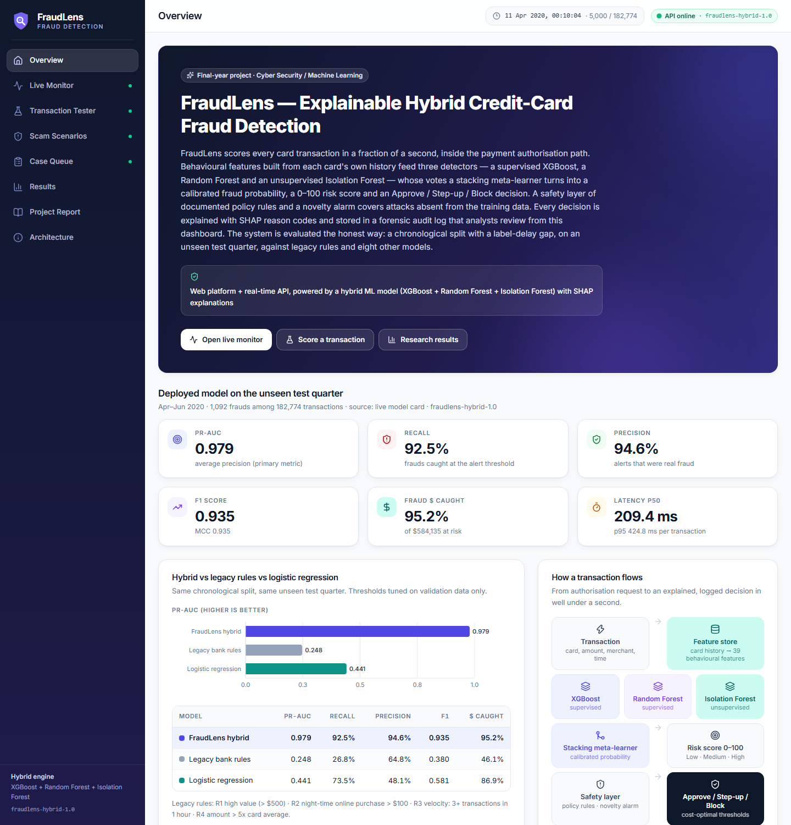
Figure 19. Overview: headline metrics of the deployed model and the transaction flow.
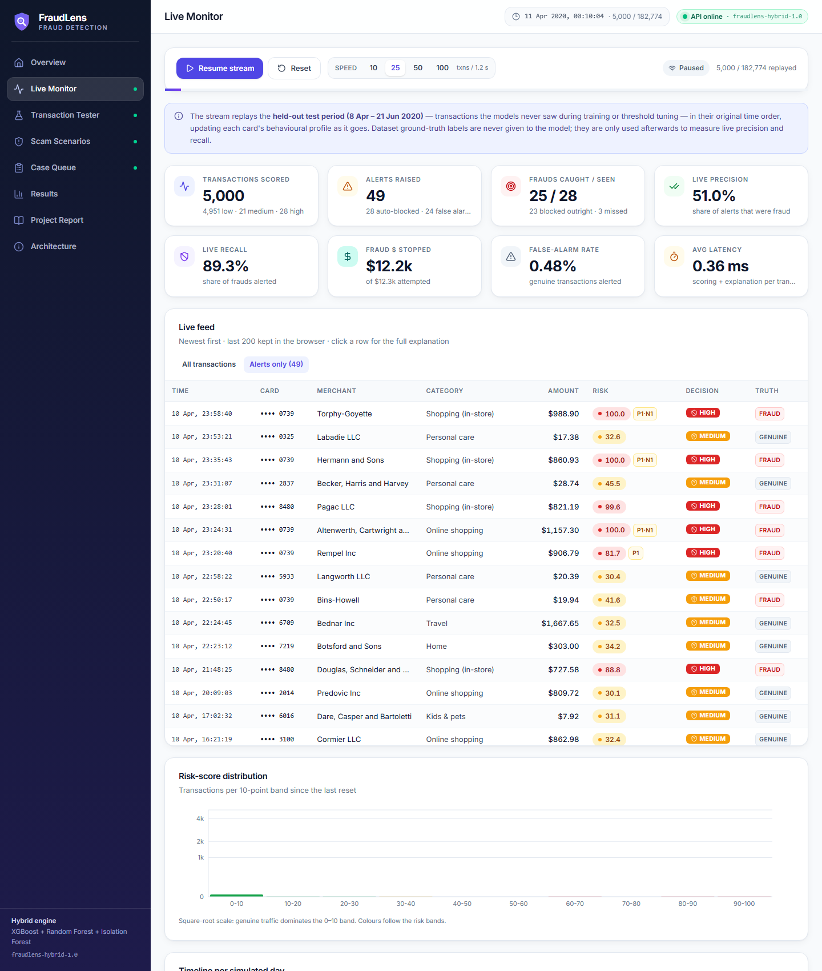
Figure 20. Live Monitor (alerts view): the unseen test quarter replayed through the API, with live precision, recall and money stopped.
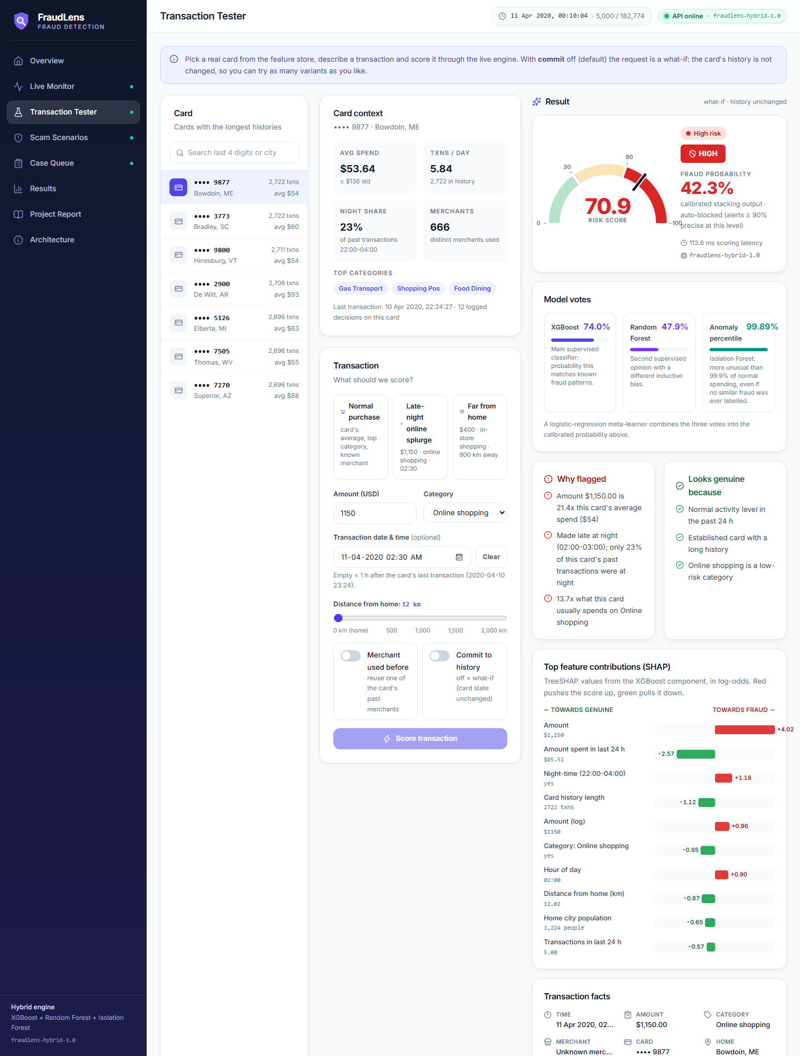
Figure 21. Transaction Tester: a real card, a late-night $1,150 online purchase, the risk gauge, detector votes and SHAP reasons.

Figure 22. Scam Scenarios: card testing escalated at step 4 by the safety layer while the ML-only risk (dashed) stays flat.
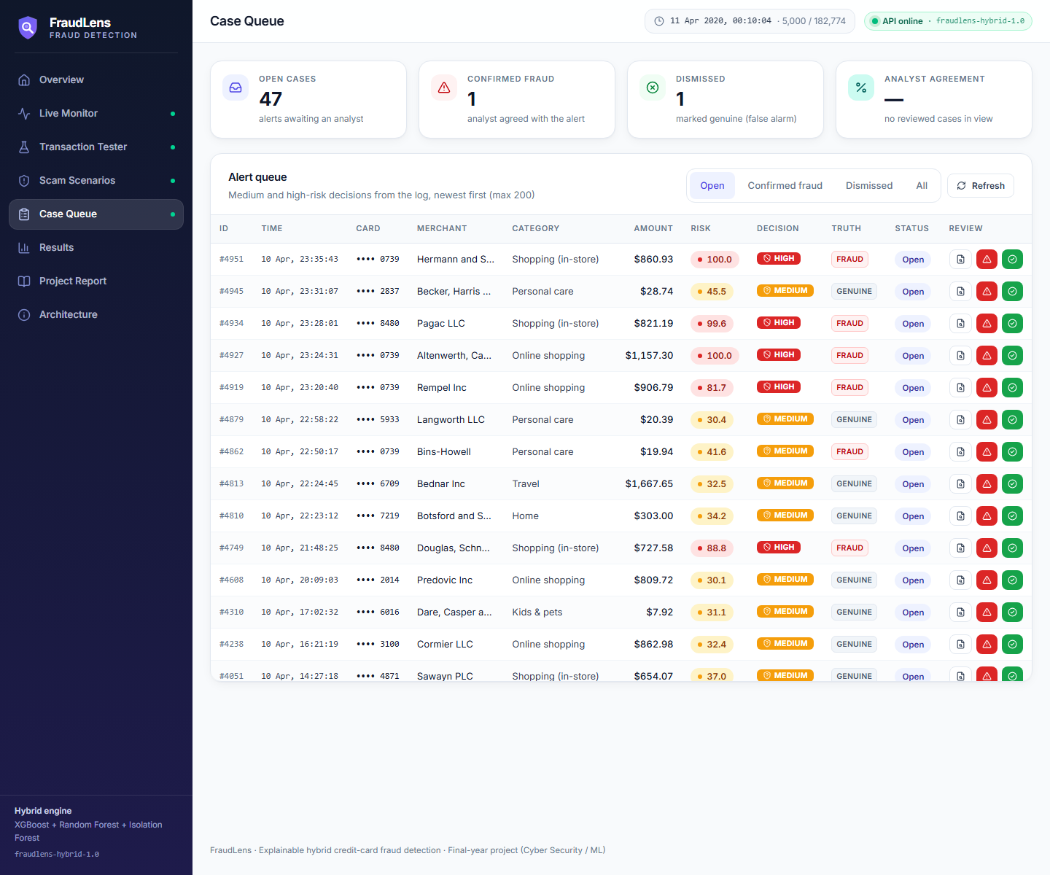
Figure 23. Case Queue: medium and high alerts awaiting analyst review, with the dataset truth for evaluation.
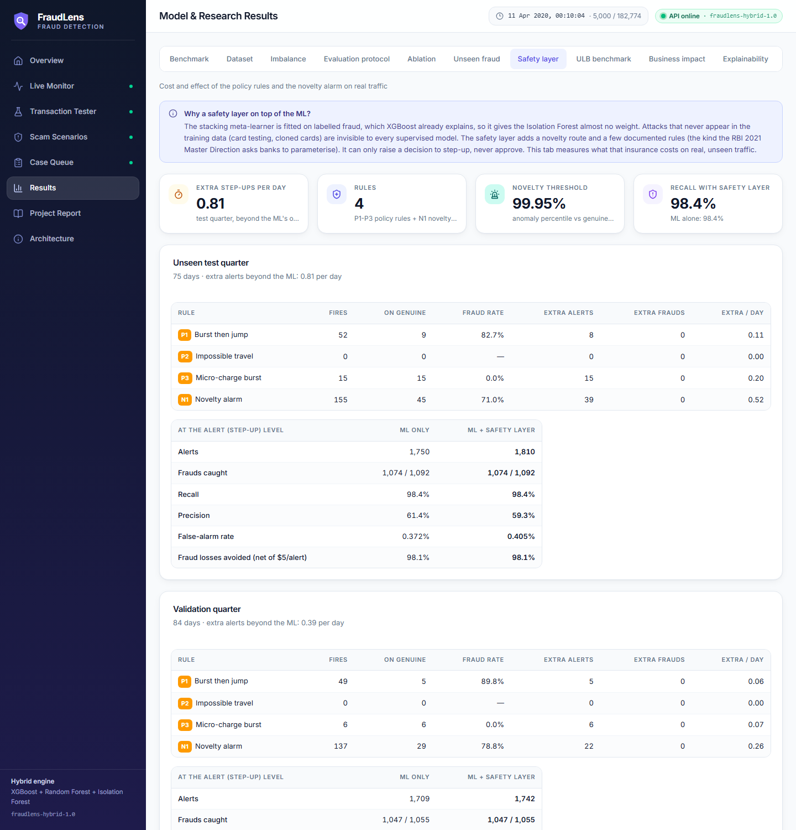
Figure 24. Results, safety-layer tab: what each rule costs and adds on real traffic.
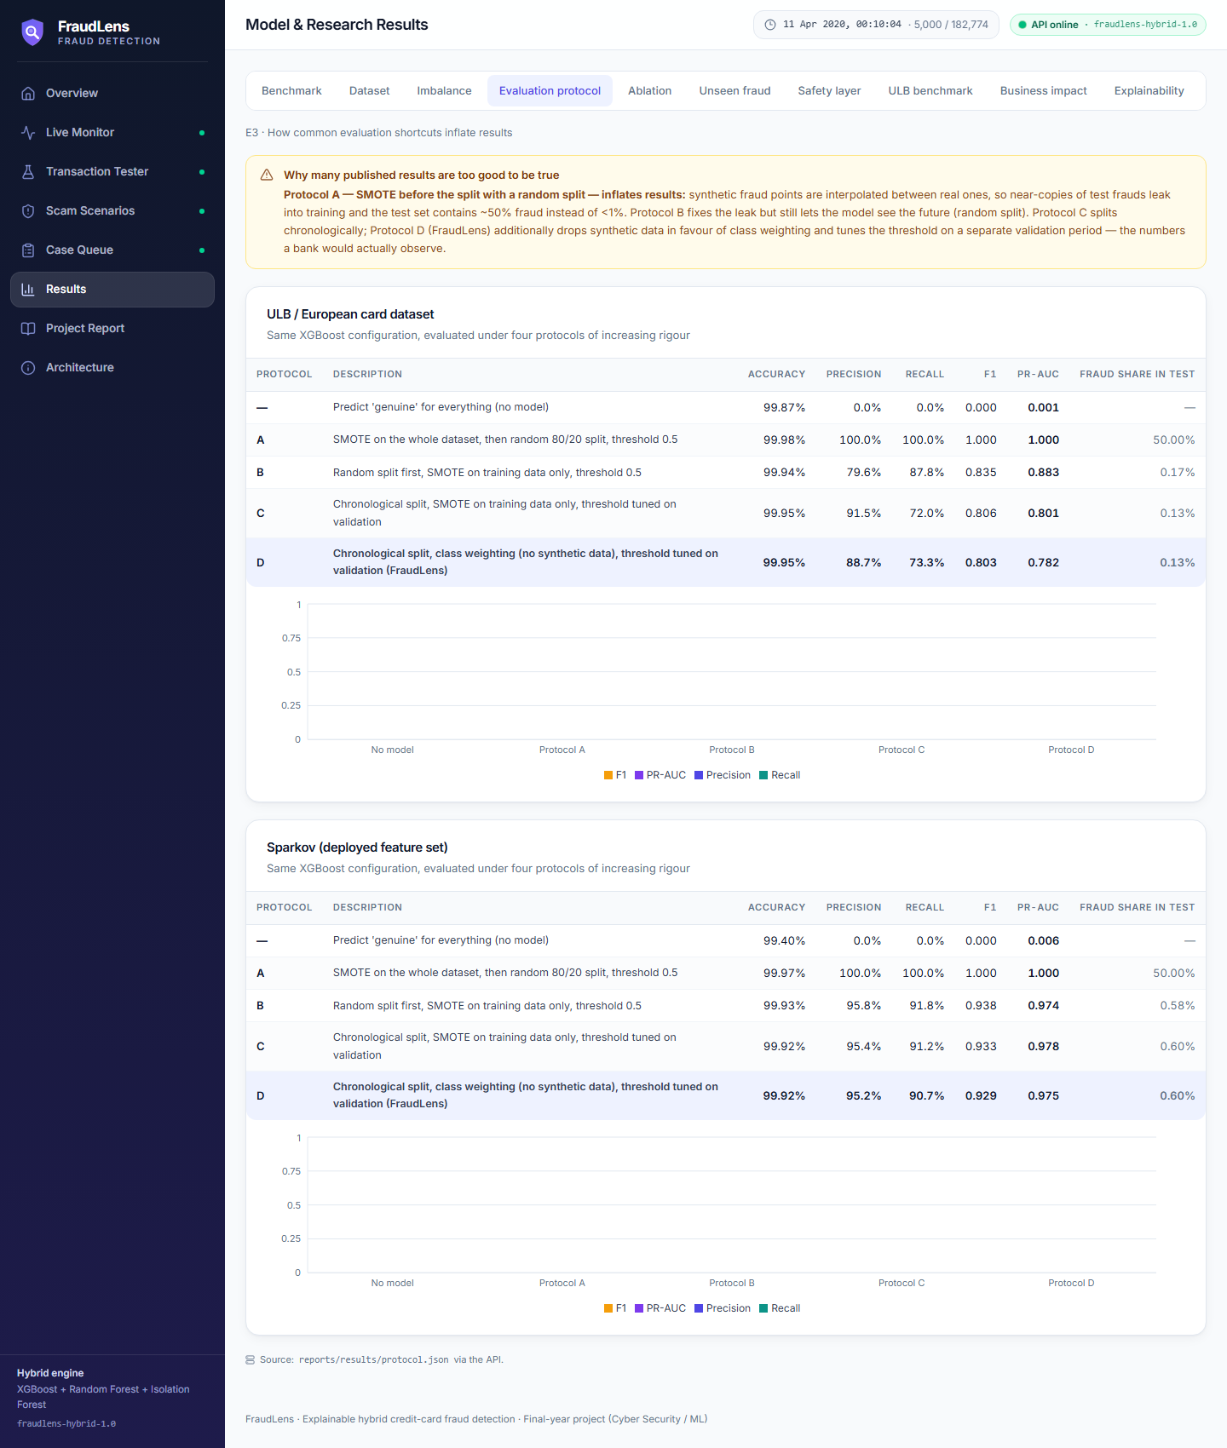
Figure 25. Results, evaluation-protocol tab: how shortcuts inflate published numbers.
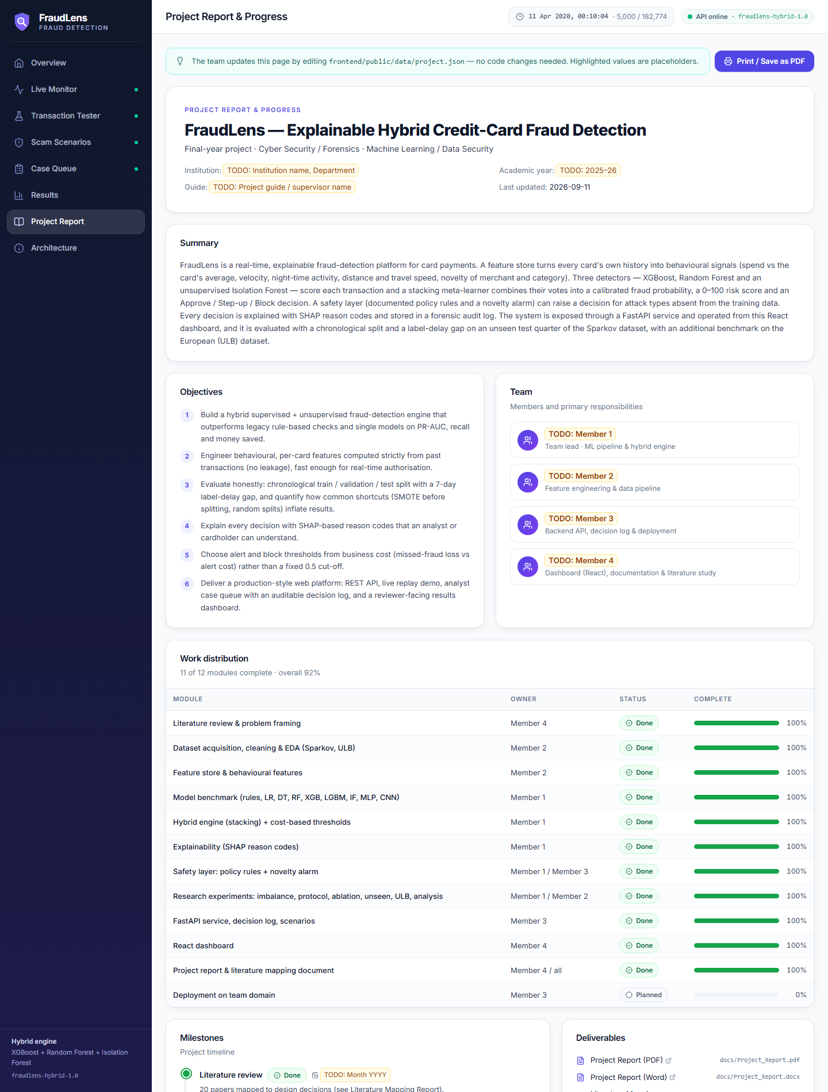
Figure 26. Project Report page for reviewers (edited through project.json).

10.4 Testing
Table 34. Automated tests (run with: pytest)
Test | What it checks
test_features: causality | Changing a future transaction never changes earlier features (no leakage)
test_features: velocity windows | 1 h / 24 h / 7 d counts and ratios computed correctly
test_features: sandbox | What-if scoring and scenarios never change live card state
test_features: online/offline parity | API features equal training features on 3,000 replayed transactions
test_metrics | Confusion counts, F1/precision/cost thresholds, accuracy paradox
test_api | Health, tokenisation, what-if purity, suspicious > normal, stream, review, scenarios, validation errors

11 How to run, test, present and deploy

11.1 Run locally (Windows PowerShell)
git clone https://github.com/Prateek22672/AI-Based-Credit-Card-Fraud-Detection-System.git
cd AI-Based-Credit-Card-Fraud-Detection-System
python -m venv .venv
.venv\Scripts\pip install -r requirements.txt
# trained models + held-out test data are included in artifacts/, so the API runs immediately:
.venv\Scripts\python -m uvicorn fraudlens.api.main:app --port 8000
# second terminal: the dashboard
cd frontend
npm install
npm run dev # open http://localhost:5173 (API docs: http://localhost:8000/docs)

11.2 Reproduce the research (optional, about 1.5 h on a laptop CPU)
.venv\Scripts\python -m fraudlens.download # both datasets (~260 MB)
.venv\Scripts\pip install -r requirements-dl.txt --index-url https://download.pytorch.org/whl/cpu
.venv\Scripts\python -m fraudlens.pipeline all # features, E1-E7, artifacts, scenarios
.venv\Scripts\python -m fraudlens.plots # figures
.venv\Scripts\python -m reporting.build # these Word + PDF reports
.venv\Scripts\python -m pytest # automated tests

11.3 Suggested demonstration (10 minutes)
- Overview page: state the problem, the verdict (web platform + hybrid ML) and the headline numbers.
- Live Monitor: press Start. Explain that these are unseen April-June 2020 transactions replayed in time order; watch alerts appear and live precision/recall converge towards the test results.
- Click a red (HIGH) row: read the reasons aloud (for example "5 transactions in the past hour", "amount 9x the card's average") and point at the three detector votes.
- Scam Scenarios: run Card testing, then Normal day. Show the risk climbing step by step for the attack and staying green for the normal customer.
- Transaction Tester: take a real card, enter its usual amount (LOW), then change to $1,150 online at 02:30 (HIGH). This shows the model judges behaviour relative to the customer.
- Case Queue: confirm one alert and dismiss one; open the audit record to show the forensic trail.
- Results page: show E3 (how shortcuts inflate numbers) and E4 (features matter most), and explain how each claim is proven.
- Project Report page: milestones and work distribution for the reviewers.

11.4 Deploy on your own domain
- Simplest (one server / VPS): docker build -t fraudlens . then docker run -p 8000:8000 fraudlens. The container serves the API and the built dashboard; point the domain (or a Cloudflare tunnel / Nginx reverse proxy) at port 8000.
- Split hosting: build the dashboard with VITE_API_URL=https://api.your-domain and upload frontend/dist to any static host (cPanel, Netlify, Vercel); run the API on a VPS or a Python host and set FRAUDLENS_CORS_ORIGINS=https://your-domain.
- Security for public demos: set FRAUDLENS_API_KEY (and the same VITE_API_KEY at build time) and a private FRAUDLENS_TOKEN_SECRET.
- Results without a server: the Results and Project Report pages also work from static files, so reviewers can browse them even if the API is offline.

12 Limitations and threats to validity
- Synthetic primary data. Sparkov is simulated; its fraud patterns are cleaner than real ones, so absolute scores are higher than a bank would see. ULB is real but anonymised, preventing behavioural features.
- Label delay is simplified to fixed 7-day gaps; in reality labels arrive at varying times and investigator feedback is biased towards alerted transactions (Dal Pozzolo et al., 2018).
- Geography is a weak signal in Sparkov (merchants are placed near home at random), so impossible-travel detection relies on policy rule P2 and is not validated on real location data.
- The safety-layer thresholds are set, not learned. The rule parameters come from domain reasoning; the 99.95th-percentile novelty threshold was chosen after looking at its alert cost on the validation and test periods. These are business settings to review with a fraud team, not tuned detection results.
- Card testing and cloned cards are demonstrated on replayed scenarios, because Sparkov contains no labelled examples of them; their detection rate on real traffic is not measured.
- Adversarial adaptation. Fraudsters who learn the rules can mimic normal behaviour; periodic retraining and the anomaly layer mitigate but do not remove this.
- Cost assumptions ($5 per alert) are illustrative; the sensitivity table shows how decisions change with the assumption.
- Social-engineering scams where the real customer authorises payment are mostly out of reach of transaction features alone.

13 Future scope
Table 35. Future work
Extension | Value | Reference
Streaming ingestion (Kafka) + Redis feature store | Bank-scale throughput | Carcillo 2018 (SCARFF), T20
Compiled tree runtime (treelite / ONNX) for the two forests | Single-call latency from ~0.2 s to a few ms | Engineering
Continuous retraining from reviewed cases, drift alarms on PSI | Adapts to new fraud patterns | T11, Lebichot 2021, Gama 2014
Graph model over card-merchant-device links | Detects organised rings and merchant compromise | T14, Liu 2021 (PC-GNN)
LSTM/Transformer over each card's transaction sequence | Richer behavioural memory | T19, Jurgovsky 2018
Mobile customer app ("Was this you?" push alerts) | Faster confirmation, fewer false blocks | Same REST API
Device, IP and payee signals | Social-engineering and account-takeover coverage | Industry practice
Validation on IEEE-CIS and real bank data | External validity | T2, T6, T9

14 Conclusion
FraudLens shows that an explainable hybrid of gradient-boosted trees, a random forest and an anomaly detector, fed with causal behavioural features, detects card fraud accurately (test PR-AUC 0.979, recall 92.5%, precision 94.6%), fast (209.4 ms per transaction) and transparently, and that it is deployable as a real web service. Just as important, the project shows how to evaluate fraud detectors honestly: several impressive published numbers can only be reproduced with data leakage, while our results hold on unseen future data, with confidence intervals and significance tests. Existing projects mainly detect fraud; FraudLens detects it, recognises unusual behaviour, prices the risk, explains the decision and leaves an audit trail.

References
- Andrea Dal Pozzolo, Olivier Caelen, Reid A. Johnson, Gianluca Bontempi (2015). Calibrating Probability with Undersampling for Unbalanced Classification. 2015 IEEE Symposium Series on Computational Intelligence (SSCI), Cape Town, pp. 159-166. https://doi.org/10.1109/SSCI.2015.33
- Andrea Dal Pozzolo, Giacomo Boracchi, Olivier Caelen, Cesare Alippi, Gianluca Bontempi (2018). Credit Card Fraud Detection: A Realistic Modeling and a Novel Learning Strategy. IEEE Transactions on Neural Networks and Learning Systems, vol. 29, no. 8, pp. 3784-3797. https://doi.org/10.1109/TNNLS.2017.2736643
- Yann-Ael Le Borgne, Wissam Siblini, Bertrand Lebichot, Gianluca Bontempi (2022). Reproducible Machine Learning for Credit Card Fraud Detection - Practical Handbook. Universite Libre de Bruxelles (online book, Jupyter Book)
- Christopher Whitrow, David J. Hand, Piotr Juszczak, David Weston, Niall M. Adams (2009). Transaction aggregation as a strategy for credit card fraud detection. Data Mining and Knowledge Discovery, vol. 18, no. 1, pp. 30-55. https://doi.org/10.1007/s10618-008-0116-z
- Alejandro Correa Bahnsen, Djamila Aouada, Aleksandar Stojanovic, Bjorn Ottersten (2016). Feature engineering strategies for credit card fraud detection. Expert Systems with Applications, vol. 51, pp. 134-142. https://doi.org/10.1016/j.eswa.2015.12.030
- Fabrizio Carcillo, Yann-Ael Le Borgne, Olivier Caelen, Yacine Kessaci, Frederic Oble, Gianluca Bontempi (2021). Combining unsupervised and supervised learning in credit card fraud detection. Information Sciences, vol. 557, pp. 317-331 (online 2019). https://doi.org/10.1016/j.ins.2019.05.042
- Fei Tony Liu, Kai Ming Ting, Zhi-Hua Zhou (2008). Isolation Forest. 2008 Eighth IEEE International Conference on Data Mining (ICDM), Pisa, pp. 413-422. https://doi.org/10.1109/ICDM.2008.17
- Leo Breiman (2001). Random Forests. Machine Learning, vol. 45, no. 1, pp. 5-32. https://doi.org/10.1023/A:1010933404324
- Tianqi Chen, Carlos Guestrin (2016). XGBoost: A Scalable Tree Boosting System. Proceedings of the 22nd ACM SIGKDD International Conference on Knowledge Discovery and Data Mining (KDD '16), pp. 785-794. https://doi.org/10.1145/2939672.2939785
- Guolin Ke, Qi Meng, Thomas Finley, Taifeng Wang, Wei Chen, Weidong Ma, Qiwei Ye, Tie-Yan Liu (2017). LightGBM: A Highly Efficient Gradient Boosting Decision Tree. Advances in Neural Information Processing Systems 30 (NIPS 2017)
- David H. Wolpert (1992). Stacked generalization. Neural Networks, vol. 5, no. 2, pp. 241-259. https://doi.org/10.1016/S0893-6080(05)80023-1
- Scott M. Lundberg, Su-In Lee (2017). A Unified Approach to Interpreting Model Predictions. Advances in Neural Information Processing Systems 30 (NIPS 2017)
- Scott M. Lundberg, Gabriel Erion, Hugh Chen, Alex DeGrave, Jordan M. Prutkin, Bala Nair, Ronit Katz, Jonathan Himmelfarb, Nisha Bansal, Su-In Lee (2020). From local explanations to global understanding with explainable AI for trees. Nature Machine Intelligence, vol. 2, no. 1, pp. 56-67. https://doi.org/10.1038/s42256-019-0138-9
- Ismini Psychoula, Andreas Gutmann, Pradip Mainali, Sharon H. Lee, Paul Dunphy, Fabien Petitcolas (2021). Explainable Machine Learning for Fraud Detection. Computer (IEEE), vol. 54, no. 10, pp. 49-59. https://doi.org/10.1109/MC.2021.3081249
- Leo Grinsztajn, Edouard Oyallon, Gael Varoquaux (2022). Why do tree-based models still outperform deep learning on typical tabular data?. Advances in Neural Information Processing Systems 35 (NeurIPS 2022), Datasets and Benchmarks Track, pp. 507-520 (Curran). https://doi.org/10.52202/068431-0037
- Ravid Shwartz-Ziv, Amitai Armon (2022). Tabular data: Deep learning is not all you need. Information Fusion, vol. 81, pp. 84-90. https://doi.org/10.1016/j.inffus.2021.11.011
- Takaya Saito, Marc Rehmsmeier (2015). The Precision-Recall Plot Is More Informative than the ROC Plot When Evaluating Binary Classifiers on Imbalanced Datasets. PLoS ONE, vol. 10, no. 3, e0118432. https://doi.org/10.1371/journal.pone.0118432
- Davide Chicco, Giuseppe Jurman (2020). The advantages of the Matthews correlation coefficient (MCC) over F1 score and accuracy in binary classification evaluation. BMC Genomics, vol. 21, article 6. https://doi.org/10.1186/s12864-019-6413-7
- Miriam Seoane Santos, Jastin Pompeu Soares, Pedro Henriques Abreu, Helder Araujo, Joao Santos (2018). Cross-Validation for Imbalanced Datasets: Avoiding Overoptimistic and Overfitting Approaches. IEEE Computational Intelligence Magazine, vol. 13, no. 4, pp. 59-76. https://doi.org/10.1109/MCI.2018.2866730
- Shachar Kaufman, Saharon Rosset, Claudia Perlich, Ori Stitelman (2012). Leakage in data mining: Formulation, detection, and avoidance. ACM Transactions on Knowledge Discovery from Data, vol. 6, no. 4, article 15, pp. 1-21. https://doi.org/10.1145/2382577.2382579
- Khizar Hayat, Baptiste Magnier (2025). Data Leakage and Deceptive Performance: A Critical Examination of Credit Card Fraud Detection Methodologies. Mathematics (MDPI), vol. 13, no. 16, article 2563. https://doi.org/10.3390/math13162563
- Ruben van den Goorbergh, Maarten van Smeden, Dirk Timmerman, Ben Van Calster (2022). The harm of class imbalance corrections for risk prediction models: illustration and simulation using logistic regression. Journal of the American Medical Informatics Association, vol. 29, no. 9, pp. 1525-1534. https://doi.org/10.1093/jamia/ocac093
- Charles Elkan (2001). The Foundations of Cost-Sensitive Learning. Proceedings of the 17th International Joint Conference on Artificial Intelligence (IJCAI-01), Seattle, pp. 973-978
- Alexandru Niculescu-Mizil, Rich Caruana (2005). Predicting good probabilities with supervised learning. Proceedings of the 22nd International Conference on Machine Learning (ICML '05), Bonn, pp. 625-632. https://doi.org/10.1145/1102351.1102430
- Sebastiaan Hoppner, Bart Baesens, Wouter Verbeke, Tim Verdonck (2022). Instance-dependent cost-sensitive learning for detecting transfer fraud. European Journal of Operational Research, vol. 297, no. 1, pp. 291-300. https://doi.org/10.1016/j.ejor.2021.05.028
- Toon Vanderschueren, Tim Verdonck, Bart Baesens, Wouter Verbeke (2022). Predict-then-optimize or predict-and-optimize? An empirical evaluation of cost-sensitive learning strategies. Information Sciences, vol. 594, pp. 400-415. https://doi.org/10.1016/j.ins.2022.02.021
- Joao Gama, Indre Zliobaite, Albert Bifet, Mykola Pechenizkiy, Abdelhamid Bouchachia (2014). A survey on concept drift adaptation. ACM Computing Surveys, vol. 46, no. 4, article 44, pp. 1-37. https://doi.org/10.1145/2523813
- Johannes Jurgovsky, Michael Granitzer, Konstantin Ziegler, Sylvie Calabretto, Pierre-Edouard Portier, Liyun He-Guelton, Olivier Caelen (2018). Sequence classification for credit-card fraud detection. Expert Systems with Applications, vol. 100, pp. 234-245. https://doi.org/10.1016/j.eswa.2018.01.037
- Fabrizio Carcillo, Andrea Dal Pozzolo, Yann-Ael Le Borgne, Olivier Caelen, Yannis Mazzer, Gianluca Bontempi (2018). SCARFF: a scalable framework for streaming credit card fraud detection with Spark. Information Fusion, vol. 41, pp. 182-194. https://doi.org/10.1016/j.inffus.2017.09.005
- Nitesh V. Chawla, Kevin W. Bowyer, Lawrence O. Hall, W. Philip Kegelmeyer (2002). SMOTE: Synthetic Minority Over-sampling Technique. Journal of Artificial Intelligence Research, vol. 16, pp. 321-357. https://doi.org/10.1613/jair.953
- Mohammad Shanaa, Sherief Abdallah (2025). A Hybrid Anomaly Detection Framework Combining Supervised and Unsupervised Learning for Credit Card Fraud Detection. F1000Research, vol. 14, article 664 (v2, Dec 2025). https://doi.org/10.12688/f1000research.166350.2
- Yang Liu, Xiang Ao, Zidi Qin, Jianfeng Chi, Jinghua Feng, Hao Yang, Qing He (2021). Pick and Choose: A GNN-based Imbalanced Learning Approach for Fraud Detection. Proceedings of the Web Conference 2021 (WWW '21), pp. 3168-3177. https://doi.org/10.1145/3442381.3449989
- The Nilson Report, press release 'Global Card Fraud Losses at $33 Billion' (GlobeNewswire) (2026-01-07). Global payment-card fraud losses (issuers, merchants, acquirers, ATM processors) in 2024. https://www.globenewswire.com/news-release/2026/01/07/3214821/0/en/global-card-fraud-losses-at-33-billion.html
- Le Borgne et al., Reproducible Machine Learning for Credit Card Fraud Detection - Practical Handbook, Foreword (citing Nilson Report 2019) (2022). Long-run growth of global card fraud losses (historical trend). https://fraud-detection-handbook.github.io/fraud-detection-handbook/Foreword.html
- EBA-ECB joint 2025 Report on Payment Fraud, ECB press release (2025-12-15). Payment fraud in the European Economic Area, 2024. https://www.ecb.europa.eu/press/pr/date/2025/html/ecb.pr251215~e133d9d683.en.html
- European Central Bank, Seventh report on card fraud (2021-10). Card-not-present (CNP) fraud share of total card fraud value (Europe). https://www.ecb.europa.eu/press/cardfraud/html/ecb.cardfraudreport202110~cac4c418e8.en.html
- UK Finance, Annual Fraud Report 2025 press release (2025-05-28). UK unauthorised fraud and remote-purchase (CNP) fraud, 2024. https://www.ukfinance.org.uk/news-and-insight/press-release/fraud-report-2025-press-release
- Reserve Bank of India, Annual Report 2025-26, Chapter VI (Regulation, Supervision and Financial Stability), Tables VI.2 and VI.3 (2026-05-29). India: bank frauds reported to RBI (frauds of Rs 1 lakh and above), latest three years. https://www.rbi.org.in/Scripts/AnnualReportPublications.aspx?Id=1466
- RBI Annual Report 2024-25 as reported by Deccan Herald and SBI Ecowrap (secondary sources; the RBI PDF is behind a bot-check) (2025-05-29). India: bank fraud figures as first published in the previous RBI Annual Report (before revisions). https://www.deccanherald.com/business/bank-frauds-value-trebles-to-over-rs-36000-crore-3563349
- Reserve Bank of India notification (2017-07-06). India: customer liability rules for unauthorised electronic banking transactions. https://www.rbi.org.in/commonman/english/scripts/Notification.aspx?Id=2336
- T1. Shobhan Banoth, K. Reddy Madhavi (2024). A Novel Deep Learning Framework for Credit Card Fraud Detection. 2024 13th International Conference on System Modeling & Advancement in Research Trends (SMART), Moradabad, India, 6-7 Dec 2024, pp. 191-196 (IEEE). https://doi.org/10.1109/SMART63812.2024.10882509
- T2. Pranav Prakash Menon, Amit Sachdeva, Gayathri V. M (2024). Fraud Shield: Credit Card Fraud Detection with Ensemble and Deep Learning. 2024 4th International Conference on Pervasive Computing and Social Networking (ICPCSN), Salem, India, 3-4 May 2024, pp. 224-230 (IEEE). https://doi.org/10.1109/ICPCSN62568.2024.00045
- T3. Bipin Bihari Jayasingh, G. Bhagya Sri (2023). Online Transaction Anomaly Detection Model for Credit Card Usage Using Machine Learning Classifiers. 2023 International Conference on Emerging Smart Computing and Informatics (ESCI), Pune, India, pp. 1-5 (IEEE). https://doi.org/10.1109/ESCI56872.2023.10100152
- T4. Rohan Pawar, Hardik Kathuria, Praveen Joe I R (2023). Credit Card Fraud Detection and Analysis. 2023 14th International Conference on Computing Communication and Networking Technologies (ICCCNT), Delhi, India, 6-8 Jul 2023, pp. 1-5 (IEEE). https://doi.org/10.1109/ICCCNT56998.2023.10306410
- T5. Suni Jose, Deepa Devassy, Anly M Antony (2023). Detection of Credit Card Fraud Using Resampling and Boosting Technique. 2023 Advanced Computing and Communication Technologies for High Performance Applications (ACCTHPA), Ernakulam, India, pp. 1-8 (IEEE). https://doi.org/10.1109/ACCTHPA57160.2023.10083376
- T6. Sreenivas Prasad B, Akash Babu N, Harthikeswar Reddy, Rimjhim Padam Singh, Sneha Kanchan (2024). A Machine Learning Approach for Credit Card Fraud Detection in Massive Datasets Using SMOTE and Random Sampling. 2024 IEEE Recent Advances in Intelligent Computational Systems (RAICS), Kothamangalam, Kerala, India, 16-18 May 2024, pp. 1-8. https://doi.org/10.1109/RAICS61201.2024.10690025
- T7. Prachi Gupta, Shatakshi Shukla, Vaishali Kikan, Ashwni Kumar (2024). Enhancing Fraud Detection in Credit Card Transactions using XGBoost and SMOTE: A Comparative Study. 2024 IEEE International Conference on Smart Power Control and Renewable Energy (ICSPCRE), Rourkela, India, 19-21 Jul 2024, pp. 1-6. https://doi.org/10.1109/ICSPCRE62303.2024.10675080
- T8. Qin Wang, Mary Jane C. Samonte, Weiqing Diao, Yongjian Zhang (2024). Design and Empirical Analysis of Data-Driven Machine Learning Models for Credit Card Fraud Detection. 2024 5th International Conference on Big Data, Artificial Intelligence and Internet of Things Engineering (ICBAIE), Shenzhen, China, 25 Oct 2024, pp. 114-117 (IEEE). https://doi.org/10.1109/ICBAIE63306.2024.11116991
- T9. Xiong Kewei, Binhui Peng, Yang Jiang, Tiying Lu (2021). A Hybrid Deep Learning Model For Online Fraud Detection. 2021 IEEE International Conference on Consumer Electronics and Computer Engineering (ICCECE), Guangzhou, China, pp. 431-434. https://doi.org/10.1109/ICCECE51280.2021.9342110
- T10. Ziyan Zhang, Shuyan Huang (2020). Credit Card Fraud Detection via Deep Learning Method Using Data Balance Tools. 2020 International Conference on Computer Science and Management Technology (ICCSMT), Shanghai, China, pp. 133-137 (IEEE). https://doi.org/10.1109/ICCSMT51754.2020.00033
- T11. Fabrizio Carcillo, Yann-Ael Le Borgne, Olivier Caelen, Gianluca Bontempi (2017). An Assessment of Streaming Active Learning Strategies for Real-Life Credit Card Fraud Detection. 2017 IEEE International Conference on Data Science and Advanced Analytics (DSAA), Tokyo, Japan, pp. 631-639. https://doi.org/10.1109/DSAA.2017.10
- T12. Yinze Yang, Yibing Yu, Tingxi Li (2022). Deep Learning Techniques for Financial Fraud Detection. 2022 14th International Conference on Computer Research and Development (ICCRD), Shenzhen, China, 7-9 Jan 2022, pp. 16-22 (IEEE). https://doi.org/10.1109/ICCRD54409.2022.9730314
- T13. Mehdi Hosseini Chagahi, Abolfazl Yekaneh, Saeed Mohammadi Dashtaki, Behzad Moshiri, Md. Jalil Piran (2026). XAI for Fraud Detection: An Attention-Based Ensemble of CNNs, GNNs, and Confidence-Driven Gating for Reliable Decision-Making. IEEE Transactions on Information Forensics and Security, vol. 21, pp. 347-356. https://doi.org/10.1109/TIFS.2025.3646480
- T14. Munikrishnaiah Sundararamaiah, Chandrasekhar Rao Katru, Chandra Sekhar Kolli, Kruti Sutaria, K. B. Venkata Brahma Rao, Ramya Maranan (2025). Similarity-Navigated Graph Neural Network-Based Fraud Detection in Credit Card Transactions Optimized with the Greylag Goose Algorithm. 2025 International Conference on Machine Learning and Autonomous Systems (ICMLAS), Prawet, Thailand, 10-12 Mar 2025, pp. 1319-1325 (IEEE). https://doi.org/10.1109/ICMLAS64557.2025.10968459
- T15. Mayank Pathak, Rohit Beniwal (2025). A Systematic Literature Survey on Credit Card Fraud Detection using Machine Learning Techniques. 2025 5th International Conference on Pervasive Computing and Social Networking (ICPCSN), Salem, India, 14-16 May 2025, pp. 149-154 (IEEE). https://doi.org/10.1109/ICPCSN65854.2025.11035471
- T16. Shubham Saini, Gaurav Bathla, Vikas Wasson (2024). Credit Card Fraud Detection using Machine Learning: Methods, Challenges and Solutions. 2024 International BIT Conference (BITCON), Dhanbad, India, 7 Dec 2024, pp. 1-6 (IEEE). https://doi.org/10.1109/BITCON63716.2024.10985587
- T17. Shruti Chawla, Sidhant Singh Bhadauriya, Abhishake Bansal, Chetna Sharma, Nomita Patwal (2024). Advancement in Credit Card Fraud Detection: A Comprehensive Review of Machine Learning Techniques. 2024 1st International Conference on Sustainable Computing and Integrated Communication in Changing Landscape of AI (ICSCAI), Greater Noida, India, 4-6 Jul 2024, pp. 1-7 (IEEE). https://doi.org/10.1109/ICSCAI61790.2024.10866665
- T18. Vishnu R. Sonwane, Siddika Zanje, Siddhant Yenpure, Yash Gunjal, Yash Kulkarni, Rohit Yeole (2024). Advanced Machine Learning Techniques for Credit Card Fraud Detection: A Comprehensive Study. 2024 5th International Conference on Smart Electronics and Communication (ICOSEC), Trichy, India, 18-20 Sep 2024, pp. 1978-1981 (IEEE). https://doi.org/10.1109/ICOSEC61587.2024.10722667
- T19. Ibomoiye Domor Mienye, Nobert Jere (2024). Deep Learning for Credit Card Fraud Detection: A Review of Algorithms, Challenges, and Solutions. IEEE Access, vol. 12, pp. 96893-96910. https://doi.org/10.1109/ACCESS.2024.3426955
- T20. Asma Cherif, Arwa Badhib, Heyfa Ammar, Suhair Alshehri, Manal Kalkatawi, Abdessamad Imine (2023). Credit card fraud detection in the era of disruptive technologies: A systematic review. Journal of King Saud University - Computer and Information Sciences, vol. 35, no. 1, pp. 145-174 (Elsevier / King Saud University). https://doi.org/10.1016/j.jksuci.2022.11.008

Appendix A: Configuration and hyper-parameters
Table 36. Key settings (fraudlens/config.py, models.py, hybrid.py)
Setting | Value
Split | train <= 2019-12-31; validation 2020-01-08 to 2020-03-31; test >= 2020-04-08
XGBoost | hist, depth 6, learning rate 0.1, subsample 0.8, colsample 0.8, scale_pos_weight = neg/pos, early stopping 50 rounds on validation PR-AUC
Random Forest | 200 trees, max depth 16, min leaf 5, sqrt features, 30% bootstrap samples, balanced_subsample weights
Isolation Forest | 300 trees, 1,024 samples per tree, fitted on genuine training transactions, 18 behaviour features
LightGBM | 63 leaves, learning rate 0.1, class weight neg/pos with max_delta_step 0.7 (without it, training is numerically unstable at a ~177x weight), early stopping 100 rounds
Safety layer | P1: 3+ txns in 1 h and amount >= 5x card average; P2: >= 500 km at > 800 km/h; P3: < $5 online after 3+ txns in 1 h; N1: anomaly percentile >= 99.95%
Meta-learner | Logistic regression (C = 1) on [logit p_xgb, logit p_rf, anomaly z-score], 5-fold out-of-fold for thresholds
Thresholds | alert = cost-optimal at $5/alert; block = lowest threshold with >= 90% precision
Deep baselines | MLP 256-128-64 with batch norm and dropout (up to 15 epochs); 1D-CNN 32/64 channels (up to 8 epochs, CPU budget); Adam 1e-3; batch 2048; positive-class weight; early stopping on validation PR-AUC
Statistics | 500 bootstrap resamples for CIs and paired tests; seed 42

Appendix B: Work distribution
Table 37. Fill in before submission
Module | Owner | Contribution
Literature review and mapping | [Member 1] | [describe]
Data, EDA and feature engineering | [Member 2] | [describe]
Models, hybrid engine and experiments | [Member 3] | [describe]
API, dashboard and deployment | [Member 4] | [describe]
Documentation and presentation | [All] | [describe]

