

**Call Forwarding System Simulator**

**CFSS**



**Software Requirements Specification Version_CFSS 0.1**

**Document Control :**

| **Project Revision History** | | | | | | | | |
| --- | --- | --- | --- | --- | --- | --- | --- | --- |
|  |  |  | |  |  |  |  |  |
| **Date** | **Version** | **Author** | **Brief Description of Changes** | | | | **Approver Signature** | |
| 09/30/2022 | 0.1(Draft) | Prateek, Alok, Abhishek, Rahul, Jinse | Basic design and documentation | | | |  | |
|  |  |  |  | | | |  | |

| **Team Members** |
| --- |

| **Employee ID:** | **Name** |
| --- | --- |
| 46264036 | Prateek Sharma |
| 46264042 | Alok Kumar |
| 46264677 | Abhishek Kumar Gupta |
| 46264081 | Rahul Dey |
| 46264105 | Jinse Thomas |

|  | | | |  |  |  |  |
| --- | --- | --- | --- | --- | --- | --- | --- |
|  |  |  | **Table of Contents** | |  |  |  |
| 1. | Introduction | | | |  |  | 4 |
|  | 1.1 | Purpose | | |  |  | 4 |
|  | 1.2 | Scope | | |  |  | 4 |
|  | 1.3 | Definitions, Acronyms, and Abbreviations | | |  |  | 4 |
|  | 1.4 | References | | |  |  | 5 |
|  | 1.5 | Overview | | |  |  | 5 |
| 2. | Overall Description | | | |  |  | 5 |
| 3. | Specific Requirements | | | |  |  | 6 |
|  | 3.1 | Functionality | | |  |  | 6 |
|  |  |  | 3.1.1 Database in server  3.1.2 Client Register  3.1.3 Call Forwarding Type  3.1.4 Client Activation and Deactivation  3.1.5 Activation Check  3.1.6 Registration Check  3.1.7 Client Unregistration  3.1.8 Server Call Forward | |  |  | 6 |
|  |  |  | 3.1.9 Deactivation Check | |  |  | 6 |
|  |  |  |  | |  |  | 6 |
|  |  |  | 3.1.10 Session Termination  3.1.11 Debug Log Messages | |  |  | 6 |
|  | 3.2 | Usability | | |  |  | 6 |
|  |
|  | 3.3 | Security | | |  |  | 7 |
|  | 3.4 | Supportability | | |  |  | 7 |
|  | 3.5 | Design Constraints | | |  |  | 7 |
|  | 3.6 | Use Case Diagram | | |  |  | 7 |
|  | 3.7 | On-line User Documentation and Help System Requirements | | |  |  | 7 |
|  | 3.8 | 0 | Purchased Components | |  |  | 7 |
|  | 3.9 Interfaces | | | |  |  | 7 |
|  | 3.10 | | Licensing Requirements | |  |  | 8 |
|  | 3.11 | | Legal, Copyright, and Other Notices | |  |  | 8 |
|  | 3.12 Applicable Standards | | | |  |  | 8 |

**Software Requirements Specification**

1. **Introduction**

The introduction of the Software Requirements Specification (SRS) provides an overview of the entire SRS with purpose, scope, definitions, acronyms, abbreviations, references and overview of the SRS. The aim of this document is to gather, analyze and give an in-depth insight into the complete Call Forwarding System Simulator implementation by defining all the requirements in detail. The intended audience includes developers, testers, project manager and the client. The detailed requirement of the call forwarding system simulator is provided in this document.

**1.1 Purpose**

Purpose of this document is to describe the requirements to provide Call Forwarding System Simulator between two clients if the client has enabled the call forwarding services. If the client is authorized and registered and has enabled the call is forwarded to another client else a normal call is placed.

**1.2 Scope**

In this project the call forwarding simulator will allow the client to connect to server and enable the call forwarding services after registering so that when another client calls the call is forwarded depending upon the 3 types of call forwarding services selected. If the client is authenticated from the database in server and the service is enabled the call get forwarded else in other case a normal call is placed and all calls are client request and forward calls are logged with timestamp. Admin has the right to add/delete/update the entries of the database.

**1.3 Definitions, Acronyms, and Abbreviations**

| CFSS | Call Forwarding System Simulator |
| --- | --- |
| SRS | Software Requirement Specification |

**1.4 References**

1. [https://www.geeksforgeeks.org/socket-programming-in-cc-handling-multiple-clients-on-server-without-multi-threading](https://www.geeksforgeeks.org/socket-programming-in-cc-handling-multiple-clients-on-server-without-multi-threading/) To handle multi-client without multi threading
2. System Requirements Specification Document
3. [https://www.geeksforgeeks.org/vector-in-cpp-stl](https://www.geeksforgeeks.org/vector-in-cpp-stl/) Vector in STL

**1.5 Overview**

The remaining sections of this document provide a general description, including characteristics of the users of this project, functionalities, and other requirements of the proposed system such as functional requirements, supporting information etc.

1. **Overall Description**

Call forwarding is an extremely handy life-saving perk used to jump inbound calls to a specified client. when one of the clients has enabled the call forwarding feature the call can be advanced by forwarding to another. In this service, we will have servers and multiple clients. The call forwarding service is provided by the server.

First, the client will request for connection which will be validated, and if the client has enabled call forwarding service, then it establishes connection between the requesting client and intended forwarding client. In the service we provide three types of call forwarding services unconditional, no reply and busy. Our server will be maintaining a database for call forwarding details. Server will allow client to register or unregister for call initially before enabling or disabling the service.

On call connect from a client, server shall check for activation of forwarding service using its database and if service is activated, then shall then forward accordingly depending on the call forwarding type.

Once unregistered, no forwarding service shall be provided Client can unregister with server if services are no longer required. If the service has been deactivated by the client the call received will be normal else all the incoming calls will be handled as per the forwarding type.

1. **Specific Requirements**

| Functional Requirements | Requirement Description | Priority |
| --- | --- | --- |
| CFSS_SR_01 | Server should maintain a database for the call forwarding details which including user authentication, type, source and destination etc. | Mandatory |
| CFSS_SR_02 | Server shall allow clients to register or unregister for call forwarding service initially before enabling or disabling the service.  Clients register/unregister requests shall be authenticated using database. | Mandatory |
| CFSS_SR_03 | Register/Unregister request shall be encrypted | Optional |
| CFSS_SR_04 | The Server should support 3 types of call forwarding services i.e. unconditional or No reply or as Busy. | Mandatory |
| CFSS_SR_05 | Shall allow authenticated and registered users to activate or deactivate the service as per their requirement | Mandatory |
| CFSS_SR_06 | Activation and Deactivation of Call forwarding request shall require encrypted authentication | Optional |
| CFSS_SR_07 | On call connect from a client, server shall check for activation of forwarding service using its database and if service is activated, then shall then forward accordingly depending on the call forwarding type. | Mandatory |
| CFSS_SR_08 | Once unregistered, no forwarding service shall be provided | Mandatory |
| CFSS_SR_09 | Admin shall allow add/delete/update of database entries | Mandatory |
| CFSS_SR_10 | Shall log all client requests and forwarded calls with date timestamp. | Mandatory |
| CFSS_CL_01 | Shall register with server to request for call forwarding service | Mandatory |
| CFSS_CL_02 | Registered and Authenticated Client can enable or disable the Call forwarding service anytime.  No restriction on number of enable/disable of Call forwarding service | Mandatory |
| CFSS_CL_03 | Shall unregister with server if services are no longer required | Mandatory |
| CFSS_CL_04 | Shall receive normal calls addressed to the client if service is deactivated else all incoming call to be handled as per call forwarding service type | Mandatory |
| CFSS_CL_05 | Shall unregister with server | Mandatory |
| CFSS_CL_06 | Should include debug log messages with at least 4 levels (FATA, INFO, WARNING, DEBUG)  https://stackoverflow.com/questions/2031163/when-to-use-the-different-log-levels | Mandatory |
| Non-Functional Requirements |  |  |
| CFSS_N_01 | The application should run (after compilation) on LINUX as well as windows | Desirable |

**3.2 Usability**

The system is user-friendly by avoiding user to know the Linux Command for search operations.

Based on menu – driven or console.

**3.3 Security**

NA

**3.4 Supportability**

The system is easy to maintain.

**3.5 Design Constraints**

The system is built using only C++ language.

**3.6 Use Case Diagram**

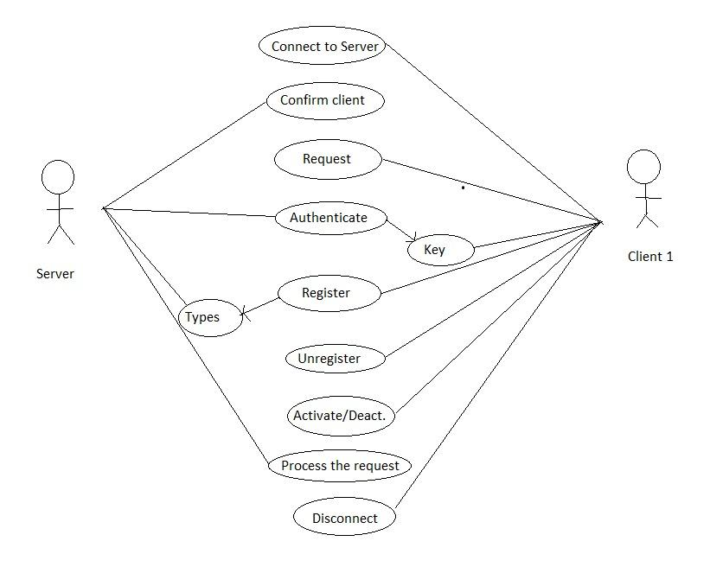

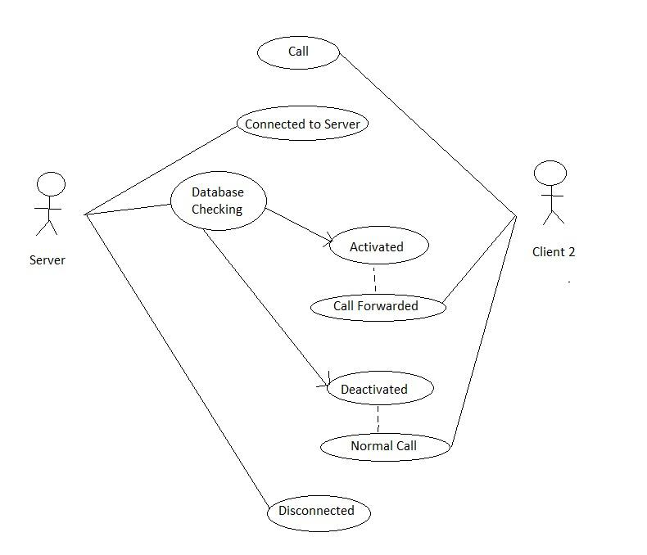

**3.7 On-line User Documentation and Help System Requirements**

Internet Connection, Desktop with Linux Terminal and Windows Powershell.

**3.8 Purchased Components**

Not Applicable.

**3.9 Interface**

File System Interface

**3.10 Licensing Requirements**

Not Applicable.

**3.11 Legal, Copyright, and Other Notices**

All rights reserved.

**3.12 Applicable Standards**

It shall be as per the industry standard.