# Title

RareVerse: An Integrated Low-Cost System for Smart Recovery and Real-Time Management of Rare and Precious Metals from E-Waste

# Abstract

Rare earth elements (REEs) and precious metals like neodymium, lithium, cobalt, and gold are critical for modern electronics, clean energy systems, and defense applications. However, their extraction is resource-intensive, highly centralized, and environmentally damaging. RareVerse introduces a novel solution: a hybrid chemical-mechanical recovery process optimized for cost and scalability, integrated with an AI-driven platform for tracking, valuation, and traceability of recovered elements. The system aims to create a sustainable circular economy model for metal recovery while reducing dependency on traditional mining and international supply chains.

# 1. Introduction

Electronic waste (e-waste) is growing rapidly worldwide, yet it remains an underutilized source of critical and valuable elements. REEs are essential to modern technologies such as electric vehicles, wind turbines, and smartphones. Despite their importance, global REE supply chains are highly vulnerable.

# 2. Global Dependency on China for Rare Earth Elements

China currently controls 60–70% of the world’s REE production and over 85% of its refining capacity. Nations like the U.S., Japan, and members of the EU remain heavily dependent on Chinese exports. Past geopolitical events, such as the 2010 export restrictions to Japan and 2023 curbs on gallium/germanium, show that REEs can be used as economic leverage.  
  
India, while possessing domestic reserves, lacks scalable extraction and refining infrastructure. This leaves India dependent on imports and vulnerable to price shocks. RareVerse addresses this gap by developing a decentralized and scalable urban mining solution focused on recovering REEs and PMs from electronic waste.

# 3. Literature Review

1. Choubey et al. (2021) – Demonstrated a complete hydrometallurgical approach—demagnetization, crushing, leaching with 2 M H₂SO₄ at 75 °C, and pH-controlled precipitation—achieving recovery rates of 95.5 % Nd, 99.9 % Pr, and 99.9 % Dy from discarded hard-disk magnets.  
  
2. Dev et al. (2025) – A comprehensive survey of REE recovery methods—hydrometallurgy, pyrometallurgy, bioleaching, ionic liquid extraction, biosorption—highlighting their pros, cons, and scalability.  
  
3. Tan & Van Veen (2024) – Focuses on NdFeB recycling methods (hydro, pyro, mechanical) and global supply-chain issues, especially reliance on Chinese exports.

# 4. The RareVerse Solution Overview

RareVerse proposes a dual innovation:  
1. A cost-efficient, green chemistry-based method for extracting REEs and PMs from common e-waste sources (HDDs, batteries, PCBs).  
2. A digital platform to track, value, and verify the recovery lifecycle using AI optimization and real-time dashboards.

# 5. Extraction Methodology

Selective component targeting (e.g., magnets from HDDs, Li-ion batteries)  
Reagents: citric acid + hydrogen peroxide, acetic acid (optional), EDTA (optional)  
Modular reactor design (low-cost apparatus)  
Chemical flow optimized for yield and environmental impact

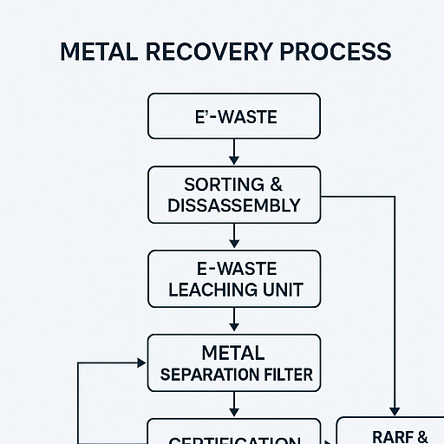

# 6. Software & Platform Architecture

Recovery dashboard: Logs extracted metals by quantity, type, and source  
AI Engine: Suggests optimal reagents, calculates live value using market APIs  
Certification: Generates recovery certificates for companies  
Inventory Management: Tracks batch-wise processing and sales

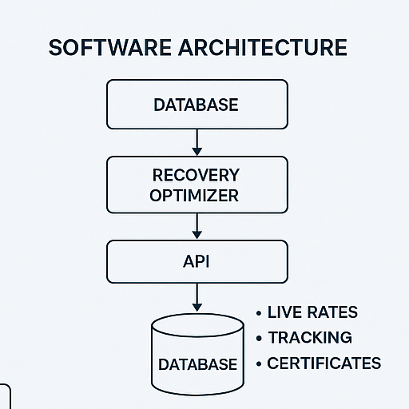

# 7. Hardware Setup

Low-cost table-top setup  
Includes: Reaction vessel, magnetic stirrer, filtration system  
Total estimated lab cost: Under ₹15,000

# 8. Marketplace Platform Vision

Connects recovered material suppliers to buyers (manufacturers, recyclers)  
UI includes: Live metal rates, stock quantity, certification status  
Filter by element, purity, region

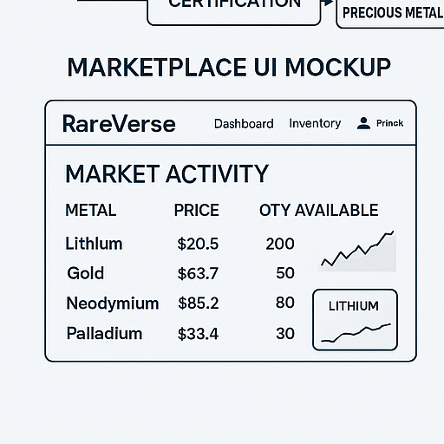

# 9. Cost Comparison

RareVerse vs Traditional refining methods  
Projected cost per gram/kg  
Scalability and breakeven estimation

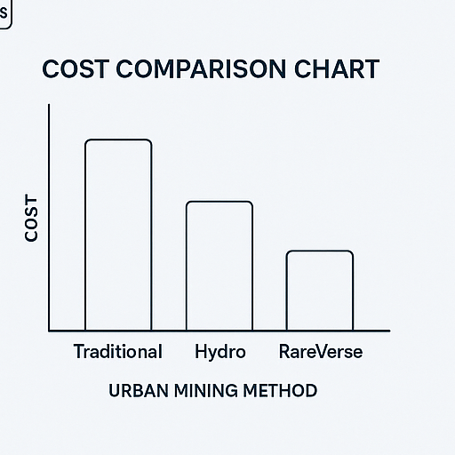

# 10. Experimental Plan and Results

Yield measurement for different sources (under planning)  
Chemical efficiency testing with controlled samples

# 11. Future Scope

Extend platform to extract platinum, palladium, rare semiconductors  
Smart component recovery (e.g., ICs, sensors)  
IoT-based bin sorting and auto-valuation  
Expansion across colleges and MSMEs for decentralization

# 12. Conclusion

RareVerse bridges the gap between e-waste and material security through an end-to-end circular recovery system. With a focus on accessibility, cost-efficiency, and traceability, it has the potential to strengthen India’s position in clean-tech materials and contribute globally to sustainable urban mining.

# 13. References

1. Choubey et al. (2021)  
2. Dev et al. (2025)  
3. Tan & Van Veen (2024)