**Splitwise++**

**Project Description**

[Splitwise](https://secure.splitwise.com) is a free tool for friends and roommates to track bills and other shared expenses. Although the app is incredibly useful, it has few bugs that make the app unreliable. And hence, I intend to implement an improved version of the app. Essentially the app will be work exactly as Splitwise with common and annoying bugs fixed and some added features.

Problem Statement:

The app primarily consists of Users and Bills. Each user needs to register before they can use the app’s features. Each user is associated with a Name, Email, Password, Phone Number and a Budget. Registered users can add Bills. Each bill is associated with a Name, an optional Description, a date, and the user who paid the bill. Each bill consists of Items. Each item belongs to a bill and is associated with the name of the item and cost. After adding a bill and items to that Bill the user will have identify, which other users will they be sharing the bill with. So, once a complete bill is created the creator must send requests to other users, of the creditors choice, to participate in the bill, so as to identify what items do they want, and should be charged appropriately.

ER – Diagram:

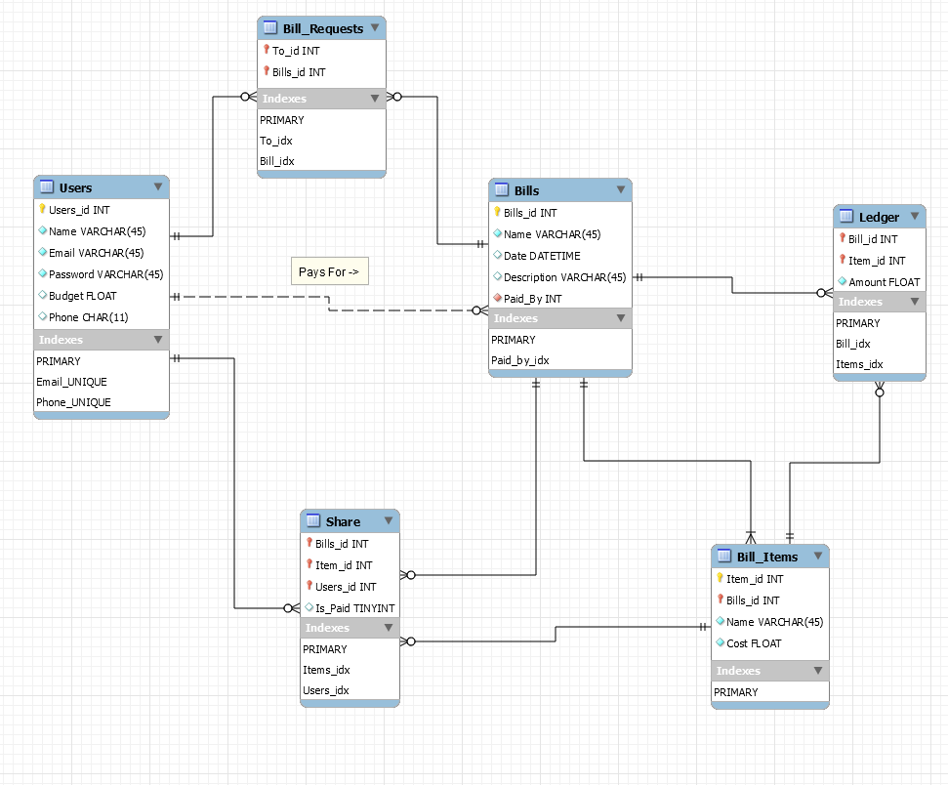

Table Descriptions:

1. Users: All the registered users will be stored in this table.
   1. Primary Key: Users_id
2. Bills: All the bills generated by any user will be stored in this table
   1. Primary Key: Bills_id
   2. Foreign Key: Paid_By References Users(Users_id)
3. Bill_Items: The Item in each bill will be added here, referenced by its bill id.
   1. Primary Key: Item_id + Bills_id
   2. Foreign Key: Bills_id References Bills(Bills_id)
4. Share: This table maintains records which user is sharing which item.
   1. Primary Key: Users_id + Item_id + Bills_id
   2. Foreign Key: Users_id References Users(Users_id), Item_id References Bill_Items(Item_id), Bills_id References Bills(Bills_id)
5. Ledger: This tables stores the shared cost of an item, after it is divided amongst all the people who are sharing it.
   1. Primary Key: Bill_id + Item_id
   2. Foreign Key: Bill_id References Bills(Bills_id), Item_id References Bill_Items(Item_id)
6. Bill_Requests: This tables stores all the requests the creditor sends to the users who they think should be sharing in the bill.
   1. Primary Key: To_id + Bills_id
   2. Foreign Key: To_id References Users(To_id), Bills_id References Bills(Bills_id)

For the data base files (ER Diagram, Create and Insert Script) check this Git Repo: [Project Repo](https://github.com/PrateekPisat/CS5200/tree/master/Project)

**Team**

I intend to work alone for this project.

**User Interaction:**

1. Users: Users will be able to perform the following operations:
   1. Login:
      1. Start the app. This loads the login page.
      2. If you are a registered user, enter your credentials.
         1. Click on Login.
         2. If valid credentials were provided, you will be granted access to the app.
      3. Else you will need to register, read sub-section b.
   2. Registration:
      1. Start the app.
      2. Click on Register, on the Login Page.
      3. Enter the necessary details in the registration window.
      4. Click on Register.
      5. The login page will appear again. Now the user can login with their credentials.
   3. Updating User Information:
      1. Start the app.
      2. Login/ Register
      3. Click on the Update User Button on the home page.
      4. Update the details as Required.
      5. Click on update.
   4. Deleting an Account:
      1. Start the app.
      2. Loin/ Register
      3. Click on the Delete User Button on the home page.
      4. Confirm that you want to delete the Account.
   5. Adding a Bill:
      1. Start the app
      2. Login/ Register.
      3. The user home-page will have a button titled Add Bill. Click on the button.
      4. Add the details for the bill. Click on Create Bill.
      5. The new window will ask the user to enter the items in that bill.
      6. Enter the details of an item, then click next. Continue for each item.
      7. After Adding the last item click on done.
      8. A new window will ask the user, who they want to split the bill with.
      9. Select a user from the drop-down menu. Click on Send.
      10. After send the bill to the last person, click on Done.
   6. Deleting a Bill:
      1. Start the app
      2. Login/ Register.
      3. The user home-page will have a button titled My Bills. Click on the button.
      4. This will show all the bills that the said user has created.
      5. Navigate through all the bills using next and previous buttons.
      6. To delete a bill, click on Delete Bill for the bill you want to delete.
      7. Confirm that you want to delete the bill.
   7. Updating a Bill:
      1. Start the app
      2. Login/ Register.
      3. The user home-page will have a button titled My Bills. Click on the button.
      4. This will show all the bills that the said user has created.
      5. Navigate through all the bills using next and previous buttons.
      6. To update a bill, click on Update Bill for the bill you want to update.
      7. Update the relevant information.
      8. Click on Update.
   8. Participating in a Bill:
      1. Start the app.
      2. Login/ Register.
      3. The home page will display the number of bill requests that were sent to you to fill out.
      4. Click on View Requests.
      5. Browse through the bills using the Next and Previous buttons.
      6. If you wish to participate in a bill, click on Participate. A new window will iterate through each item of the selected bill.
         1. This will open a window displaying all the items in that bill.
         2. Navigate through the list using next and previous buttons.
         3. If you wish to pay for an item, click on “Include me in this”. Continue for all items, in each of the pending bills.
         4. Else click next to display the next item.
      7. Else click on delete, indicating you do not want to participate in this bill.
   9. Updating Participation.
      1. Start the app
      2. Login/ Register.
      3. The user home-page will have a button titled My Bills. Click on the button.
      4. Now click on Show Participated Bills.
      5. This will load all the bills the user has participated in.
      6. Navigate through the list using next and previous buttons. Click on the update button to update the participation of a bill.
      7. This will show all the items of the selected bill.
      8. Navigate using the next and previous buttons, updating participation in individual items as needed.
      9. Once complete click on Done.
   10. Adding/ Updating Budget:
       1. Start the app.
       2. Login/ Register.
       3. In the user home page, click on add budget.
       4. Specify your monthly budget.
       5. Click on Set.

**Technical Specifications:**

1. DBMS: MySQL. Version 8.0
2. Backend: Java. Version 1.7+ (Developed on version 1.8)
3. Frontend: Java Swing Applet.
4. Libraries:
   1. JFreeChart for Data Visualization, Version 1.0.19
   2. Connector/J for Database connection, Version 8.0.12
   3. JCalender for a GUI calendar, Version 1.4