Efficient Route Optimization Using Classical Pathfinding Algorithms



Faculty : DR.SUSMI JACOB
Presented by
R NIHARIKA – AP23110011226
SK.SADIYA PARVIN -AP23110011235
S.BHAVYA -AP23110011222
LIKITH – AP23110011221

1. Introduction
Pathfinding is the process of finding the shortest route between two points and is widely used in navigation systems, robotics, and games. It is based on concepts from Graph Theory, where maps are represented as nodes and edges.
This project develops a visualizer to demonstrate how different pathfinding algorithms work on real-world data from OpenStreetMap. The goal is to compare their performance and behavior.

2. Background Study
Pathfinding problems are modeled using graphs consisting of nodes (locations) and edges (paths). The shortest path problem focuses on finding the minimum-cost route. These techniques are widely used in GPS navigation, AI, and networking systems.

3. Problem Statement
To solve a maze/navigation problem using the shortes path algorithms , where a car must find the shortest path from a starting point to a destination while moving only in the allowed directions. The system should efficiently determine the optimal route and visualize the path.

4. Proposed System
The system is a visual tool that allows users to select start and end points on a map and observe how algorithms find paths. It uses real-world map data and displays step-by-step execution.

5. Algorithms Involved

5.1 Dijkstra’s Algorithm

Theory
Dijkstra’s Algorithm is a widely used pathfinding algorithm for finding the shortest path between nodes in a weighted graph. It is based on principles from Graph Theory and follows a greedy approach by always selecting the node with the minimum distance from the start.
The algorithm works by gradually expanding outward from the source node, updating the shortest known distance to each node. It ensures that once a node is visited, the shortest path to that node is finalized. This makes the algorithm reliable and optimal for graphs with non-negative edge weights.

Algorithm Steps
- Initialize all nodes with distance = ∞, except the start node (distance = 0).
- Mark all nodes as unvisited.
- Add the start node to the open list.
- Select the node with the smallest distance.
- For each neighbor of the current node:
  - Calculate new distance = current distance + edge weight
  - If new distance is smaller, update the neighbor’s distance
- Mark the current node as visited.
- Repeat steps until the destination node is reached or all nodes are visited.

Pseudocode 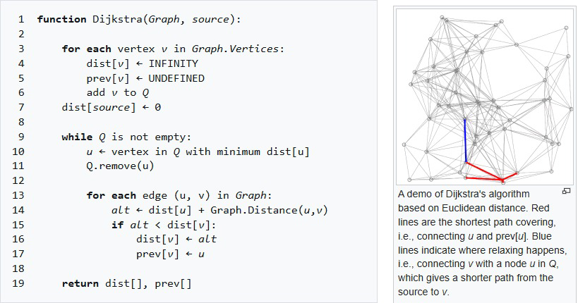
Time Complexity
- Using simple array: O(V²)
- Using priority queue (heap): O(E log V)
Where:
- V = number of vertices
- E = number of edges
Space Complexity
- O(V)
Used for storing distances, visited nodes, and parent references.
Optimality
Dijkstra’s Algorithm always finds the shortest path as long as all edge weights are non-negative.
Completeness
The algorithm guarantees finding a solution if a path exists between the start and destination nodes.

5.2 A* (A-Star) Algorithm
Theory
The A* Algorithm is an advanced pathfinding technique used to find the shortest path between two nodes efficiently. It improves upon Dijkstra’s Algorithm by using a heuristic function to guide the search toward the goal.
A* evaluates each node using the function:
$$f(n)=g(n)+h(n)$$
Where:
- $g(n)$= actual cost from start to node
- $h(n)$= estimated cost from node to goal
Algorithm Steps
- Initialize the start node with:
  - $g(n)=0$
  - $h(n)=heuristicdistancetogoal$
- Add the start node to the open list.
- Select the node with the lowest $f(n)$value.
- If the selected node is the goal, stop.
- Move the node to the closed list.
- For each neighbor:
  - Calculate $g(n)$and $h(n)$
  - Compute $f(n)=g(n)+h(n)$
  - If a better path is found, update values
- Repeat until the goal is reached.
Pseudocode 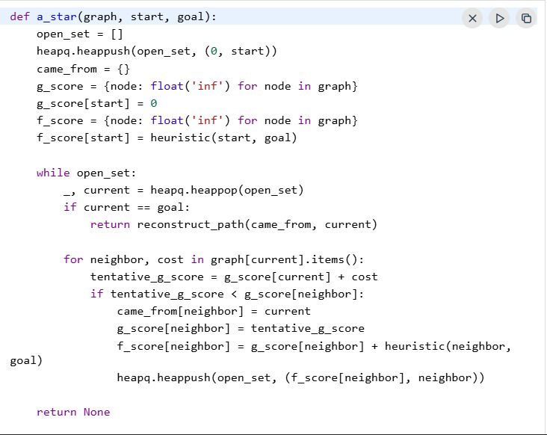
Time Complexity
- O(E log V) (using priority queue)
Where:
- V = number of vertices
- E = number of edges
Space Complexity
- O(V)
Stores open list, closed list, and cost values.
Optimality
A* guarantees the shortest path if the heuristic is admissible and consistent (never overestimates).
Completeness
A* always finds a solution if a path exists.

5.3 Greedy Best-First Search (GBFS)

Theory
Greedy Best-First Search is a pathfinding algorithm that selects nodes based solely on their estimated distance to the goal. Unlike Dijkstra or A*, it ignores the actual cost from the start, focusing only on the heuristic. This makes it very fast but not always optimal.
The algorithm uses a heuristic function $h(n)$, usually the straight-line (Euclidean) distance to the goal:
$$h(n)=\sqrt{(x_{goal}-x_{n})^{2}+(y_{goal}-y_{n})^{2}}$$
GBFS is effective when speed is more important than path optimality, such as in real-time applications or AI agents in games.

Algorithm Steps
- Initialize the start node and compute its heuristic $h(start)$.
- Add the start node to the open list.
- While the open list is not empty:
  - Select the node with the smallest heuristic value $h(n)$.
  - If this node is the goal, stop.
  - Move the node to the visited list.
  - For each neighbor:
    - Calculate $h(neighbor)$
    - If the neighbor is unvisited, add it to the open list.
- Repeat until the goal is reached or the open list is empty.

Pseudocode
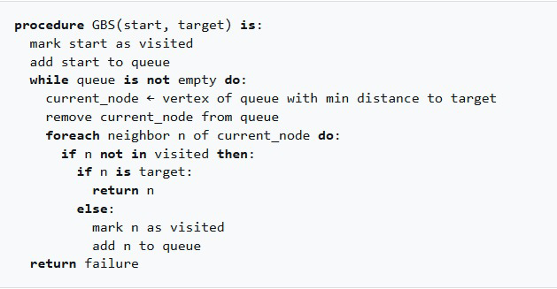

Time Complexity
- O(E) in practice (depends on graph density)
- Very fast because it ignores path cost and explores fewer nodes
Space Complexity
- O(V)
Stores open list and visited nodes
Optimality
Not guaranteed
Since it ignores the path cost from start, GBFS may produce longer paths or fail in complex mazes.

Completeness
Usually complete
It can find a path if one exists, but may require backtracking in obstructed environments.

5.4 Bidirectional Search

Theory
Bidirectional Search is an efficient pathfinding algorithm that reduces the search space by simultaneously searching from both the start and the goal. Instead of exploring the graph from only one direction, it runs two searches:
- Forward Search: From the start node
- Backward Search: From the goal node
The searches continue until they meet at a common node. This reduces the number of nodes explored and improves performance, especially in large graphs. Bidirectional Search is based on Graph Theory concepts.
Algorithm Steps
- Initialize two open sets:
  - openSetStart with the start node
  - openSetGoal with the goal node
- Initialize two closed sets to track visited nodes.
- Repeat until a common node is found or both open sets are empty:
  - Expand a node from the forward search
  - Expand a node from the backward search
  - If a node appears in both closed sets, the searches have met
- Reconstruct the path by connecting the forward and backward paths through the meeting node.
- Stop once the full path from start to goal is found.

Pseudocode
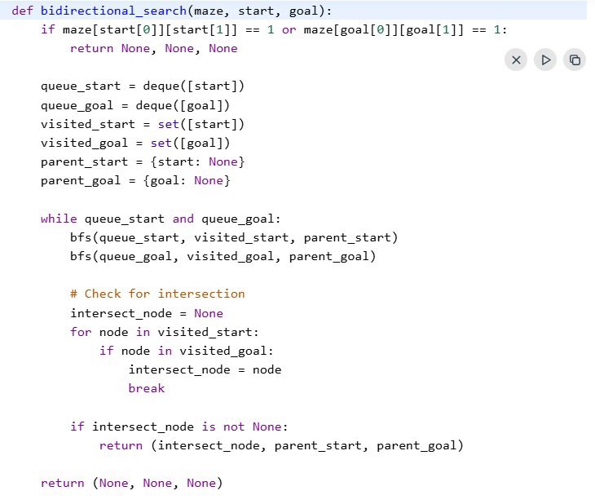
Time Complexity
- O(b^(d/2))
Where b = branching factor, d = depth of the solution
- Much faster than single-direction search (O(b^d))
Space Complexity
- O(V)
Maintains two sets of open and closed nodes
Optimality
Optimal
Bidirectional Search finds the shortest path when both searches are uniform.

Completeness
Complete
It guarantees a solution if a path exists between start and goal.

- Algorithm Comparison
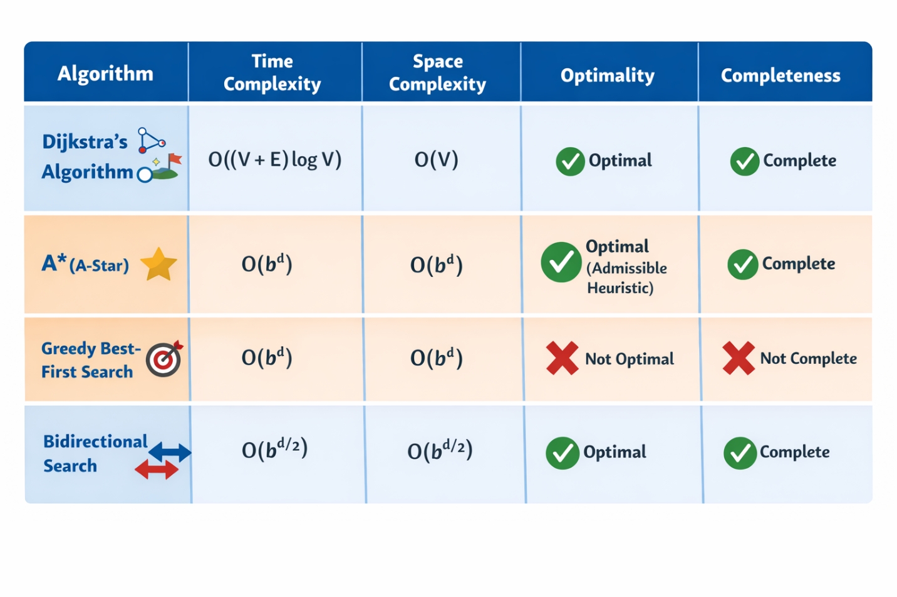

7 OUTPUT IMAGES

7.1 Dijikstra
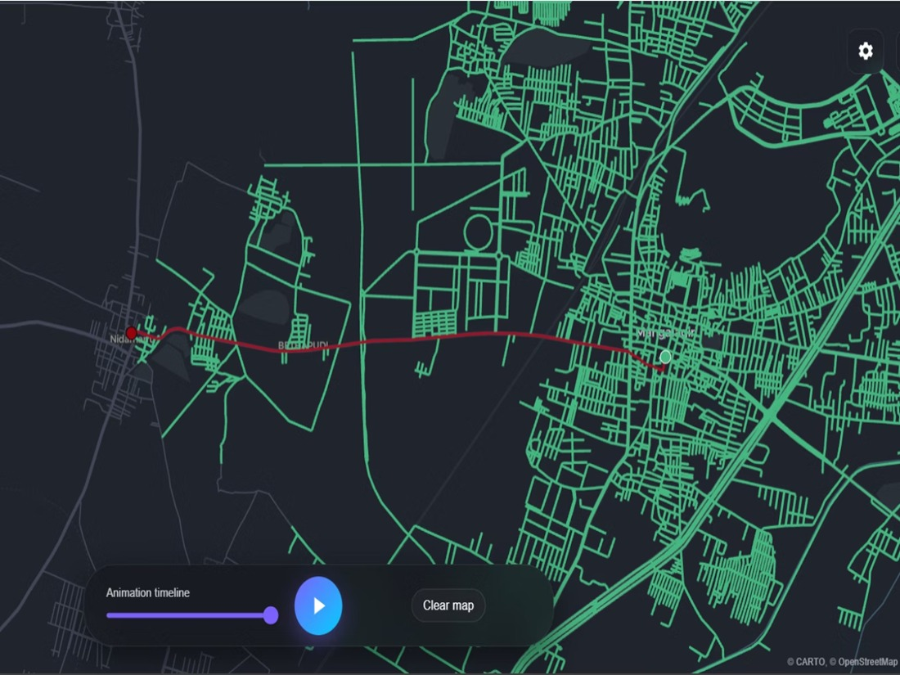

7.2 Greedy BFS
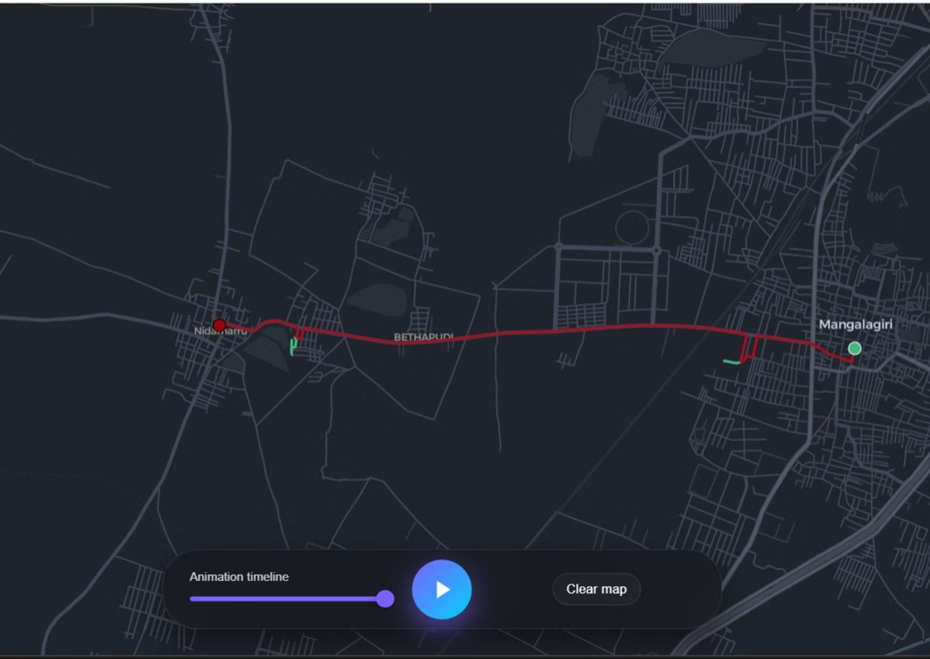

7.3 A*(A-Start)
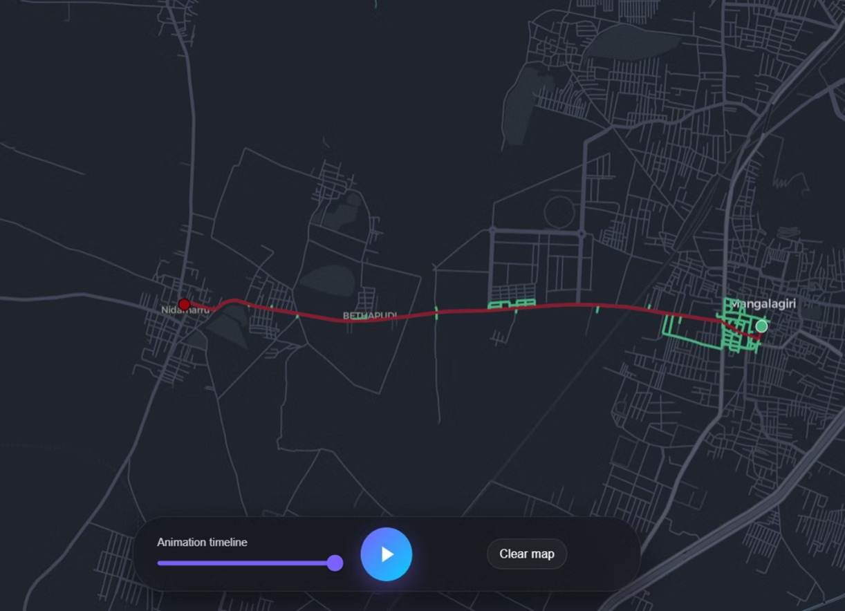

7.4 Bidirectional
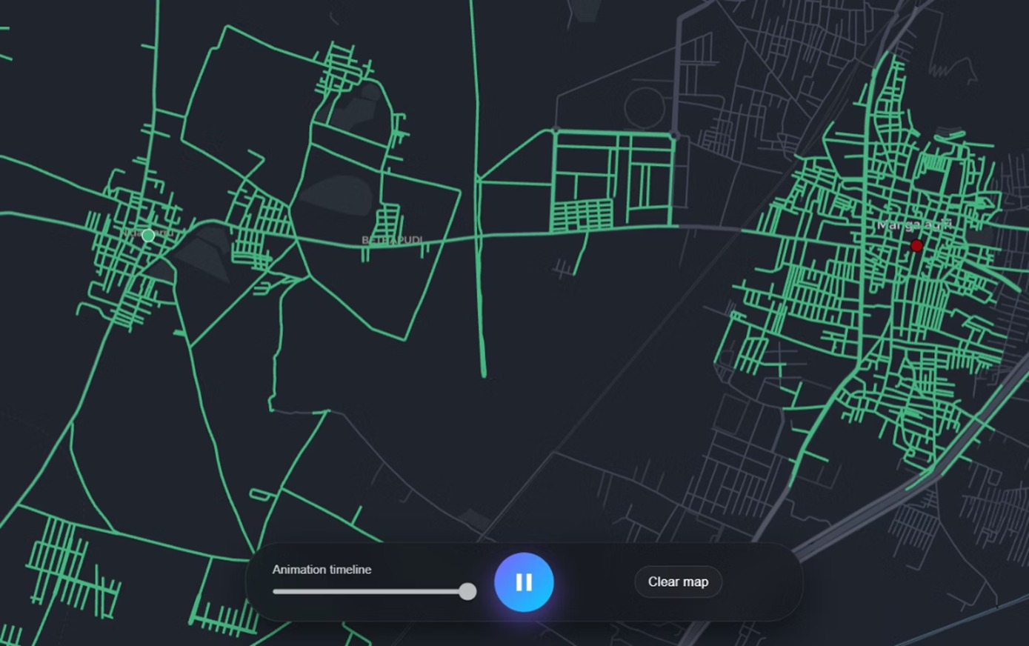
8 . CONCLUSION
In this project, we implemented four pathfinding algorithms: Dijkstra, A*, Greedy Best-First Search, and Bidirectional Search. Each algorithm demonstrates a different approach, balancing speed, memory usage, and optimality. Dijkstra guarantees the shortest path, while A* uses a heuristic to improve efficiency. Greedy Best-First is very fast but not always optimal, and Bidirectional Search reduces the search space by exploring from both ends. Using real-world maps, the project visualized how these algorithms explore paths and manage resources. Overall, it highlights their applications in navigation, robotics, and game development.

