# SUMMER TRAINING PROJECT

ON

ONLINE SHOPPING CART

UNDER TAKEN AT

**INVENIO BUSINESS SOLUTIONS PVT. LTD**



**IN PARTIAL FULFILLMENT OF AWARD OF THE DEGREE OF BACHELOR’S OF TECHNOLOGY**

**IN COMPUTER SCIENCE AND ENGINEERING FROM**

**MAHARAJA AGARSEN INSTITUTE OF TECHNOLOGY ROHINI SECTOR-22**

**PREFACE**

 Online shopping has spread into every corner of the world where Internet is easily accessible. However, online shoppers need to have a credit or debit card in order to make purchases online. Online shopping has the trend of increasing year on year especially among those who are internet savvy.   
  
One third of people that shop online use a search engine such as Google.com to find what they are looking for and about one fourth find websites by word of mouth. Despite the recent economic downturn, there is still a growing trend of online shoppers as they are looking for cheaper products to purchase online. Online shoppers tend to be price sensitive. Online retailers are vying with their competitors by slashing prices especially during Christmas and New Year season. This in turn brings about benefits to online shoppers and helps to turn onlookers into buyer.

The Online Shopping Cart application enables vendors to setup online shops, customers to browse  through the shops and a system administrator to approve and reject requests for new shopsand maintain lists of shop categories. Also on the agenda isdesigning an online shopping site to manage the items in the shop and also help customers purchase them online without having tovisit the shop physically.

 Our online shopping cart will use the internet as the sole method for selling goods to its consumers. The consumer will be in complete control of his/her shopping experience by using the “unique storefront” concept.

Shopping will be highly personalized and the cart will provide lower prices than most competitors. This, in brief, is a description of our product which will showcase a complete shopping experience in as cart package.

**INDEX**

1. Invenio Business Solutions
   1. About us …………………………………………………………………...7
   2. Why Invenio………………………………………………………………….7
   3. Careers & Trainings.....…………………………………………………….....8
2. SAPUI5
3. Introduction .....................................................................................................9
4. What is Sapui5?...............................................................................................10
5. How It Works?................................................................................................11
6. Libraries...........................................................................................................12
7. Architecture.....................................................................................................13
8. Development kit..............................................................................................14
9. Shopping Cart Application
   1. Overview...............................................................................................................15
   2. Advantages............................................................................................................16
   3. Disadvantages........................................................................................................17
   4. Future Scope……………………………………………………………………...18
10. Designed Application
    1. Sapui5 App...........................................................................................................19
    2. List of tables…………………………………………………………………….20-21
    3. App Structure.........................................................................................................22
    4. Different Views....................................................................................................23-26
       * Master pages
       * Detail pages
       * Recent History
       * The Buy button
11. Conclusion.....................................................................................................................27
12. Biblography/References.................................................................................................28

 INVENIO BUSINESS SOLUTIONS

Invenio is recognized as a global leader in solving business challenges with IT solutions. We have created strategic relationships with some of the world's leading organizations, from Universal Music Group and News UK to the governments of Saudi Arabia and the Maldives. When you meet us, you'll discover a company that has successfully maintained its values and client focus through significant growth.   **­­**

Why choose Invenio :

Customer focus

Our outstanding customer focus means we have never lost a customer

Expertise

Our deep understanding of select industries helps customers increase efficiency and profitability

Global

We are a truly global SAP consultancy, with offices and clients all around the world

Flexible

We constantly adapt to the changing needs of our customers to meet their objectives

Transparency

No hidden fees, no binding contracts, and an open and honest approach

Value driven

We create innovative solutions to deliver real business value

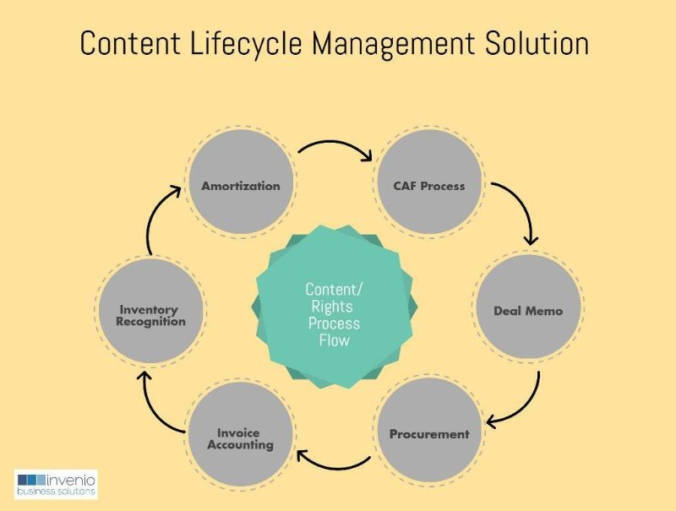

**CAREERS & TRAININGS**

At Invenio our mission is to shake up the world of IT consulting by offering only the highest customer service. As a result of this mission, we are now one of the fastest growing companies in our sector today. Our customers trust Invenio to ensure that their systems are taken care of 24/7, and every one of our employees is committed to repaying this trust by providing a world class customer experience.

In short,our employees are the secret to our success.

Invenio solve business challenges using the latest technology with a focus on SAP solutions. Our exceptional customer focus, transparent approach and deep industry knowledge have delivered outstanding success for our customers.

Training programmes delivered through a network of CDC centres spread across the country. CDC centres have state-of-the-art infrastructure and expert faculties who groom students for the corporate world by imparting training in specific technologies and have cumulatively trained students.

Our training programs are designed specifically for corporates. Leveraging a team of seasoned multi-certified faculty members, we have the capability to deliver customised training solutions for your organisation in any location within India.

**SAP USER INTERFACE 5**

SAPUI5 offers powerful development concepts : 

* One consistent user experience for your apps
* Responsive across browsers and devices - smartphones, tablets, desktops
* Built-in extensibility concepts at code and application level
* Data binding types and Model-View-Controller (MVC)
* Feature-rich UI controls for handling complex UI patterns and predefined layouts for typical use cases.

UI controls automatically adapt themselves to the capabilities of each device.

* Full translation support
* Keyboard interaction support and accessibility features

And many more....

SAPUI5 is a client UI technology based on JavaScript, CSS and HTML5. SAPUI5 applications run within a browser.

SAPUI5 comes with all of the features needed to cover most current application requirements such as Full translation Support, built in extensibility concepts at code and application level, keyboard interaction. Last but not the least, it also uses the open source jQuery library as a foundation.

Applications built with SAPUI5 are responsive across browsers and devices – they run on smart phones, tablets, and desktops. The UI controls automatically adapt themselves to the capabilities of each device.

**WHAT IS SAPUI5 ?**

SAPUI5 ([SAP](http://searchsap.techtarget.com/definition/SAP) user interface for [HTML 5](http://searchsoa.techtarget.com/definition/HTML-5)) is a collection of [libraries](http://searchsqlserver.techtarget.com/definition/library) that developers can use to build desktop and mobile applications that run in a [browser](http://searchwindevelopment.techtarget.com/definition/browser).

With SAP's SAPUI5 [JavaScript](http://searchsoa.techtarget.com/definition/JavaScript) toolkit, developers can build SAP web applications using HTML5 web development standards.

The UI controls automatically adapt themselves to the capabilities of each device. To do this, SAPUI5 provides robust development concepts to create apps with consumer-grade, browser-based business applications. In a nutshell, UI5 is a client UI technology based on JavaScript, CSS and HTML5.

Servers come into play for deploying your applications, storing the SAPUI5 libraries, and connecting to a database. Depending on the environment in which you are using SAPUI5, the libraries and your applications are stored for instance on an App Server or an HANA Cloud Platform. The preferred way to access business data for your application is by using the OData model through an SAP Gateway.

When users access an SAPUI5 application from their device, a request is sent to the respective server to load the application into the browser. The view accesses the relevant libraries. Usually, the model is also instantiated and business data is fetched from the database.

The SAPUI5 runtime is a client-side HTML5 rendering library containing a rich set of standard and extension controls. It provides a lightweight programming model for desktop and mobile applications. Based on JavaScript, it supports Rich Internet Application (RIA) like client-side features.

SAPUI5 complies with Open Ajax and can be used together with standard JavaScript libraries.

## 

## How does SAPUI5 work?

To begin, you must understand SAPUI5’s primary, underlying develop concept. SAPUI5 supports the Model View Controller (MVC) concept, “[a software architectural pattern for implementing user interfaces](https://en.wikipedia.org/wiki/Model%E2%80%93view%E2%80%93controller)”. As a developer, you are encouraged to use the MVC to keep the data model handling, the UI design and the application logic separate. This helps in facilitating UI development in addition to modifying the different parts.

[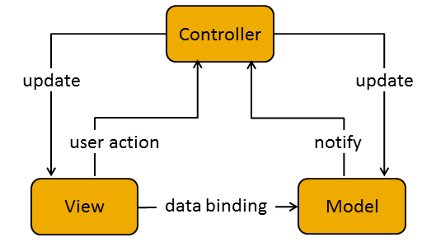](https://blogs.sap.com/wp-content/uploads/2015/09/mvc_799737.png)

**Model:**

 This is the part that is accountable for the management, retrieval, and updating of the data that is being viewed in your application.

**View:**

This part is accountable for interpreting and rendering the initial UI. The view in the context of SAPUI5, generates the presentation to the user based on changes in the model.

**Controller:**

This is one of the most important parts. This is the part that is accountable for separating the view logic from the data logic. The Controller responds to user interaction and “view events” by adjusting the view and the model. The controller is essentially sending commands to the model to update it’s state, like editing a document in a word processing application. Similar to views, Controllers carry the same name as the related view (if there is a 1:1 relationship). Controller names always end with controller.js .

**LIBRARIES**

There are various JavaScript and CSS libraries that you can use in combination for the application development. SAPUI5 can use these libraries in combination and they are called SAPUI5 control libraries.

Common SAPUI5 control libraries −

* Sap.ui.commons for control fields, buttons, etc.
* Sap.m is the most common control library and is used for mobile devices
* Sap.ui.table includes table control
* Sap.ui.ux3

**Control Library Combinations**

* You can use the control library sap.m with other control libraries - sap.ui.unified, sap.viz, sap.ui.table, sap.ui.layout, and sap.suite.
* You can combine control libraries - sap.ui.commons, sap.ui.table, sap.ui.ux3 and sap.ui.suite with each other.
* You can also combine control library sap.ui.commons and sap.ui.ux3 with other libraries like sap.ui.core, sap.ui.unified, sap.ui.layout, and sap.ui.table.
* You can combine sap.viz with all other libraries.

**ARCHITECTURE**

In SAP UI5 architecture, you have three layers −

* At the top, is the presentation layer, where UI5 components are consumed by devices like mobile, tablets, and laptops.
* At the middle layer, is the application clients that includes SAP UI5 libraries for theming and control. UI5 control libraries include

1. Sap.viz
2. Sap.ui.commons (Controls like text fields and buttons)
3. Sap.ui.table (Input controls for table)
4. Sap.ui.ux3
5. Sap.m (Includes input control for mobile devices)

* At the bottom, is the option server component. This includes SAP Net Weaver Application Server for ABAP/Java, SAP backend, HANA XS engine for development or database.

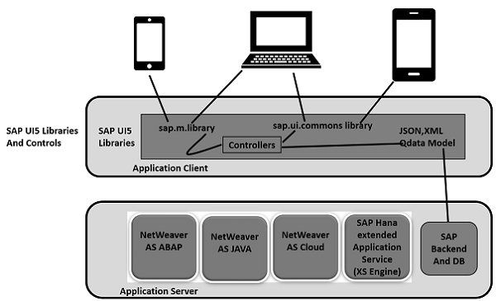

**DEVELOPMENT KIT**

SAP UI5 development kit for HTML5 provides you an environment for the development of web-based applications and it provides an application with one consistent user experience. Web apps that you develop with SAP UI5 are responsive across browsers and devices, and they can run on smart phones, tablets, and desktops.

The UI controls automatically adapt themselves to the capabilities of each device.

You can use SAP UI5 on the following platforms −

* SAP HANA
* SAP HANA Cloud Platform
* SAP NetWeaver for SAP NetWeaver 7.4 or higher
* User interface add-on for SAP NetWeaver for SAP NetWeaver Application Server 7.3x

You can deploy the application on the server that includes storing the libraries and getting data from the database. You can use the NetWeaver Application server or HANA Cloud platform for application deployment, and data can be accessed by a business application using the OData model using Gateway. Take a look at the following illustration.

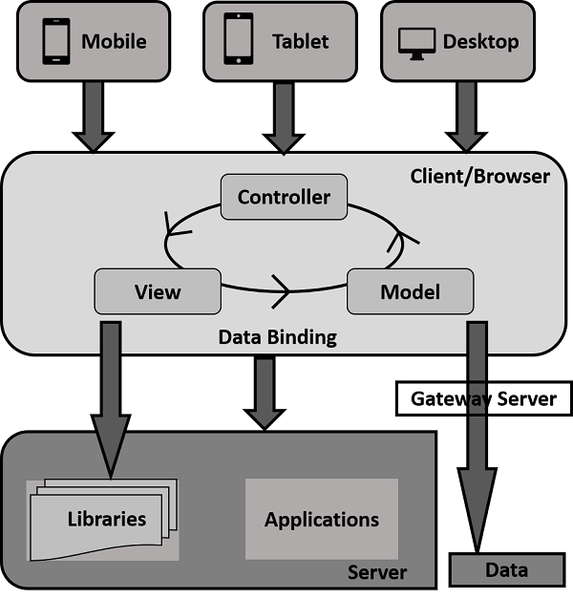

When a user sends a client request from his mobile/laptop, a request is sent to the server to load the application in a browser, and data is accessed via database and the relevant libraries are accessed.

**ONLINE SHOPPING CART**

Online shopping is a form of [electronic commerce](https://en.wikipedia.org/wiki/Electronic_commerce) which allows consumers to directly buy [goods](https://en.wikipedia.org/wiki/Good_(economics)) or [services](https://en.wikipedia.org/wiki/Service_(economics)) from a seller over the [Internet](https://en.wikipedia.org/wiki/Internet) using a [web browser](https://en.wikipedia.org/wiki/Web_browser). Consumers find a product of interest by visiting the [website](https://en.wikipedia.org/wiki/Website) of the retailer directly or by searching among alternative vendors using a [shopping search engine](https://en.wikipedia.org/wiki/Shopping_search_engine), which displays the same product's availability and pricing at different e-retailers. Customers can shop online using a range of different computers and devices, including [desktop computers](https://en.wikipedia.org/wiki/Desktop_computer), [laptops](https://en.wikipedia.org/wiki/Laptop), [tablet computers](https://en.wikipedia.org/wiki/Tablet_computer) and [smart phones](https://en.wikipedia.org/wiki/Smartphone).

An online shop evokes the physical analogy of buying [products](https://en.wikipedia.org/wiki/Product_(business)) or services at a regular ["bricks-and-mortar"](https://en.wikipedia.org/wiki/Brick_and_mortar_business) [retailer](https://en.wikipedia.org/wiki/Retailing) or [shopping center](https://en.wikipedia.org/wiki/Shopping_center); the process is called business-to-consumer (B2C) online shopping. When an online store is set up to enable businesses to buy from another businesses, the process is called business-to-business (B2B) online shopping. A typical online store enables the customer to browse the firm's range of products and services, view photos or images of the products, along with information about the product specifications, features and prices.

Online stores typically enable shoppers to use "search" features to find specific models, brands or items. Online customers must have access to the Internet and a valid [method of payment](https://en.wikipedia.org/wiki/Online_shopping#Payment) in order to complete a transaction, such as a [credit card](https://en.wikipedia.org/wiki/Credit_card), a [debit card](https://en.wikipedia.org/wiki/Debit_card), or a service such as [PayPal](https://en.wikipedia.org/wiki/PayPal). For physical products (e.g., paperback books or clothes), the e-retailer ships the products to the customer; for digital products, such as [digital audio files](https://en.wikipedia.org/wiki/Digital_audio_file) of [songs](https://en.wikipedia.org/wiki/Song) or [software](https://en.wikipedia.org/wiki/Software), the e-retailer typically sends the file to the customer over the Internet. The largest of these online retailing corporations are [Ali baba](https://en.wikipedia.org/wiki/Alibaba_Group), [Amazon.com](https://en.wikipedia.org/wiki/Amazon.com), and [eBay](https://en.wikipedia.org/wiki/EBay).

Customers are attracted to online shopping not only because of high levels of convenience, but also because of broader selections, competitive pricing, and greater access to information. Business organizations seek to offer online shopping not only because it is of much lower cost compared to bricks and mortar stores, but also because it offers access to a worldwide market, increases customer value, and builds sustainable capabilities.

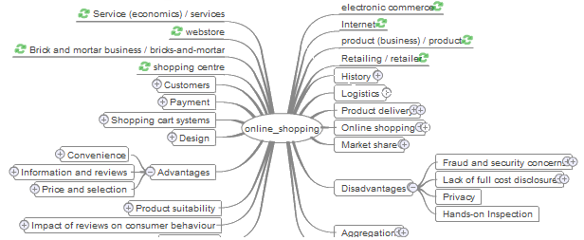

**ADVANTAGES OF ONLINE SHOPPING CART**

* **Multiple Payment Mode Compatibility**

A well-designed **online shopping cart** allows you to process payments many ways. While credit card processing with the **online shopping cart** is a staple feature, superior shopping carts include all types of online payment methods, such as PayPal and Google Checkout. Multiple payment options make the purchase possible for all types of visitors to the website, which boosts sales.

* **Digital Product Storage and Delivery Systems**

When people make a payment for a digital product, they expect to receive it immediately. You need to provide this service, but be aware of the danger of digital products being stolen or shared freely. The digital product storage and delivery systems of the **online shopping cart** can deal with both aspects of e-commerce. They ensure quick and prompt delivery and protect the digital product from being freely shared or stolen.

* **Tracking Sales Trends and Visitor Patterns**

One of the advantages of e-commerce services like PayLoadZ is the ability to track and assess trends, visitor patterns and buyer behavior. This becomes doubly easy with a good **online shopping cart**. The **shopping cart** can provide data and analysis regarding which content is performing better and driving sales, the time users take to make their purchase decisions, where the user drops from the page and past sales. Tracking sales trends and visitor patterns can help an e-commerce website cater to its buyers better, which can lead to greater profits.

* **The Use of Auto Responders**

Email marketing is one of the most effective modes of attracting buyers. Email marketing is usually done through auto responders, which are software programs or scripts designed to automatically send people emails. Auto responders inherent in a **shopping cart** can be used for marketing, for delivering digital products and for giving payment confirmations.

* **Improved Product Management**

A young e-commerce website might not see product management as an issue, but an established one cannot ignore it. As an e-commerce website grows, its offerings also grow. This makes managing them more difficult. Most good online shopping carts come with product management tools designed to help e-commerce entrepreneurs cope with growth issues.

**DISADVANTAGES OF ONLINE SHOPPING CART**

### 1. Delay in delivery

Long duration and lack of proper inventory management result in delays in shipment. Though the duration of selecting, buying and paying for an online product may not take more than 15 minutes; the delivery of the product to customer’ s doorstep takes about 1-3 weeks. This frustrates the customer and prevents them from shopping online.

### 2. Lack of significant discounts in online shops

Physical stores offer discounts to customers and attract them so this makes it difficult for e-tailers to compete with the offline platforms.

### 3. Lack of touch and feel of merchandise in online shopping

Lack of touch-feel-try creates concerns over the quality of the product on offer. Online shopping is not quite suitable for clothes as the customers cannot try them on.

### 4. Lack of interactivity in online shopping

Physical stores allow price negotiations between buyers and the seller. The show room sales attendant representatives provide personal attention to customers and help them in purchasing goods. Certain online shopping mart offers service to talk to a sales representative

### 5. Lack of shopping experience

The traditional shopping exercise provides lot of fun in the form of show-room atmosphere, smart sales attendants, scent and sounds that cannot be experienced through a website. Indians generally enjoy shopping. Consumers look forward to it as an opportunity to go out and shop.

### 6. Lack of close examination in online shopping

A customer has to buy a product without seeing actually how it looks like. Customers may click and buy some product that is not really required by them. The electronic images of a product are sometimes misleading. The color, appearance in real may not match with the electronic images.

People like to visit physical stores and prefer to have close examination of good, though it consumes time. The electronic images vary from physical appearance when people buy goods based on electronic images.

### 7. Frauds in online shopping

Sometimes, there is disappearance of shopping site itself. In addition to above, the online payments are not much secured. So, it is essential for e-marketers and retailers to pay attention to this issue to boost the growth of e-commerce. The rate of cyber crimes has been increasing and customers’ credit card details and bank details have been misused which raise privacy issues.

**FUTURE SCOPE**

The current level of empirical research done on retail in the Indian context is miniscule. This study is concentrated on perceptions and evaluations of food & grocery stores and seeks to build on the very little research done in retailing in general, and data mining in retailing in particular. In the future, researchers can seek other relevant research problems from the industry and from existing literature. In terms of future scope, a variety of data mining techniques can be used by researchers to simplify customer perceptions and attitudes. Every day, every hour and every minute, tera-bytes of data gets generated from millions of shoppers, yet, retail managers/ business executives always grapple with relevant information that can help retailers/ researchers design strategies to generate customer loyalty. Some of the world’s largest retailers such as Wal-Mart, Tesco’s, Carrefour etc. utilize this data to generate certain knowledge that can help them in modeling and predicting customer behavior and further in order to know their customers better. Thus data mining can not only be applied in retailing but also can be applied in the other sectors such as banking, medicine, education, tourism, insurance and so on.

Data mining is the task of finding useful information/ knowledge from huge volume of data. Data mining can be applied through a variety of other techniques such as concept description, cluster analysis, factor analysis, classification and prediction, association analysis, evolution analysis, outlier analysis and many other different tools such as Clementine, Weka, Statistica, SAS, MINITAB, etc. can be used for the application of various data mining techniques. In terms of managerial and technical approach, researchers can research certain niche customer segments such as the elderly, only students, only male professionals etc.

Additional sectors, such as apparel retailing, fashion products, consumer electronics, luxury brands, mobile retailing etc. can be researched. Emerging formats such as airport 150 retailing, online-retailing, vending machines, membership clubs, multi-level marketing etc. are also very under-researched areas.

Even within grocery retailing, specific formats such as supermarkets, hypermarkets, convenience stores and traditional open markets etc. are very relevant areas of research for future.

**SAPUI5 APPLICATION**

Sapui5 Application is created on the MVC model described earlier in which the view or look or the front end of the application is controlled by project.xml file.

The Controller is formed on the project.js file with respect to the view file of the project. Each View has its specific controller that controls the changes made by the user.

The model file on the other hand is used to retrieve data on the project from the server or through the files present in the system

All these files along with index.html file, runs application on browser, are embedded inside the web content of the project.

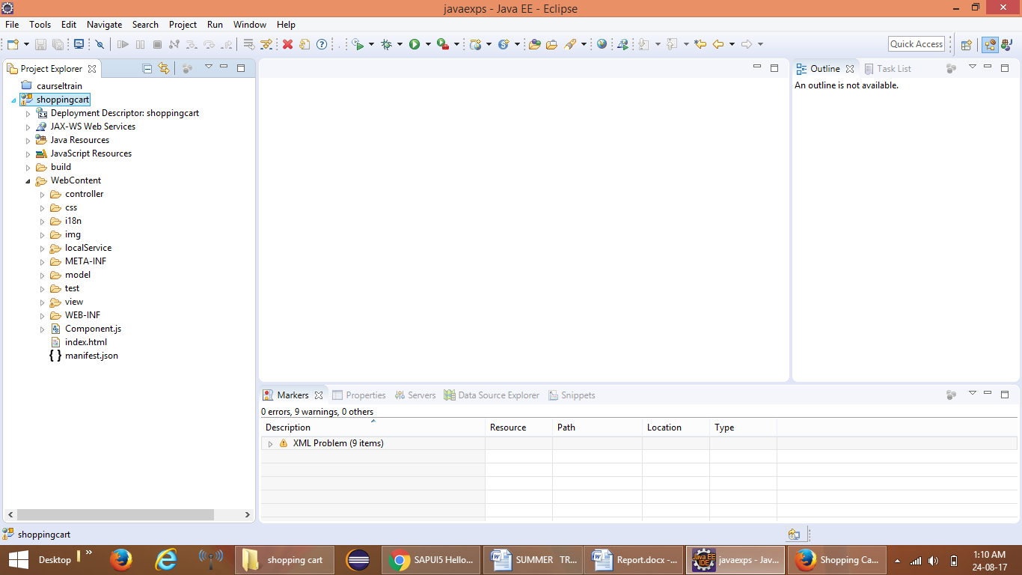

**LIST OF TABLES**

The following is the list of tables containing the information about different products in the shopping

cart . Each category of products have its’ own separate table

Some of them are :-

1. Table regarding the information of the products inside master pages

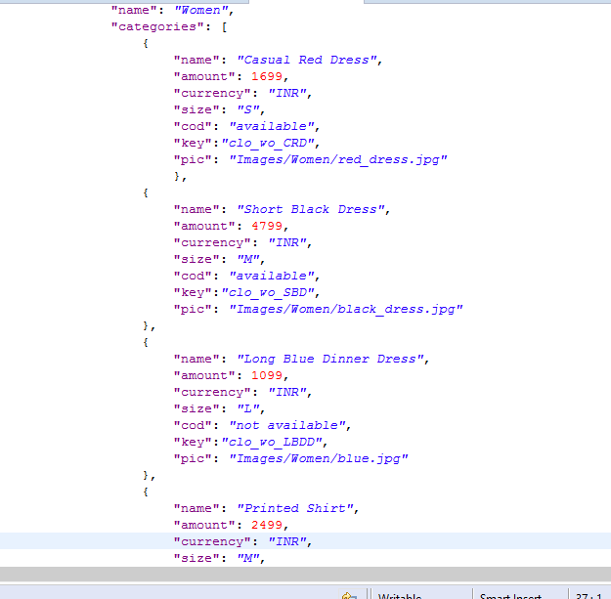

1. Table regarding the recently viewed products or the browsing history.

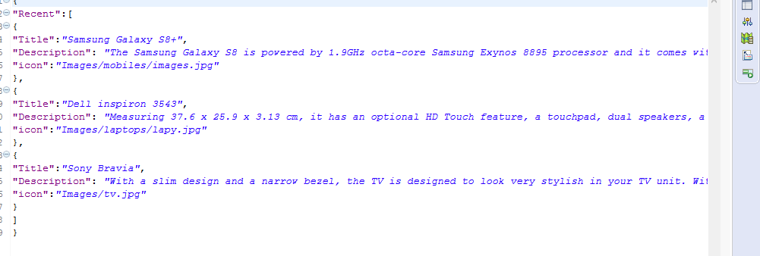

1. Table regarding the specifications the products inside the detail pages.

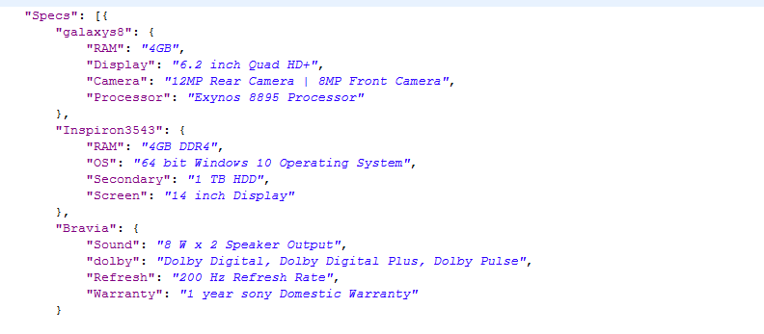

**APP STRUCTURE**

The Shopping Cart website has the following file structure placed inside the web content folder of the shopping cart website.

1. Images folder – Contains all the images used in the application.
2. Shopping site folder- Contains the .XML file and the .JS file used for the markup and control of the application.
3. Model Files – The files with .JSON ext. are the model files .They are used to retrieve data and information regarding objects or products on the shopping cart.

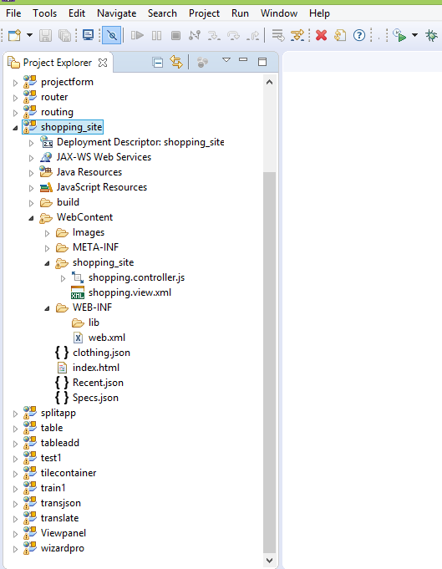

**DIFFERENT VIEWS**

HOME PAGE

This is the first or the home page of the shopping cart website . It is based on the concept of SPLITAPP

in which the webpage is divided into two sections containing master pages on the left side with their detail pages on the right side . Each master having a detail page.

The master pages contain the different categories of products available with further divisions in them.

Each master pages has one or more detail pages containing the information regarding the product and it’s images for good user interaction

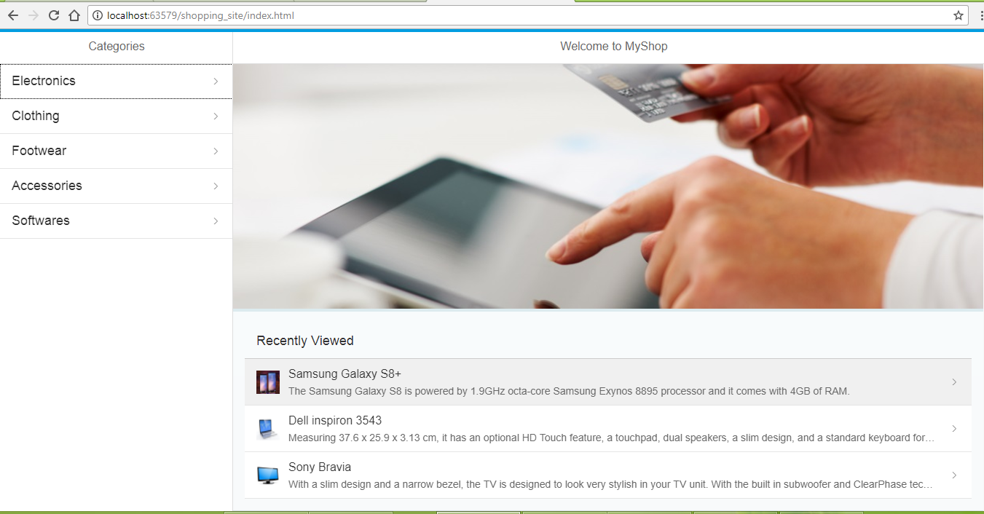

RECENT HISTORY

There is a small section below the welcome page or the image which shows the recently viewed items or products by the user based on the search history .

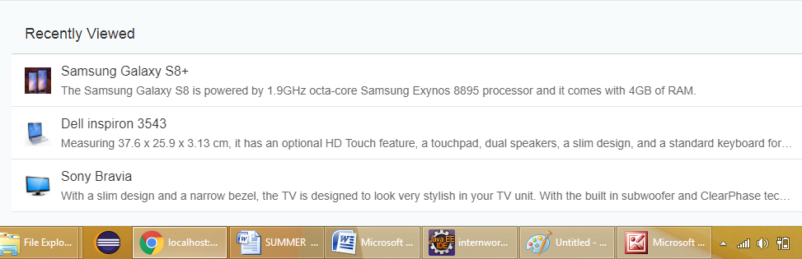

MASTER PAGES

These are some of the master pages containing details about the products in a more user friendly

way. So ,the customer can easily search for the material of their choice through a series of menu.

A navigation button is also provided in the top left corner of the master pages to move back easily

for the user.

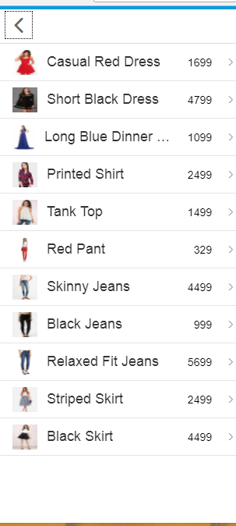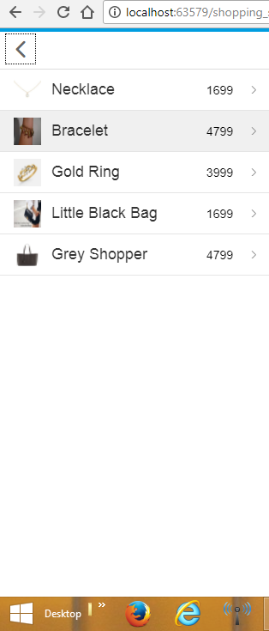

Detail Pages

The next part are the detail pages containing the detailed information regarding the product to allow

user have a complete look up of the product . Each master page is linked to it’s detail page of the product.

A navigation button is also provided in the top left corner of the detail pages to move back easily

for the user.

In detail pages , a different button named as buy button is also present so as the user clicks it to buy the

product if he she likes which takes the user to the payment gateway .

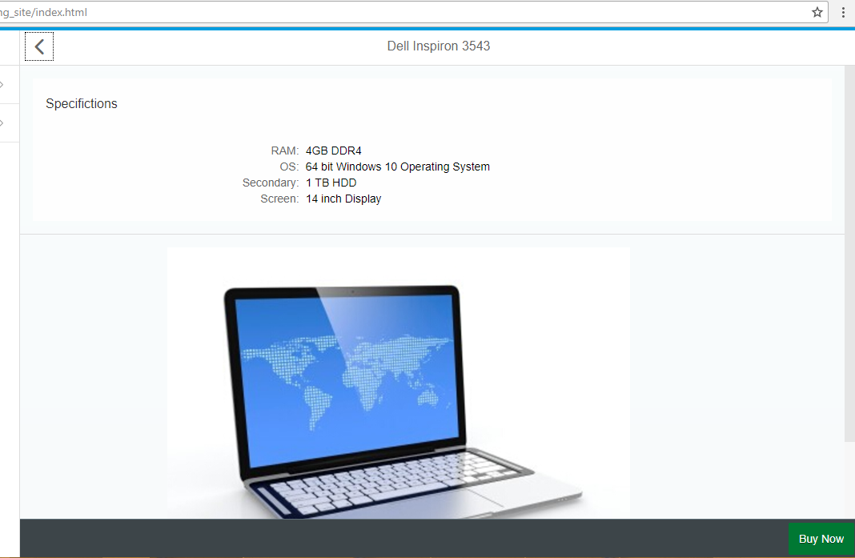

**CONCLUSION**

The Online Shopping Cart Application made on SAPUI5 platform helped us learn the basics of Web App Development and how to effectively use the SAPUI5 platform for making Apps.

We learned installing Eclipse along with all the SapUi5 Tools and Sap libraries for efficient working and proper Configuring of Eclipse

We used the concepts of HTML, Javascript and Json which formed the brains behind the interface design of all the Views in the App. We used Libraries, markup, File models, Interfaces etc. to efficient program the Application.

We also learned about managing Views and Fragments and efficiently going and passing Information from one View to another through Intent.

We learned about the SAPUI5 Cloud Platform which helped in running and testing the app as and when required.

We learned about the three types of files made in project. The one file which keeps a log of all the views is called the project.xml file. A JavaScript file (.js format) and a data model file (.json format) was created for each separate view.

All the Basic features which are necessary for the Online Business and the Consumer have been incorporated in this Application and efficient and proper working of all these features have been checked.

**REFERENCES / BIBLOGRAPHY**

# Books -: SAPUI5: The Comprehensive Guide

by  [Christiane Goebels](http://www.amazon.in/Christiane-Goebels/e/B01J5GRVS8/ref=dp_byline_cont_book_1)  (Author), [Denise Nepraunig](http://www.amazon.in/s/ref=dp_byline_sr_book_2?ie=UTF8&field-author=Denise+Nepraunig&search-alias=stripbooks) (Author), [Thilo Seidel](http://www.amazon.in/s/ref=dp_byline_sr_book_3?ie=UTF8&field-author=Thilo+Seidel&search-alias=stripbooks) (Author)

**Internet References -:**

**About Online Shopping**

https://www.youtube.com/watch?v=qTchplNGM5Q

<https://en.wikipedia.org/wiki/Online>Shopping

<http://docslide.us/documents/an-overview-and-future-scope-of-online-shoping.html>

**About Sapui5 and Library Tools**

<https://en.wikipedia.org/wiki/Sapui5>

https://sapui5.hana.ondemand.com/#docs/guide/95d113be50ae40d5b0b562b84d715227.html

**Other References**

<https://accounts.google.com>

<https://en.wikipedia.org/wiki/Sapui5_version_history>

<http://www.goodreturns.in/2014/12/05/online-shopping-what-are-the-advantages-disadvantages-325811.html>

http://www.indiafinancebazaar.com/personal-finance/advantages-online-shopping

<https://www.quora.com>

https://www.tutorialspoint.com

https://sapui5.hana.ondemand.com/#docs/api/symbols/sap.ui.html