To run project install python 3.7 then using pip command install django using below command

Pip install django

Put Blockchain folder in your system C directory and run below command to start web server then open browser and enter below /URL to get below screen

[http://127.0.0.1:8000/inde78*/x.html](http://127.0.0.1:8000/inde78*/x.html) and press enter to get below screen

This project consist of 4 modules

Peer Module: using this module we will add peer details to application

Block Module: using this module we can add peer to block

Transaction Module: one peer can transfer coin to other peer

Chain module: if transaction completes and hash code validated then transaction will be added to chain module

First screen

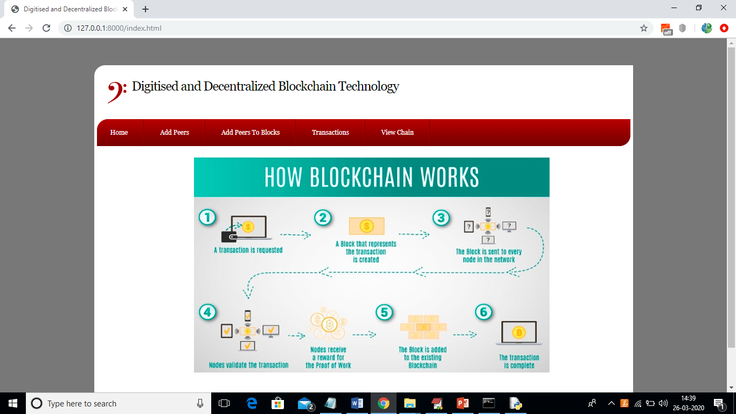

In above screen click on ‘Add Peers’ link to add new peer details

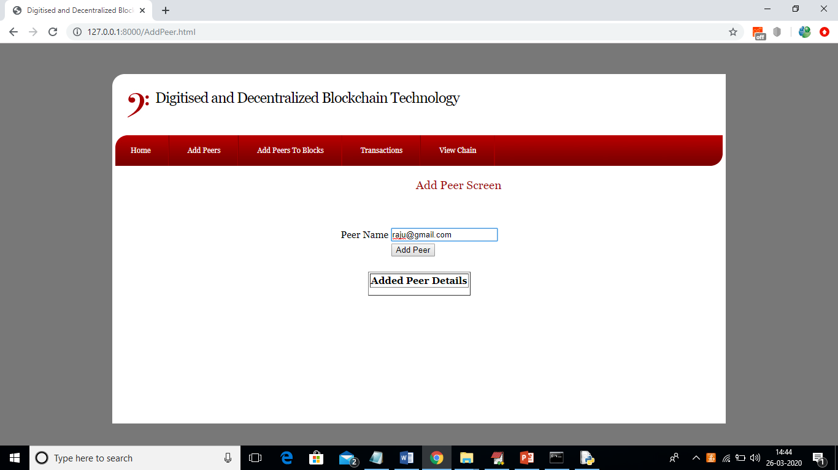

In above screen I am adding new peer as ‘raju@gmail.com’ and the entry will be available here till it added to block and after adding to block entry will be deleted from peer screen. Now click on ‘Add Peer’ button to get below screen

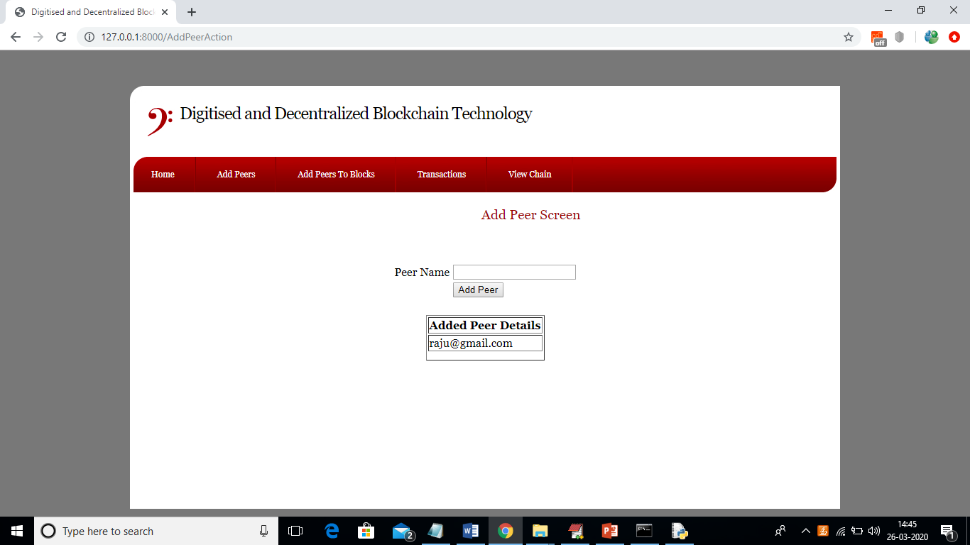

In above screen we can see newly added peer details showing in above screen table. Now click on ‘Add Peers To Blocks’ link to add this peer to block chain.

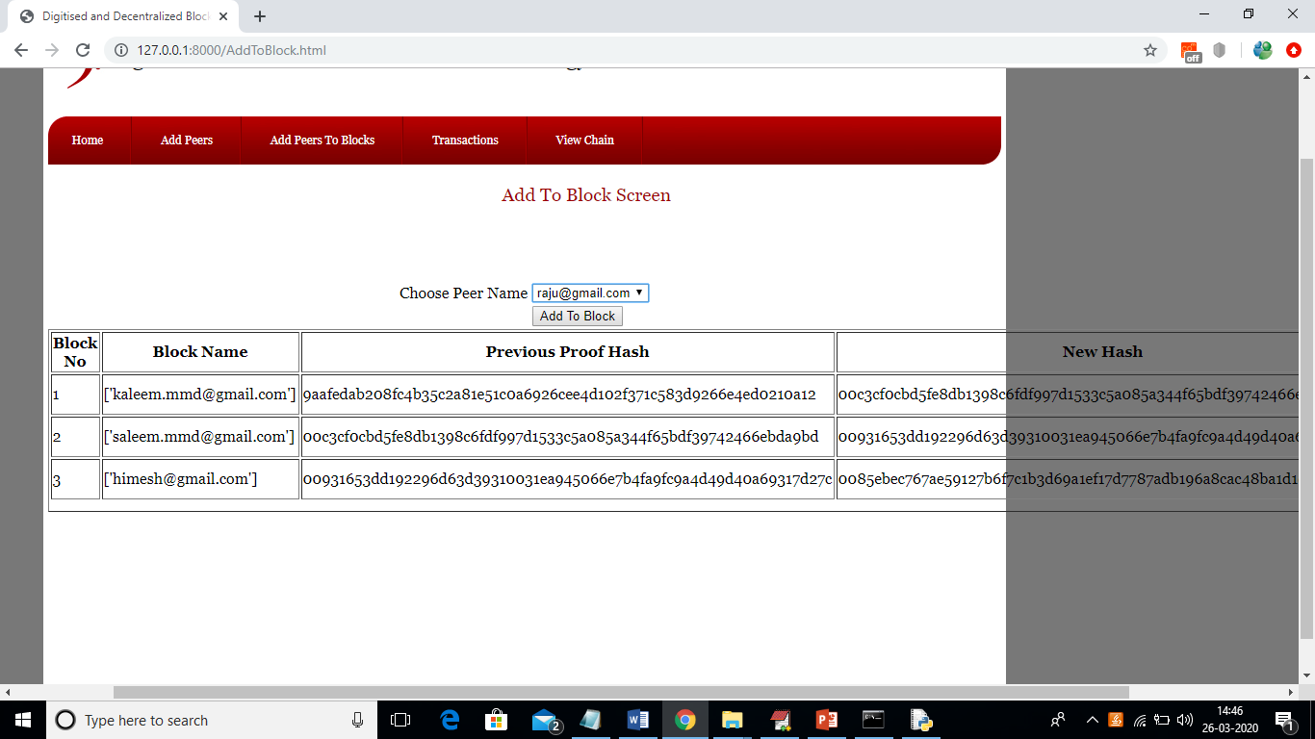

In above screen all added peers to block chain will be displayed here with their old and new hash code as proof of work. We can see in above screen New Hash of first row is match with previous hash of second row and goes on till transaction executed successfully with hash validation. Scroll above screen to view created date also.

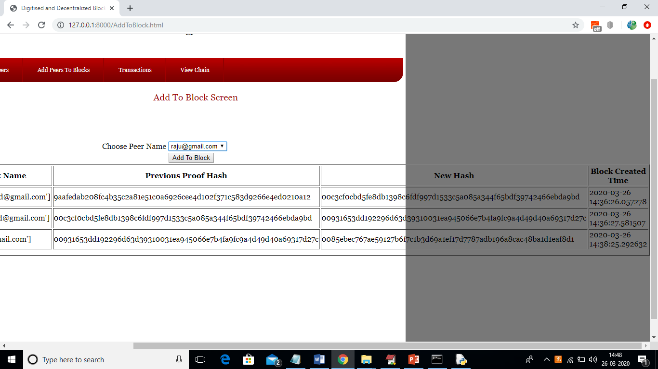

Now we can select new peer name from drop down box and click on ‘Add to Block’ button to add new peer to new block

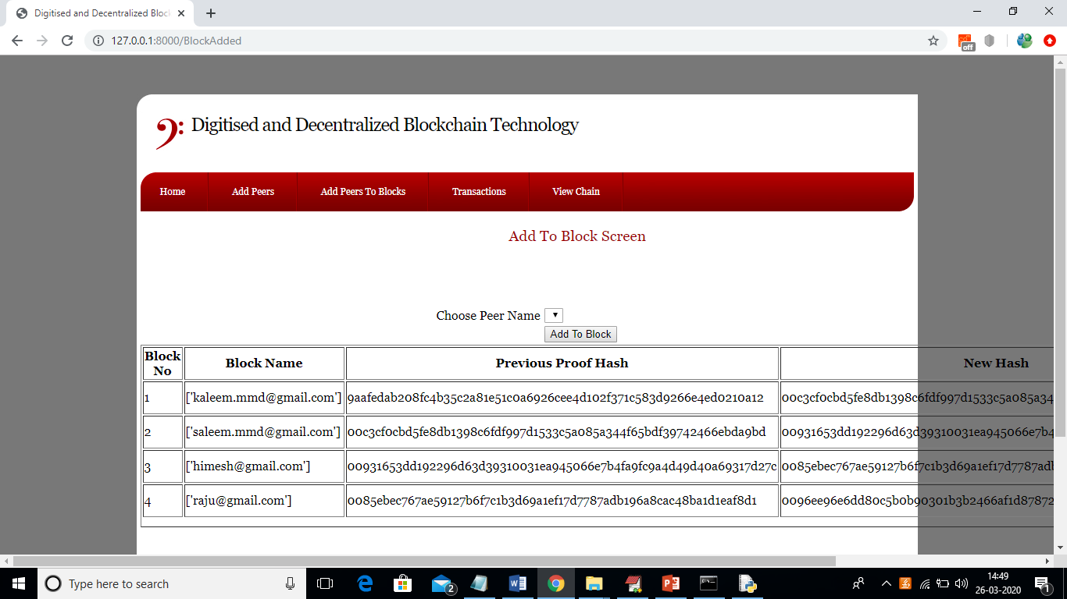

In above screen new peer also added to block and once it added then that peer will be removed from drop down box. Now click on ‘Transactions’ link to perform transaction between block chain users.

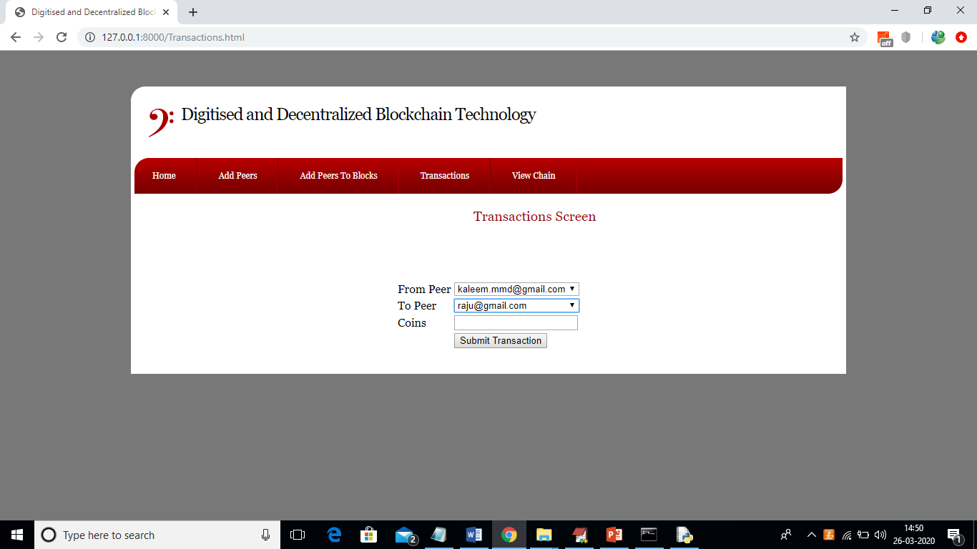

In above screen from peer and choose desire to peer from drop down box and then enter amount and click on ‘Submit Transaction’ button to transfer fund

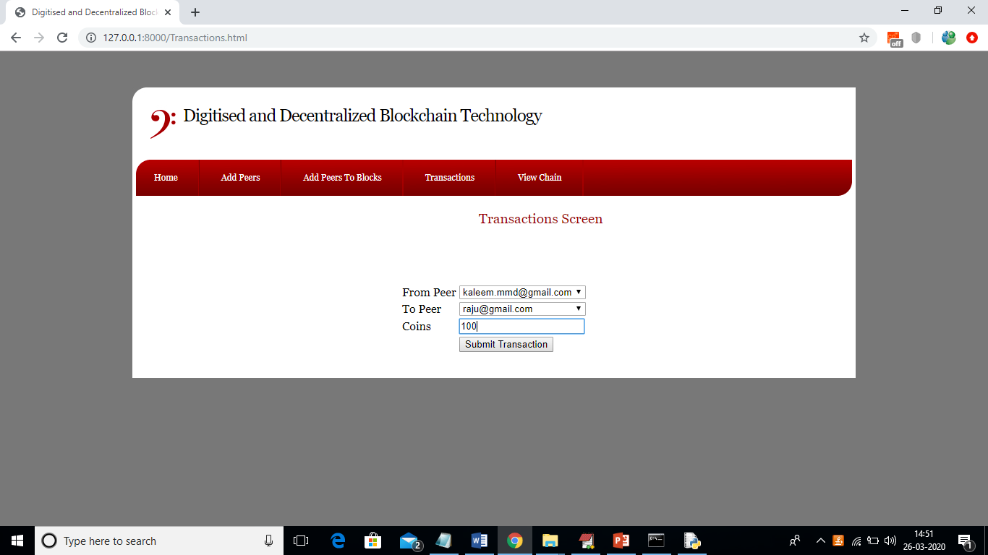

In above screen I am sending 100 coins and after transaction complete will get below screen

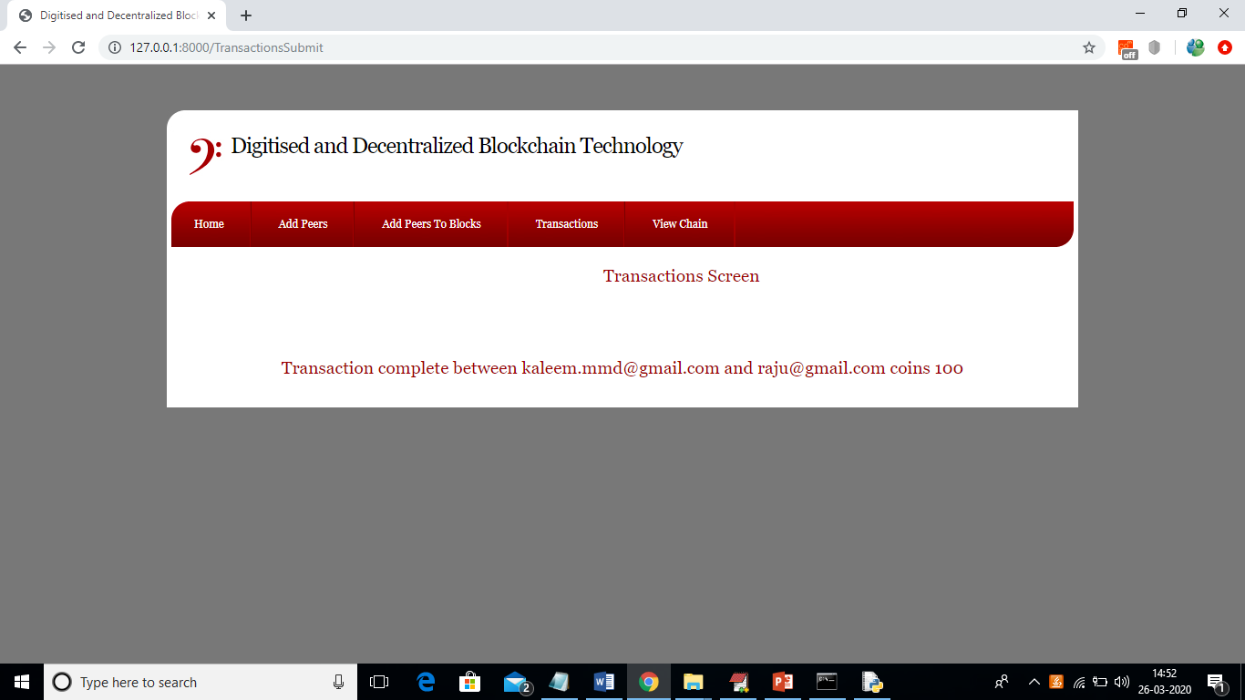

Now click on ‘View Chain’ link to view all transactions details

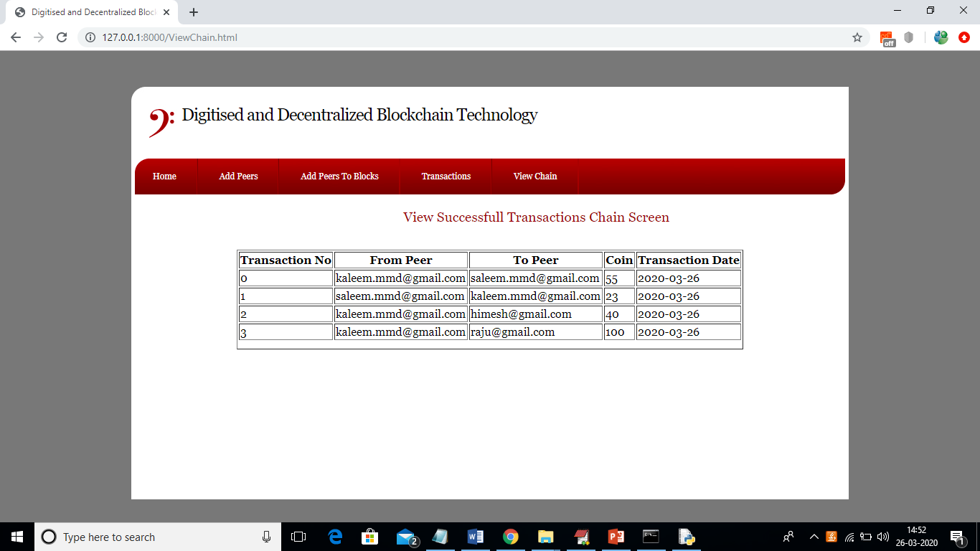

In above screen from block chain we can retrieve all transaction details. Below block chain code use to validate transactions

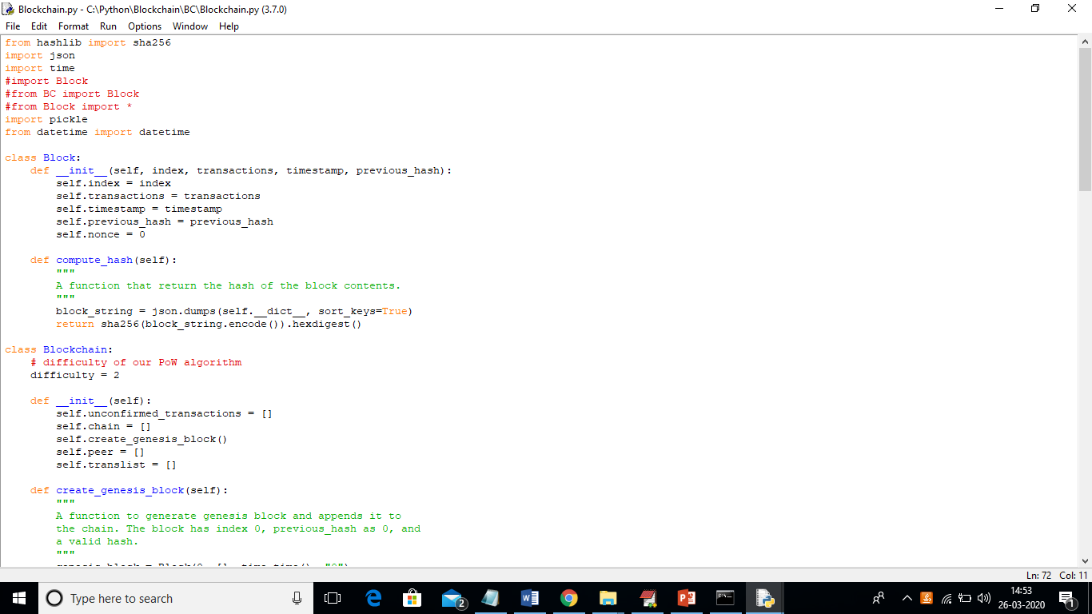

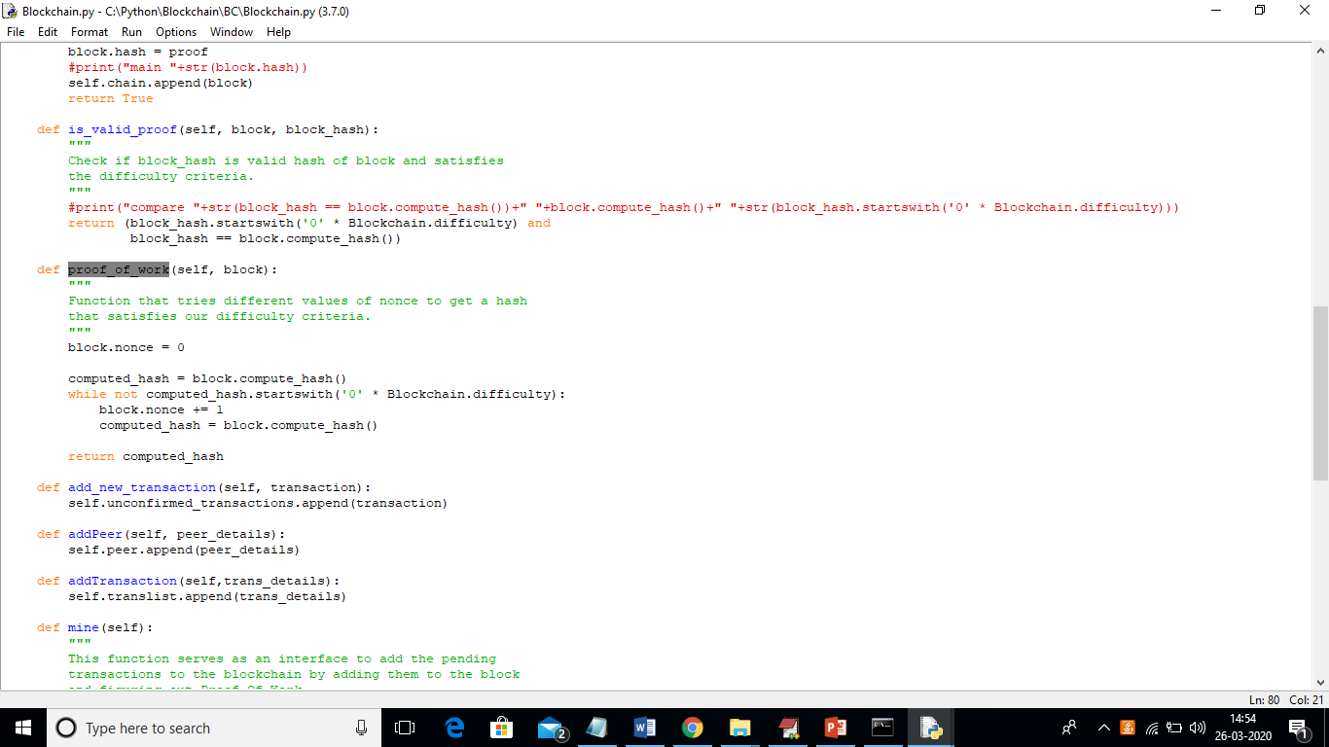

In above screen is_valid_proof and proof_of_work functions validate all transactions with old and new hash code