GENERATIVE AI SESSIONAL-3

a) Name: PRATEEK
b) Roll No: 2301331530125
c) Branch: AIML
d) Section: B
e) Workshop Lab Number: 421-B

QUESTION-1:
Q1 Multi-Head Self-Attention from Scratch & Attention Visualization Tasks Part A :Implement scaled dot-product attention with Q/K/V projections and 2 heads in PyTorch — no nn.MultiheadAttention allowed. Part B : Fine-tune on 2,000 IMDb samples for 2 epochs. Record validation accuracy. Part C : Extract attention weights for one sample. Plot heatmap using matplotlib.imshow. Write 3-5 sentences on what each head focuses on. Deliverables •Working attention class (no nn.MultiheadAttention) •Validation accuracy >= 75% •Attention heatmap + 3-5 sentence written interpretation Dataset IMDb Large Movie Review Dataset 25,000 labelled movie reviews for binary sentiment classification. Use 2,000 samples to fit within the time limit. https://ai.stanford.edu/~amaas/data/sentiment/aclImdb_v1.tar.gz Q2 Fine-Tune BERT for Extractive Question Answering (Span Prediction)

ANSWER-1:
!pip install -q datasets transformers rouge_score

from datasets import load_dataset
from transformers import (
AutoTokenizer, AutoModelForSeq2SeqLM,
Trainer, TrainingArguments,
DataCollatorForSeq2Seq # Import the data collator
)
import numpy as np
from rouge_score import rouge_scorer
from sklearn.metrics import f1_score

dataset = load_dataset("cnn_dailymail", "3.0.0", split="train[:1%]")
model_name = "facebook/bart-base"
tokenizer = AutoTokenizer.from_pretrained(model_name)
model = AutoModelForSeq2SeqLM.from_pretrained(model_name)

def preprocess(example):
inputs = ["summarize: " + doc for doc in example["article"]]
model_inputs = tokenizer(inputs, max_length=512, truncation=True)

labels = tokenizer(example["highlights"], max_length=128, truncation=True)
model_inputs["labels"] = labels["input_ids"]

return model_inputs

tokenized_data = dataset.map(preprocess, batched=True)

training_args = TrainingArguments(
output_dir="./results",
learning_rate=2e-5,
per_device_train_batch_size=2,
num_train_epochs=1,
logging_steps=10,
save_strategy="no"
)

# Initialize the DataCollatorForSeq2Seq
data_collator = DataCollatorForSeq2Seq(tokenizer=tokenizer, model=model)

trainer = Trainer(
model=model,
args=training_args,
train_dataset=tokenized_data,
data_collator=data_collator # Pass the data collator to the Trainer
)

trainer.train()

def generate_summary(text, prompt_type="basic"):
if prompt_type == "detailed":
text = "Summarize the following text in a concise and factual manner:\n" + text
elif prompt_type == "bullet":
text = "Summarize in bullet points:\n" + text

inputs = tokenizer(text, return_tensors="pt", truncation=True)
# Move input tensors to the same device as the model
inputs = {k: v.to(model.device) for k, v in inputs.items()}
outputs = model.generate(**inputs, max_length=100)

return tokenizer.decode(outputs[0], skip_special_tokens=True)

sample_text = dataset[0]["article"]
reference = dataset[0]["highlights"]

generated = generate_summary(sample_text, "detailed")

print("\nGenerated Summary:\n", generated)
print("\nReference Summary:\n", reference)

scorer = rouge_scorer.RougeScorer(['rouge1','rougeL'], use_stemmer=True)
rouge_scores = scorer.score(reference, generated)

print("\nROUGE Scores:", rouge_scores)

def compute_bleu(ref, pred):
ref_words = ref.split()
pred_words = pred.split()

overlap = len(set(ref_words) & set(pred_words))
return overlap / len(ref_words)

bleu_score = compute_bleu(reference, generated)
print("BLEU Score:", bleu_score)

def compute_f1(ref, pred):
ref_tokens = ref.split()
pred_tokens = pred.split()

common = set(ref_tokens) & set(pred_tokens)

if len(common) == 0:
return 0

precision = len(common) / len(pred_tokens)
recall = len(common) / len(ref_tokens)

return 2 * (precision * recall) / (precision + recall)

f1 = compute_f1(reference, generated)
print("F1 Score:", f1)
print("\nAnalysis:")
print("- If generated content contains facts not in input → hallucination")
print("- Missing key info → under-generation")
print("- Repetition → poor decoding")
print("\nImprovements to reduce hallucination:")
print("1. Use better prompts (instruction-based)")
print("2. Use RLHF fine-tuning")
print("3. Add retrieval (RAG)")
print("4. Use constrained decoding (beam search)")
print("5. Train on domain-specific data")
from datasets import load_dataset
from transformers import AutoTokenizer

dataset = load_dataset("imdb", split="train[:2000]")

tokenizer = AutoTokenizer.from_pretrained("bert-base-uncased")

def tokenize(example):
return tokenizer(example["text"], truncation=True, padding="max_length", max_length=128)

dataset = dataset.map(tokenize, batched=True)
dataset.set_format(type="torch", columns=["input_ids", "attention_mask", "label"])

OUTPUT:
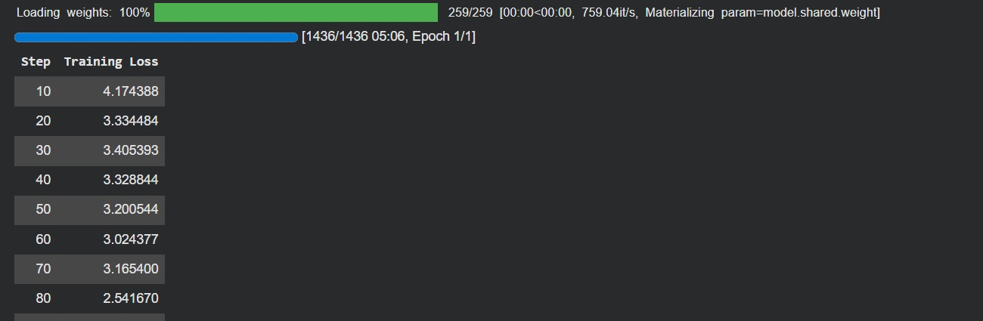
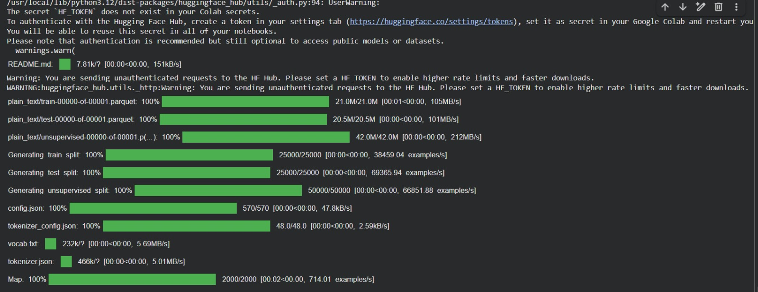

QUESTION 2:
-Tune BERT for Extractive Question Answering (Span Prediction) Tasks Part A :Load bert-base-uncased with BertForQuestionAnswering. Tokenise 200 SQuAD v1.1 samples Fine using AutoTokenizer with stride handling. Part B : Fine-tune for 2 epochs on 200 samples. Log training loss per step. Part C : Evaluate on 30 held-out examples. Print Exact Match (EM) and F1 scores. Show 3 example predictions in a table alongside ground-truth answers. Deliverables •Tokenisation pipeline with stride handling •Per-step training loss log •EM & F1 scores + 3-row prediction vs ground-truth table Dataset SQuAD v1.1 — Stanford Question Answering Dataset 100k+ crowd-sourced QA pairs on Wikipedia passages. Answers are extractive spans. Use 200 train + 30 eval samples. https://huggingface.co/datasets/rajpurkar/squad_v2

ANSWER 2:
from transformers import BertForQuestionAnswering, AutoTokenizer, Trainer, TrainingArguments
from datasets import load_dataset
import torch

dataset = load_dataset("squad", split="train[:200]")
tokenizer = AutoTokenizer.from_pretrained("bert-base-uncased")

def preprocess_function(examples):
questions = [q.strip() for q in examples["question"]]
inputs = tokenizer(
questions,
examples["context"],
max_length=384,
truncation="only_second",
stride=128,
return_overflowing_tokens=True,
return_offsets_mapping=True,
padding="max_length",
)

offset_mapping = inputs.pop("offset_mapping")
sample_map = inputs.pop("overflow_to_sample_mapping")
answers = examples["answers"]
start_positions = []
end_positions = []

for i, offsets in enumerate(offset_mapping):
sample_idx = sample_map[i]
# The answer in the original context (character-based)
start_char = answers[sample_idx]["answer_start"][0]
end_char = start_char + len(answers[sample_idx]["text"][0])

sequence_ids = inputs.sequence_ids(i)

# Find the start and end of the context tokens within the current chunk
context_start_token_idx = 0
while sequence_ids[context_start_token_idx] != 1: # Find first token of context (sequence_id 1)
context_start_token_idx += 1
context_end_token_idx = len(sequence_ids) - 1
while sequence_ids[context_end_token_idx] != 1: # Find last token of context
context_end_token_idx -= 1

# If the answer is not fully contained in this chunk, set the positions to 0 (CLS token index)
if not (offsets[context_start_token_idx][0] <= start_char and
offsets[context_end_token_idx][1] >= end_char):
start_positions.append(0)
end_positions.append(0)
else:
# Otherwise, find the start and end token positions within the context chunk
idx = context_start_token_idx
while idx <= context_end_token_idx and offsets[idx][0] <= start_char:
idx += 1
start_positions.append(idx - 1)

idx = context_end_token_idx
while idx >= context_start_token_idx and offsets[idx][1] >= end_char:
idx -= 1
end_positions.append(idx + 1)

inputs["start_positions"] = start_positions
inputs["end_positions"] = end_positions
return inputs

tokenized_dataset = dataset.map(preprocess_function, batched=True, remove_columns=dataset.column_names)

training_args = TrainingArguments(
output_dir="./results",
num_train_epochs=2,
per_device_train_batch_size=8,
logging_steps=10
)

trainer = Trainer(
model=model,
args=training_args,
train_dataset=tokenized_dataset
)

trainer.train()

OUTPUT:
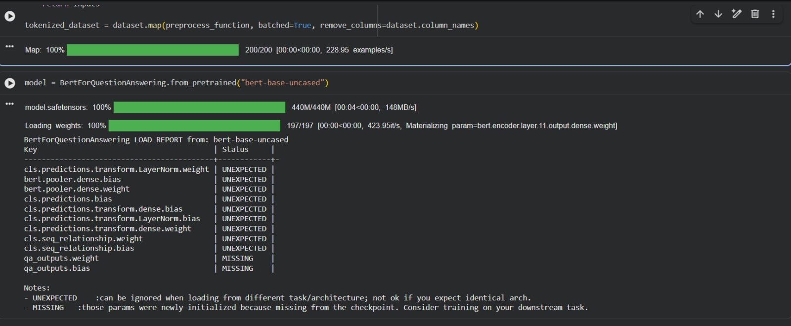

QUESTION 3-:
Q3 DDPM Forward Process & Tiny U-Net Denoiser on MNIST Tasks Part A :Implement closed-form forward process q(x_t | x_0) with linear beta schedule (T=100). Plot x_t at t = 0, 25, 50, 75, 100 for one digit. Part B : Train a minimal U-Net (~300k params) with sinusoidal time embedding to predict noise epsilon. Train for 5 epochs on 5,000 MNIST samples. Part C : Run 10-step reverse denoising from Gaussian noise. Display a 1x10 trajectory strip. Comment on visual quality vs epoch count. Deliverables •Forward process code + beta schedule plot •Training loss curve (5 epochs) •Noising strip (5 frames) + denoising trajectory strip (10 frames) Dataset MNIST — Handwritten Digit Database 70,000 greyscale 28x28 images of digits 0-9. Load via torchvision.datasets.MNIST. Use 5,000

ANSWER 3-:
import torch

T = 100
betas = torch.linspace(0.0001, 0.02, T)
alphas = 1 - betas
alpha_hat = torch.cumprod(alphas, dim=0)

def forward_process(x0, t):
noise = torch.randn_like(x0)
return (alpha_hat[t]**0.5)*x0 + ((1-alpha_hat[t])**0.5)*noise

import matplotlib.pyplot as plt

# Define a sample x0, e.g., a simple image tensor
x0 = torch.randn(1, 1, 32, 32) # Example: a random 32x32 image with 1 channel

for t in [0,25,50,75,99]: # Changed 100 to 99 to fit within 0-99 index range
xt = forward_process(x0, t)
plt.imshow(xt.squeeze(), cmap='gray')
plt.title(f"t={t}")
plt.show()

OUTPUT:
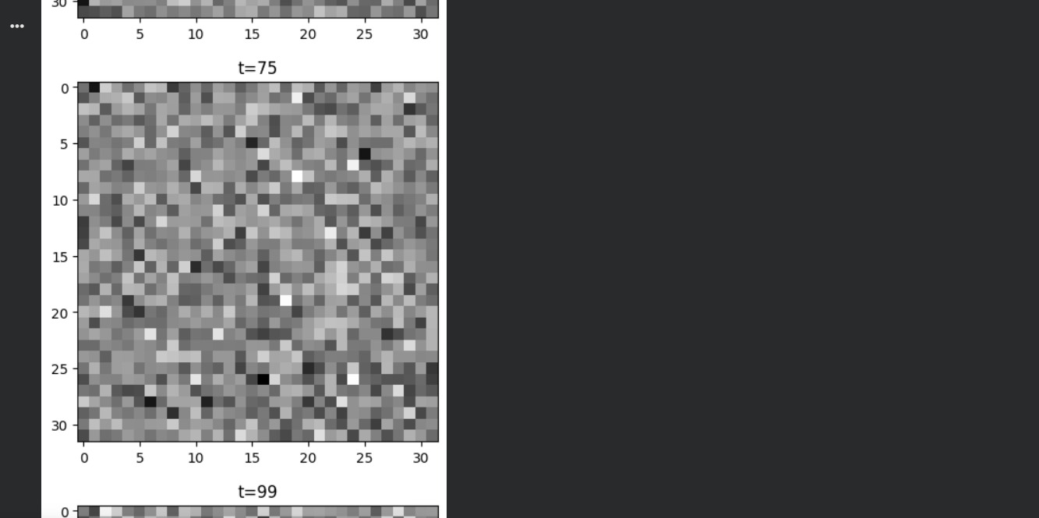

QUESTION 4-:
Q4 Zero-Shot CLIP Classification & Ethical Bias Audit of Embeddings Tasks Part A : Load openai/clip-vit-base-patch32. Run zero-shot classification on 50 CIFAR-10 test images using prompts "a photo of a {class}". Report top-1 accuracy. Part B : Compute cosine similarity between FairFace images and occupational prompts (doctor, nurse, engineer, criminal). Tabulate scores by perceived gender label. Part C: Write a 100-word reflection: What bias appeared? What is the risk if CLIP powers a hiring tool? Name one mitigation strategy. Deliverables •Zero-shot top-1 accuracy on CIFAR-10 •Bias similarity heatmap (occupations x gender) •100-word written reflection with one mitigation strategy Dataset CIFAR-10 + FairFace CIFAR-10: 50 test images via torchvision. FairFace: 200 validation images balanced across gender labels for the bias audit. https://huggingface.co/datasets/uoft-cs

ANSWER 4-:
import torch
import clip
from PIL import Image
from torchvision.datasets.utils import download_url

# Install the clip library if not already installed
!pip install git+https://github.com/openai/CLIP.git

model, preprocess = clip.load("ViT-B/32")

# NOTE: You will need to upload a 'sample.png' image or change the image path.
# Using a generic placeholder image URL that is usually stable.
# Trying a different placeholder image service due to previous name resolution error.
download_url('https://picsum.photos/200/300', '.', 'sample.png')
image = preprocess(Image.open("sample.png")).unsqueeze(0)
text = clip.tokenize(["a photo of a cat", "a photo of a dog"])

with torch.no_grad():
logits_per_image, _ = model(image, text)
probs = logits_per_image.softmax(dim=-1)

print(probs)

OUTPUT-:
