ICETOOL

CASE STUDY

DOCUMENT CONTROL

Version | Date | Author | Comments
1.0 | 11/20/15 | TCS | Initial

Table of Contents

1. THE REQUIREMENT STATEMENT: 3

2. PROCESS STEPS: 3

A. JCL EXERCISES: 3

B. CASE STUDY for ICETOOL
1. CASE STUDY 1 4
2. CASE STUDY 2 5
3. CASE STUDY 3 5
4. CASE STUDY 4 6
APPENDIX A 7

ICETOOL

- The Requirement Statement:

This exercise is aimed at providing a complete knowledge on important and frequently used Utilities on ICETOOL in JCL.

- Process Steps:

A. JCL Exercises:

Find out the JCL errors if any in the following statements. Correct the errors in ICETOOL .

Allocate yourself a time frame of 20 minutes for this exercise.

//EXAMP JOB A492,PROGRAMMER
//TOOL EXEC PGM=ICETOOL
//TOOLMSG DD SYSOUT=A
//DFSMSG DD SYSOUT=A
//TOOLIN DD *
SORT FROM(BKS) TO(DAPUBS,PRPUBS) USING(SPUB)
/*
//BKS DD DSN=TRCID.SORT.SAMPIN,DISP=SHR
//DAPUBS DD DSN=&&DSRT,DISP=(,PASS),SPACE=(CYL,2,2)),UNIT=SYSDA
//PRPUBS DD DSN=TRCID.SORT.SAMPOUT,DISP=SHR
//SYSPRINT DD SYSOUT=A
//SPUBCNTL DD *
SORT FIELDS=(106,4,A,1,75,A),FORMAT=CH
/*
//
For the following questions, write down the required JCL statements.
Allocate yourself a time frame of 15 minutes for this exercise.

Q1. Which tool in parameter is used to compare two files on a specified field?
Create output files as required -
a) With Matching Records
b) With Non-Matching Records

Q2. How can you print a report with header and trailer built?

Q3. How can you reformat input records with below format to Output format mentioned below ?
Input Format:
CUST ID starts from col 1 to col 5 should be Numeric.
CUST NAME starts from col 6 to col 17 should be Alphabetic.
ACCNTNO starts from col 18 to col 21 should be Numeric.
TRANTYPE starts from col 28 to col 33 should be Numeric.
ROOT NO starts from col 22 to col 27 should be Numeric.
Output Format:
CUST NAME starts from col 1 to col 12 should be Alphabetic.
ACCNTNO starts from col 13 to col 15 should be Numeric.
CUST ID starts from col 16 to col 21 should be Numeric.
TRANTYPE starts from col 28 to col 33 should be Numeric.
ROOT NO starts from col 22 to col 27 should be Numeric.
Q4.What is the tool in parameter used to split a file containing employee names into 26 files, each containing the names starting with A, B, C and so on.

B. Case Study for ICETOOL

Copy the sample JCL named ICETOOL from TRG1T.ILP.JCLCASE to TRCXXX.BANKING.ICETOOL.JCL using ISPF 3.3 option with same parameters of source file. Refer Appendix A for all case studies.

1. Case Study 1

Allocate yourself a time frame of 60 minutes for this case study (15 minutes for each Case).
Copy the sample JCL named ICETOOL from TRG1T.ILP.JCLCASE to TRCXXX.BANKING.PROC.JCL using ISPF 3.3 option. Refer Appendix A

Write a JCL to sort input file based on the account number in ascending order and filter records based on condition where transaction type equal to CREDIT or DEBIT

Hint: Use ICETOOL

The following tool in parameter should be performed to do this task

SORT FROM(BKS) TO(DAPUBS,PRPUBS) USING(SPUB)

Note: BKS, DAPUBS,PRPUBS, SPUB are user defined variables used as DD name for referring respective data sets.
You have to refer the same DD name while passing the data sets
For input data set you have to refer DD name as BKS,
For output data set you have to refer DD name as DAPUBS,PRPUBS,
For control card data set you have to refer DD name as SPUB

Record layout of input master file:

Name of input file: TRYxxx.BANKING.MASTER.FILE
Record Length: 80
Block size: 800
Record Format: Fixed Block

CUST ID starts from col 1 to col 5, should be Numeric.
CUST NAME starts from col 6 to col 36, should be Alphabetic.
ACCNTNO starts from col 37 to col 52, should be Numeric.
TRAN TYPE starts from col 54 to col 59, should be Alphabetic.
FILLER starts from col 60 to col 80, should be Alphanumeric.

Record layout of output file:
Name of output file: TRYXXX.BANKING.SORTOUT
Record Length: 80
Block size: 800
Record Format: Fixed Block

Record layout of output file is as same as master file.

Control card :

Note:The sort should be based on the account number in ascending order
Filter records based on condition where transaction type equals to CREDIT or DEBIT

- Case Study 2

Write a JCL to print the messages containing minimum, maximum, average and total of the following fields present in the input file
a. Customer ID
b. Account Number

Hint: Use ICETOOL

Tool in parameter :

STATS FROM(ALL) ON(1,5,ZD) ON(37,16,ZD)

Note: For input data set you have to refer DD name as ALL

Input file:
Name of input file: TRYxxx.BANKING.MASTER.FILE
Same input file used for case study1

Output file:
Name of output file: TRYxxx.BANKING.STATS.MASTER
Record Length: 80
Block size: 800
Record Format: Fixed Block

Control card :
Note: There is no control card required for this case

- Case Study 3

Write a JCL to print message containing the count of values in a range from 0020000 to 0120156 of account number present in the input file.

Hint: Use ICETOOL

Tool in parameter :

RANGE FROM(CADASD) ON(37,16,ZD) HIGHER(0120156) LOWER(0020000)

Note: For input data set you have to refer DD name as CADASD

Input file:
Name of input file: TRYxxx.BANKING.MASTER.FILE
Same input file used for case study1

Output file:
Name of output file: TRYxxx.BANKING.RANGE.MASTER
Record Length: 80
Block size: 800
Record Format: Fixed Block

Control card :
Note: There is no control card required for this case

- Case Study 4

Write a JCL to copy only the first 10 records of the input file to output file.

Hint: Use ICETOOL

Tool in parameter :

COPY FROM(REGNIN1) TO(T1) USING(CTL1)

Note:
You have to refer the same DD name while passing the data sets
For input data set you have to refer DD name as REGNIN1
For output data set you have to refer DD name as T1
For control card data set you have to refer DD name as CTL1

Input file:
Name of input file: TRYxxx.BANKING.MASTER.FILE
Same input file used for case study1

Output file:
Name of output file: TRYxxx.BANKING.COPY.MASTER
Record Length: 80
Block size: 800
Record Format: Fixed Block

Control card :
Use STOPAFT keyword to copy the required number of rows.

APPENDIX A

Please find the sample JCL in the below link,
Case Study 1:
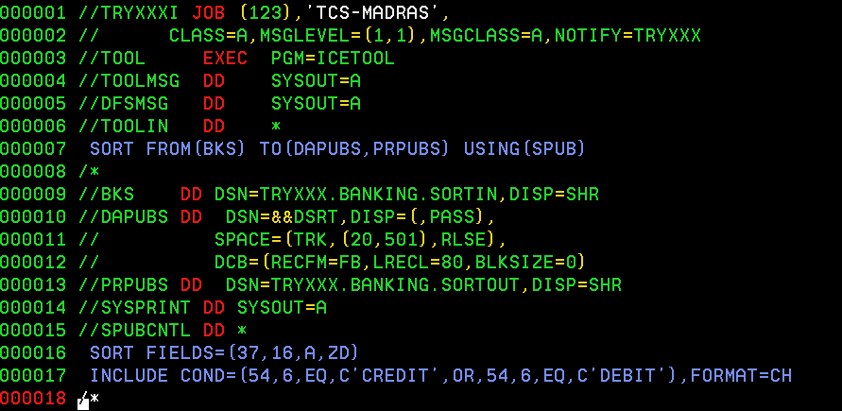

Case Study 2:
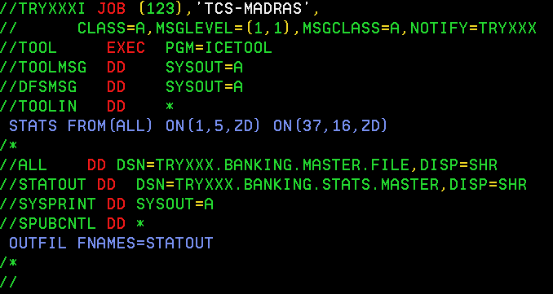

Case Study 3:
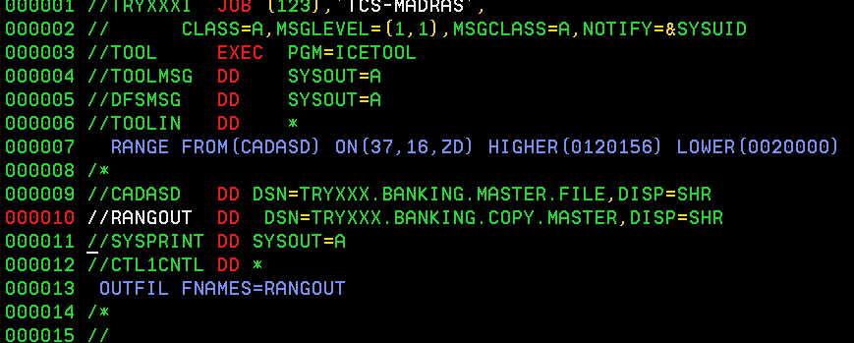

Case Study 4:
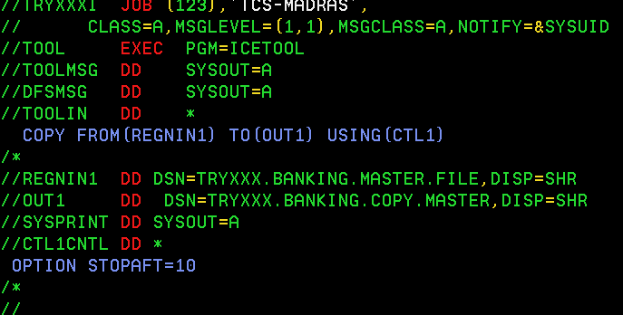

TRG1T.ILP.JCLCASE(ICETOOL)
