PROCEDURES AND OVERRIDES JCL CASE STUDY

DOCUMENT CONTROL

Version | Date | Author | Comments
1.0 | 11/20/15 | TCS | Initial

Table of Contents

1. THE REQUIREMENT STATEMENT: 3

2. JCL CASE STUDY 5
1. CASE STUDY 1 5

2. CASE STUDY 2 6
APPENDIX A 7

Procedures and Overrides in JCL

1. The Requirement Statement:

This exercise is aimed at providing a complete knowledge on the concepts of Procedures and Override Parameter in JCL. After completing the case study, the associates will have better knowledge of Procedures and Override parameters

- JCL Case Study

Allocate yourself a time frame of 40 minutes for this exercise (20 minutes each for Case I and Case II).

Case I : Cataloged procedure

STEP 1: Create PROC

Copy the sample JCL named BANKING from TRG1T.ILP.JCLCASE to TRCXXX.BANKING.PROC.JCL using ISPF 3.3 option with same parameters of source file.

DSN = TRCXXX.BANKING.PROC.JCL
RECFM= FB,
Length = 80 bytes,
Block Size = 800

Create cataloged procedure using IEFBR14 utility with DCB parameters as mentioned below.

Name of the PROC: BANKING
DSN = TRCXXX.BANKING.PROCIN
RECFM= FB,
Length = 80 bytes,
Block Size = 800,

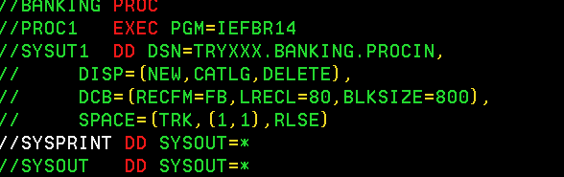

STEP 2: Calling PROC

Call procedure from another JCL with the attributes given below.
- Copy the calling PROC JCL named PROCCAL from TRG1T.ILP.JCLCASE to TRCXXX.BANKING.PROC.JCL using ISPF 3.3 option using the same attributes as mentioned in STEP1.

- STEP1 can be coded as PROC= BANKING or BANKING

- JCLLIB order library should point to the PDS where proc BANKING is coded

JCLLIB ORDER =TRCXXX.BANKING.PROC.JCL
- Submit the JCL and the file TRYXXX.BANKING.PROCIN will be created.

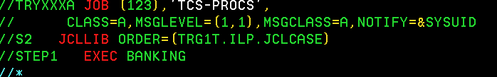

STEP 3: Over ride parameter

While calling the procedure BANKING ,you have to override the input file (TRYxxx.BANKING.PROCIN) with the below mentioned file and submit the job.
Then the below mentioned file will be created and can be browsed using ISPF option 3.4

PROC1.SYSUT1 TRYxxx.BANKING.MASTER.FILE

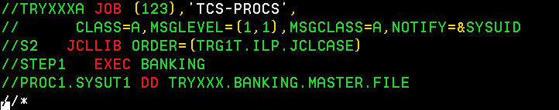

Case II: In-stream procedure

Create in-stream procedure using JCL SORT utility and sort the records based on the following parameter mentioned in sort card

STEP 1:

Copy the sample JCL named INSTPRC from TRG1T.ILP.JCLCASE to TRCXXX.BANKING.PROC.JCL using ISPF 3.3 option using the same attributes as mentioned in STEP1 of CASE I.

Using the SORT Utility create a PROC and Instead of giving data sets in SORTIN, SORTOUT and SYSIN you replace it with symbolic parameter and pass the value of the data sets while calling the PROC as specified below in APPEDIX A

Name of the PROC: INSTR
SORTIN : &DSNNAME
SORTOUT : &DSNOUT
SYSIN : &DATAC

STEP 2:
Sort the input files based on the account number in ascending order
While calling the PROC in STEP2 input file, output file and sort card data set needs to be provided with below specifications.

Data set Specifications:

The following input file should be used while calling the PROC
Name of input file: TRYxxx.BANKING.MASTER.FILE
Record Length: 80
Block size: 800
Record Format: Fixed Block

The following output file should be used while calling the PROC
Name of output file: TRYxxx.BANKING.OUTFILE.PROC
Record Length: 80
Block size: 800
Record Format: Fixed Block

The following sort file should be used as data card while calling the PROC
Name of sort file: TRYxxx.BANKING.DATACRD
Record Length: 80
Block size: 800
Record Format: Fixed Block

SORT CARD:
The sort should be based on the account number in ascending order and the sort

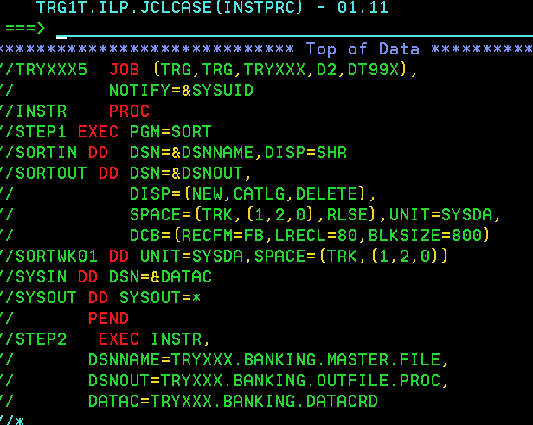

APPENDIX A

Please find the sample JCL in the below link,Override using symbolic Parameters:

TRG1T.ILP.JCLCASE(BANKING)
TRG1T.ILP.JCLCASE(PROCCAL)
TRG1T.ILP.JCLCASE(INSTPRC)

