**Virtual Key for Repositories**

This document contains sections for:

* Sprint planning and Task completion
* Core concepts used in project
* Flow of the Application.
* Demonstrating the product capabilities, appearance, and user interactions.
* Unique Selling Points of the Application
* Conclusions

The code for this project is hosted at https://github.com/Prateekdu/Phase-1-Practice-Project.git .

The project is developed by Prateek Dubey.

## Sprints planning and Task completion

The project is planned to be completed in 1 sprint. Tasks assumed to be completed in the sprint are:

* Creating the flow of the application
* Initializing git repository to track changes as development progresses.
* Writing the Java program to fulfill the requirements of the project.
* Testing the Java program with different kinds of User input
* Pushing code to GitHub.
* Creating this specification document highlighting application capabilities, appearance, and user interactions.

## Core concepts used in project

Collections framework, File Handling, Sorting, Flow Control, Recursion, Exception Handling, Streams API

## Flow of the Application

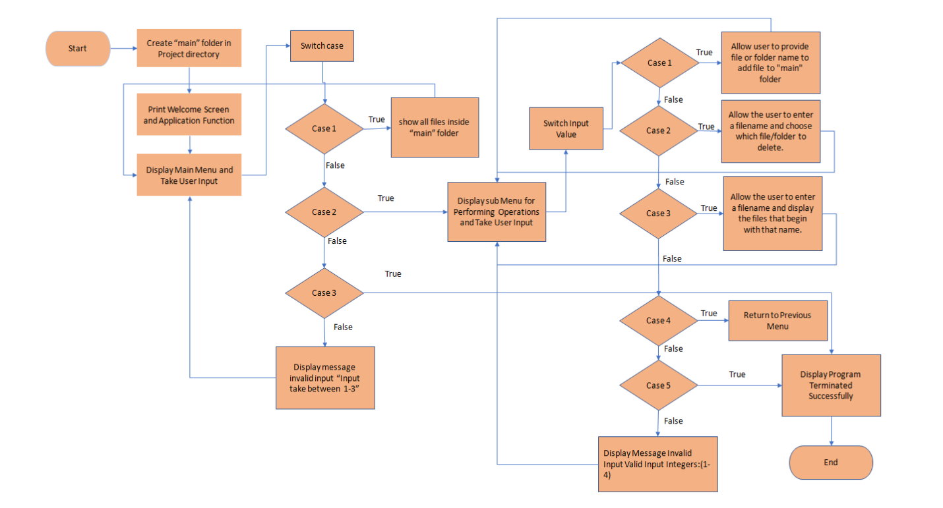

## Demonstrating the product capabilities, appearance, and user interactions

To demonstrate the product capabilities, below are the sub-sections configured to highlight appearance and user interactions for the project:

1. Creating the project in Eclipse
2. Writing a program in Java for the entry point of the application (**Main.java**)
3. Writing a program in Java to display Menu options available for the user (**VertualDemo.java**)
4. Writing a program in Java to handle Menu options selected by user (**VirtualDemo.java**)
5. Writing a program in Java to perform the File operations as specified by user (**Operations.java**)
6. Pushing the code to GitHub repository

## **Step 1:** Creating a new project in Eclipse

* Open Eclipse
* Go to File -> New -> Project -> Java Project -> Next.
* Type in any project name and click on “Finish.”
* Select your project and go to File -> New -> Class.
* Enter **Main** in any class name, check the checkbox “public static void main(String[] args)”, and click on “Finish.”

## **Step 2:** Writing a program in Java for the entry point of the application (**Main.java**)

**package** VirtualKeyFotYourRepositories;

**public** **class** Main {

**public** **static** **final** String ***path*** = "C:\\Users\\Prateek\\Desktop\\assessment1";

**public** **static** **void** main(String[] args) {

VirtualDemo vd = **new** VirtualDemo();

vd.introScreen();

vd.mainMenu();

}

}

## **Step 3:** Writing a program in Java to display Menu options available for the user (**VirtualDemo.java**)

* Select your project and go to File -> New -> Class.
* Enter **VirtualDemo** in class name and click on “Finish.”
* **VirtualDemo** consists methods for -:
  1. Displaying Welcome Screen
  2. Displaying Main Menu
  3. Displaying Sub Menu for File Operations

**Step 3.1:** Writing method to display Welcome Screen

**public** **void** introScreen()

{

System.***out***.println();

System.***out***.println("* WELCOME TO THE LOCKEDME APPLICATION *");

System.***out***.println();

System.***out***.println("* PRATEEK DUBEY *");

System.***out***.println();

System.***out***.println("* Directory: " + Main.***path*** +" *");

System.***out***.println("\n\n");

}

**Output:**

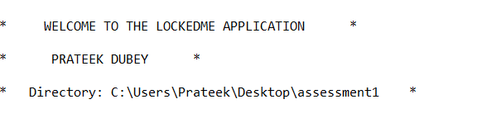

**Step 3.2:** Writing method to display main Menu

**public** **void** mainMenuOptions()

{

System.***out***.println("-------------------------------------");

System.***out***.println("| MAIN MENU |");

System.***out***.println("- - - - - - - - - - - - - - - - - - -");

System.***out***.println("| Select any one of the following: |");

System.***out***.println("| 1 - List All Files |");

System.***out***.println("| 2 - More Options |");

System.***out***.println("| 3 - Exit |");

System.***out***.println("-------------------------------------");

System.***out***.println("Enter your choice : ");

}

**Output:**

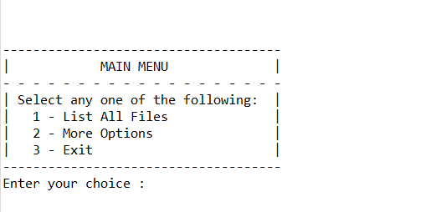

**Step 3.3:** Writing method to display Sub Menu for File Operations

**public** **void** subMenuOptions() {

System.***out***.println("-------------------------------------");

System.***out***.println("| SUB MENU |");

System.***out***.println("-------------------------------------");

System.***out***.println("| Select any one of the following: |");

System.***out***.println("| 1 - Add a file |");

System.***out***.println("| 2 - Delete a file |");

System.***out***.println("| 3 - Search a file |");

System.***out***.println("| 4 - Go Back |");

System.***out***.println("-------------------------------------");

System.***out***.println("Enter your choice : ");

}

**Output:**

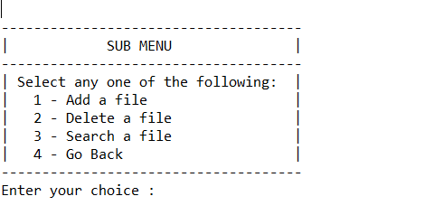

## **Step 4:** Writing a program in Java to handle Menu options selected by user (**VirtualDemo.java**)

* Select your project and go to File -> New -> Class.
* Enter **Virtual** class name and click on “Finish.”
* **HandleOptions** consists methods for -:
  1. Handling input selected by user in main Menu
  2. Handling input selected by user in sub Menu for File Operations

**Step 4.1:** Writing method to handle user input in main Menu

**public** **void** mainMenu()

{

**int** choice = 0;

**char** decision = 0;

**do**

{

mainMenuOptions();

**try**

{

choice = Integer.*parseInt*(scan.nextLine());

}

**catch** (Exception e)

{

System.***out***.println(e);

mainMenu();

}

**switch** (choice)

{

**case** 1:

System.***out***.println();

**try**

{

p.listAllFiles(Main.***path***);

}

**catch**(Exception e)

{

System.***out***.println(e.getMessage());

}

System.***out***.println("\n***********************************\n");

**break**;

**case** 2:

System.***out***.println();

subMenu();

**break**;

**case** 3:

System.***out***.println("\n Are you sure you want to exit ? ");

System.***out***.println(" (Y) ==> Yes (N) ==> No ");

decision = scan.nextLine().toUpperCase().charAt(0);

**if**(decision == 'Y')

{

System.***out***.println("\n");

exitScreen();

System.*exit*(1);

}

**else** **if**(decision == 'N')

{

System.***out***.println("\n");

mainMenu();

}

**else**

{

System.***out***.println("\nInvalid Input \nValid Inputs :(Y/N)\n");

mainMenu();

}

**default**:

System.***out***.println("\nInvalid Input \nValid Input Integers:(1-3)\n");

mainMenu();

}

}

**while**(**true**);

}

**Output:**

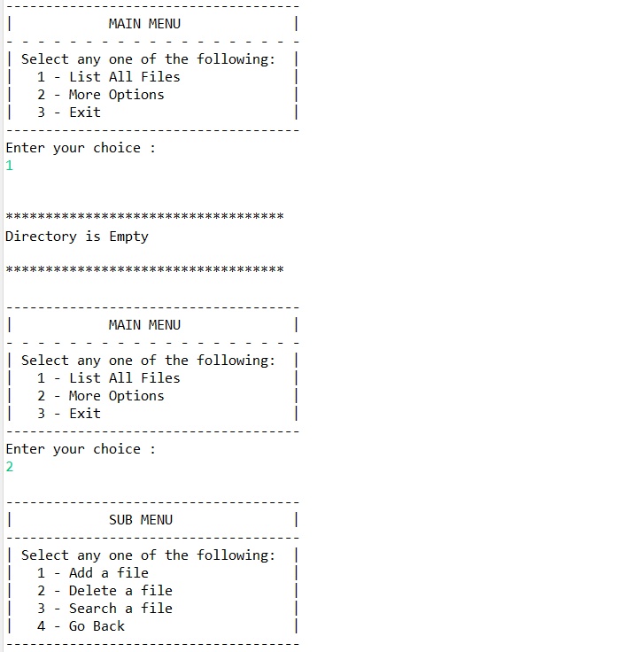

**Step 4.2:** Writing method to handle user input in Sub Menu for File Operations

**public** **void** subMenu() {

String file = **null**;

String fileName = **null**;

**int** choice = 0;

**do** {

subMenuOptions();

**try** {

choice = Integer.*parseInt*(scan.nextLine());

} **catch** (NumberFormatException e) {

System.***out***.println("Invalid Input \nValid Input Integers:(1-4)");

subMenu();

}

**switch** (choice) {

**case** 1:

System.***out***.println("\n==> Adding a File...");

System.***out***.println("Please enter a file name : ");

file = scan.nextLine();

fileName = file.trim();

**try** {

p.createNewFile(Main.***path***, fileName);

}

**catch**(Exception e) {

System.***out***.println(e);

}

System.***out***.println("\n**********************************\n");

**break**;

**case** 2:

System.***out***.println("\n==> Deleting a File...");

System.***out***.println("Please enter a file name to Delete : ");

file = scan.nextLine();

fileName = file.trim();

**try** {

p.deleteFile(Main.***path***, fileName);

}

**catch**(Exception e)

{

System.***out***.println(e.getMessage());

}

System.***out***.println("\n***********************************\n");

**break**;

**case** 3:

System.***out***.println("\n==> Searching a File...");

System.***out***.println("Please enter a file name to Search : ");

file = scan.nextLine();

fileName = file.trim();

**try** {

p.searchFile(Main.***path***, fileName);

}

**catch**(Exception e) {

System.***out***.println(e.getMessage());

}

System.***out***.println("\n***********************************\n");

**break**;

**case** 4: mainMenu();

**break**;

**default**:

System.***out***.println("Invalid Input \nValid Input Integers:(1-4)");

subMenu();

}

file = **null**;

fileName = **null**;

}**while**(**true**);

}

**Output:**

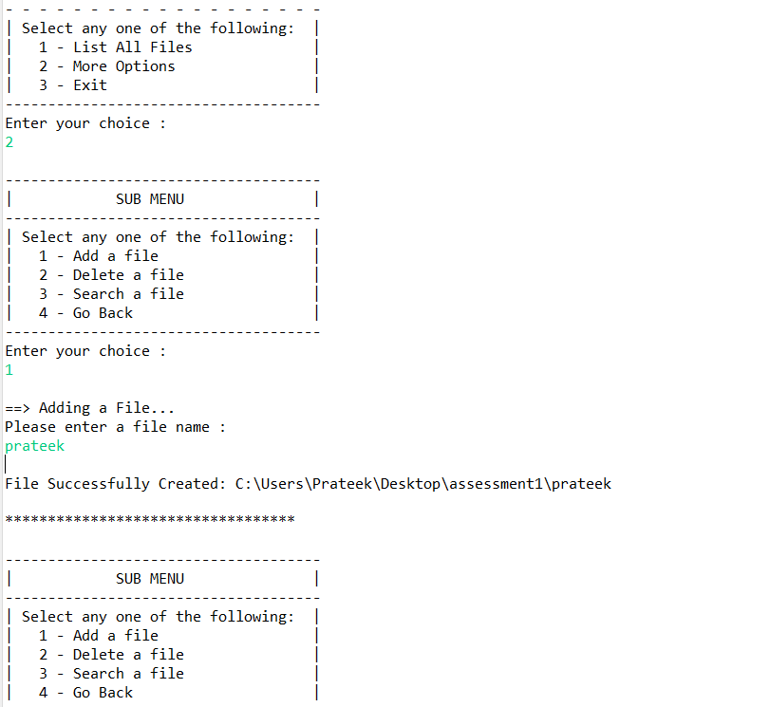

## **Step 5:** Writing a program in Java to perform the File operations as specified by user (**Operations.java**)

* Select your project and go to File -> New -> Class.
* Enter **Operations** in class name and click on “Finish.”
* **Operations** consists methods for -:
  1. Displaying all files in “main” folder in ascending order .
  2. Creating a file/folder as specified by user input.
  3. Search files as specified by user input in “main” folder and it’s subfolders.
  4. Deleting a file/folder from “main” folder

**Step 5.1:** Writing method to display all files in “main” folder in ascending order

**public** **void** listAllFiles(String path) {

**if** (path == **null** || path.isEmpty() || path.isBlank())

**throw** **new** NullPointerException("Path cannot be Empty or null");

File dir = **new** File(path);

**if**(!dir.exists())

**throw** **new** IllegalArgumentException("Path does not exist");

**if**(dir.isFile())

**throw** **new** IllegalArgumentException("The given path is a file. A directory is expected.");

String [] files = dir.list();

System.***out***.println("\n***********************************");

**if**(files != **null** && files.length > 0) {

Set<String>filesList = **new** TreeSet<String>(Arrays.*asList*(files));

System.***out***.println("The Files in "+ dir.getAbsolutePath() + " are: \n");

**for**(String file1:filesList) {

System.***out***.println(file1);

}

System.***out***.println("\nTotal Number of files: "+ filesList.size());

}**else** {

System.***out***.println("Directory is Empty");

}

}

**Output:**

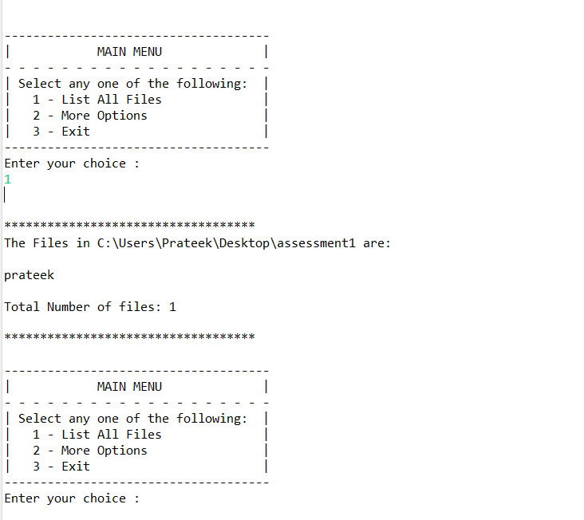

**Step 5.3:** Writing method to create a file/folder as specified by user input.

**public** **void** createNewFile(String path , String fileName) **throws** IOException {

**if** (path == **null** || path.isEmpty() || path.isBlank())

**throw** **new** NullPointerException("Path cannot be Empty or null");

**if** (fileName == **null** || fileName.isEmpty() || fileName.isBlank())

**throw** **new** NullPointerException("File Name cannot be Empty or null");

File newFile = **new** File(path + File.***separator*** + fileName);

**boolean** createFile = newFile.createNewFile();

**if** (createFile) {

System.***out***.println("\nFile Successfully Created: " + newFile.getAbsolutePath());

}**else** **if**(!createFile) {

System.***out***.println("\nFile Already Exist.. Please try again." );

}

}

**Output:**

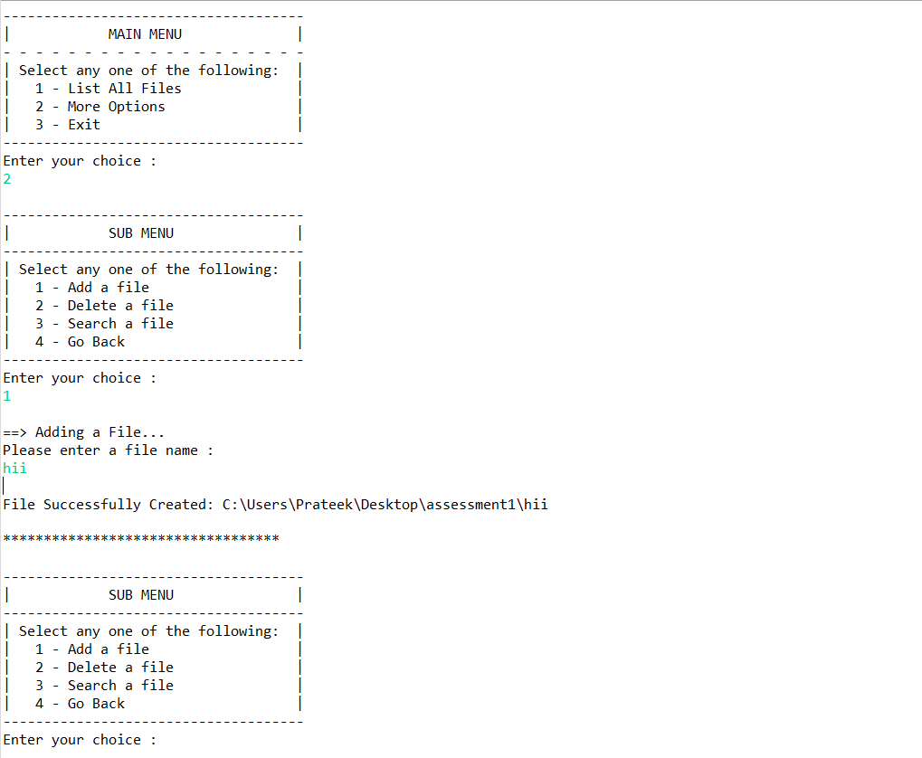

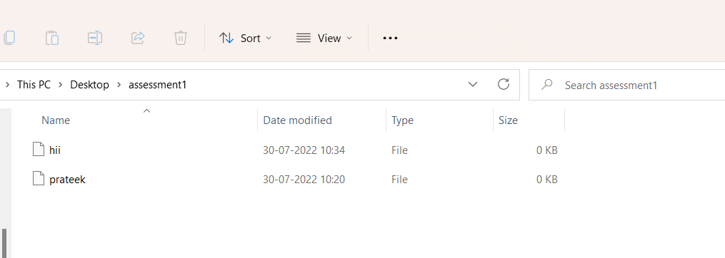

**Step 5.4:**  Writing method to search for all files as specified by user input in “main” folder and it’s subfolders.

**public** **void** searchFile(String path , String fileName){

**if** (path == **null** || path.isEmpty() || path.isBlank())

**throw** **new** NullPointerException("Path cannot be Empty or null");

**if** (fileName == **null** || fileName.isEmpty() || fileName.isBlank())

**throw** **new** NullPointerException("File Name cannot be Empty or null");

File dir = **new** File(path);

**if**(!dir.exists())

**throw** **new** IllegalArgumentException("Path does not exist");

**if**(dir.isFile())

**throw** **new** IllegalArgumentException("The given path is a file. A directory is expected.");

String [] fileList = dir.list();

**boolean** flag = **false**;

Pattern pat = Pattern.*compile*(fileName);

**if**(fileList != **null** && fileList.length > 0) {

**for**(String file:fileList) {

Matcher mat = pat.matcher(file);

**if**(mat.matches()) {

System.***out***.println("File Found at location: " + dir.getAbsolutePath());

flag = **true**;

**break**;

}

}

}

**if**(flag == **false**)

System.***out***.println("File Not Found.. Please try again.");

}

**Output:**

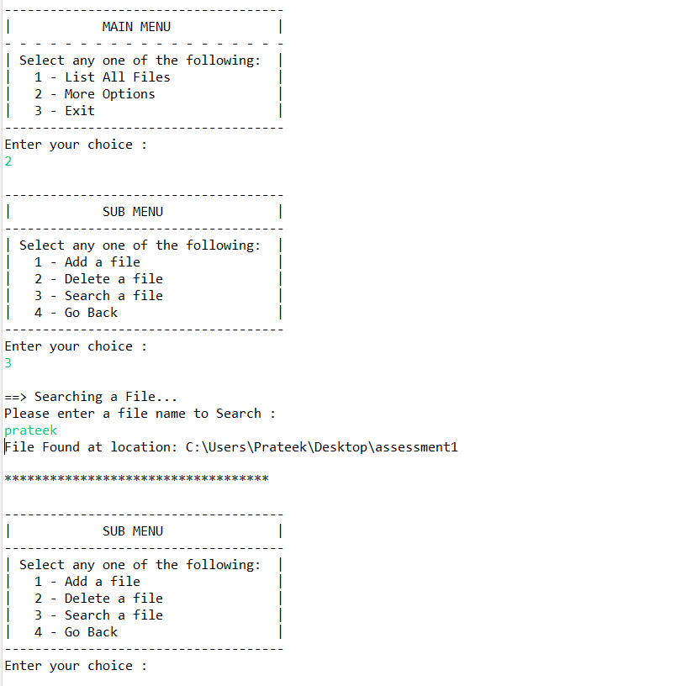

**Step 5.5:**  Writing method to delete file/folder specified by user input in “main” folder

**public** **void** deleteFile(String path , String fileName) **throws** IOException {

**if** (path == **null** || path.isEmpty() || path.isBlank())

**throw** **new** NullPointerException("Path cannot be Empty or null");

**if** (fileName == **null** || fileName.isEmpty() || fileName.isBlank())

**throw** **new** NullPointerException("File Name cannot be Empty or null");

File newFile = **new** File(path + File.***separator*** + fileName);

**boolean** deleteFile = newFile.delete();

**if** (deleteFile) {

System.***out***.println("\nFile deleted Successfully");

}**else** {

System.***out***.println("\nFile Not Found.. Please try again." );

}

}

**Output:**

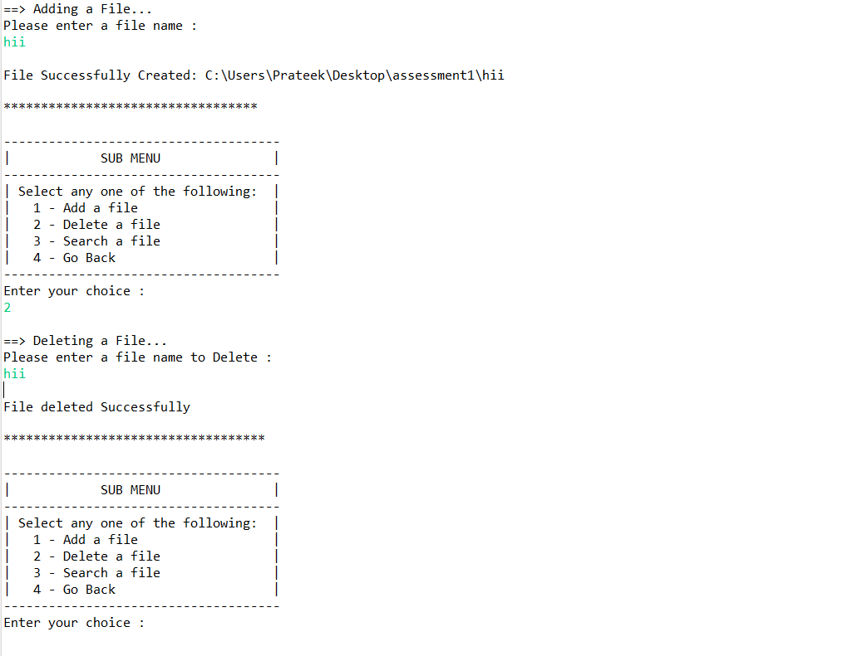

## **Step 6:** Pushing the code to GitHub repository

* Open your command prompt and navigate to the folder where you have created your files.

**cd <folder path>**

* Initialize repository using the following command:

**git init**

* Add all the files to your git repository using the following command:

**git add .**

* Commit the changes using the following command:

**git commit . -m <commit message>**

* Push the files to the folder you initially created using the following command:

**git push -u origin master**

## Unique Selling Points of the Application

1. The application is designed to keep on running and taking user inputs even after exceptions occur. To terminate the application, appropriate option needs to be selected.
2. The application doesn’t restrict user to specify the exact filename to search/delete file/folder.
3. The application also allows user to delete file which are not empty.
4. The user is able to seamlessly switch between options or return to previous menu even after any required operation like adding, searching, deleting or retrieving of files is performed.
5. When the option to retrieve files in ascending order is selected, user is displayed with two options of viewing the files.
   1. Ascending order of all files and folders inside the “main” folder.

## Conclusions

Further enhancements to the application can be made which may include:

* Conditions to check if user is allowed to delete the file or add the file at the specific locations.
* Allowing user to search, delete, add file in the main folder.