**React (Introduction)**

React is an open source JavaScript library for creating user interfaces.

Used for building user interfaces, It is not responsible for routing or making HTTP request.

Used for handling the view layer of our application.

It allows us to create large web application than can change data without reloading the webpage.

**Why Learn React?**

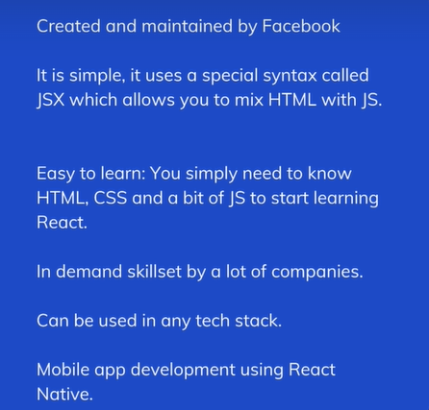

**Component Based architecture**

An application can be broken down into multiple small components.

Components allow reuse of code .

**Installing Tool**

Download new version of node. After node installed check version [node –version].

Download VS code.

**What is a component?**

* Parts of user interfaces
* Core building block of react
* An application comprises of multiple small components.
* Small components combined together form the entire UI
* Components can be nested inside one another

**Components in code**

* Component code is placed in javascript file.
* Example: App component is placed in App.js file
* There are two types of components functional component and a class component

**Functional Component**

* Function component is a javascript function that accepts input called props(properties) and return HTML which describes the UI.

Function Welcome(props){

Return <h1> Hello,{props.name}</h1>

}

This function is a valid react component because it accepts a sing props and return a react element.

We call such components as functional components because they are literally JavaScript functions.

**Class Component**

Class Welcome extend React.component{

Render()

{

Return <h1> Hello ,{this.props.name}</h1>;

}

}

A class component is nothing but regular ES6 classes that extend form react’s component class.

They must contain a render method which return HTML.

**Props**

Props are object that hold information to control behavior of a component.

Problem with props is that they are immutable.

State is also an object that hold some information but that information may change over the lifetime of that component.

|  |  |
| --- | --- |
| **Props** | **State** |
| Passes to the component. | Conatined inside component |
| Props are immutable. | State can be changed |
| Props can be accessed as props, this.props | Functional: use State Hook  Class:this.state |
| They are like parameters passed to a function | They are like variables declared in the function |