Name – Prateek Gupta
Usn – 1NT19IS115

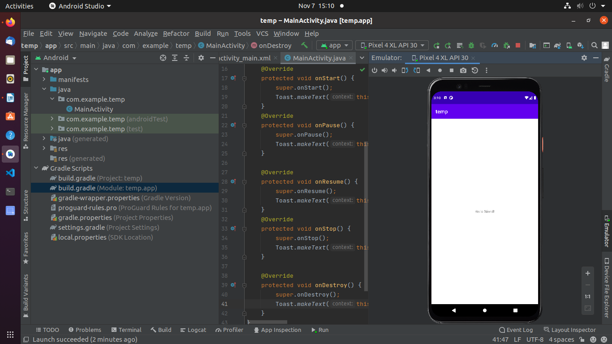
package com.example.temp;
import androidx.appcompat.app.AppCompatActivity;
import android.os.Bundle;
import android.widget.Toast;
public class MainActivity extends AppCompatActivity {
@Override
protected void onCreate(Bundle savedInstanceState) {
super.onCreate(savedInstanceState);
setContentView(R.layout.activity_main);
Toast.makeText(this, "ACTIVITY CREATED", Toast.LENGTH_SHORT).show();
}
@Override
protected void onStart() {
super.onStart();
Toast.makeText(this, "ACTIVITY STARTED", Toast.LENGTH_SHORT).show();
}
@Override
protected void onPause() {
super.onPause();
Toast.makeText(this, "ACTIVITY PAUSED", Toast.LENGTH_SHORT).show();
}
@Override
protected void onResume() {
super.onResume();
Toast.makeText(this, "ACTIVITY Resume", Toast.LENGTH_SHORT).show();
}
@Override
protected void onStop() {
super.onStop();
Toast.makeText(this, "ACTIVITY Stopped", Toast.LENGTH_SHORT).show();
}
@Override
protected void onDestroy() {
super.onDestroy();
Toast.makeText(this, "ACTIVITY Destroy", Toast.LENGTH_SHORT).show();
}
}

