CS 331 – Software Engineering Lab
Assignment 5
SmartScribe – AI-Powered Essay Evaluation System

Part I: Hosting the Application Components [5 Marks]

Application Components (from Assignment 4)
# | Component | Technology
1 | Frontend (UI) | React 18 + Vite (SPA)
2 | Backend (API) | FastAPI (Python / uvicorn)
3 | Database | SQLite (file-based, embedded)
4 | AI Service | OpenRouter LLM API (external SaaS)
5 | Auth Provider | Google OAuth 2.0 (external SaaS)

A. Host Site
Component | Target Platform | Rationale
React Frontend | Vercel | Free tier, global CDN, auto-deploy from GitHub, HTTPS by default
FastAPI Backend | Render (or Railway) | Supports Python runtimes, free tier, persistent server, HTTPS auto
SQLite Database | Co-located on Render filesystem | File-based; runs alongside the backend process on the same server
OpenRouter AI API | External – openrouter.ai | Third-party LLM gateway; no self-hosting required
Google OAuth | External – accounts.google.com | Google-managed; accessed via googleapis.com userinfo endpoint

B. Deployment Strategy

Step 1 – Repository Setup
- Both backend/ and modern_scribe/ reside in one GitHub repository.
- Separate deployment pipelines are configured — one for the frontend (Vercel) and one for the backend (Render).

Step 2 – Backend Deployment (Render)
- Create a Web Service on Render, linked to the GitHub repo.
- Set root directory → backend/
- Build Command: pip install -r requirements.txt
- Start Command: uvicorn main:app --host 0.0.0.0 --port 8000
- Add Environment Variables in Render dashboard:
- OPENROUTER_API_KEY = <key>
- JWT_SECRET = <strong-secret>
- GOOGLE_CLIENT_ID = <client-id>
- Render auto-assigns a public HTTPS URL (e.g., https://smartscribe-api.onrender.com).

Step 3 – Frontend Deployment (Vercel)
- Import the GitHub repo into Vercel.
- Set root directory → modern_scribe/
- Build Command: npm run build | Output directory: dist
- Add Environment Variables:
- VITE_API_BASE_URL = https://smartscribe-api.onrender.com
- VITE_GOOGLE_CLIENT_ID = <client-id>
- Vercel auto-deploys on every push to the main branch.

Step 4 – API Communication Configuration
- React frontend uses VITE_API_BASE_URL to target the correct backend.
- CORS is enabled in main.py via FastAPI's CORSMiddleware, whitelisting the Vercel domain.
- All protected API calls include the header: Authorization: Bearer <JWT>

Step 5 – Database Initialization
- database.py → init_db() is called automatically on startup via @app.on_event('startup').
- Creates the users and essays tables in smartscribe.db on the Render filesystem.

C. Security Measures
Security Mechanism | Details
JWT (HS256) | All protected routes validate a signed JWT. 24-hour expiry. Secret key stored in env var JWT_SECRET.
bcrypt Password Hashing | User passwords hashed with bcrypt (salted). Plain-text passwords never stored or transmitted.
Google Token Server-Side Verify | Backend calls googleapis.com/oauth2/v3/userinfo to independently verify the Google access token; never trusts client claims alone.
HTTPS / TLS | Vercel and Render enforce HTTPS by default — all data in transit is encrypted end-to-end.
Environment Variables | All secrets (API keys, JWT secret, Google Client ID) stored as server-side env vars, never committed to source code.
CORS Restriction | CORSMiddleware configured to allow only the trusted Vercel frontend origin in production.

Part II: User Access & Interaction Diagrams [10 Marks]

System Architecture Diagram
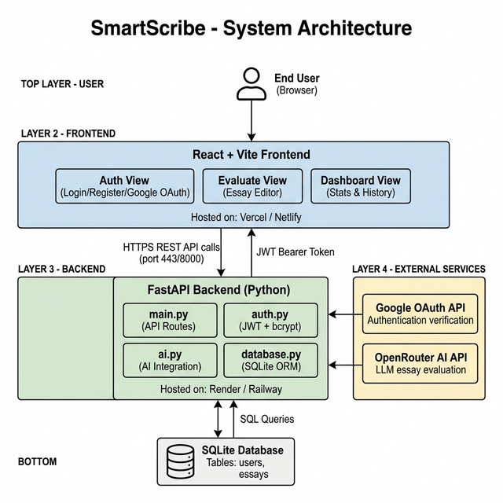
Figure 1: SmartScribe – System Architecture (Component View)

User Interaction & Component Flow Diagram
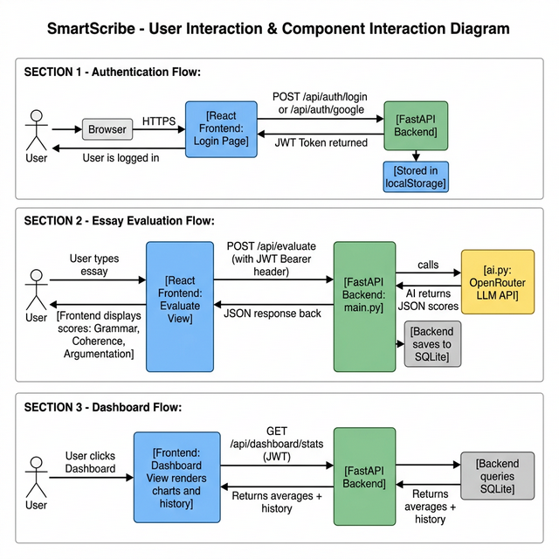
Figure 2: SmartScribe – User Interaction & API Communication Flows

Interaction Flow Descriptions

Flow 1 — User Authentication (Email/Password)
User (Browser)
├── Opens SmartScribe URL → Vercel CDN serves React SPA
├── Fills Login form
│
├─► [React Frontend] ── POST /api/auth/login ──► [FastAPI Backend]
│ {username, password} │
│ ├── verifies bcrypt hash (auth.py)
│ ├── generates JWT HS256 (auth.py)
│ └─► returns { access_token }
│
└── JWT stored in localStorage → User redirected to /evaluate

Flow 2 — Google OAuth Sign-In
User clicks "Sign in with Google"
│
├─► [Google OAuth Popup] → user consents → Google returns access_token to Frontend
│
├─► [React Frontend] ── POST /api/auth/google ──► [FastAPI Backend]
│ { credential: <google_access_token> } │
│ ├── calls googleapis.com/oauth2/v3/userinfo
│ ├── verifies token server-side
│ ├── creates / finds user in SQLite
│ └─► returns { access_token (JWT) }
└── User is logged in with SmartScribe JWT

Flow 3 — Essay Evaluation
User writes essay → clicks "Evaluate"
│
├─► [React Frontend] ── POST /api/evaluate ──────────────► [FastAPI: main.py]
│ Authorization: Bearer <JWT> │
│ { title, content } │
│ ├── auth.get_current_user_id() → validates JWT
│ ├── ai.get_ai_evaluation() → OpenRouter LLM API
│ │ └─► returns JSON { grammar, coherence, argumentation, feedback }
│ ├── db.save_essay() → SQLite INSERT
│ └─► JSON scores returned
└── Frontend renders: Grammar / Coherence / Argumentation score cards + AI feedback

Flow 4 — Dashboard
User navigates to Dashboard
│
├─► [React Frontend] ── GET /api/dashboard/stats ──► [FastAPI Backend]
│ Authorization: Bearer <JWT> │
│ ├── db.get_average_scores(user_id)
│ ├── db.get_user_essays(user_id)
│ └─► { averages, recent_essays }
└── Frontend renders progress charts and essay submission history

Part III: Implementation of Application Components [10 Marks]
Two core components are implemented and their interactions are demonstrated below:
- Component 1: Authentication Module (auth.py + /api/auth/* routes)
- Component 2: AI Evaluation Module (ai.py + /api/evaluate route)

Component 1: Authentication Module
Attribute | Detail
File | backend/auth.py + backend/main.py (routes)
Responsibility | User registration, login, Google OAuth verification, JWT issuance and validation
Libraries | python-jose (JWT), bcrypt (password hashing), httpx (Google API calls)
Endpoints | POST /api/auth/register, POST /api/auth/login, POST /api/auth/google

Key Code — auth.py (JWT + bcrypt)
from jose import JWTError, jwt
import bcrypt, os
from datetime import datetime, timedelta

SECRET_KEY = os.getenv("JWT_SECRET", "supersecret-key")
ALGORITHM = "HS256"
ACCESS_TOKEN_EXPIRE_MINUTES = 60 * 24 # 24 hours

def get_password_hash(password: str) -> str:
salt = bcrypt.gensalt()
return bcrypt.hashpw(password.encode("utf-8"), salt).decode("utf-8")

def verify_password(plain_password: str, hashed_password: str) -> bool:
return bcrypt.checkpw(plain_password.encode("utf-8"),
hashed_password.encode("utf-8"))

def create_access_token(data: dict):
to_encode = data.copy()
expire = datetime.utcnow() + timedelta(minutes=ACCESS_TOKEN_EXPIRE_MINUTES)
to_encode.update({"exp": expire})
return jwt.encode(to_encode, SECRET_KEY, algorithm=ALGORITHM)

async def get_current_user_id(token: str = Depends(oauth2_scheme)):
payload = jwt.decode(token, SECRET_KEY, algorithms=[ALGORITHM])
return int(payload.get("sub"))

Key Code — Google OAuth Route (main.py)
@app.post("/api/auth/google")
async def google_login(body: GoogleAuth):
# Server-side verification: call Google's userinfo endpoint
async with httpx.AsyncClient() as client:
resp = await client.get(
"https://www.googleapis.com/oauth2/v3/userinfo",
headers={"Authorization": f"Bearer {body.credential}"}
)
if resp.status_code != 200:
raise HTTPException(status_code=401, detail="Invalid Google token.")

userinfo = resp.json()
google_id = userinfo.get("sub")
email = userinfo.get("email")
full_name = userinfo.get("name", "Google User")
username = f"g_{google_id}"

db_user = db.get_user_by_username(username) or db.get_user_by_email(email)
if not db_user:
uid = db.create_user(username, email,
auth.get_password_hash(google_id + "_google_secret"),
full_name)
else:
uid = db_user["id"]

token = auth.create_access_token(data={"sub": str(uid)})
return {"access_token": token, "token_type": "bearer", ...}
Interactions with other components:
- Interacts with Database Module (database.py) to create/retrieve user records.
- Issues JWT tokens that are required by all other protected API endpoints.
- Frontend Auth.jsx sends credentials here and stores the returned JWT in localStorage.

Component 2: AI Evaluation Module
Attribute | Detail
File | backend/ai.py + backend/main.py (route)
Responsibility | Calls the OpenRouter LLM API with the essay, parses JSON scores, triggers database save
Libraries | openai (OpenAI-compatible client), json, re
Endpoint | POST /api/evaluate (JWT-protected)

Key Code — ai.py (LLM Integration)
from openai import OpenAI # OpenAI-compatible client for OpenRouter
import json, re, os

def get_ai_evaluation(title, content):
client = OpenAI(
base_url="https://openrouter.ai/api/v1",
api_key=os.getenv("OPENROUTER_API_KEY"),
)
prompt = f"""You are an expert essay grader. Evaluate the following essay.
Title: {title}
Content: {content}

Provide three scores (0-100) and feedback. Output EXACTLY as valid JSON:
{{ "grammar": 85, "coherence": 78, "argumentation": 92, "feedback": "..." }}
"""
response = client.chat.completions.create(
model="openrouter/auto",
messages=[{"role": "user", "content": prompt}],
)
text = response.choices[0].message.content
res = json.loads(re.search(r'\{.*\}', text, re.DOTALL).group(0))
overall = round((res["grammar"] + res["coherence"] + res["argumentation"]) / 3, 1)
return {"grammar": res["grammar"], "coherence": res["coherence"],
"argumentation": res["argumentation"], "overall": overall,
"feedback": res["feedback"]}

Key Code — Evaluation Route (main.py)
@app.post("/api/evaluate")
async def evaluate_essay(
essay: EssaySubmit,
user_id: int = Depends(auth.get_current_user_id) # ← JWT validation
):
result = ai.get_ai_evaluation(essay.title, essay.content) # ← AI Module

db.save_essay( # ← Database Module
user_id=user_id,
title=essay.title, content=essay.content,
grammar=result["grammar"], coherence=result["coherence"],
argument=result["argumentation"], overall=result["overall"],
feedback=result["feedback"]
)
return result
Interactions with other components:
- Auth Module validates the JWT before evaluation begins (Depends(auth.get_current_user_id)).
- Database Module (db.save_essay) persists scores so the Dashboard can retrieve history.
- OpenRouter external API performs actual LLM inference and returns structured JSON.
- Frontend Evaluate.jsx sends the essay payload and renders the returned score cards.

Component Interaction Summary
Frontend (Evaluate.jsx)
│
│ POST /api/evaluate
│ Authorization: Bearer <JWT>
│ { title, content }
▼
FastAPI Backend (main.py → evaluate_essay)
│
├── auth.get_current_user_id() ─── validates JWT ────────────── [Auth Component]
│
├── ai.get_ai_evaluation() ─── OpenRouter LLM API ────────── [AI Component]
│ └─► JSON { grammar, coherence, argumentation, feedback }
│
└── db.save_essay() ─── SQLite INSERT ─────────────── [Database Component]

Database Schema
-- users table
CREATE TABLE users (
id INTEGER PRIMARY KEY AUTOINCREMENT,
username TEXT NOT NULL UNIQUE,
email TEXT NOT NULL UNIQUE,
password TEXT NOT NULL, -- bcrypt hashed
full_name TEXT DEFAULT '',
created_at TEXT DEFAULT (datetime('now'))
);

-- essays table
CREATE TABLE essays (
id INTEGER PRIMARY KEY AUTOINCREMENT,
user_id INTEGER NOT NULL,
title TEXT DEFAULT 'Untitled Essay',
content TEXT NOT NULL,
grammar_score REAL DEFAULT 0,
coherence_score REAL DEFAULT 0,
argument_score REAL DEFAULT 0,
overall_score REAL DEFAULT 0,
feedback TEXT DEFAULT '',
submitted_at TEXT DEFAULT (datetime('now')),
FOREIGN KEY (user_id) REFERENCES users(id) ON DELETE CASCADE
);

