s

Crime Analysis (Baton Rouge)

***Wireframe Documentation***

Homepage

We have divided the main report into multiple Sections: -

1. First thing anyone will see a KPI card indicating the number dollars invested in all the startups for edtech combined:

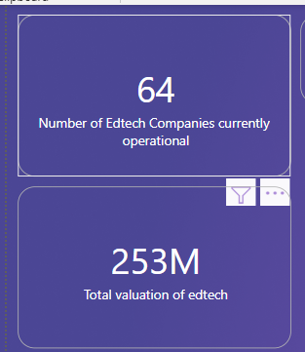

1. The Usesr will encounter another section having multiple slicer for filtering values accordingly

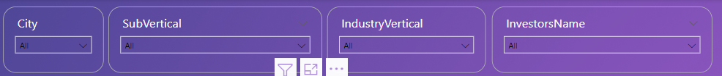

Based on User’s input, our Power BI report’s data will change accordingly. A sample view is below:

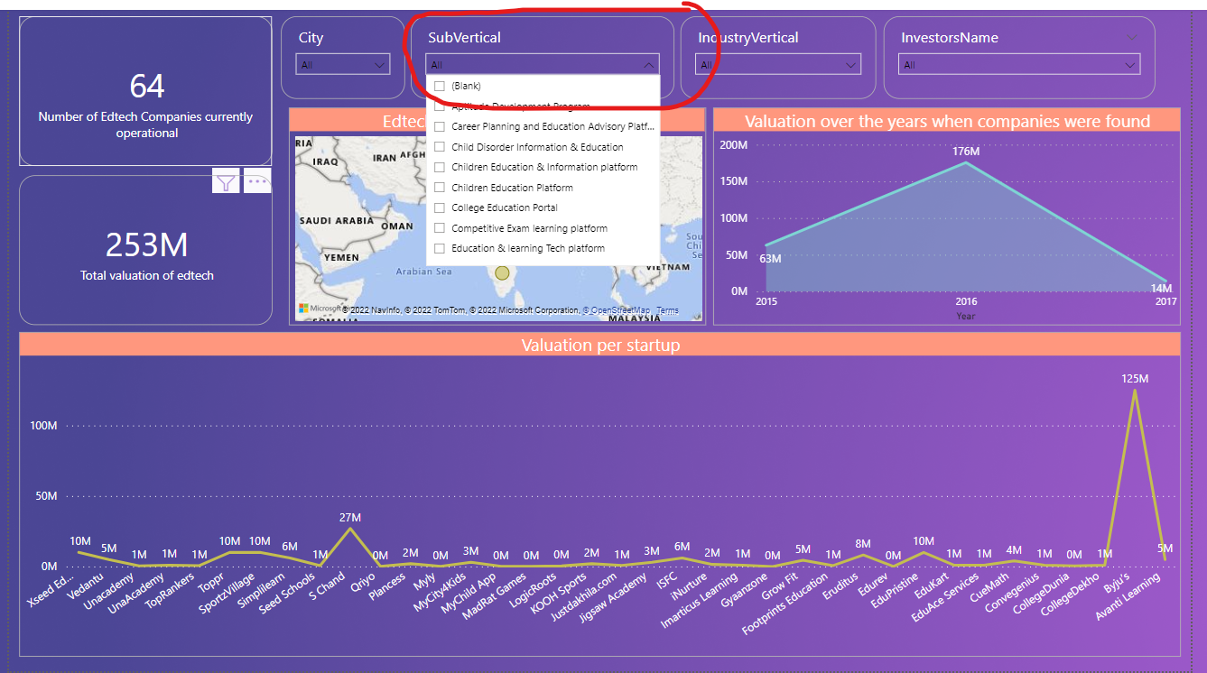

# Main report Page

This is the sample report where we have no applied filters currently.

