Financial Crime Analysis (Multiple banks)

***Wireframe Documentation***

Homepage

We have divided the main report into multiple Sections: -

1. First thing anyone will see a KPI card indicating the numbers where names are self evident what these numbers report itself there:

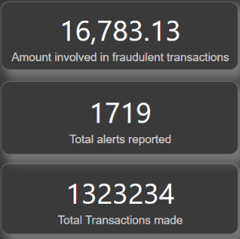

1. The Usesr will encounter another section having multiple slicer for filtering values accordingly

Based on User’s input, our Power BI report’s data will change accordingly. A sample view is below:

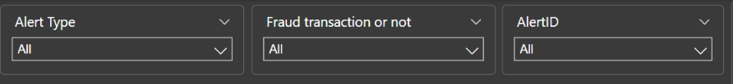

# Main report Page

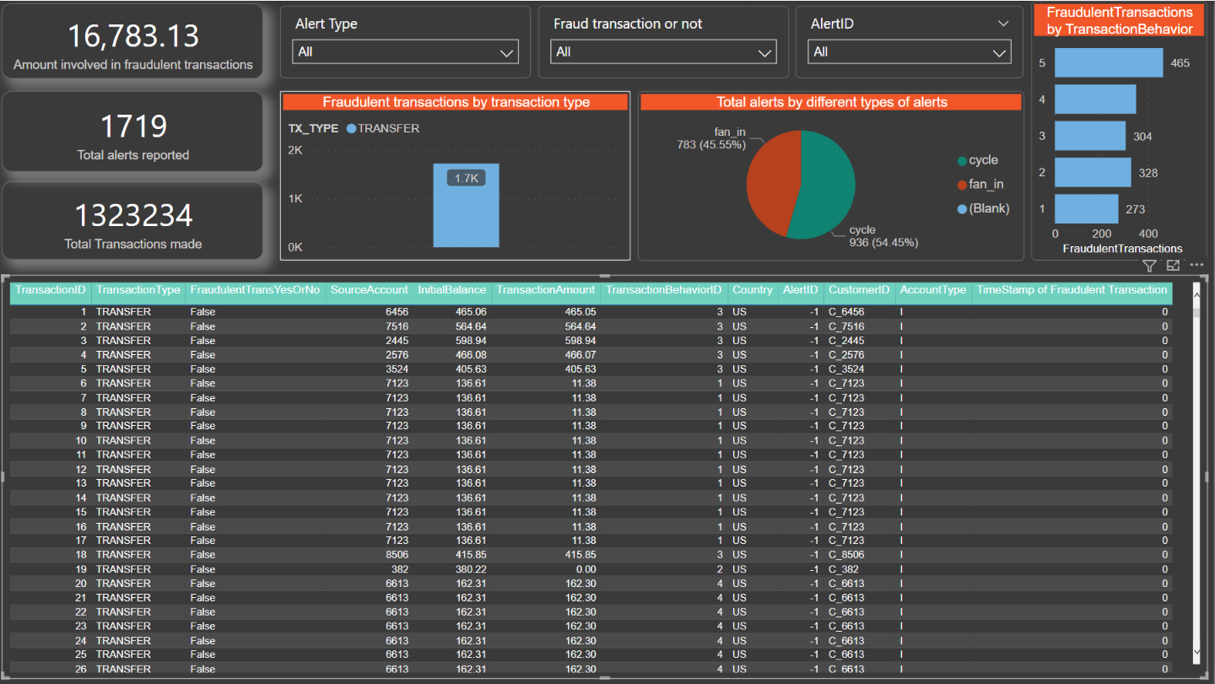

This is the sample report where we have no applied filters currently.

# About Page

In this Page, we will get a small introduction about the detailed information about definition of crime

