Low Level Design

Stock Market Analysis report (Power BI)

|  |  |
| --- | --- |
| Written By | Prateek Jha |
| Document Version | 1.0 |
| Last Revised Date | 21st May 2022 |

**Document Control**

### Change Record:

|  |  |  |  |
| --- | --- | --- | --- |
| **Version** | **Date** | **Author** | **Comments** |
| 1.0 | 21 – May -  2022 | Prateek Jha | Introduction & Architecture defined, Architecture & Architecture Description appended and updated |
|  |  |  |  |
|  |  |  |  |
|  |  |  |  |
|  |  |  |  |
|  |  |  |  |

### Reviews:

|  |  |  |  |
| --- | --- | --- | --- |
| **Version** | **Date** | **Reviewer** | **Comments** |
|  |  |  |  |

### Approval Status:

|  |  |  |  |  |
| --- | --- | --- | --- | --- |
| **Version** | **Review**  **Date** | **Reviewed By** | **Approved By** | **Comments** |
|  |  |  |  |  |

Contents

1. Introduction 1
   1. What is Low-Level design document? 1
   2. Scope 1
2. Architecture 2
3. Architecture Description 3
   1. Data Description 3
   2. Web Scrapping 3
   3. Data Transformation 3
   4. Data Insertion into Database 3
   5. Export Data from Database 3
   6. Data Pre-processing 3
   7. Data Clustering 3
   8. Model Building 4
   9. Data from User 4
   10. Data Validation 4
   11. User Data Inserting into Database 4
   12. Data Clustering 4
   13. Model Call for Specific Cluster 4
   14. Recipe Recommendation & Saving Output in Database 4
   15. Deployment 4
4. Unit Test Cases 5

# Introduction

## What is Low-Level design document?

The goal of LLD or a low-level design document (LLDD) is to give the internal logical design of the actual program code for Crime Analysis report prepared for the given dataset. LLD describes the class diagrams with the methods and relations between classes and program specs. It describes the modules so that the programmer can directly code the program from the document.

## Scope

Low-level design (LLD) is a component-level design process that follows a step-by-step [refinement](https://en.wikipedia.org/wiki/Refinement_(computing)) process. This process can be used for designing data structures, required software architecture, source code and ultimately, performance of the final product. Overall, the data organization may be defined during requirement analysis and then refined during data design work

# Architecture

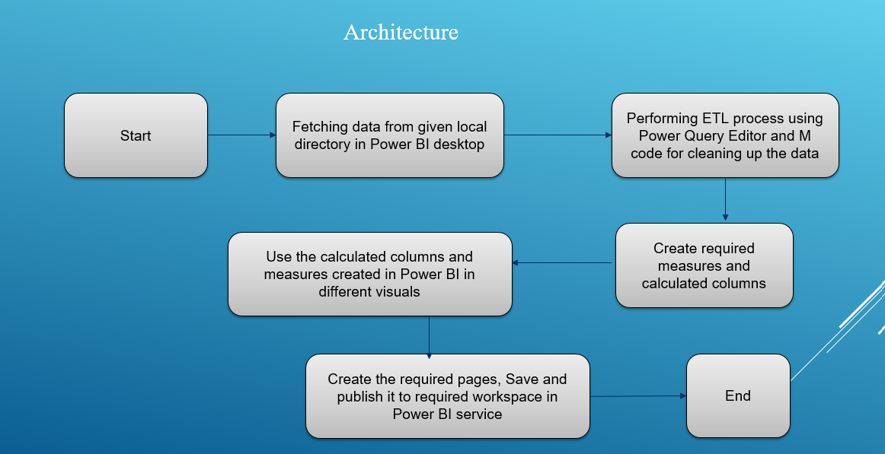

# Architecture Description

## Data Description

The dataset available with us contains 470k + rows for different companies belonging to Equity type stocks and their high/low/opening/closing prices are available for all active days starting from year 2000 for next 21 years. The dataset used for creating the report is available here:

<https://drive.google.com/file/d/1MFuGLfg0pzpZhH-3ZoIZv607GD2pGZtS/view>

## Data Transformation

In the Transformation Process, we will be using M code in Power BI’s Power query editor for cleaning the data and some transformation part as well.

## Data from User

The data provided to us has different informative columns such as Date, CompanyName(Symbol), Series(Type of stock), Open , close, high, low, last, VWAP, Column, Turnover, Trades, Deliverables volume and %Deliverables across different years

## Deployment

Once the data is imported from locally stored csv files provided from client we import the entire files directly in Power BI, use the Power Query editor for transformation/ preprocessing, creation of measures and calculated columns is done , report creation and deployed in Power BI service(cloud) for sharing purposes within the organization.