Stock Market’s Trend Analysis (Multiple stocks)

***Wireframe Documentation***

Homepage

We have divided the main report into multiple Sections: -

1. First thing anyone will see a KPI card indicating the numbers where names are self-evident what these numbers report itself there:

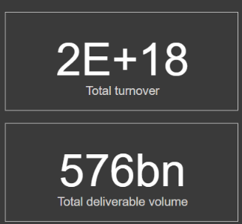

1. The Usesr will encounter another section having multiple slicer for filtering values accordingly

Based on User’s input, our Power BI report’s data will change accordingly. A sample view is below:

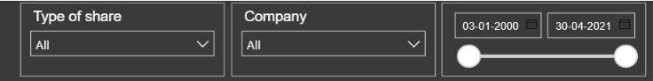

# Main report Page

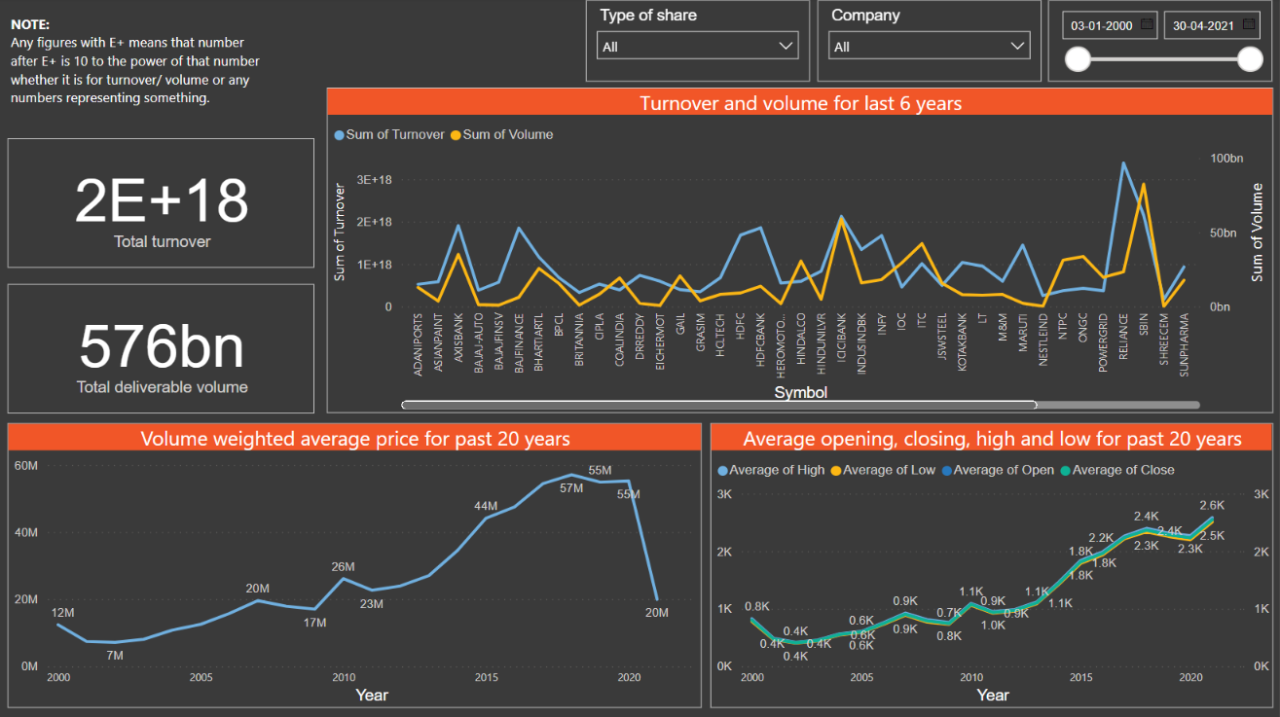

This is the sample report where we have no applied filters currently.

# About Page

In this Page, we will get a small introduction about the detailed information about definition of crime

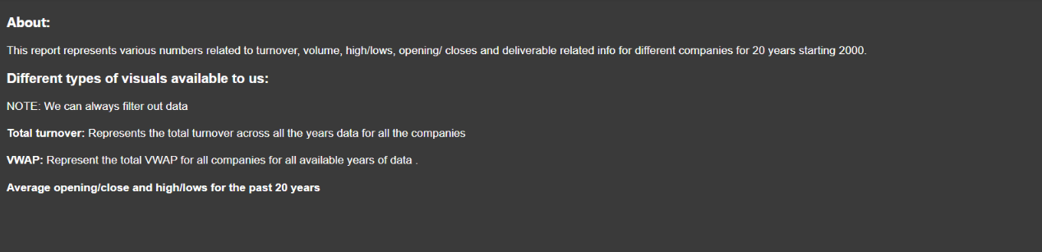

# Details Page:

In this Page, we will get a small introduction about the detailed information about definition of crime. This page is preferably hidden and used for showing detailed info when we hover over the line chart visual for Turnover and volume visual

